David G. Liston 505 Park Avenue
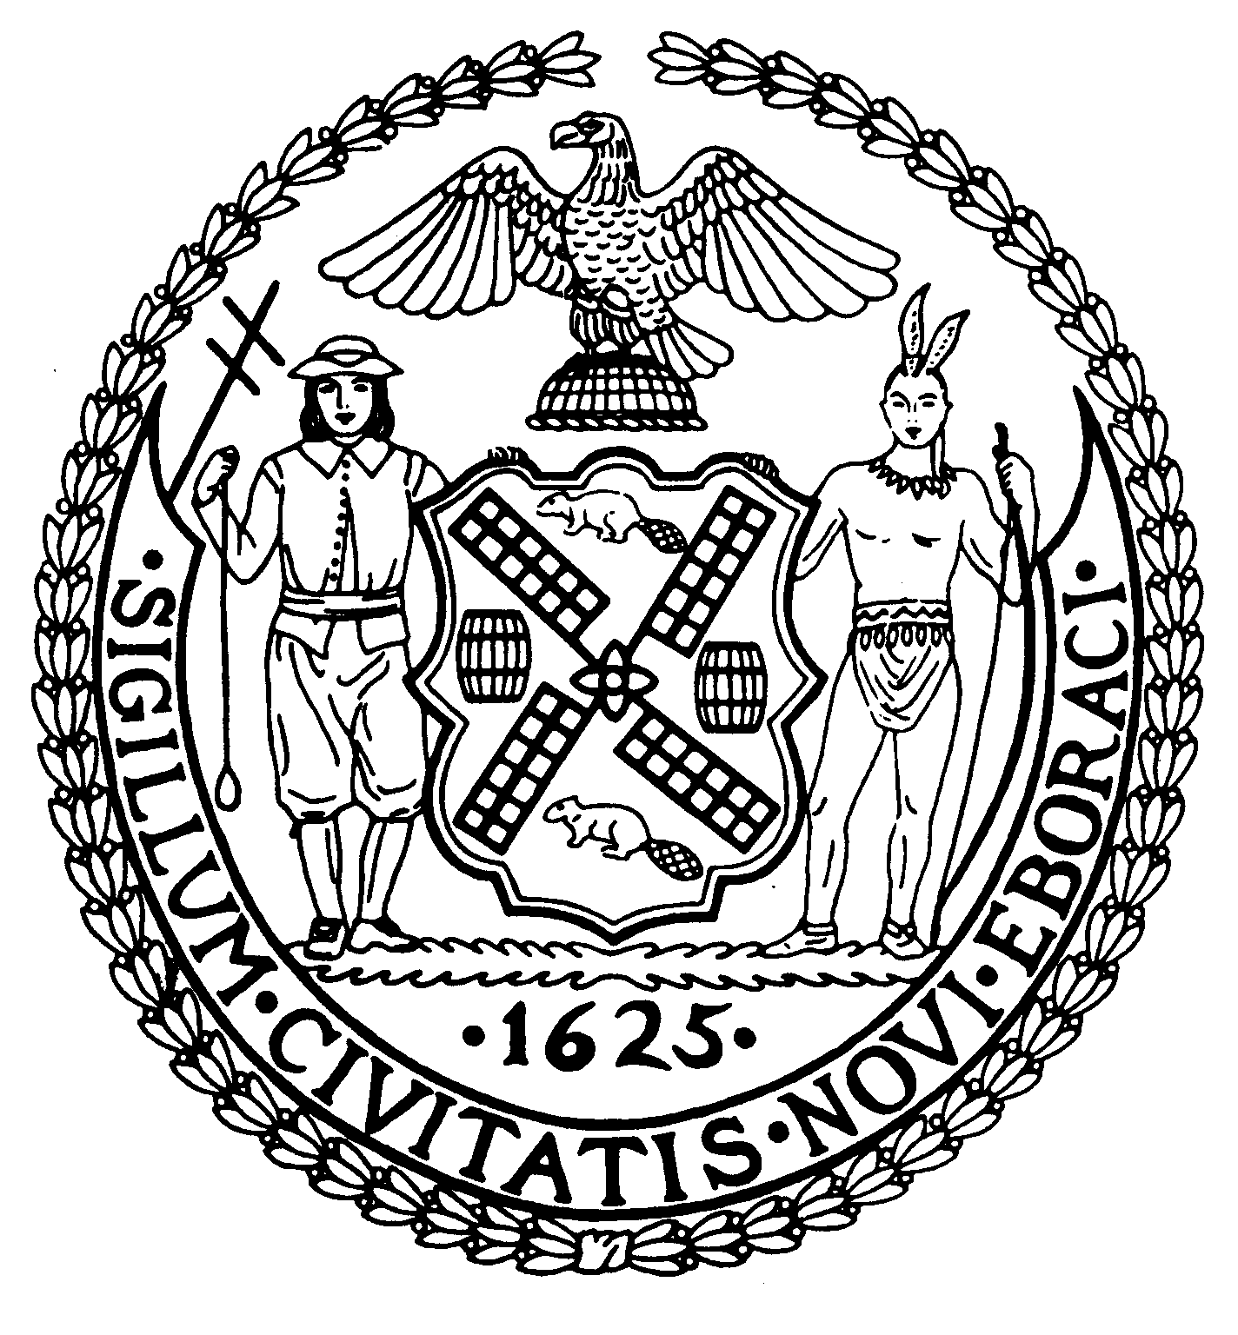
Chairman Suite 620
New York, N.Y. 10022

Maxine Brannon (212) 758-4340
District Manager (212) 758-4616 (Fax)
www.cb8m.com Website
. info@cb8m.com - E-Mail

The City of New York
Manhattan Community Board 8

March 21, 2008

Margaret Forgione
Manhattan Borough Commissioner
NYC Department of Transportation
59 Maiden Lane, 35th Flr.
New York, NY 10038
Re: The Congestion Pricing Plan
Dear Commissioner Forgione:

At the March 19, 2008 Full Board meeting, Community Board 8M adopted the following resolution by a vote of 27 in favor, 6 opposed, 3 Abstentions:

WHEREAS, traffic congestion in the central business district of Manhattan has been increasing on a yearly basis with the result that it is very difficult to carry out business in the area, and

WHEREAS, the traffic congestion in the central business district of Manhattan has led to deteriorating air quality with an adverse impact on health and the environment, and

WHEREAS, it is necessary to provide a continuing source of money for mass transit improvements in order to bolster the budget of the MTA,

THEREFORE BE IT RESOLVED, Community Board 8 supports the congestion pricing plan as recommended by the Traffic Congestion Mitigation Commission in its report of January 31, 2008, with the following changes:

- Elimination of the EZ PASS toll offset for drivers using the bridges and tunnels from New Jersey, and
- Elimination of any charges on residents in the residential permit parking program.

Please advise this office of any action taken regarding this matter.

Sincerely,

David G. Liston Jonathan Horn and Charles Warren
Chair Co-Chairs, Transportation Committee

cc: Hon. Michael Bloomberg, Mayor of the City of New York
Hon. Scott M. Stringer, Manhattan Borough President
Hon. Rose Pierre-Louis, Deputy Manhattan Borough President
Hon. Carolyn Maloney, United States Congress Member
Hon. Liz Krueger, New York State Senator
Hon. Jonathan Bing, New York State Assembly Member
Hon. Micah Kellner, New York State Assembly Member
Hon. Daniel Garodnick, New York City Council Member
Hon. Jessica Lappin, New York City Council Member
Lolita Jackson, Manhattan Director, Community Assistance Unit
Shaan Khan, Director of Comm. Affairs & Constituent Services, Manhattan Borough President’s Office
Cullen Barrie, Community Affairs Liaison, Manhattan Borough President’s Office
Elliot Sanders, Executive Director, MTA-NYC Transit
Janette Sadik-Khan, Commissioner, NYC Department of Transportation

