Jacqueline Ludorf 505 Park Avenue
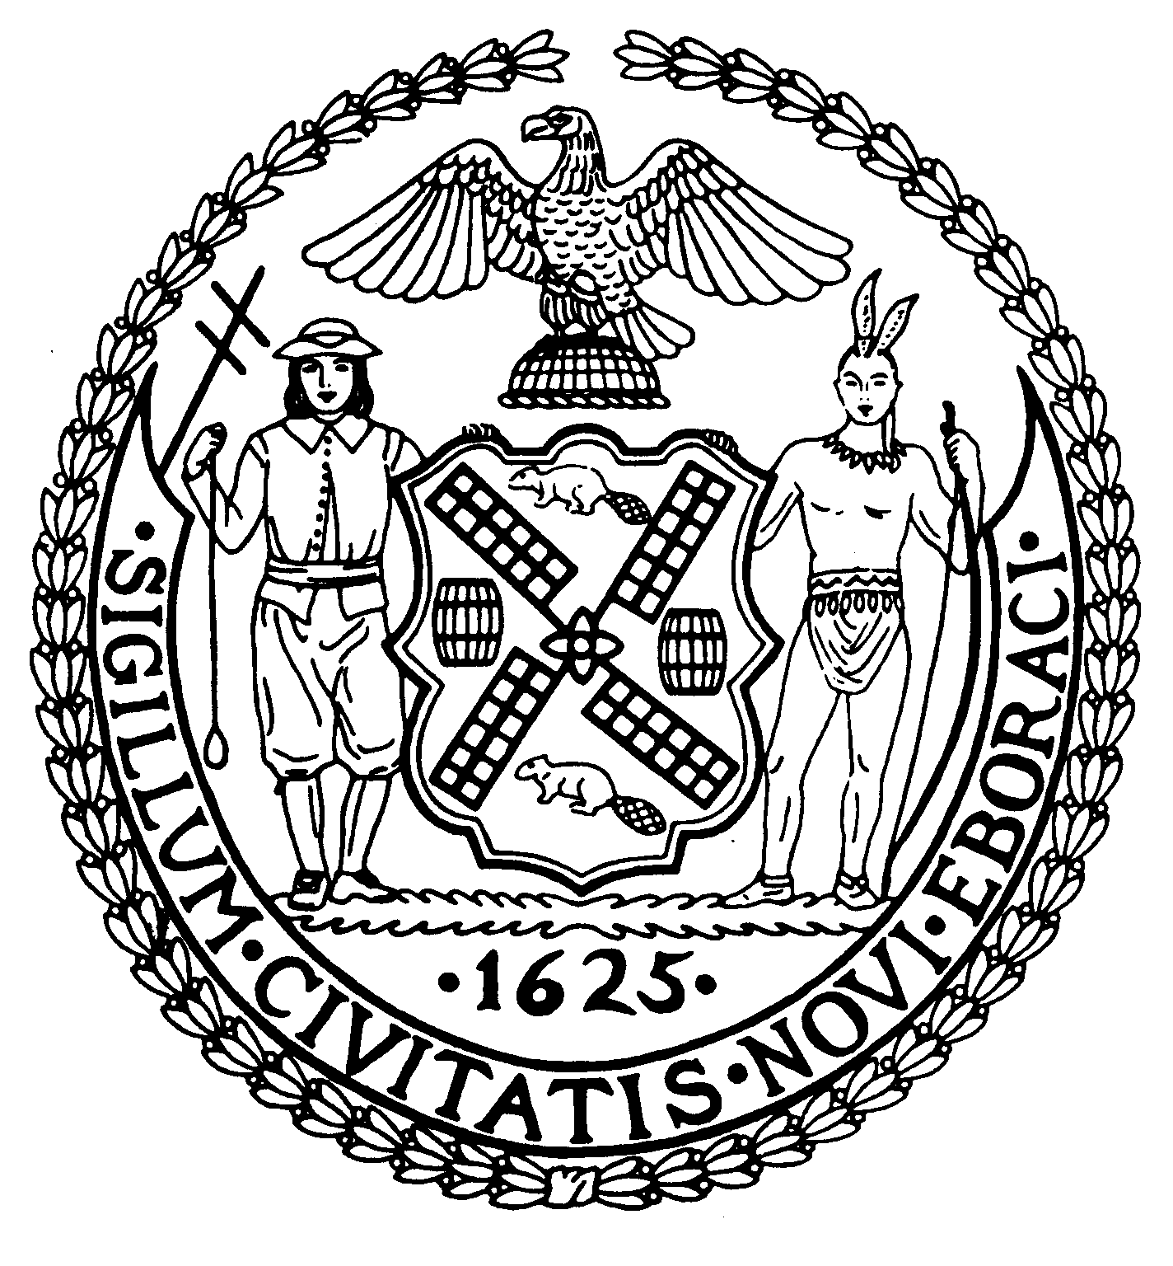
Chair Suite 620
New York, N.Y. 10022

Latha Thompson (212) 758-4340
District Manager (212) 758-4616 (Fax) info@cb8m.com – E-Mail www.cb8m.com – Website

The City of New York
Manhattan Community Board 8

September 24, 2009

Department of Consumer Affairs
Jonathan Mintz
New York City Department of Consumer Affairs
42 Broadway
New York, NY 10004
Fax: 212-487-4221

RE: Street Vendors within the Upper East Side

Dear Mr. Mintz:

At the September 16, 2009 Full Board meeting of Manhattan Community Board 8, the following resolution was adopted by a vote of 44 in favor, 2 opposed, and 0 abstention.

WHEREAS street vending is proliferating, and

WHEREAS small businesses are suffering and in decline, and

WHEREAS a significant number of licensed vendors are non compliant, and

WHEREAS licenses and permits are being sold or loaned, and

WHEREAS our streets are crowded with pedestrian shoppers, bus and subway travelers, and

WHEREAS vendor rules and regulations are complicated and they are across multiple government entities, and

WHEREAS enforcement is ineffective and insufficient considering the number of infractions, and

WHEREAS there are government initiated investigations into vendor practices which have uncovered fraud and corruption, demonstrating a serious threat to public health and safety,

BE IT RESOLVED THAT Manhattan Community Board 8 strongly urges that the street vendor issues should be a priority for our administration, and

BE IT FURTHER RESOLVED THAT Manhattan Community Board 8 strongly urges there be a moratorium on the authorization of new street vending licenses and permits and that a separate self-funding vendor enforcement squad be created without delay.

Please advise this office of any action taken regarding this matter.

Sincerely,

Jacqueline Ludorf Nicholas Viest
Chair Chair, Vendor Task Force Committee

Cc: Hon. Michael Bloomberg, Mayor of the City of New York
Hon. Scott M. Stringer, Manhattan Borough President
Hon. Jose Serrano, New York State Senator
Hon. Liz Krueger, New York State Senator

Hon. Micah Kellner, New York State Assembly Member

Hon. Jonathan Bing, New York State Assembly Member
Hon. Jessica Lappin, New York City Council Member
Hon. Daniel Garodnick, New York City Council Member
Thomas Farley, Commissioner, Department of Health and Mental Hygiene
Margaret Forgione, Manhattan Borough Commissioner, Department of Transportation
Inspector James Murtagh, Commanding Officer 19th Precinct

