2nd Avenue Subway Construction Look Ahead
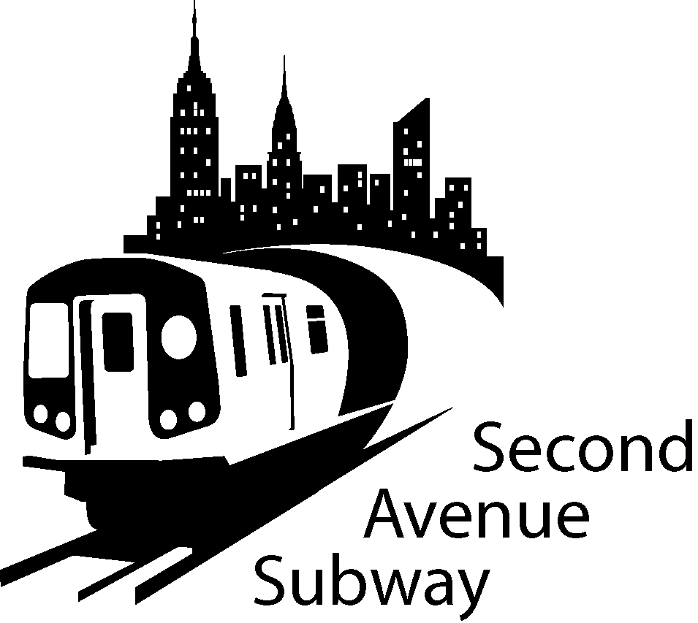
location  East and West  Shaft Site | description OF WORK | duration  MAY 11  may 24
Work between 69th and 70th Streets | EAST SIDE  Excavate and install support of excavation for relocation of water and electric utilities. | Monday thru Saturday
Work between 70th and 71st Streets  . | WEST SIDE  New traffic pattern established | Monday thru Saturday
Work between 71st and 72nd Streets | EAST SIDE  Excavate and install support of excavation for relocation electric utilities.  . | Monday thru Saturday
Work between 72nd and 73rd Streets. | EAST SIDE  Excavate and install support of excavation for relocation electric utilities. Installing new gas main  . | Monday thru Saturday

SAS Work Hours: **

7:00 am to 10:00 pm, Monday through Friday

10:00 am to 6:00 pm on Saturday

**BE ADVISED: Con Ed, Empire City Subway and Verizon may be performing cable and gas line work outside regular SAS construction Hours. Some of this work will take place on 2nd Ave between 68th and 74th Streets will be intermittently carried out in support of the Second Avenue Subway
If you have additional questions, please contact Claudia Wilson at (212) 792-9716 from 9:00AM to 5:00PM Monday through Friday, or contact the 2nd Avenue Subway Hotline 24 hours/7 days a week at (646)252-2670. TRAFFIC UPDATE 68th Street to 74th Street
Four lanes of traffic have been moved to the WEST SIDE of Second Avenue Work zone will be set up on the EAST SIDE of Second Ave The EAST SIDE work zone will be approximately 40 FOOT wide, plus 7’ sidewalk No Standing at anytime on the EAST SIDE of Second Ave No Standing on the WEST SIDE 7AM-10AM and 4PM-7PM Monday-Friday No Standing on WEST SIDE 10 AM-4PM, EXCEPT trucks loading and unloading Parking ALLOWED on WEST SIDE 7PM-7AM Weekdays and all day Saturday and Sunday No Parking Anytime on 72nd and 73rd Streets

