Jacqueline Ludorf 505 Park Avenue, Suite 620
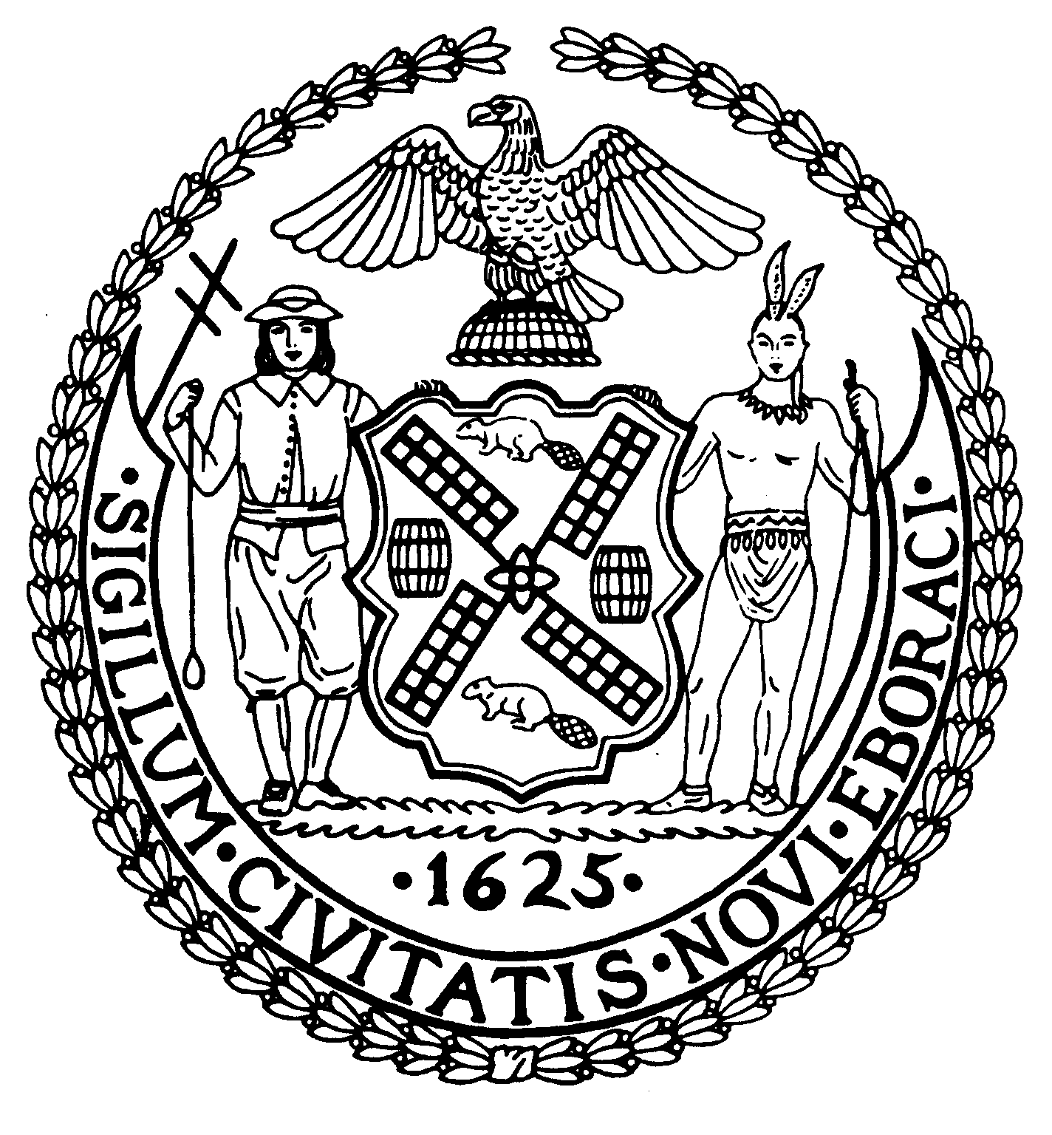
Chair New York, N.Y. 10022-1106
(212) 758-4340
Latha Thompson (212) 758-4616 (Fax)
District Manager w ww.cb8m.com - Website
info@cb8m.com - E-Mail

The City of New York
Manhattan Community Board 8
Public Hearing
Street Life Committee

Tuesday, October 5, 2010, 7:00 p.m.
*New York Blood Center, 310 East 67th Street, Auditorium, 7:00PM

Applications will only be approved based upon the applicants’ agreement to the following stipulations:
    - The applicant will abide by the bicycle guidelines,
    - The applicant will keep the front of the establishment clean,
    - The applicant will not place A-frames in front of the establishment,
    - The applicant will be denied if they participate in bar-crawls.

Members Present: Nick Viest, Jonathan Horn, Laura Lijewski, Marco Tamayo, Laurence Parnes, Matt Bondy, Judy Schneider, James Clynes

Members Absent (Excused): Cos Spagnoletti, Domenico George Minerva, Joie Anderson, Betty Cooper Wallerstein, Faith Bondy
Unanimous Cafes: 1(a), 1(b), 1(c), 1(d), 1(e), 1(f), 1(g), 1(h), 1(i), 1(j), 1(k), 2(a)
Unanimous SLA: 3(a), 4(a), 4(f), 4(g)
Non Unanimous SLA: 4(d), 4(e)

Agenda

1. Renewal Applications to the Department of Consumer Affairs for Sidewalk Cafes:
- By the Glass, Inc. d/b/a Uva Restaurant, 1486 Second Avenue (77th/78th Streets) – Renewal application for an unenclosed sidewalk café with 8 tables and 16 seats, DCA #1190933. Due date: Oct. 15th Hours:5p – 12a weekdays 5p – 1a weekends Food/Drink: 70/30

WHEREAS there are no changes to the café and no objections raised by the public,

BE IT RESOLVED THAT the application is approved.

6-0-0. YES: Viest, Horn, Clynes, J. Schneider, Lijewski, Parnes

- Egg White, Inc. d/b/a Blockheads, 1563 Second Avenue (81st/82nd Streets) – Renewal application for an unenclosed sidewalk café with 9 tables and 16 seats, DCA #1023023. Due date: Oct. 15th Hours: 11- 1a weekdays and 11 – 2a weekends Food/Drink: 80/20.

WHEREAS there are no changes to the café and no objections raised by the public,

BE IT RESOLVED THAT the application is approved.

6-0-0. YES: Viest, Horn, Clynes, J. Schneider, Lijewski, Parnes

- K.K.&D of 79th St. Rest. Corp. d/b/a Nectar Café, 1022 Madison Avenue (@ 79th Street) – Renewal application for an unenclosed sidewalk café with 3 tables and 12 seats, DCA #1171759. Due date: Oct. 18th Hours: 6a – 9p weekdays and 6p – 8p weekends Food/Drink:90/10

WHEREAS there are no changes to the café and no objections raised by the public,

BE IT RESOLVED THAT the application is approved.

6-0-0. YES: Viest, Horn, Clynes, J. Schneider, Lijewski, Parnes

- Baraonda Restaurant, Inc. d/b/a Baraonda Restaurant, 1439 Second Avenue (@ 75th Street) – Renewal application for an unenclosed sidewalk café with 20 tables and 40 seats, DCA #1215929. Due date: Oct. 25th Hours5p – 12a weekdays and 11a – 1a weekends. Food/Drink: 80/20.

WHEREAS there are no changes to the café and no objections raised by the public,

BE IT RESOLVED THAT the application is approved.

6-0-0. YES: Viest, Horn, Clynes, J. Schneider, Lijewski, Parnes

- Phillipos Restaurant, Inc. d/b/a Barking Dog Luncheonette, 1678 Third Avenue (@ 94th Street) – Renewal application for an unenclosed sidewalk café with 16 tables and 32 seats, DCA #1222470. Due date: Nov. 4th Hours: 8a – 11p. Food/Drink: 90/10

WHEREAS there are no changes to the café and no objections raised by the public,

BE IT RESOLVED THAT the application is approved.

6-0-0. YES: Viest, Horn, Clynes, J. Schneider, Lijewski, Parnes

- Thierry, Inc. d/b/a le Charlog, 19 East 69th Street (@ Madison Avenue) – Renewal application for an unenclosed sidewalk café with 6 tables and 17 seats, DCA #1167909. Due date: Nov. 4th Hours: 12p – 12a. Food/Drink: 95/5

WHEREAS there are no changes to the café and no objections raised by the public,

BE IT RESOLVED THAT the application is approved.

7-0-0. YES: Viest, Horn, Clynes, J. Schneider, Lijewski, Parnes, Tamayo)

- 62 & 1st, LLC d/b/a Merchants NY, 1125 First Avenue (61st/62nd Streets) – Renewal application for an unenclosed sidewalk café with 20 tables and 40 seats, DCA #1136669. Due date: Nov. 4th. Hours: 11:30a – 4a Food/Drink: 60/40

WHEREAS there are no changes to the café and no objections raised by the public,

BE IT RESOLVED THAT the application is approved.

7-0-0. YES: Viest, Horn, Clynes, J. Schneider, Lijewski, Parnes, Tamayo

- Haru Too, Inc. d/b/a Haru Sake Bar, 1327 Third Avenue (@ 76th Street) – Renewal application for an unenclosed sidewalk café with 19 tables and 38 seats, DCA #1106426. Due date: Nov. 5th. Hours: 12p – 12a. weekdays, 12p – 1a weekends. Food/Drink: 78/22.

WHEREAS there are no changes to the café and no objections raised by the public,

BE IT RESOLVED THAT the application is approved.

7-0-0. YES: Viest, Horn, Clynes, J. Schneider, Lijewski, Parnes, Tamayo

- Remedy Bar Group, LLC d/b/a Uptown, 1576 Third Avenue (88th/89th Streets) – Renewal application for an unenclosed sidewalk café with 9 tables and 21 seats, DCA #1161913. Due date: Oct. 15th. Hours: 4p – 2a weekdays and 11a – 4a. Food/Drink: 60/40.

WHEREAS there are no changes to the café and no objections raised by the public,

BE IT RESOLVED THAT the application is approved.

8-0-0. YES: Viest, Horn, Clynes, J. Schneider, Lijewski, Parnes, Tamayo, Bondy

- Arkady, Inc. d/b/a Al Forno Pizzeria, 1484 Second Avenue (77th/78th Streets) – Renewal application for an unenclosed sidewalk café with 9 tables and 19 seats, DCA #1103699. Due date: Nov. 1st. Hours: 12p – 11p. Weekdays and 12p – 12a. Food/Drink: 80/20.

WHEREAS there are no changes to the café and no objections raised by the public,

BE IT RESOLVED THAT the application is approved.

  - YES: Viest, Horn, Clynes, J. Schneider, Lijewski, Parnes, Tamayo, Bondy

Did not submit paperwork to the Board Office
k. Tiramisu Restaurant, LLC d/b/a Tiramisu Restaurant, 1410 Third Avenue (@ 80th Street) – Renewal application for an unenclosed sidewalk café with 13 tables and 26 seats, DCA #1282359. Due date: Nov. 5th. Hours: 12pm – 11pm weekdays, 11am – 12am Sat. and Sun, and 11am -11pm Sundays. Food/Drink: 10/10
WHEREAS there are no changes to the café and no objections from a member of the public,
BE IT RESOLVED THAT the application is approved.
8-0-0. YES: Viest, Horn, Clynes, J. Schneider, Lijewski, Parnes, Tamayo, Bondy
- Virgilia Café, Inc. d/b/a Antonucci, 168 East 81st Street (Lexington/ Third Ave) – Renewal application for an unenclosed sidewalk café with 4 tables and 16 seats, DCA #1225069. Due date: Oct. 28th

- New Applications to the Department of Consumer Affairs for Sidewalk Cafes:
a. Paramount Foods, Inc, dba Baluchi’s1724 Second Avenue (89th/90th Streets) – New application for an unenclosed sidewalk café with 7 tables and 13 seats, DCA #1371211. Due date: Nov. 5th Hours: 12p – 11p. Food/Drink: Food/Drink: 90/10.
WHEREAS there is ample space for a café,
BE IT RESOLVED THAT the application is approved.
8-0-0. YES: Viest, Horn, Clynes, J. Schneider, Lijewski, Parnes, Tamayo, Bondy

3. Alterations or Transfer Applications to the New York State Liquor Authority for Liquor Licenses:
- G & G Café, Inc., 1303 Third Avenue (74th/75th Streets) – Application to make alterations to an on-premises liquor license Hours: 12 – 2a weekdays and 12 – 4a weekends. Food/Drink: 70/30.
WHEREAS the application is to make alterations inside the establishment,
BE IT RESOLVED THAT the application is approved.
8-0-0. YES: Viest, Horn, Clynes, J. Schneider, Lijewski, Parnes, Tamayo, Bondy

4. New Applications to the New York State Liquor Authority for Liquor Licenses:
- Elim Deli Café, Inc., 851 Lexington Avenue (64th/65th Streets) – New application for a beer only license Hours: 7a – 11:30p Food/Drink:80/20.
WHEREAS this application is from a deli establishment with food service,
BE IT RESOLVED THAT the application is approved.
8-0-0. YES: Viest, Horn, Clynes, J. Schneider, Lijewski, Parnes, Tamayo, Bondy
- The Explorers Club d/b/a The Explorers Club, 46 East 70th Street (Park/Madison Avenues) – New application for an on-premises liquor license (Laid over from the October meeting, at applicant’s request)
Numerous residents appeared to express opposition to the application. There was a lengthy discussion and the committee decided to lay over the application so it can receive additional information about the frequency and type of events that the Club would hold. Laid over to November
- One 83 Restaurant, 1608 First Avenue (83rd/84th Streets) – New application for an on-premises liquor license
The committee wishes to see plans for the back yard use as well as make sure that members of the public are aware that there is a rear yard use. Laid over to November.
- Jamon Jamon, LLC, 247 East 81st Street (@ Second Avenue) – New application for an on-premises liquor license. Hours: 11a – 4a. Food/Drink: 35/65.
WHEREAS the establishment is in the former space of Etas Unis,
WHEREAS there is no kitchen,
WHEREAS the establishment will be modeled after a Spanish style European Café serving cheeses and Spanish hams and sandwiches,
WHEREAS the bar will be relatively small with 8 seats,
WHEREAS there will only be background music,
WHEREAS the applicant agrees to shut the front doors by 10p,
BE IT RESOLVED THAT the application is approved.
7-1-0. YES: Viest, Horn, Clynes, J. Schneider, Parnes, Tamayo, Bondy.
NO: Lijewski)
- Heidi’s House, LLC d/b/a Heidi’s House by the Side of the Road, 308 East 78th Street (Second/Third Avenues) – New application for a wine and beer license (Laid over from the September meeting, at applicant’s request)
WHEREAS the applicant said they submitted paperwork prior to the previous meeting.
WHEREAS the establishment will be a small wine bar,
WHEREAS the owner has spoken to residents in the building,
WHEREAS the owners live directly across the street from the establishment,
WHEREAS the owners agreed to shut the front doors by 10p,
BE IT RESOLVED THAT the application is approved.
7-1-0. YES: Viest, Horn, Clynes, J. Schneider, Parnes, Tamayo, Bondy
NO: Lijewski
- MJAJ Food Corp. d/b/a EATS, 1055 Lexington Avenue (@ 75th Street) – New application for an on-premises liquor license Hours: 8a-12am. Food/Drink: 65/35
WHEREAS the application is for a new establishment serving an upscale cuisine,
WHEREAS the applicant will need to get DCA's permission to use the enclosed cafe space,
WHEREAS a letter of "No Objection" has been filed with the Dept of Buildings regarding the Certificate of Occupancy which the owner does not currently have,

BE IT RESOLVED THAT the application is approved.

8-0-0. YES: Viest, Horn, Clynes, J. Schneider, Lijewski, Parnes, Tamayo, Bondy

g. NYC 1, LLC d/b/a Neely’s Pig Parlor, 1125 First Avenue (61st/62nd Streets) – New application for an on-premises liquor license Hours: 11:30a – 4a Food/Drink: 60/40
WHEREAS this establishment will take over the upstairs space from Merchants NY,
WHEREAS the representative stated that this would be a high end barbecue restaurant,

WHEREAS the applicant stated that the signage would be tastefully done,

BE IT RESOLVED THAT the application is approved.

8-0-0. YES: Viest, Horn, Clynes, J. Schneider, Lijewski, Parnes, Tamayo, Bondy

Did not submit paperwork to the Board Office
h. Pink Salmon of NY, Inc., 1364 Lexington Avenue (90th/91st Street) – New application for an wine and beer license (Laid over from the October meeting, at applicant’s request)
i. Corp to be formed by Larry Mcintyre, 1681 First Avenue (@ 87th Street) – New application for an on-premises liquor license

Layovers/Withdrawals
- North East Corner of Third Avenue & East 66th Street - New application for a NEWSTAND, DCA #1366600 (Laid over to the November meeting, at the request of the Street Life Committee)
- Italian on 78, Inc., 1496 Second Avenue (@ 78th Street) – Application to make alterations to an on-premises liquor license (Application withdrawn, at applicant’s request on 9/24/10)
- Casa Antonucci, LLC d/b/a Di Casa, 24 East 81st Street (Madison/5th Avenues) – New application for an on-premises liquor license (Application withdrawn, at applicant’s request on 9/27/10)
- UES Rest Corp. d/b/a Saloon, 1584 York Avenue (83rd/84th Streets) – Application to transfer an on-premises liquor license (Laid over to the November meeting, at applicant’s request on 10/4/10)
- Stoney MG, Inc. d/b/a Ryan’s Daughter, 350 East 85th Street (First/Second Avenues) – New application for an on-premises liquor license (Laid over to the November meeting, at applicant’s request on 10/4/10)

  - New Applications to the Department of Consumer Affairs for Newsstand:
Did not submit paperwork to the Board Office
a. North East Corner of First Avenue and 71st Street - New application for a newsstand, DCA #1370179
The applicant did not have the necessary paperwork. Laid over to November

