Jacqueline Ludorf 505 Park Avenue, Suite 620
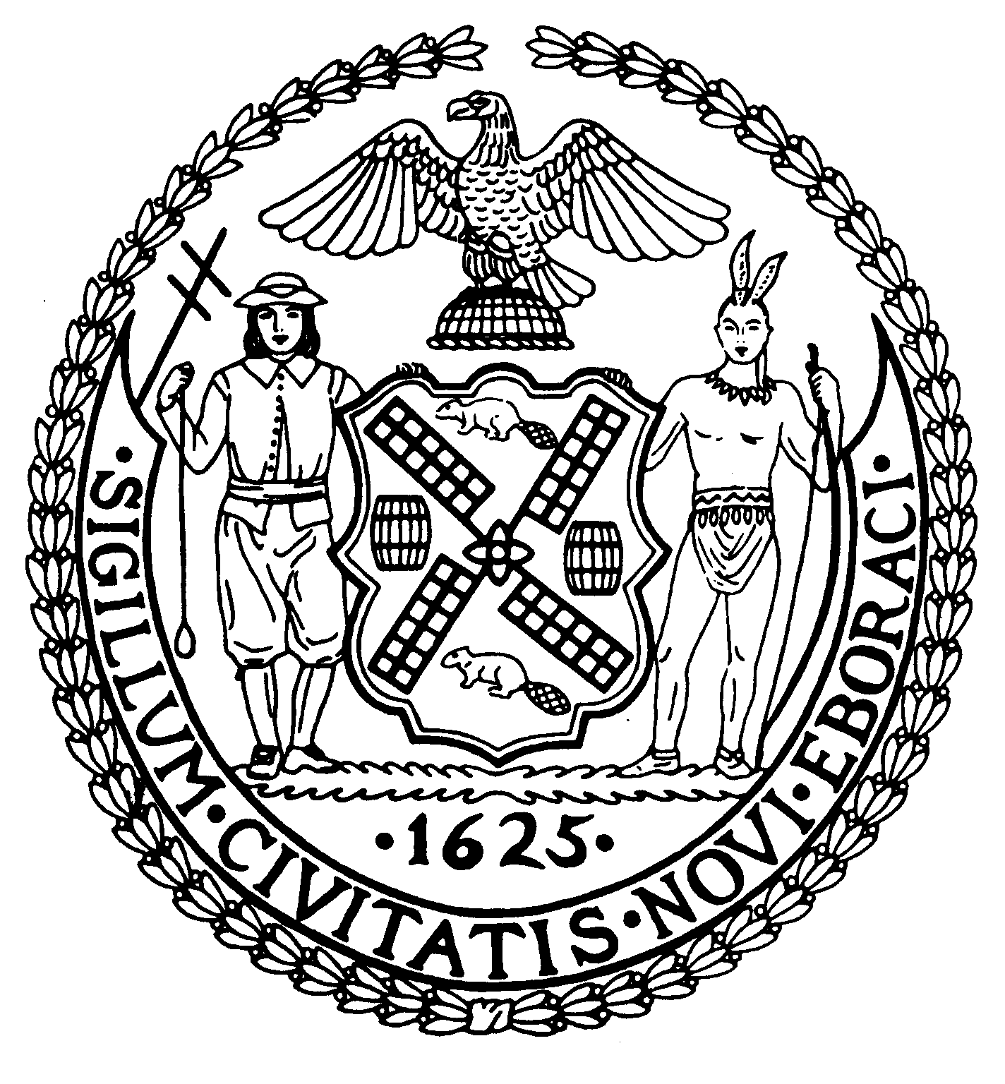
Chair New York, N.Y. 10022-1106
(212) 758-4340
Latha Thompson (212) 758-4616 (Fax)
District Manager w ww.cb8m.com - Website
info@cb8m.com - E-Mail

The City of New York
Manhattan Community Board 8
Public Hearing
Street Life Committee

Tuesday, November 1, 2011, 7:00 p.m.
Marymount Manhattan College, 221 East 71st Street, Regina Peruggi Room, 2nd Fl

Applications will only be approved based upon the applicants’ agreement to the following stipulations:
    - The applicant will abide by the bicycle guidelines,
    - The applicant will keep the front of the establishment clean,
    - The applicant will not place A-frames in front of the establishment,
    - The applicant will be denied if they participate in bar-crawls.

Members Present: Cos Spagnoletti, Nick Viest, Domenico Minerva, Laurence Parnes, Joie Anderson, Marco Tamayo, Molly Blayney, Matt Bondy

Excused Members: James Clynes
Unanimous Cafes: 1b, 2a
Non Unanimous Cafes:
Unanimous SLA: 3a, 4a, 4b, 4c, 4d, 4f, 4g
Unanimous Disapproval:

Agenda

- Renewal Applications to the Department of Consumer Affairs and/or Department of City Planning for a Sidewalk Cafe:
  - A La Turk, Inc. d/b/a Ala Turk, 1417 Second Avenue (@ 74th Street) – Renewal application for an unenclosed sidewalk café with 12 tables and 22 seats, DCA #1315623. Due date: Nov. 28th Hours: 11a – 12a Mon – Th. 11a – 1a Fri-Sat. 12p – 12a Sun. Food/Drink: 80/20.
Applicant did not appear. NO POSITION.
  - Lenox Room Corp. d/b/a T-Bar Steak & Lounge, 1278 Third Avenue (73rd/74th Streets) – Renewal application for an unenclosed sidewalk café with 4 tables and 8 seats, DCA #1136163. Due date: Dec. 5th Hours: 12p – 12a. Food/Drink: 75/25.
WHEREAS there are no changes to the café and there was no objection from the public,
BE IT RESOLVED THAT the application is Approved.
7-0-0. Yes: Cos Spagnoletti, Nick Viest, Nico Minerva, Laurence Parnes, Joie Anderson, Marco Tamayo, Molly Blayney

- New Applications to the Department of Consumer Affairs and/or Department of City Planning for a Sidewalk Cafe:
- Luma Restaurant, Inc. d/b/a Lusardi’s Restaurant, 1494 Second Avenue (@ 78th Street) – New application for an unenclosed sidewalk with 9 tables and 20 seats, DCA #1410849. Due date: Nov. 28th. Hours: 8a – 1a. Food/Drink: 80/20.
WHEREAS there is over 10’ of clearance,
BE IT RESOLVED THAT the application is Approved.
7-0-0. Yes: Cos Spagnoletti, Nick Viest, Nico Minerva, Laurence Parnes, Joie Anderson, Marco Tamayo, Molly Blayney

- Transfer/Alterations Applications to the New York State Liquor Authority for Liquor Licenses:
  - 347 East 85th Partners, LLC d/b/a Luna Rossa, 347 E. 85th Street (Second/First Avenues) - Application to alter an existing wine and beer only license to include full liquor (Laid over once at the applicants request)
WHEREAS the applicant is adding a liquor license as his customers are requesting mixed drinks,
WHEREAS there will only be a service bar,
BE IT RESOLVED THAT the application is Approved.
7-0-0. Yes: Cos Spagnoletti, Nick Viest, Nico Minerva, Laurence Parnes, Joie Anderson, Marco Tamayo, Molly Blayney

- New Applications to the New York State Liquor Authority for Liquor Licenses:
  - IL Travatore, LLC d/b/a Salumeria Rosi Parmacotto, 903 Madison Avenue (72nd/73rd Streets) – New application for a wine and beer only license (Laid over once, in the month of Sept., at applicant’s request) Hours: 9a – 11p. Food/Drink: 70/30.
WHEREAS the applicant has owned a restaurant on the West Side for 3 years,
WHEREAS no members of the public objected,
BE IT RESOLVED THAT the application is Approved.
7-0-0. Yes: Cos Spagnoletti, Nick Viest, Nico Minerva, Laurence Parnes, Joie Anderson, Marco Tamayo, Molly Blayney

b. Crown Alley, LLC d/b/a TBD, 1590 Second Avenue (82nd/83rd Streets) – New application for an on-premises liquor license. Hours: 12p – 4a weekdays and 11a – 4p on weekends. Food/Drink: 60/40.
WHEREAS agrees to shut the front door/windows at 10p,
BE IT RESOLVED THAT the application is Approved.
7-0-0. Yes: Cos Spagnoletti, Nick Viest, Nico Minerva, Laurence Parnes, Joie Anderson, Marco Tamayo, Molly Blayney

c. TNTE. LLC d/b/a Dragonfly Restaurant, 1463 Third Avenue (82nd/83rd Streets) – New application for an on-premises liquor license Hours: 12p – 1a Mon – Thurs. 12p – 4a Fri – Sat. 10a – 12a Sun. Food/Drink: 70/30.
WHEREAS agrees to close the window/doors at 10p,
BE IT RESOLVED THAT the application is Approved.
7-0-0. Yes: Cos Spagnoletti, Nick Viest, Nico Minerva, Laurence Parnes, Joie Anderson, Marco Tamayo, Molly Blayney

- 804 Lexington Avenue Restaurant, Inc. d/b/a Burger Heaven, 804 Lexington Avenue (@ 62nd Street) – New application for an on-premises liquor license. (Laid over two times, in the months of July and Sept., at applicants request) Hours: 7a – 9:30p Food/Drink: 7a – 9:30p.
BE IT RESOLVED THAT the application is Approved.
7-0-0. Yes: Cos Spagnoletti, Nick Viest, Nico Minerva, Laurence Parnes, Joie Anderson, Marco Tamayo, Molly Blayney

Layovers/Withdrawals
- Make UES, LLC d/b/a Make Meaning, 1501 Third Avenue (84th/85th Streets) – New application for a wine and beer only license (Received request to be laid over, to the Dec. meeting, on 10/31. This is the first request.)

- 1032 Lexington Ave. Rest., Inc. d/b/a TBD, 1032 Lexington Avenue (73rd/74th Streets) – New application for an on-premises liquor license (Received request to be laid over, to the Dec. meeting, on 11/1. This is the second request.)
WHEREAS the committee is denying all 2nd layovers as standard policy to ensure that application come before the community board prior to approval by the State Liquor authority,
BE IT RESOLVED THAT the application is DIS-Approved but the applicant is encouraged to appear if they wish to apply for their license.
7-0-0. Yes: Cos Spagnoletti, Nick Viest, Nico Minerva, Laurence Parnes, Joie Anderson, Marco Tamayo, Molly Blayney

- BDNYC94, Inc. d/b/a Barking Dog Luncheonette, 1678 Third Avenue (@ 94th Street) – New application for an on-premises liquor license (Received request to be laid over, to the Dec. meeting, on 10/28. This is the third request.)
WHEREAS the committee is denying all 2nd layovers as standard policy to ensure that application come before the community board prior to approval by the State Liquor authority,
BE IT RESOLVED THAT the application is DIS-Approved but the applicant is encouraged to appear if they wish to apply for their license.
7-0-0. Yes: Cos Spagnoletti, Nick Viest, Nico Minerva, Laurence Parnes, Joie Anderson, Marco Tamayo, Molly Blayney

