Jacqueline Ludorf 505 Park Avenue, Suite 620
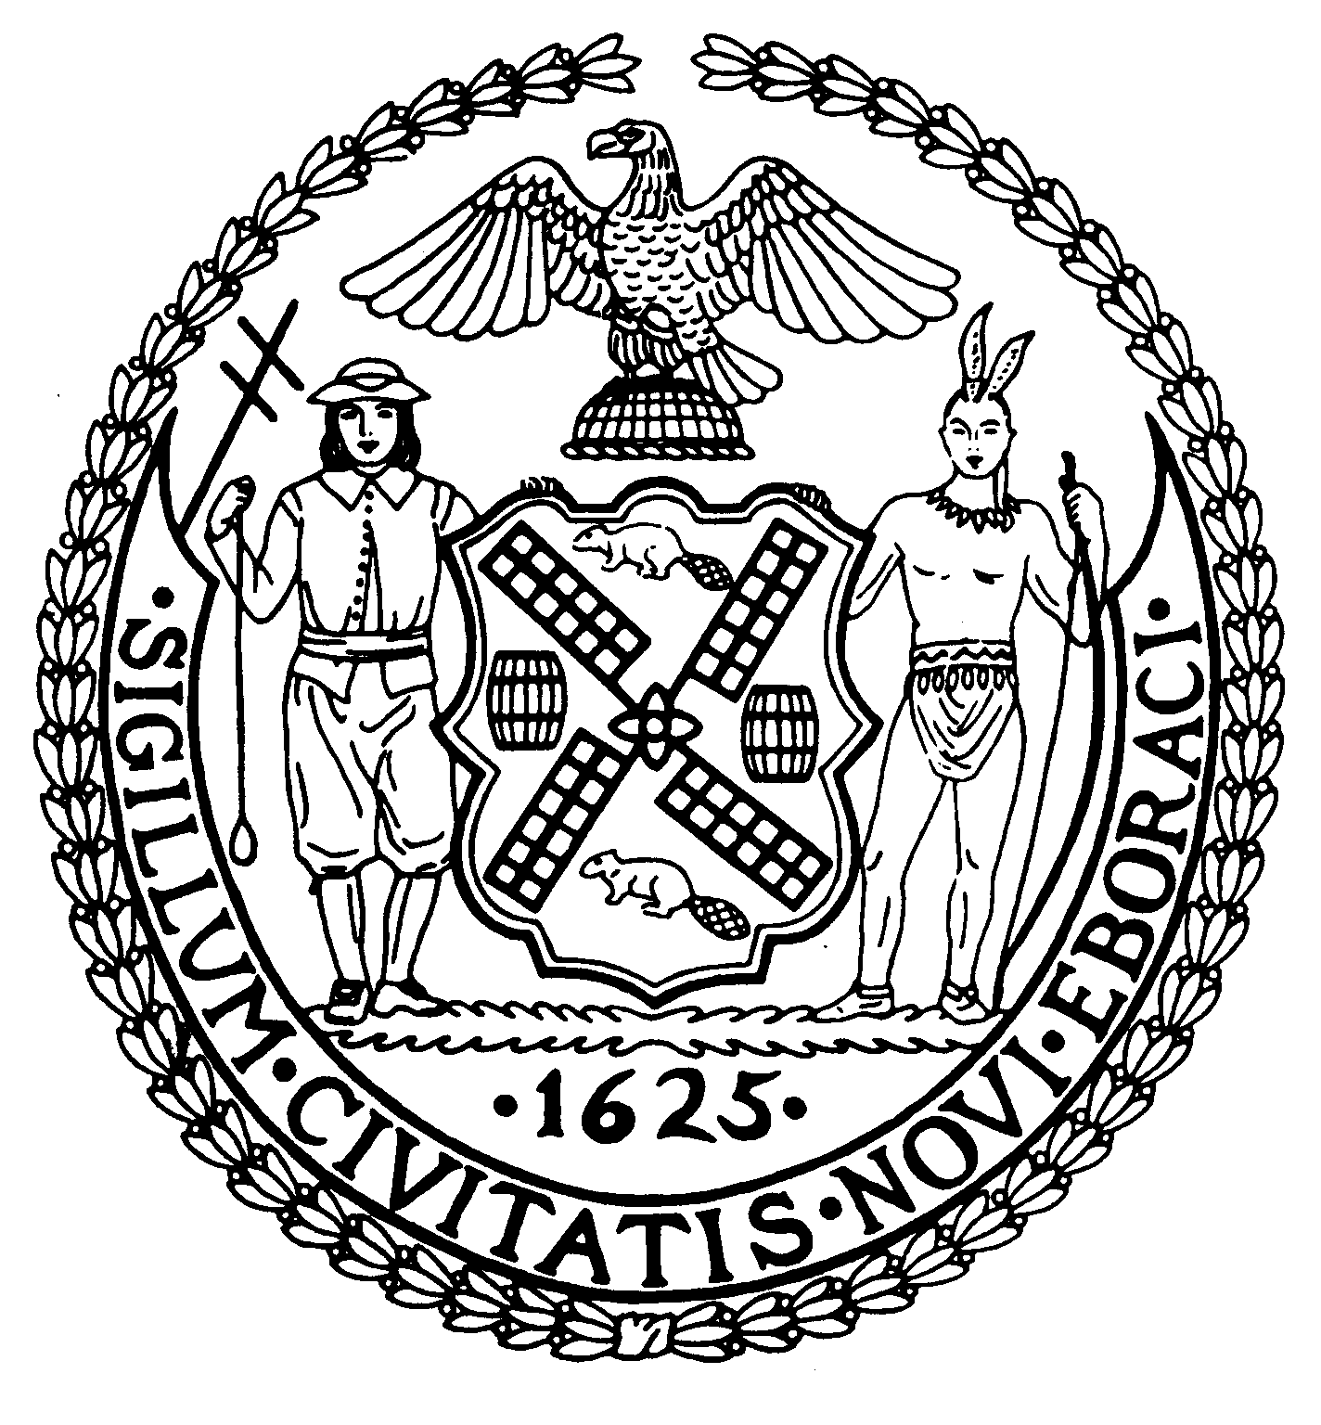
Chair New York, N.Y. 10022-1106
(212) 758-4340
Latha Thompson (212) 758-4616 (Fax)
District Manager w ww.cb8m.com - Website
info@cb8m.com - E-Mail

The City of New York
Manhattan Community Board 8
Public Hearing
Street Life Committee

Tuesday, January 4, 2011, 7:00 p.m.
Hunter College School of Social Work, Hexter Lounge, 7:00PM

Applications will only be approved based upon the applicants’ agreement to the following stipulations:
    - The applicant will abide by the bicycle guidelines,
    - The applicant will keep the front of the establishment clean,
    - The applicant will not place A-frames in front of the establishment,
    - The applicant will be denied if they participate in bar-crawls.

Agenda

1. Renewal Applications to the Department of Consumer Affairs for Sidewalk Cafes:
- Steven Jay, LLC d/b/a Parlor Steakhouse, 1600 Third Avenue (@ 90th Street) – Renewal application for an unenclosed sidewalk café with 13 tables and 26 seats, DCA #1306814. Due date: 1/24/11
- MBRP Restaurant, Inc. d/b/a The Stumble Inn, 1454 Second Avenue (@ 76th Street) – Renewal application for an unenclosed sidewalk café with 12 tables and 25 seats, DCA #0955674. Due date: 1/24/11
- Taro Rest, Inc. d/b/a Due, 1396 Third Avenue (79th/80th Streets) – Renewal application for an unenclosed sidewalk café with 4 tables and 8 seats, DCA #0835262. Due date: 1/31/11
- Mavima Restaurant, Inc. d/b/a Brio, 786 Lexington Avenue a/k/a 137 East 61st Street – Renewal application for an unenclosed sidewalk café with 6 tables and 12 seats, DCA #1184384. Due date: 2/7/11
- Genino, Inc. d/b/a Vico, 1302 Madison Avenue (92nd/93rd Streets) – Renewal application for an unenclosed sidewalk café with 2 tables and 8 seats, DCA #1276520. Due date: 1/21/11

2. New/Re-Apply/Amendment Applications to the Department of Consumer Affairs for Sidewalk Cafes:
- Spice Corner 236, Inc. d/b/a Spice, 1479 First Avenue (@ 77th Street) – Application for an assignment of consent (new ownership) for an unenclosed sidewalk café with 4 tables and 8 seats, DCA #1378222. Due date: 1/21/11

Did not submit paperwork
- A la Turk, Inc. d/b/a A La Turka, 1417 Second Avenue (@ 74th Street) – New re-application for an enclosed sidewalk café with 12 tables and 39 seats, DCA #1343596.

2. Transfer/Alterations Applications to the New York State Liquor Authority for Liquor Licenses:
- Nargila Place, Inc. d/b/a Nargila Grill, 1599 York Avenue (84th/85th Streets) – New application for the transfer of a wine and beer license
- B&A Pizzaiolo, LLC d/b/a TBD, 1544 Second Avenue (80th/81st Street) – New application for the transfer of an on-premises liquor license

3. New Applications to the New York State Liquor Authority for Liquor Licenses:
- Zesty Pizzeria, Inc., 1693 Third Avenue (@ 95th Street) – New application for a beer only license
- K&D By the Glass, LLC, 1372 Madison Avenue (@ 96th Street) – New application for a wine and beer license (Laid over from the December meeting, at Board’s request)
- An entity to be formed by Fernando Gonzales d/b/a Lime Jungle, 1420 Second Avenue (@ 74th Street) – New application for an on-premises liquor license
- Tatmar Restaurant, Inc. d/b/a Quatorze Bis, 323 East 79th Street (First/Second Avenues) – New application for an on-premises liquor license
- East End Kitchen, LLC d/b/a TBD, 539 East 81st Street (York/ East End Avenue) – New application for an on-premises liquor license
- 24 East 81st Street, LLC d/b/a The Crown, 24 East 81st Street (Madison/Fifth Avenues) – New application for an on-premises liquor license
Did not submit paperwork
- Pull Cart d/b/a Arcade at Bethesda Terrace, Central Park – New application for a wine and beer license (Laid over from the December meeting, at applicant’s request)

Layovers/Withdrawals
- The Best Chocolate Cake in UES, LLC d/b/a the Best Chocolate Cake in the World, 1046 Madison Avenue (79th/80th Streets) – New application for a wine and beer license (Laid over to the Feb. meeting, at applicant’s request)
- Michael Eigen or Entity to be formed d/b/a Premier CRU Wine Merchants, 1163 Madison Avenue (85th/86th Streets) – New application for an on-premises liquor license (Laid over to the Feb. meeting, at applicant’s request)
- 1724 Foods, LLC d/b/a Baluchi’s Restaurant, 1724 Second Avenue (89th/90th Streets) – New application for the transfer of a wine and beer license (Removed from the agenda)

