Jacqueline Ludorf 505 Park Avenue, Suite 620
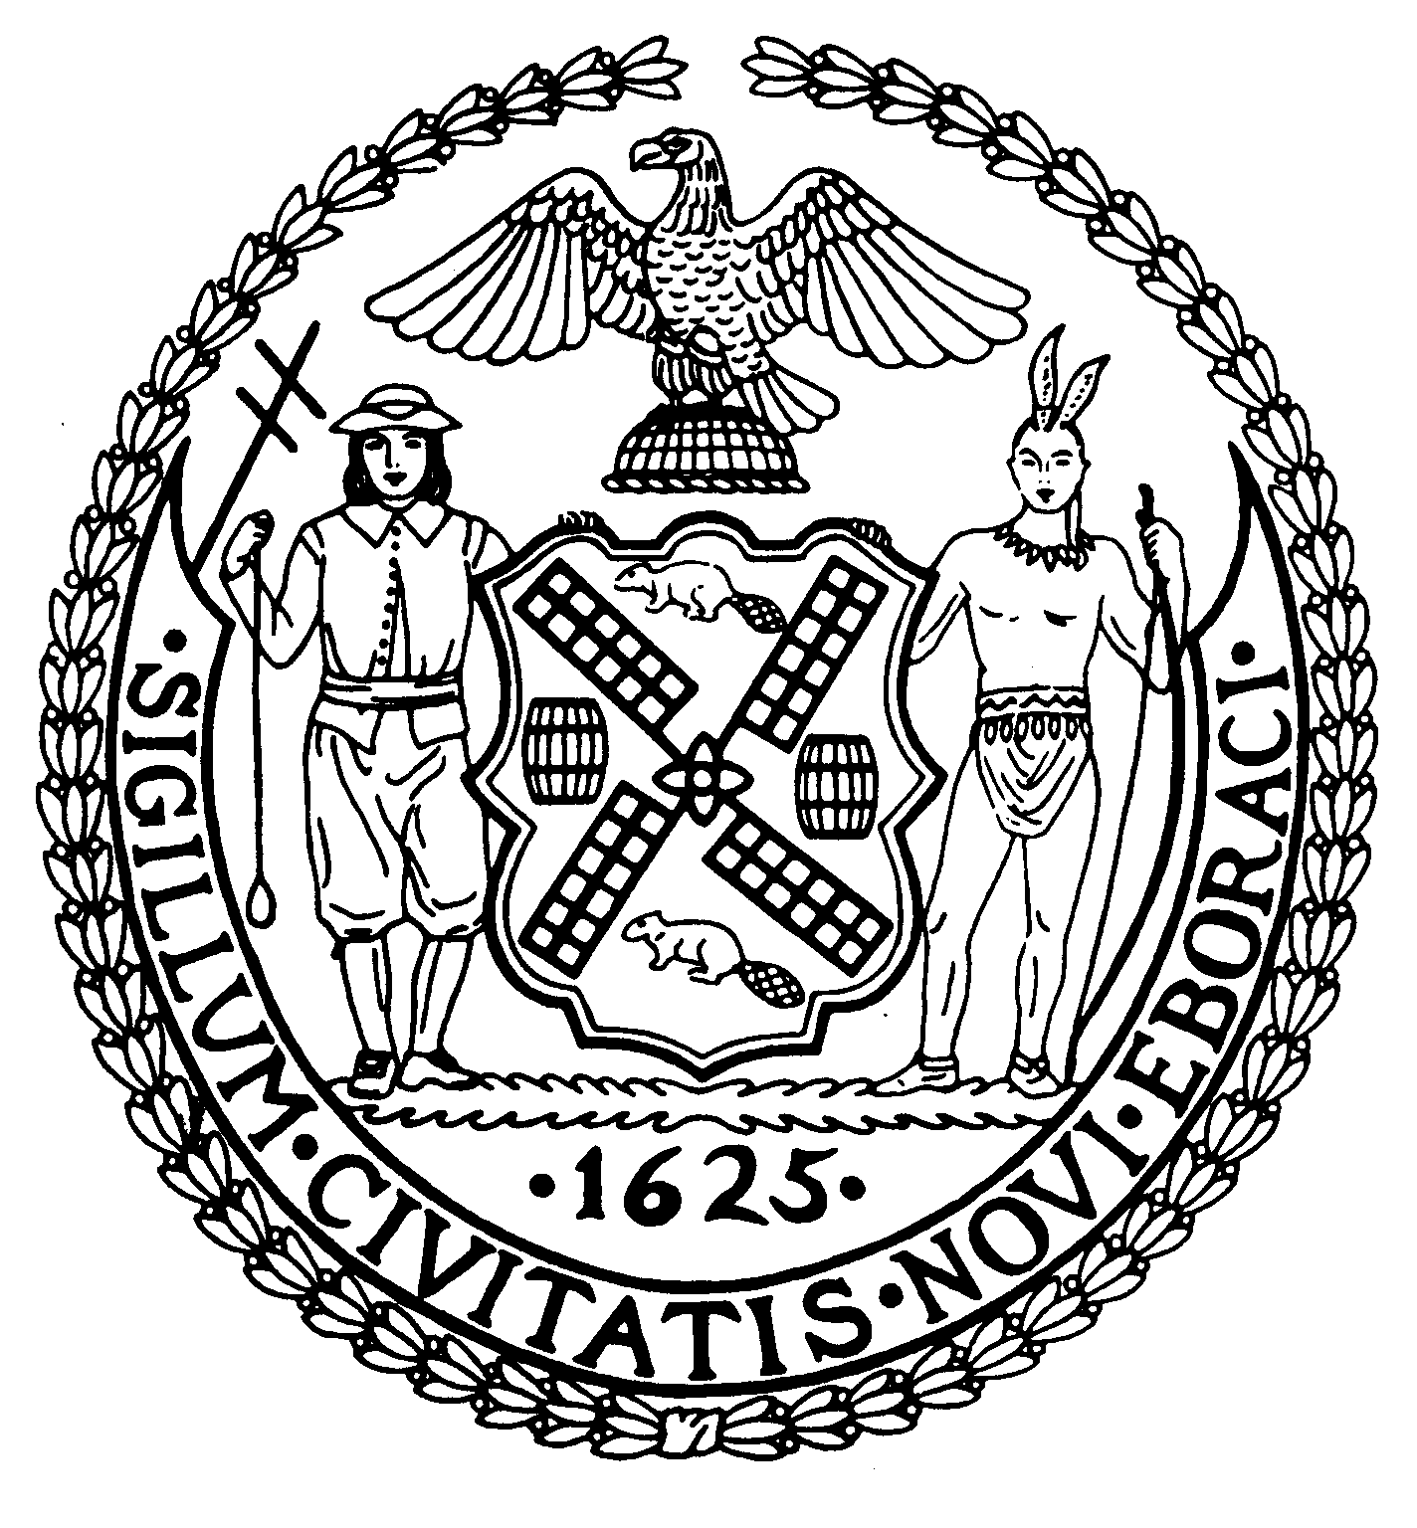
Chair New York, N.Y. 10022-1106
(212) 758-4340
Latha Thompson (212) 758-4616 (Fax)
District Manager w ww.cb8m.com - Website
info@cb8m.com - E-Mail

The City of New York
Manhattan Community Board 8
Public Hearing
Street Life Committee

Tuesday, February 1, 2011, 7:00 p.m.
Hunter College School of Social Work, Hexter Lounge, 7:00PM

Applications will only be approved based upon the applicants’ agreement to the following stipulations:
    - The applicant will abide by the bicycle guidelines,
    - The applicant will keep the front of the establishment clean,
    - The applicant will not place A-frames in front of the establishment,
    - The applicant will be denied if they participate in bar-crawls.

Members Present: Cos Spagnoletti, Nick Viest, Jonathan Horn, Nico Minerva, Marco Tamayo, Laurence Parnes, James Clynes, Judith E. Schneider, M. Barry Schneider, Molly Blayney

Excused Members: Faith Bondy, Laura Lijewski, Matt Bondy, Joie Anderson

Unanimous Cafes: 2a, 2b, 3a
Non Unanimous Cafes: 3b
Unanimous SLA: 5a, 5b, 5c, 6a

Agenda

- Complaints –
a. Wicker Park, 1469 3rd Avenue aka 200 E. 83rd Street – Noise complaints and quality of life issues. Residents complained about music and crowd noise come from the establishment, garbage outside of the establishment and unruly drunk patrons creating disturbances late at night. The committee advised the owner that his café is coming up for renewal in March and that we will take into account the progress made dealing with these complaints when evaluating his application.

2. Renewal Applications to the Department of Consumer Affairs for Sidewalk Cafes:
- Nectar Restaurant Corp. d/b/a Nectar Restaurant, 1090 Madison Avenue (81st/82nd Streets) – Renewal application for an enclosed sidewalk café with 12 tables and 24 seats, DCA #0699252. Due date: 2/28/11. Hours: 7a – 10p. Food/Drink: 95/5
WHEREAS there are no changes to the café and no one from the public objected,
BE IT RESOLVED THAT the application is Approved.
9-0-0. Yes: Cos Spagnoletti, Nick Viest, Jonathan Horn, Marco Tamayo,
Laurence Parnes, James Clynes, Judith E. Schneider, M. Barry Schneider,
Molly Blayney

- Age, Inc. d/b/a Petaluma, 1356 First Avenue (72nd/73rd Street) – Renewal application for an unenclosed sidewalk café with 11 tables and 33 seat, DCA #1209214. Due date: 2/14/11 Hours: 11:30a – 11p. Food/Drink: 77/23.
WHEREAS there are no changes to the café and no one from the public objected,
BE IT RESOLVED THAT the application is Approved.
9-0-0. Yes: Cos Spagnoletti, Nick Viest, Jonathan Horn, Marco Tamayo,
Laurence Parnes, James Clynes, Judith E. Schneider, M. Barry Schneider,
Molly Blayney

3. New/Re-Apply/Amendment Applications to the Department of Consumer Affairs for Sidewalk Cafes:
- 301 East 80th Grocery, LLC d/b/a Cascabel Taqueria, 1538 Second Avenue (80th/81st Street) – Application for a new unenclosed sidewalk café with 20 tables and 40 seats, DCA #1380690. Due date: 2/28/11 Hours: 11:30a – 10p Food/Drink: 80/20.
WHEREAS there is ample clearance for the café,
BE IT RESOLVED THAT the application is Approved.
10-0-0. Yes: Cos Spagnoletti, Nick Viest, Jonathan Horn, Marco Tamayo,
Laurence Parnes, James Clynes, Judith E. Schneider, M. Barry Schneider,
Molly Blayney, Nico Minerva
Did not submit paperwork
- 63rd Street Bagel Café, Inc. d/b/a Hot & Crusty, 1201 Second Avenue (63rd/64th Street) – Application to re-apply for an unenclosed sidewalk café with 5 tables and 10 seats, DCA #1028853. Due date: 2/28/11
WHEREAS the applicant did not appear,
WHEREAS the committee was unclear over whether the applicant was changing the configuration of their café to add tables on the side street,
WHEREAS the committee was concerned that the café would be approved under a new configuration if the application was held over to March,
BE IT RESOLVED THAT the application is DIS-Approved.
6-4-0. Yes: Nick Viest, Jonathan Horn, Marco Tamayo, James Clynes, Molly Blayney,
Nico Minerva
No: Cos Spagnoletti, Laurence Parnes, Judith E. Schneider, M. Barry Schneider

  - Transfer/Alterations Applications to the New York State Liquor Authority for Liquor Licenses:
- 920 Dream Unlimited, Inc. d/b/a Pamir Kabab, 1437 First Avenue (74th/75th Streets) – New application to make alterations to an on-premises liquor license
Adjourned until next month, at applicant’s request

5. New Applications to the New York State Liquor Authority for Liquor Licenses:
- Danilos Bar, Inc. d/b/a Club, 1728 Second Avenue (89th/90th Street) – new application for a wine and beer license Hours: 12p – 12a weekdays and 12p – 1a weekends. Hours: 35/65.
WHEREAS there were no objections from the public,
BE IT RESOLVED THAT the application is Approved.
10-0-0. Yes: Cos Spagnoletti, Nick Viest, Jonathan Horn, Marco Tamayo,
Laurence Parnes, James Clynes, Judith E. Schneider, M. Barry Schneider,
Molly Blayney, Nico Minerva

- Eighty Third and First, LLC d/b/a Felice Wine Bar, 1593 First Avenue (@ 83rd Street) –New application for an on-premises liquor license Hours:4p – 12a. Food/Drink: 80/20.
WHEREAS there were no objections from the public,
BE IT RESOLVED THAT the application is Approved.
10-0-0. Yes: Cos Spagnoletti, Nick Viest, Jonathan Horn, Marco Tamayo,
Laurence Parnes, James Clynes, Judith E. Schneider, M. Barry Schneider,
Molly Blayney, Nico Minerva

- CM654, LLC d/b/a Lime Jungle, 1420 Second Avenue (@ 74th Street) – New application for an on-premises liquor license (Laid over from the January meeting, at applicant’s request) Hours: 12p – 12a weekdays, 12p – 2a weekends Food/Drink:25/75.
WHEREAS the DBA is Kristina’s not Lime Jungle,
WHEREAS the establishment will be a wine bar with light food service,
WHEREAS the establishment will serve cocktails combined with wine and liquor,,
BE IT RESOLVED THAT the application is Approved.
10-0-0. Yes: Cos Spagnoletti, Nick Viest, Jonathan Horn, Marco Tamayo,
Laurence Parnes, James Clynes, Judith E. Schneider, M. Barry Schneider,
Molly Blayney, Nico Minerva

  - Renewal Applications to the New York State Liquor Authority for Liquor Licenses:
- MBRP Restaurant, Inc. d/b/a The Stumble Inn, 1454 Second Avenue (@ 76th Street) – Renewal application for an on-preemies liquor license Hours: 11:30a – 4a Food/Drink 40/60.
WHEREAS, members of the community have complained about ongoing issues, particularly noise from patrons,

WHEREAS residents met with one of the managers earlier and were told that the establishment would take measures to reduce the noise problems,

WHEREAS, the owner of The Stumble Inn appeared before the Street Life committee and said that he thought the prior issues had been dealt with but expressed a willingness to work with the residents to find solutions,

WHEREAS the community members and owner agreed to meet and submit to the CB 8 Board office mutually agreed upon conditions to ameliorate the noise problems,

THEREFORE BE IT RESOLVED, that Manhattan Community Board 8M approves the renewal of the on-premises liquor license subject to terms and conditions mutually agreed to by the establishment and the members of the public, a list of which will be provided to the committee chairs prior to the Full Board meeting.

BE IT RESOLVED THAT the application is Approved.
10-0-0. Yes: Cos Spagnoletti, Nick Viest, Jonathan Horn, Marco Tamayo,
Laurence Parnes, James Clynes, Judith E. Schneider, M. Barry Schneider,
Molly Blayney, Nico Minerva

