Jacqueline Ludorf 505 Park Avenue, Suite 620
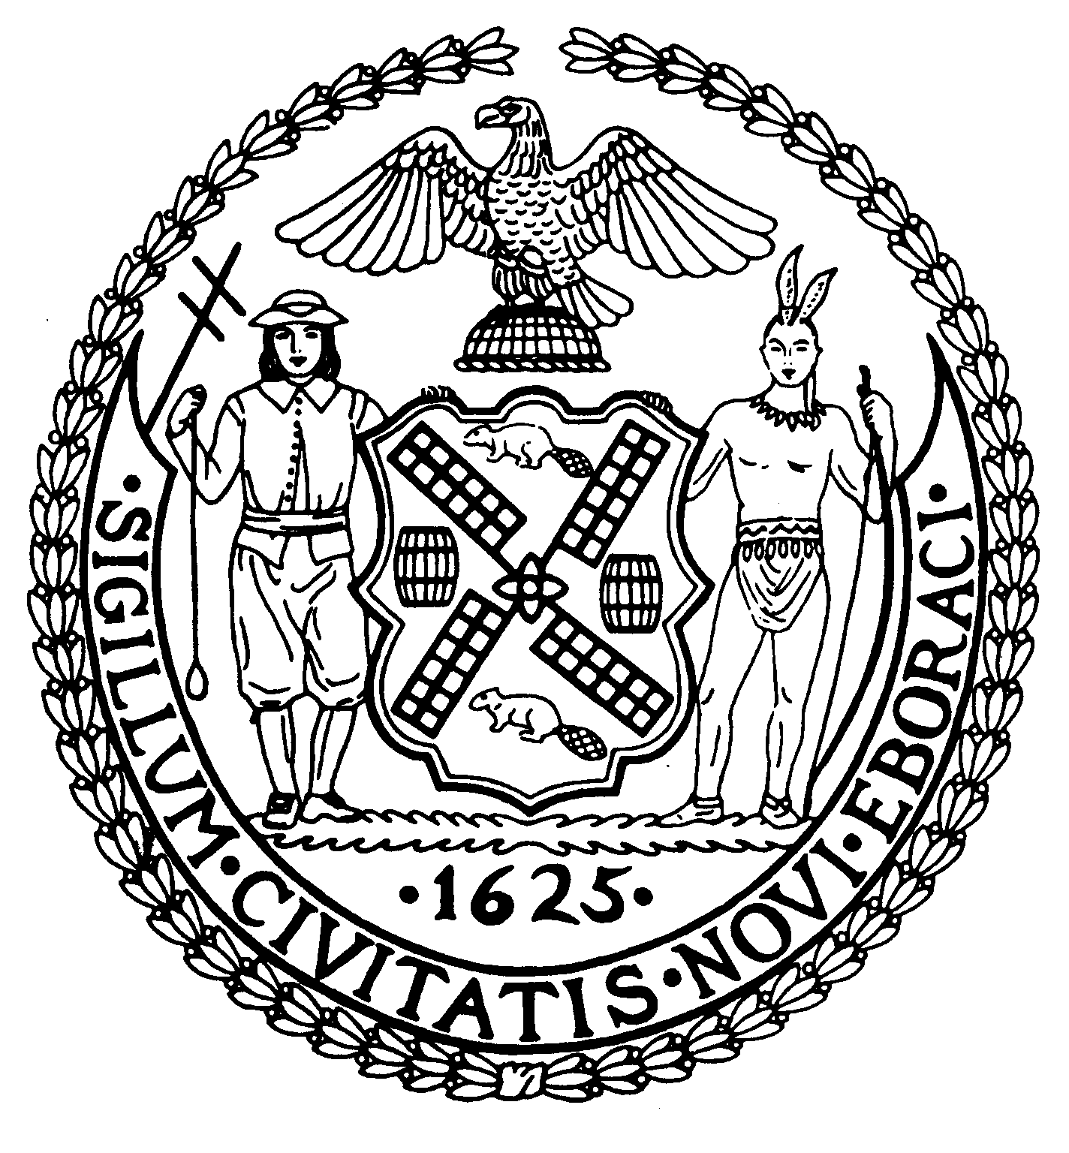
Chair New York, N.Y. 10022-1106
(212) 758-4340
Latha Thompson (212) 758-4616 (Fax)
District Manager w ww.cb8m.com - Website
info@cb8m.com - E-Mail

The City of New York
Manhattan Community Board 8
Public Hearing
Street Life Committee

Tuesday, February 2, 2010, 7:00 p.m.
Hunter College School of Social Work, 129 East 79th Street, Auditorium

Applications will only be approved based upon the applicants’ agreement to the following stipulations:
    - The applicant will abide by the bicycle guidelines,
    - The applicant will keep the front of the establishment clean,
    - The applicant will not place A-frames in front of the establishment,
    - The applicant will be denied if they participate in bar-crawls.

Members Present: Cos Spagnoletti, Nick Viest, Jonathan Horn, James Clynes, Domenico George Minerva, Laura Lijewski, Matt Bondy

Members Absent (Excused): Faith Bondy, Betty Cooper Wallerstein, Joie Anderson, Marco Tamayo
Unanimous Cafes: 1 (a), 1(b), 1(d)
Non Unanimous Cafes: 1(c)
Unanimous SLA: 2 (a), (b), (c)
Non Unanimous SLA: 2 (d), 2(e)

Agenda

1. Renewal Applications to the Department of Consumer Affairs for Sidewalk Cafes:
- Artaki Corp. d/b/a Peter’s on 83rd, 1606 First Avenue (83rd/84th Streets) – Renewal application for an unenclosed sidewalk café with 6 tables and 12 seats, DCA #1191822. Due date: Feb. 2nd. Hours: 10a – 11p weeknights and 8a – 11p weekends. Food/Drink: 90/10.
WHEREAS there are no changes to the café and no one from the public objected,
BE IT RESOLVED THAT the application is Approved.
5-0-0. Yes: Cos Spagnoletti, Nick Viest, Jonathan Horn, Domenico George Minerva, Laura Lijewski

- Orama Inc. d/b/a Trata, 1331 Second Avenue (@ 70th Street) – Renewal application for an unenclosed sidewalk café with 24 tables and 51 seats, DCA #1190200. Due date: Feb. 11th. Hours: 12p – 11p weekdays and 12p – 12a weekends. Food/Drink: 75/25.

WHEREAS there are no changes to the café and no one from the public objected,
BE IT RESOLVED THAT the application is Approved.
6-0-0. Yes: Cos Spagnoletti, Nick Viest, Jonathan Horn, James Clynes, Domenico George Minerva, Laura Lijewski

- Braho Restaurant Corp d/b/a Barking Dog Luncheonette, 1453 York Avenue (@ 77th Street) – Renewal application for an unenclosed sidewalk café with 9 tables and 17 seats, DCA #1220174. Due date: Feb. 8th. Hours: 7a – 11p M - Sun. Food/Drink: 80/20.
WHEREAS there are no changes to the café,
BE IT RESOLVED THAT the application is Approved.
4-0-2. Yes: Cos Spagnoletti, Nick Viest, Jonathan Horn, James Clynes, Domenico George Minerva
Abstain: Jonathan Horn, , Laura Lijewski

- Martell’s NYC , LLC d/b/a Wicker Park, 200 East 83rd Street (@ 3rd Avenue) – Renewal application for an unenclosed sidewalk café with 26 tables and 54 seats, DCA #1231318. Due date: Feb. 8th Hours: 12p – 4am M - Sun. Food/Drink: 65/35.
WHEREAS there are no changes to the café and no one from the public objected,
BE IT RESOLVED THAT the application is Approved.
6-0-0. Yes: Cos Spagnoletti, Nick Viest, Jonathan Horn, James Clynes, Domenico George Minerva, Laura Lijewski

2. New Applications to the New York State Liquor Authority for Liquor Licenses:
- 152 East 86, LLC d/b/a Shake Shack, 152 East 86th Street (Lexington/ Third Avenues) – New application for a beer and wine license. Hours: 10:30a – 12a M - Sun. Food/Drink: 70/30.
WHEREAS this is a new application at this location,
WHEREAS the applicant currently owns 11 restaurants including Shake Shack in Madison Square Park, Union Square Café, Gramercy Tavern and The Modern,
WHEREAS there will be outdoor seating,
WHEREAS they will only allow beer/wine to be consumed on their premises and will have proper staffing to prevent it being taken off their site,
WHEREAS there will be cue lines within the property used by Shack Shack,
WHEREAS the establishment will stop serving at 11p,
WHEREAS the management agreed to re-look at the hours if they get complaints from the neighbors,
BE IT RESOLVED THAT the application is Approved.
6-0-0. Yes: Cos Spagnoletti, Nick Viest, Jonathan Horn, James Clynes, Domenico George Minerva, Laura Lijewski

- NAAM, Inc., 1700 Second Avenue (@ 88th Street) – New application for a liquor, wine, and beer (on-premises) license (Laid over from the Jan. ’10 hearing, at the applicant’s request). Hours: 12p – 2am M - Sun. Food/Drink: 75/25.
WHEREAS this application is from a new owner,
WHEREAS the new owner has no relationship to the previous owner,
BE IT RESOLVED THAT the application is Approved.
7-0-0. Yes: Cos Spagnoletti, Nick Viest, Jonathan Horn, James Clynes, Domenico George Minerva, Laura Lijewski, Matt Bondy

- Ging Restaurant Inc d/b/a Ging, 1564 Third Avenue (87th/88th Streets) – New application for a transfer of a liquor, wine, and beer (on-premises) license. Hours: 11:30a – 11p M – F, 12:30p – 12a Sat., 12:30p – 11p Sun. Food/Drink: 85/15.
WHEREAS this application is from a new owner who is retaining the name of the establishment,
BE IT RESOLVED THAT the application is Approved.
7-0-0. Yes: Cos Spagnoletti, Nick Viest, Jonathan Horn, James Clynes, Domenico George Minerva, Laura Lijewski, Matt Bondy

- Satelip Restaurant Corp d/b/a Satelite, 166 East 82nd Street (Lexington/Third Avenues) – New application for a liquor, wine, and beer (on-premises) license. Hours: 11a – 2am M – Sun. Food/Drink: 80/20.
WHEREAS this application is for the space that was occupied by Le Refuge,
WHEREAS this application is for use of the rear yard,
WHEREAS the previous establishment also used of the rear yard,
WHEREAS there is no music in the rear yard,
WHEREAS the applicant will cease use of the rear yard at 9p,
BE IT RESOLVED THAT the application is Approved.
5-2-0. Yes: Cos Spagnoletti, Nick Viest, Jonathan Horn, James Clynes, Domenico George Minerva
No: Laura Lijewski, Matt Bondy

- UES Rest Corp. d/b/a Saloon, 1584 York Avenue (83rd/84th Streets) – New application for a transfer of a liquor, wine, and beer (on-premises) license. Hours: 11a – 12a weekdays and 11a – 4am weekends. Food/Drink: 30/70.
WHEREAS, the Saloon has a history of community complaints regarding noise and other issues, and
WHEREAS, this application is for a transfer of the license to completely new owners, and
WHEREAS, the new owners appeared before the committee and acknowledged their awareness of these issues and their desire and intent to deal with them, and
WHEREAS, one of the new owners has previous experience at another establishment within Community Board 8 which successfully resolved noise complaints from nearby residents, and
WHEREAS, the existing license is valid until 11/30/11 and the current owners stated their intention to remain open should this transfer not be approved, and
WHEREAS, the NYC Cabaret license is valid for another 14 months, and
THEREFORE BE IT RESOLVED that Community Board 8M approves this application subject to the following conditions:
- Prior to the Full Board meeting on February 17, 2009, the applicant provide the board office with an updated copy of their SLA application that contains the correct hours of operation and other revisions requested by the committee.
- The applicant will include in either the Method of Operation section of their SLA application or in a separate letter addressed to the community board a statement that they are aware of the specific community complaints and concerns about this establishment (noise, street conditions, etc.), their commitment to address these problems in a timely manner and the specific steps they will immediately take to resolve or mitigate these concerns.

BE IT RESOLVED THAT the application is Approved.
4-3-0. Yes: Cos Spagnoletti, Jonathan Horn, James Clynes, Domenico George Minerva
No: Laura Lijewski, Matt Bondy, Nick Viest

