Jacqueline Ludorf 505 Park Avenue, Suite 620
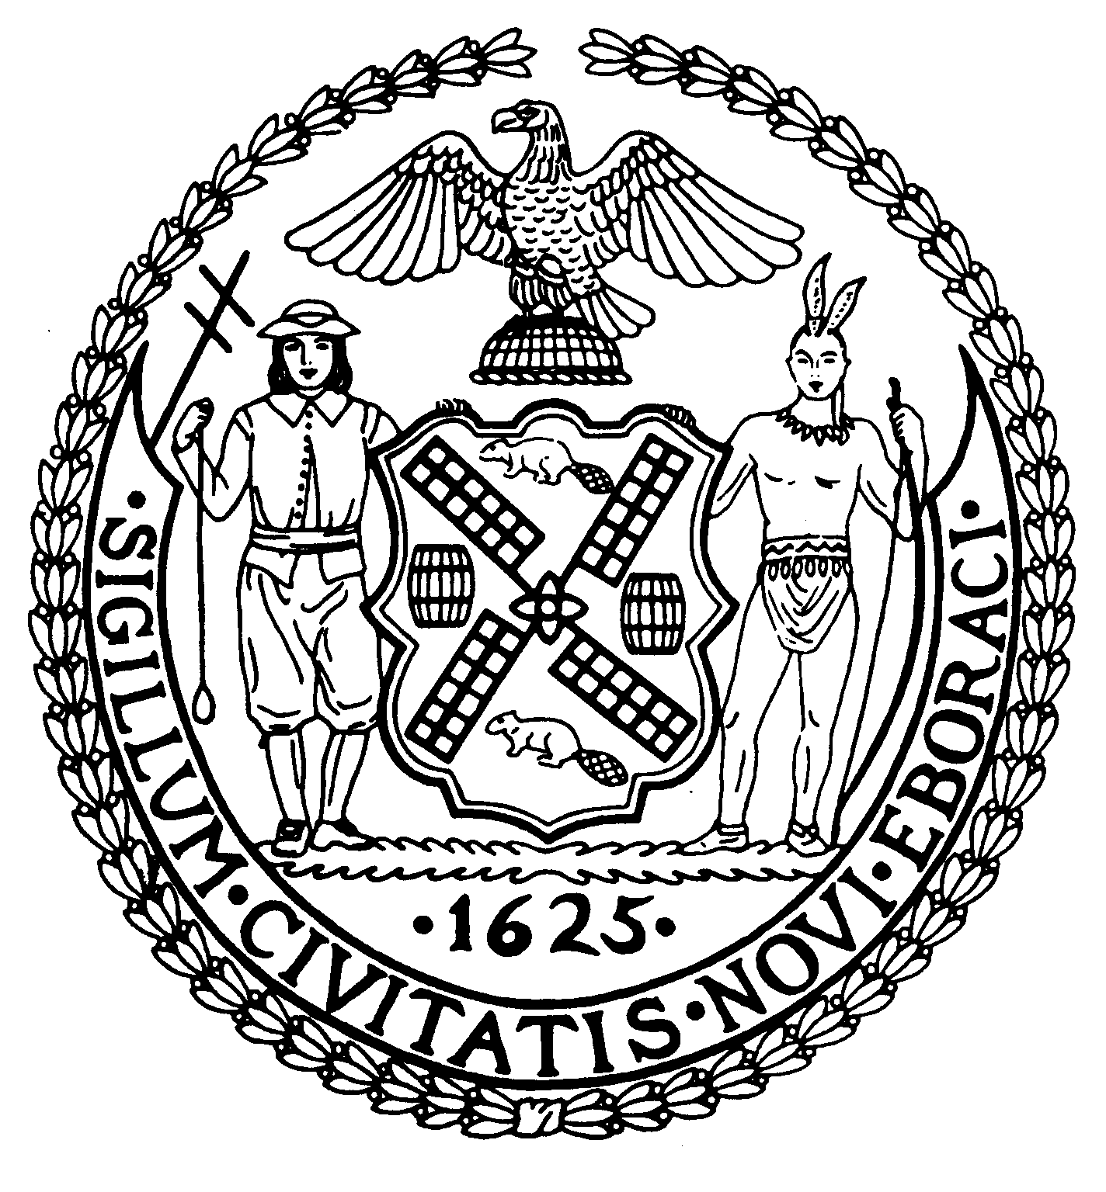
Chair New York, N.Y. 10022-1106
(212) 758-4340
Latha Thompson (212) 758-4616 (Fax)
District Manager w ww.cb8m.com - Website
info@cb8m.com - E-Mail

The City of New York
Manhattan Community Board 8
Public Hearing
Street Life Committee

Tuesday, April 6, 2010, 7:00 p.m.
Hunter College School of Social Work, 129 East 79th Street, Auditorium

Applications will only be approved based upon the applicants’ agreement to the following stipulations:
    - The applicant will abide by the bicycle guidelines,
    - The applicant will keep the front of the establishment clean,
    - The applicant will not place A-frames in front of the establishment,
    - The applicant will be denied if they participate in bar-crawls.

Agenda

- Continued Discussion:
  - UES Rest Corp. d/b/a Saloon, 1584 York Avenue (83rd/84th Streets) – Continued discussion regarding a new application for an transfer of an on-premises liquor license
  - 1460 Second Avenue Restaurant Group, LLC d/b/a Southern Hospitality, 1460 Second Avenue (76th/77th Streets) – Continued discussion regarding noise complaints and other quality of life issues

2. New or Re-Apply Applications to the Department of Consumer Affairs for Sidewalk Cafes:
- 1460 Second Avenue Restaurant Group, LLC d/b/a Southern Hospitality, 1460 Second Avenue (76th/77th Streets) – Re-apply application for an unenclosed sidewalk café for 12 tables and 26 seats, DCA #1249978. Due date: April 23rd
- Amber Asian One, Inc. d/b/a Amber, 1406 Third Avenue (@ 80th Street) – New application for an unenclosed sidewalk café with 20 tables and 43 seats, DCA #1346272. Due date: April 19th

3. New Applications to the New York State Liquor Authority for Liquor Licenses:
  - Oui Cater Inc., d/b/a Heavenly Rest Stop, 2 East 90th Street (@ Fifth Avenue) – New application for a beer and wine license (Laid over from the March’10 hearing, at the applicant’s request on 2/25/10)
  - Imperial Feast III Corp d/b/a Fuji Asian Restaurant, 1367 First Avenue (73rd/74th Streets) – New application for a beer and wine license (Laid over from the March ‘10 hearing, at the applicant’s request on 3/2/10)
  - PQ Carnegie Hill Inc. d/b/a Le Pain Quotidien, 1309 Lexington Avenue (87/88th Streets) – New application for a beer and wine license
  - Jasmine on 2nd Ave., Ltd. d/b/a Jasmine Restaurant, 1619 Second Avenue(@ 84th Street) – Upgrade application from a beer and wine license to an on-premises liquor license
  - Mike Burns or Corp to be formed, 1647 Second Avenue (85th/86th Streets) – New application for a transfer of an on-premises liquor license
  - Bardolino Restaurant Inc. d/b/a Bardolino, 1496 Second Avenue (@ 78th Street) – New application for an on-premises liquor license (Laid over from the March ’10 hearing, at the applicant’s request on 2/25/10)
  - Polo Restaurant Inc. d/b/a Polo Restaurant, 1593 Second Avenue (82nd/83rd Streets) – New application for an on-premises liquor license
  - FT 81 Street, LLC d/b/a Bar Veloce, 1561 Second Avenue (81st Street) aka 247 E. 81st Street – New application for an on-premises liquor license

Adjourned or Withdrawn:
- Brooklyn Flea d/b/a Central Park Summer Stage @ Rumsey Playfield (72nd Street & 5th Ave.) – New application for a beer and wine license (Adjourned until a later date, at applicant’s request)
- Corp to be Formed d/b/a Etats Unis, 242 East 81st Street (Second/Third Avenues) – New application for an on-premises liquor license (Withdrawn at the applicant’s request, as of 3/25/10)
- Elim Deli Café Inc., 851 Lexington Avenue (64th/65th Streets) –New application for a beer only license (Withdrawn at the applicant’s request, as of 3/26/10)

4. Renewal Applications to the New York State Liquor Authority for Liquor Licenses:
- Provo Services, LLC d/b/a Danny & Eddie’s, 1643 First Avenue (85th/86th Streets) -
- Renewal application for an on-premises liquor license
- Discussion of noise complaints and other quality of life issues

