2nd Avenue Subway Construction Look Ahead
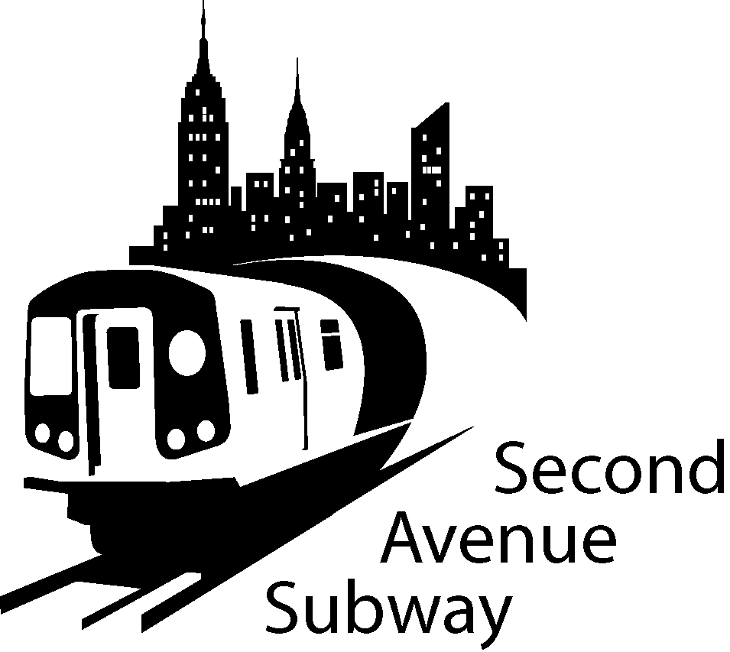
location  east Side  Launch Box | description of work | duration  may 11  may 24
Work between 95thand 94rdStreets | EAST SIDE Installing slurry wall panels. Excavate for utility box and support. WEST SIDE Hanging new water main under decking. | Monday thru Saturday
Work between 94thand 93rdStreets | EAST SIDE Installing slurry wall panels. WEST SIDE Hanging new water main under decking. | Monday thru Saturday
Work between 93rdand 92nd Street | EAST SIDE Installing secant pile wall. Installing deck beams. Excavate for utility box and support. WEST SIDE Hanging new water main under decking | Monday thru Saturday
Work between 92ndand 91st Streets | EAST SIDE Installing deck beams and decking. WEST SIDE Hanging new water main under decking | Monday thru Saturday

SAS Work Hours: **

7:00 am to 10:00 pm, Monday through Friday

10:00 am to 6:00 pm on Saturday

**BE ADVISED: Con Ed, Empire City Subway and Verizon may be performing cable and gas line work outside regular SAS construction Hours. Some of this work will take place on 2nd Ave between 91st and 96th St and will be intermittently carried out in support of the Second Avenue Subway
If you have additional questions, please contact Claudia Wilson at (212) 792-9716 from 9:00AM to 5:00PM Monday through Friday, or contact the 2nd Avenue Subway Hotline 24 hours/7 days a week at (646)252-2670
- Four lanes of traffic have been moved to the WEST Side of 2nd AVE
- Work zone will be set up on the EAST SIDE of Second Ave
- The EAST SIDE work zone will be approximately 40 FOOT wide, plus 7' sidewalk
- No Standing at anytime on the EAST SIDE of Second Ave 91st Street to 95th Street No Standing on the WEST SIDE 7AM-10AM and 4PM-7PM Monday-Friday
- No Standing on WEST SIDE 10AM-4PM, EXCEPT trucks loading and unloading
- Parking ALLOWED on WEST SIDE 7PM-7AM Weekdays and all day Saturday and Sunday

