James G. Clynes 505 Park Avenue, Suite
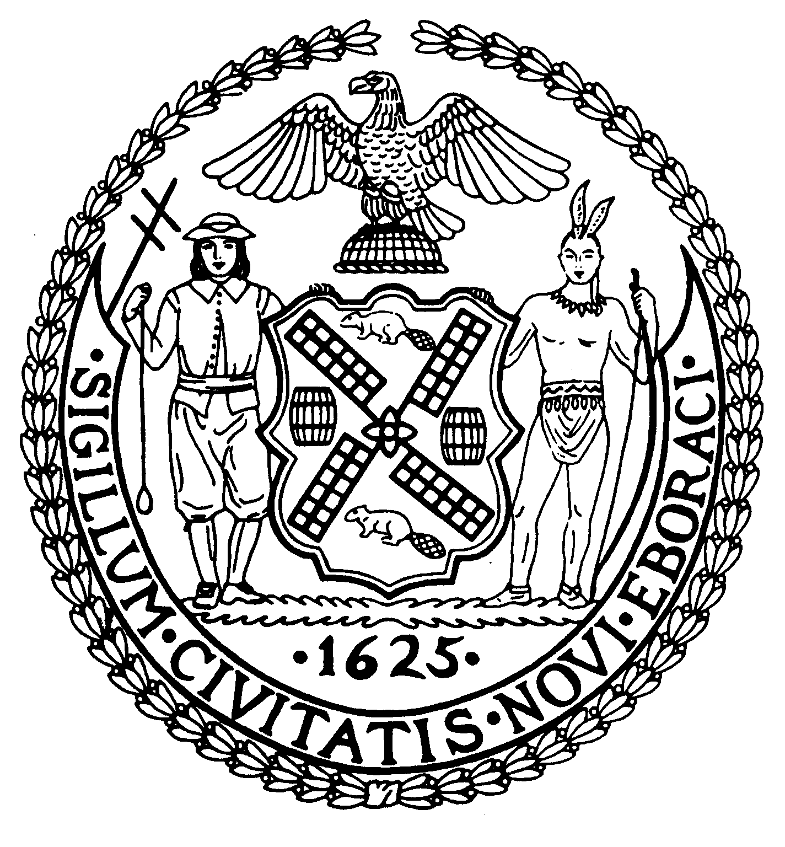

Chairman New York, N.Y. 10022-1106

(212) 758-4340
Latha Thompson (212) 758-4616 (Fax)
District Manager www.cb8m.com - Website
info@cb8m.com - E-Mail

The City of New York
Manhattan Community Board 8

Housing Committee

Brick Presbyterian Church
62 East 92nd Street (b/w Park & Madison Avenues)
Carnegie Room
Tuesday, February 9, 2016
6:30PM
Agenda

- Section 421-a Partial Tax Exemption Application – 501 East 74th Street, Block 1486 Lot 1 – New York, New York 10021, a 20 story, 82 unit rental building at the corner of York Avenue and 74th Street.
- Old Business

- New Business

PLEASE NOTE: Please check CB8M.COM website. Go to Committees on menu bar and scroll down to Housing. Click on that and scroll down:
- Community Updates, as well as, agendas, minutes and resolutions from prior meetings are available if you were unable to attend.

Ed Hartzog, Chair

