Jacqueline Ludorf 505 Park Avenue, Suite 620
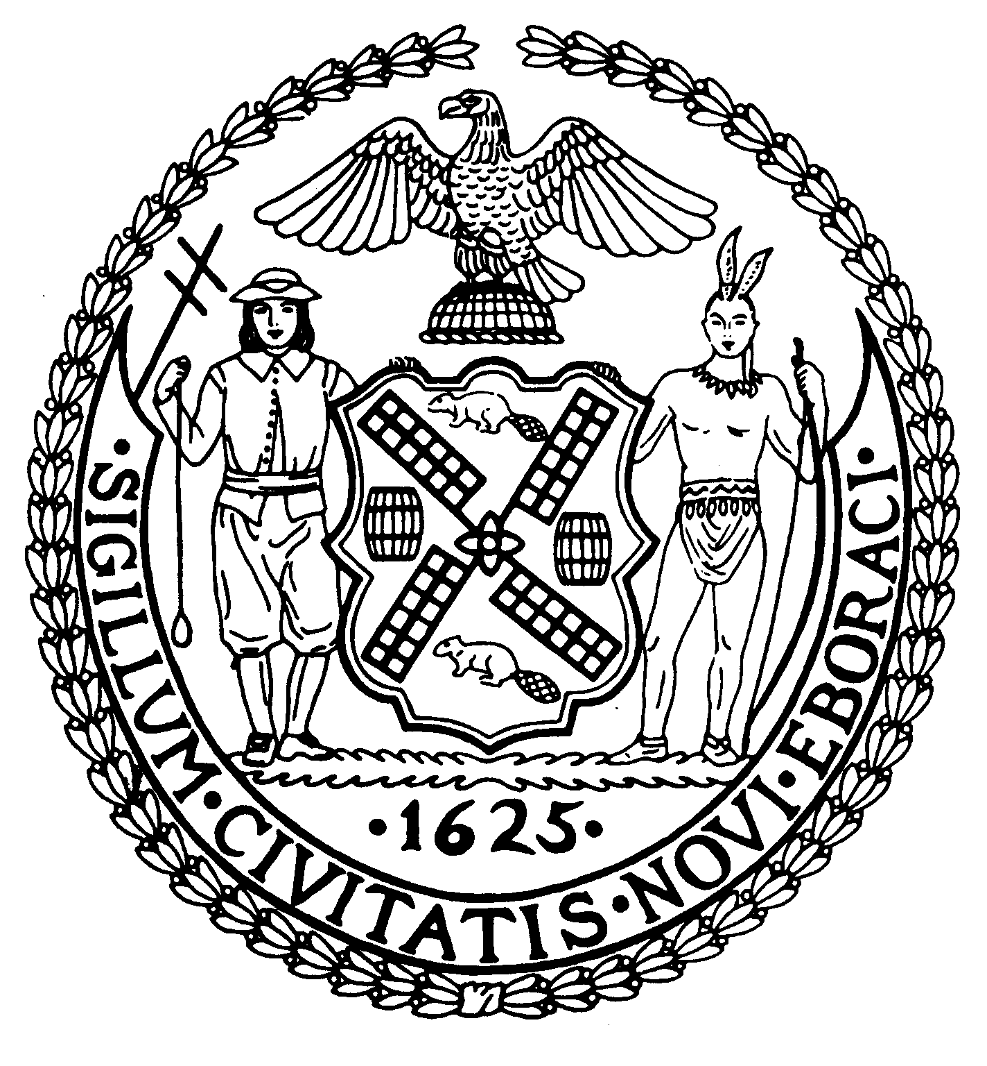
Chair New York, N.Y. 10022-1106

(212) 758-4340
Latha Thompson (212) 758-4616 (Fax)
District Manager www.cb8m.com - Website
info@cb8m.com E-Mail

The City of New York

Manhattan Community Board 8

Landmarks Committee, September 13, 2010 – 6:30PM
Hunter College School of Social Work, 129 East 79th Street, Room 1010

Agenda
PLEASE NOTE: When evaluating Applications for Certificates of Appropriateness, the Landmarks Committee of Community Board 8M ONLY considers the appropriateness of the proposal to the architecture of the building and, in the case of a building within an Historic District, the appropriateness of the proposal to the character of that Historic District. All testimony should be related to such appropriateness. The Committee recommends a Resolution to the full Community Board, which votes on a Resolution to be sent to the Landmarks Preservation Commission. These Resolutions are advisory; the decision of the Landmarks Preservation Commission is binding.

Applicants and members of the public who are interested in the issues addressed are invited, but not required, to attend the Land Use/Full Board Meeting on September 15, 2010 at Hunter College School of Social Work, 129 East 79th Street, Auditorium at 6:30PM. They may testify for up to three minutes in the Public Session, which takes place at 6:30PM. Members of the Board will discuss the items in executive session; if a member of the public wishes a comment made or a question asked at this time, he must ask a Board Member to do it for him.

- The Loeb Boathouse Restaurant in Central Park-(East 72nd Street at Park Drive North)-Individual Landmark-Mr. Nicholas Koutsomipis, architect-Application to replace existing exterior bar and to restore/replace the patio and dock around the bar. (joint with Parks Committee)

- 15 East 93rd Street-(Fifth and Madison)-Carnegie Hill Historic District-Mr. Gary Savitzky, architect-A four-story rowhouse built in 1891-92 by William Graul. Application to restore the exiting façade.

- Old Business

- New Business - Proposed Hellgate Historic District

Jane Parshall and David Liston – Co-Chairs, Landmarks Committee

