Jacqueline Ludorf 505 Park Avenue, Suite 620
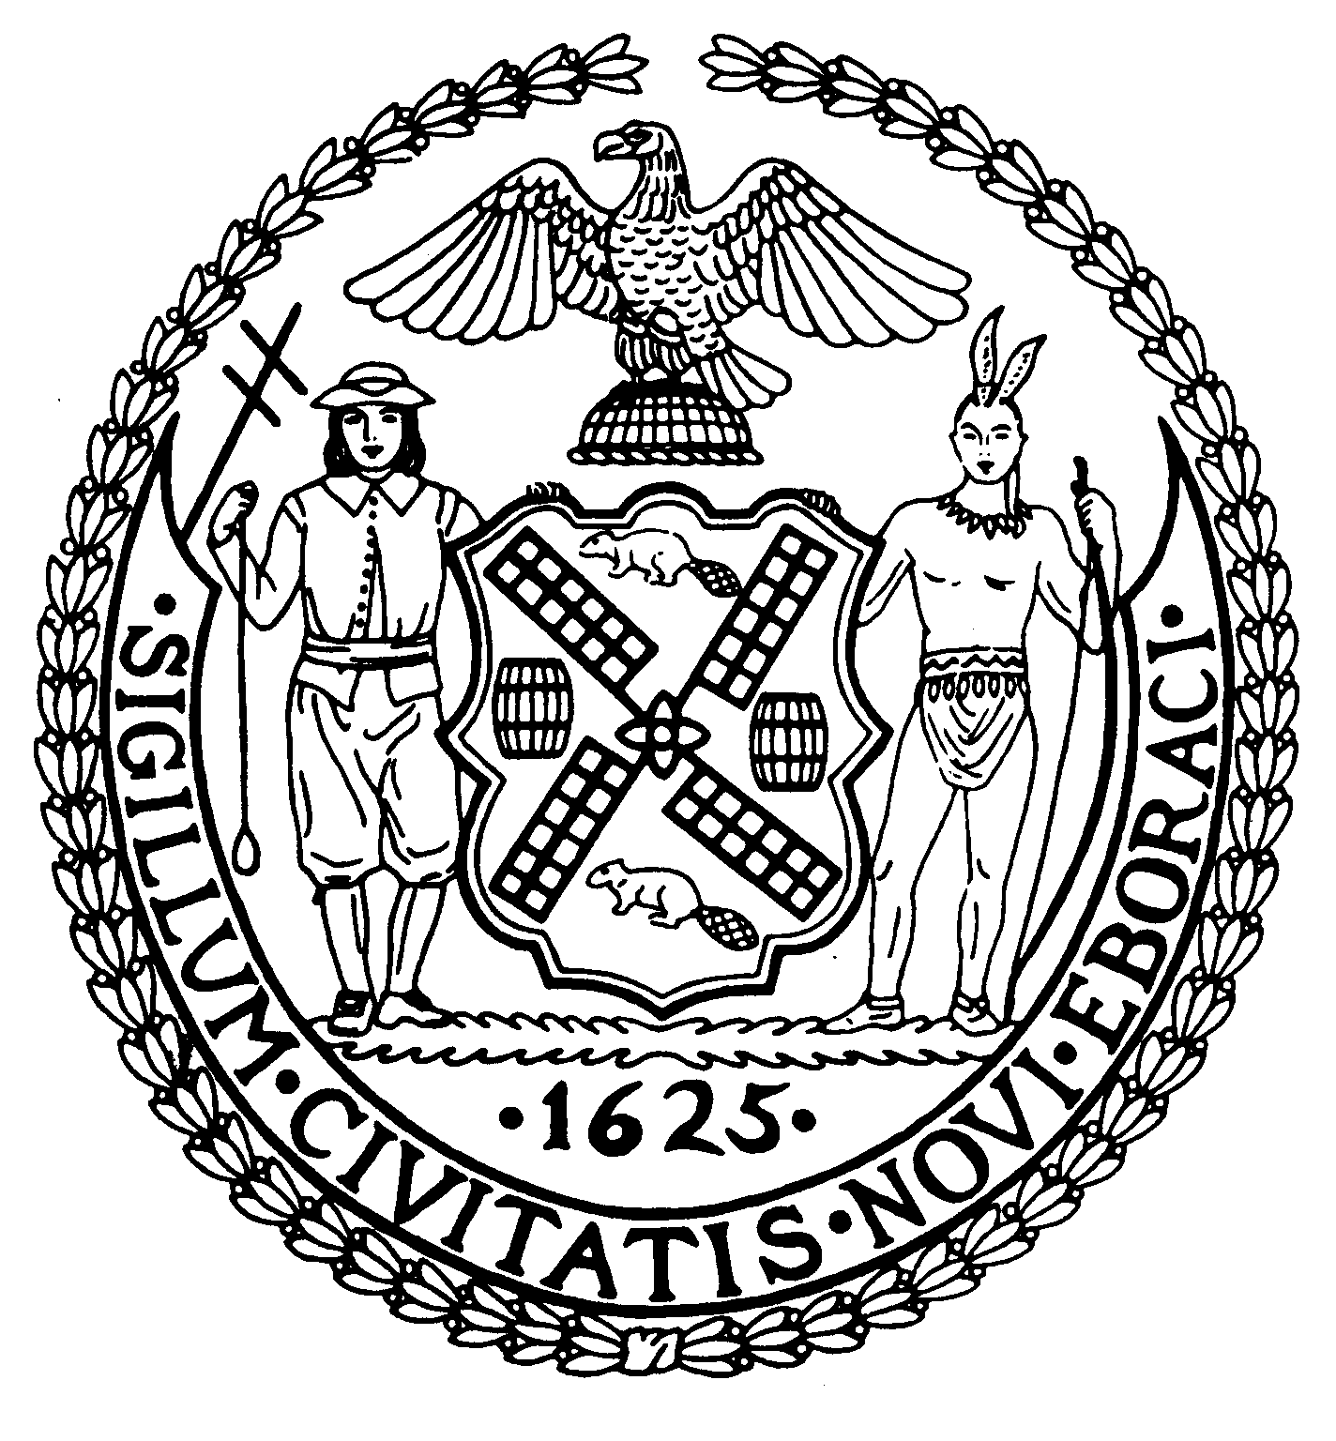
Chair New York, N.Y. 10022-1106

(212) 758-4340
Latha Thompson (212) 758-4616 (Fax)
District Manager www.cb8m.com - Website
info@cb8m.com E-Mail

The City of New York

Manhattan Community Board 8

Landmarks Committee, October 18, 2010 – 6:30PM
Hunter College School of Social Work, 129 East 79th Street, Auditorium

Agenda
PLEASE NOTE: When evaluating Applications for Certificates of Appropriateness, the Landmarks Committee of Community Board 8M ONLY considers the appropriateness of the proposal to the architecture of the building and, in the case of a building within an Historic District, the appropriateness of the proposal to the character of that Historic District. All testimony should be related to such appropriateness. The Committee recommends a Resolution to the full Community Board, which votes on a Resolution to be sent to the Landmarks Preservation Commission. These Resolutions are advisory; the decision of the Landmarks Preservation Commission is binding.

Applicants and members of the public who are interested in the issues addressed are invited, but not required, to attend the Full Board Meeting on October 20, 2010 at Hunter College School of Social Work, 129 East 79th Street, Auditorium at 6:30PM. They may testify for up to three minutes in the Public Session, which takes place at 6:30PM. Members of the Board will discuss the items in executive session; if a member of the public wishes a comment made or a question asked at this time, he must ask a Board Member to do it for him.

- The Solomon R. Guggenheim Foundation – 1071 Fifth Avenue (@ 89th Street) – Individual Landmark - Expanded Carnegie Hill Historic District - Andre Kikoski Architect, PLLC - Modern style museum building designed by Frank Lloyd Wright and built in 1956-59. Application is to install a free standing kiosk in front of the building.

- 17 East 90th Street and 22 East 91st Street (Fifth and Madison Avenues)-Spence School-Individual Landmark-Carnegie Hill Historic District- Mr. Shelly Friedman, Friedman and Gotbaum, LLP-17 East 90th Street, A five story townhouse designed by F. Burrall Hoffman, Jr. and built in 1917-19. 22 East 91st Street-The eight story neo-Georgian style school, designed by John Russell Pope in 1929. Applications for the restoration of 17 East 90th Street and to connect it to the main school building at 22 East 91st Street.

- 930 Fifth Avenue (@ 74th Street) – Upper East Side Historic District - Mr. Kevin Bone, architect - A nineteen-story Classicizing Modern apartment building designed by Emery Roth & Sons, and built in 1940. Application to install new windows.

- 841 Lexington Avenue (@ 64th Street) - Upper East Side Historic District Extension – Mr. Daniel P. Allen, architect – A Simplified Colonial Revival style store and apartment building, designed by Thomas W. Lamb Inc., and built in 1929. Application is to replace storefront infill and install signage.

- 44 East 74th Street (Madison and Park Avenues) – Upper East Side Historic District – Mr. Paul Gregory, architect – A Beaux Arts style residence, designed by the George F. Pelham and built in 1904-1905. Application is to legalize modifications to a bay window and replacement of a window without Landmarks Preservation Commission permits.

- Old Business

- New Business

Jane Parshall and David Liston – Co-Chairs, Landmarks Committee

