Jacqueline Ludorf 505 Park Avenue, Suite 620
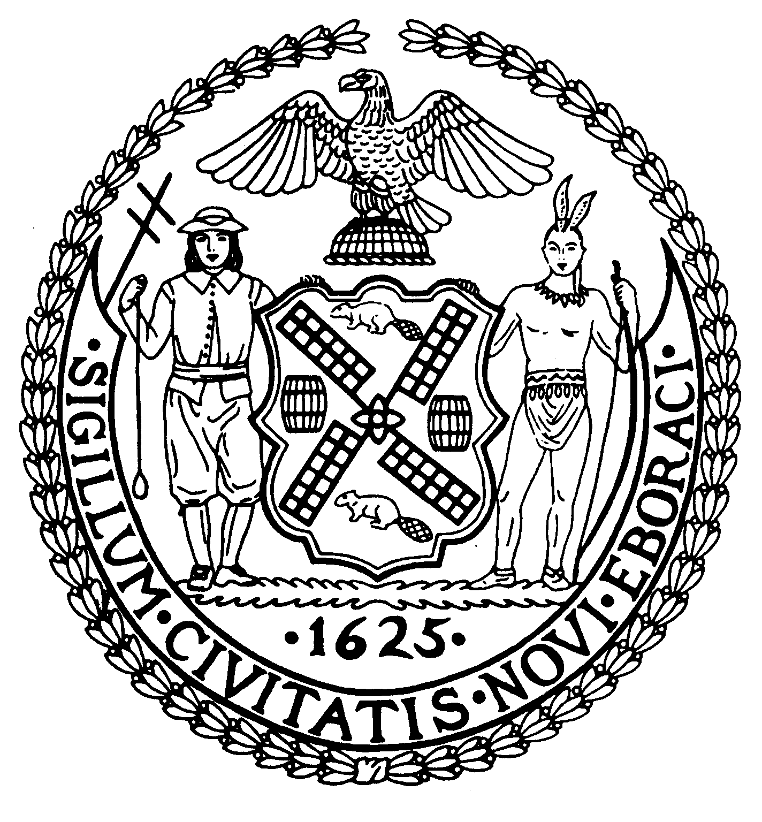
Chair New York, N.Y. 10022-1106

(212) 758-4340
Latha Thompson (212) 758-4616 (Fax)
District Manager www.cb8m.com - Website
info@cb8m.com E-Mail

The City of New York

Manhattan Community Board 8

Landmarks Committee, November 15, 2010 – 6:30PM
Hunter College School of Social Work, 129 East 79th Street, Auditorium

Agenda
PLEASE NOTE: When evaluating Applications for Certificates of Appropriateness, the Landmarks Committee of Community Board 8M ONLY considers the appropriateness of the proposal to the architecture of the building and, in the case of a building within an Historic District, the appropriateness of the proposal to the character of that Historic District. All testimony should be related to such appropriateness. The Committee recommends a Resolution to the full Community Board, which votes on a Resolution to be sent to the Landmarks Preservation Commission. These Resolutions are advisory; the decision of the Landmarks Preservation Commission is binding.

Applicants and members of the public who are interested in the issues addressed are invited, but not required, to attend the Land Use/Full Board Meeting on November 17, 2010 at the New York Blood Center, 310 East 67th Street, Auditorium at 6:30PM. They may testify for up to three minutes in the Public Session, which takes place at 6:30PM. Members of the Board will discuss the items in executive session; if a member of the public wishes a comment made or a question asked at this time, he must ask a Board Member to do it for him.

- 17 East 90th Street, an Individual Landmark, and 22 East 91st Street (Fifth and Madison Avenues) - Spence School - Carnegie Hill Historic District - Mr. Shelly Friedman, Friedman and Gotbaum, LLP - 17 East 90th Street, A five story townhouse designed by F. Burrall Hoffman, Jr. and built in 1917-19. 22 East 91st Street -The eight story neo-Georgian style school, designed by John Russell Pope in 1929. Applications for the restoration of 17 East 90th Street and to connect it to the main school building at 22 East 91st Street.

- 124 East 62nd Street (Park and Lexington Avenues) - Upper East Side Historic District – Mr. Mark Gerstle, expeditor and Judy Licht-Della Femina, co-owner – A three story Italianate style brownstone building designed by Robert Mook, and built in 1869-70. Application to legalize a fence.

- 21 East 65th Street (Madison and Fifth Avenues) - Upper East Side Historic District – Mr. Shea Murdock, Murdock Young Architects - A rowhouse built in 1881 and altered in the neo-Federal style by Scott & Prescott in 1929. Application is to modify the storefront entryway.

- Public Hearing: PROPOSED HELLGATE HISTORIC DISTRICT: The proposed area of designation includes the rowhouses on the north side of 94th Street and the south side of 95th Street between Lexington and Third Avenues and the rowhouses, synagogue and a seven-story apartment building (built in 1900) on Lexington Avenue. The rowhouses of these three contiguous blockfronts were built in the 1870s and designed in the neo-Grec style by Thom & Wilson, one of the most prolific architectural firms in rowhouse design in Manhattan. The Hellgate houses are among the earliest rowhouses constructed in Carnegie Hill and mirror in style and dates similar rowhouses built one block west on 94th Street, located within the Carnegie Hill Historic District. This application is being submitted by Carnegie Hill Neighbors.

- 205 East 61st Street (Third and Second Avenues) – Treadwell Farm Historic District – Michael Zenreich, architect – A rowhouse built in 1873-74 and remodeled in the 20th century. Application is to install a barrier free access lift.

- Old Business/New Business

Jane Parshall and David Liston – Co-Chairs, Landmarks Committee

