Jacqueline Ludorf 505 Park Avenue, Suite 620
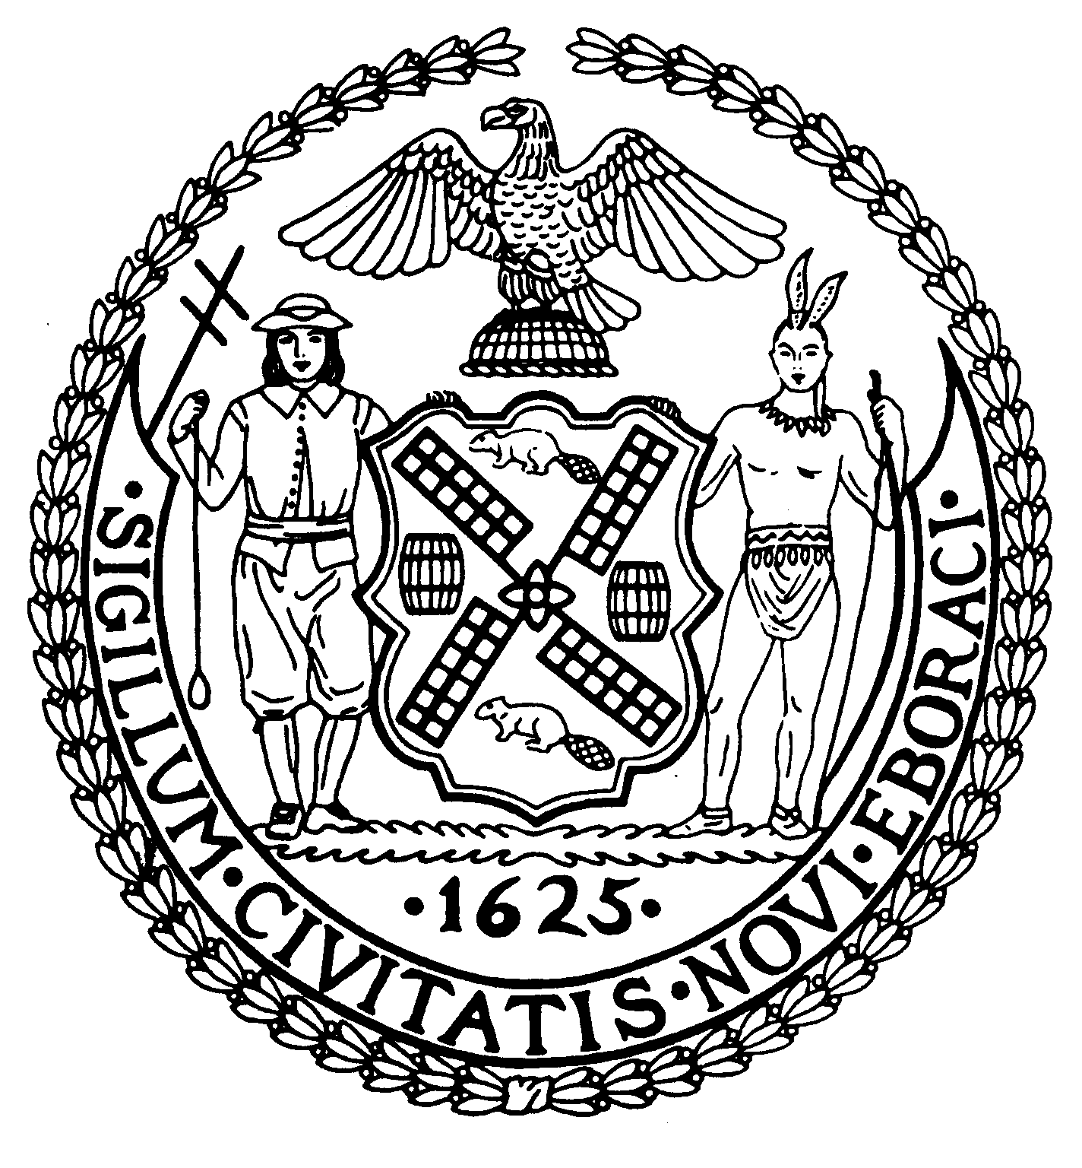
Chair New York, N.Y. 10022-1106

(212) 758-4340
Latha Thompson (212) 758-4616 (Fax)
District Manager www.cb8m.com - Website
info@cb8m.com E-Mail

The City of New York

Manhattan Community Board 8

Landmarks Committee, March 15, 2010 – 6:30PM
Hunter College School of Social Work, 129 East 79th Street, Room 1010

Agenda
PLEASE NOTE: When evaluating Applications for Certificates of Appropriateness, the Landmarks Committee of Community Board 8M ONLY considers the appropriateness of the proposal to the architecture of the building and, in the case of a building within an Historic District, the appropriateness of the proposal to the character of that Historic District. All testimony should be related to such appropriateness. The Committee recommends a Resolution to the full Community Board, which votes on a Resolution to be sent to the Landmarks Preservation Commission. These Resolutions are advisory; the decision of the Landmarks Preservation Commission is binding.

Applicants and members of the public who are interested in the issues addressed are invited, but not required, to attend the Land Use/Full Board Meeting on March 17, 2010 at the Ramaz School, 125 East 85th Street, Auditorium at 6:30PM. They may testify for up to three minutes in the Public Session, which takes place at 6:30PM. Members of the Board will discuss the items in executive session; if a member of the public wishes a comment made or a question asked at this time, he must ask a Board Member to do it for him.

- 21 East 66th Street (Fifth-Madison)-Upper East Side Historic District- Luigi Landi, Architect-A neo-Gothic style apartment building designed by Fred F. French and built in 1920-21. Application for a proposed penthouse addition.
- 1402 Lexington Avenue (East 92nd-93rd Streets)-Carnegie Hill Historic District-Omer Fenik, Architect-A neo-Grec/Romanesque Revival rowhouse designed by C. Abbott French & Co., and built in 1886-87. Application for alterations to storefront, removal of violation for “installation of sign band without permits” and for “installation of slate tile at storefront roof without permits.
- 960 Madison Avenue (East 75th-76th Streets)-Upper East Side Historic District- Fred L. Sommer, Architect-A neo-Grec style rowhouse designed by James Frame and built in 1877-78 and altered in 1916 with a two-story storefront extension. Application to alter window openings.
- 20 East 82nd Street (Fifth-Madison)-Upper East Side Historic District-Thomas Morbitzer, Architect-A French Beaux-Arts style townhouse designed by Richard W. Buckley and built in 1901. Application to repair existing steps, fence, gate and add a new gate at steps.
- 783-789 Park Avenue (East 73rd-74th Streets) aka 101 East 73rd Street -Upper East Side Historic District-Josh Brandfonbrener Architect-A modern style apartment building designed by George Pelham, Jr., and built in 1930-1040. Application to install a ramp in the rear service yard of the building.
- 923 Fifth Avenue (East 73rd-74th Streets)-Upper East Side Historic District-Ted Bodnar, Architect-An apartment building designed by Sylvan Bien and built in 1949-51. Application to increase the size of the glazing at the second floor where there are currently three separate windows to one large window opening via the removal of the separating piers and the installation of a new steel structural beam.
- 12 East 76th Street (Fifth-Madison)-Upper East Side Historic District-Umberto Squarcia, Architect-A building constructed in 1881-82 and altered in 1946 by James Casale. Application to redesign the façade.
- Old Business
- New Business

Jane Parshall and David Liston – Co-Chairs, Landmarks Committee

