Jacqueline Ludorf 505 Park Avenue
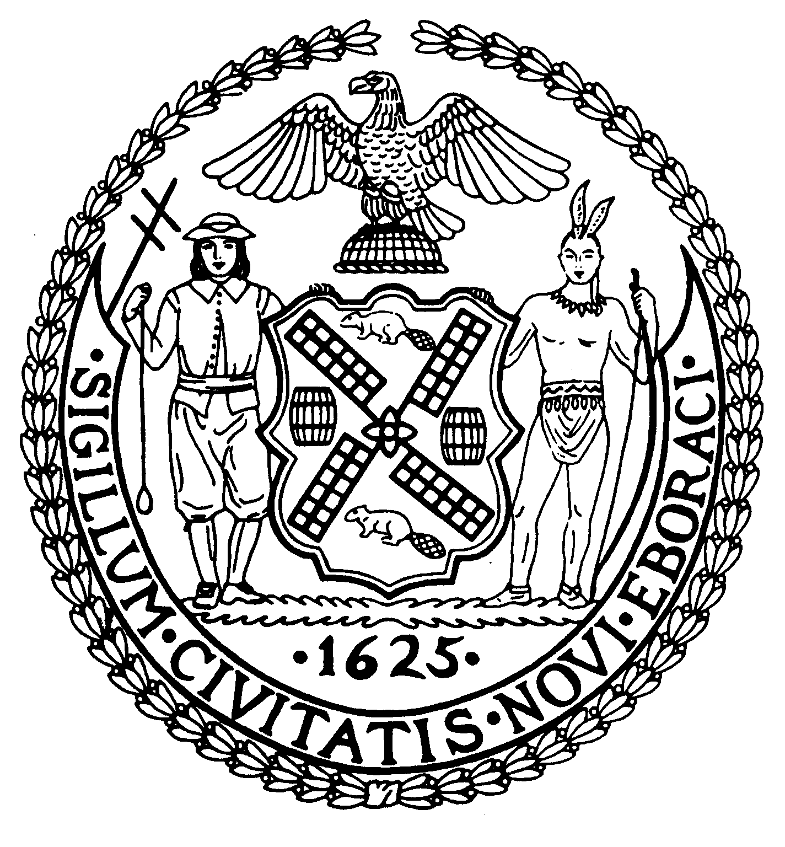
Chairman Suite 620
New York, N.Y. 10022

Latha Thompson (212) 758-4340
District Manager (212) 758-4616 (Fax)
www.cb8m.com Website
info@cb8m.com - E-Mail

The City of New York
Manhattan Community Board 8

LAND USE MEETING
WEDNESDAY, MARCH 9, 2011
Hunter College School of Social Work
129 East 79th Street, Auditorium
6:30PM

Community Board Members Present: Elizabeth Ashby, Kenneth Austin, Michele Birnbaum, Molly Blayney, Matthew Bondy, Roy Carlin, Barbara Chocky, James Clynes, Christina Davis, Susan Evans, A. Scott Falk, George Fuchs, Ruth Halberg, Jonathan Horn, Dave Kleckner, Jacqueline Ludorf, Domenico Minerva, Laurence Parnes, Jane Parshall, Mary Boresz Pike, N. Sharon Pope, Rita Lee Popper, Margaret Price, David Rosenstein, Barbara Rudder, Judith Schneider, Helene Simon, Teri Slater, Cos Spagnoletti, H. Patrick Stewart, Debra Teitelbaum, Alexander Tisch, Elaine Walsh, Charles Warren, Hedi White
Community Board Members (Excused): Joie Anderson, David Helpern, William Sanchez, M. Barry Schneider, Marco Tamayo, Nicholas Viest
Community Board Members (Unexcused): Michael Auerbach, Lori Ann Bores, Deirdre Breslin, Sarah Chu, Lorance Hockert, Lorraine Johnson, Laura Lijewski, David Liston, Ellen Polivy
Total Attendance: 35

Chair Jacqueline Ludorf called the meeting to order at 6:30PM.

1. Street Life Committee

1a. New Ko-Sushi Japanese Restaurant, Inc. d/b/a Kosushi Japanese Restaurant, 1329-1335 Second Avenue (70th/71st Street) – Renewal application for an enclosed sidewalk café with 15 tables and 44 seats, DCA #1285670. Due date: March 10th. Hours: 11a – 11p weekdays 1p – 11p weekends. Food/Drink: 95/5
BE IT RESOLVED THAT Manhattan Community Board 8 takes no position on this application.
Manhattan Community Board 8 did not take a position on the above referenced application. The motion to approve the application was voted down, with a vote of 14 in favor, 15 opposed, and 4 abstentions.

1b. Steven Jay, LLC d/b/a Parlor Steakhouse, 1600 Third Avenue (@ 90th Street) - Renewal application for an enclosed sidewalk café with 14 tables and 28 seats, DCA #1287124. Due date: March 10th. Hours: 12p – 11p weekdays and 11a – 12a weekends. Food/Drink: 80/20
WHEREAS there are no changes to the café and there was no objection from the public,
BE IT RESOLVED THAT the application is Approved.
Manhattan Community Board 8 adopted the resolution by a vote of 30 in favor, 0 opposed, and 0 abstentions.

1c. TJ 104 Restaurant, Corp. d/b/a Timmy’s by the River, 1737 York Avenue (90th/91st Street) – Renewal application for an unenclosed sidewalk café with 9 tables and 22 seats, DCA #1295832. Due date: March 14th: 7a – 11p. Food/Drink: 90/10.
WHEREAS there are no changes to the café and there was no objection from the public,
BE IT RESOLVED THAT the application is Approved.
Manhattan Community Board 8 adopted the resolution by a vote of 30 in favor, 0 opposed, and 0 abstentions.

1d. Grace’s Marketplace, Inc. d/b/a Grace’s Trattoria Café & Grill, 201 East 71st Street (@ Third Avenue) – Renewal application for an unenclosed sidewalk café with 6 tables and 12 seats, DCA #1013198. Due date: March 17th. Hours: 11a – 10p weekdays and 11a – 10:30p weekends
WHEREAS there are no changes to the café and there was no objection from the public,
BE IT RESOLVED THAT the application is Approved.
Manhattan Community Board 8 adopted the resolution by a vote of 30 in favor, 0 opposed, and 0 abstentions.

1e. 205 East 75th Street, LLC d/b/a Fulton, 205 East 75th Street (Third/Second Avenues) – Renewal application for an unenclosed sidewalk café with 14 tables and 29 seats, DCA #1227438. Due date: March 18th. Hours: 11:30 - 11p weekdays 10:30p – 9p weekends. Food/Drink: 70/30.
WHEREAS there are no changes to the café and there was no objection from the public,
BE IT RESOLVED THAT the application is Approved.
Manhattan Community Board 8 adopted the resolution by a vote of 30 in favor, 0 opposed, and 0 abstentions.

1f. 60th Street Restaurant, Corp. d/b/a Patsy’s, 206 East 60th Street (@ Third Avenue) – Renewal application for an unenclosed sidewalk café with 9 tables and 18 seats, DCA # 1106418. Due date: March 25th Hours: 11a – 10p weekdays and 11a – 11p weekends. Food/Drink: 90/10.
WHEREAS there are no changes to the café and there was no objection from the public,
BE IT RESOLVED THAT the application is Approved.
Manhattan Community Board 8 adopted the resolution by a vote of 30 in favor, 0 opposed, and 0 abstentions.

1g. Vero Inc. d/b/a Vero, 1483 Second Avenue (77th/78th Streets) – Renewal application for an unclosed sidewalk café with 7 tables and 14 seats, DCA #1228814. Due date: April 4th Hours: 4p – 3a weekdays and 12p – 4a weekends. Food/Drink: 60/40.
WHEREAS there are no changes to the café and there was no objection from the public,
BE IT RESOLVED THAT the application is Approved.
Manhattan Community Board 8 adopted the resolution by a vote of 30 in favor, 0 opposed, and 0 abstentions.

2a. 1475 Second Avenue Bagel, LLC d/b/a Pick a Bagel, 1475 Second Avenue (76th/77th Streets) – New application for an unenclosed sidewalk café with 10 tables and 20 seats, DCA #1381059. Due date: March 7th Hours: 6a – 12a. Food/Drink: 90/10.
WHEREAS this application results from a change in ownership,
WHEREAS there is a reduction of 2 tables and 4 chairs from the previous café,
WHEREAS there is ample clearance of 12 ft from the café to the curb,
BE IT RESOLVED THAT the application is Approved.
Manhattan Community Board 8 adopted the resolution by a vote of 33 in favor, 0 opposed, and 0 abstentions.

2b. BLT Burger 2nd Avenue NYC, LLC d/b/a Go Burger, 1450 Second Avenue (75th/76th Street) – New application for an unenclosed sidewalk café with 9 tables and 18 seats, DCA #1381146. Due date: March 7th Hours: 11:30a – 11:30 p Food/Drink: 75/25
WHEREAS the clearance of the café exceeds 11 ft,
WHEREAS there were no objects made by the public,
BE IT RESOLVED THAT the application is Approved.
Manhattan Community Board 8 adopted the resolution by a vote of 30 in favor, 0 opposed, and 0 abstentions.

2c. PQ Carnegie Hill, Inc. d/b/a Le Pain Quotidien, 1309 Lexington Avenue (88th/89th Streets) – New application for an unenclosed sidewalk café with 4 tables and 8 seats, DCA #1381014. Due date: March 7th. Hours: 7a – 8:30p. Food/Drink: 70/30.
WHEREAS 4 residents appeared to object to the location of this café,
WHEREAS the residents stated that they are concerned that the heavy pedestrian traffic at this location makes a café unsuitable,
WHEREAS several committee members raised similar concerns about the congestion at this site,
BE IT RESOLVED THAT the application is Approved.
Manhattan Community Board 8 adopted the resolution by a vote of 26 in favor, 6 opposed, and 1 abstention.

2d. Tenzan Sushi Corp., 1714 Second Avenue (@ 89th Street) – New application for an unenclosed sidewalk café with 10 tables and 23 seats, DCA #1381672. Due date: March 17th. Hours: 11:30a – 12a weekdays 11:30a – 1a weekends. Food/Drink: 80/20.
WHEREAS application is for a license for the café area,
WHEREAS there were no objections from the public,
BE IT RESOLVED THAT the application is Approved.
Manhattan Community Board 8 adopted the resolution by a vote of 30 in favor, 0 opposed, and 0 abstentions.

2e. 1477 Restaurant Associates, LLC d/b/a Bar Italia, 1477 Second Avenue (@ 77th Street) – New application for an unenclosed sidewalk café with 14 tables and 37 seats, DCA #1382408. Due date: March 31st. Hours: 4p – 2a Mon – Thurs., 12p – 3a Fri – Sat. 12p – 1a Sun. Food/Drink/60/40.
WHEREAS application is for a license for the café area,
WHEREAS there were no objections from the public,
BE IT RESOLVED THAT the application is Approved.
Manhattan Community Board 8 adopted the resolution by a vote of 30 in favor, 0 opposed, and 0 abstentions.

3a. 301 East 80th Grocery, LLC d/b/a Cascabel Taqueria, 1538 Second Avenue (@ 80th Street) – Application to make alternations to an on-premise liquor license. Hours: 11:30 – 12a weekdays and 11:30a – 1a weekends Food/Drink: 80/20.
WHEREAS this application for a license to cover the café,
WHEREAS there were no objections from the public,
BE IT RESOLVED THAT the application is Approved.
Manhattan Community Board 8 adopted the resolution by a vote of 32 in favor, 0 opposed, and 1 abstention.

3b. 1710 Restaurant Corp d/b/a Carino Ristorante, 1710 Second Avenue (88th/89th Streets) – Application to make alterations to an on-premises liquor license Hours: 5p – 11p. Food/Drink: 80/20.
WHEREAS this application for a license to cover the café,
WHEREAS there were no objections from the public,
BE IT RESOLVED THAT the application is Approved.
Manhattan Community Board 8 approved the resolution by a vote of 32 in favor, 0 opposed, and 1 abstention.

3d. 1701 Pizza, Ltd d/b/a Luigi’s Pizza, 1701 First Avenue (@ 88th Street) – Application to transfer a beer and wine license Hours: 11a – 10p. Food/Drink: 80/20.
WHEREAS the applicant is buying the business from his cousin,
WHEREAS there were no objections from the public,
BE IT RESOLVED THAT the application is Approved.
Manhattan Community Board 8 adopted the resolution by a vote of 32 in favor, 0 opposed, and 1 abstention.

3e. LLC to be formed d/b/a TBD, currently “Petaluma” 1356-8 First Avenue (@ 73rd Street) – Application to transfer an on-premises liquor license Hours: 11:30a – 11p. Food/Drink: 75/25.
WHEREAS the application is being made because of transfer of ownership,
WHEREAS there are no plans to change the existing operation,
BE IT RESOLVED THAT the application is Approved.
Manhattan Community Board 8 adopted the resolution by a vote of 32 in favor, 0 opposed, and 1 abstention.

4a. Venky’s Food Corp d/b/a Om Restaurant, 1593 Second Avenue (82nd/83rd Streets) – New application for an on-premises liquor license Hours: 11:30a – 10:30p weekdays 11:30a – 11p weekends. Food/Drink: 70/30.
WHEREAS the applicants have experience as former managers at Baluchi’s,
WHEREAS there were no objections made by the public,
BE IT RESOLVED THAT the application is Approved.
Manhattan Community Board 8 adopted the resolution by a vote of 32 in favor, 0 opposed, and 1 abstention.

4g. 920 Dream Unlimited, Inc. d/b/a Pamir Kabab, 1437 First Avenue (74th/75th Streets) – Application to make alterations to an on-premises liquor license
WHEREAS the applicant has failed to appear 3 times consecutively,
BE IT RESOLVED THAT the application is disapproved.
Manhattan Community Board 8 adopted the resolution by a vote of 35 in favor, 0 opposed, and 1 abstention.

2. Old Business

No old business.

3. New Business

No new business.

The meeting was adjourned at 7:03PM.

