Jacqueline Ludorf 505 Park Avenue
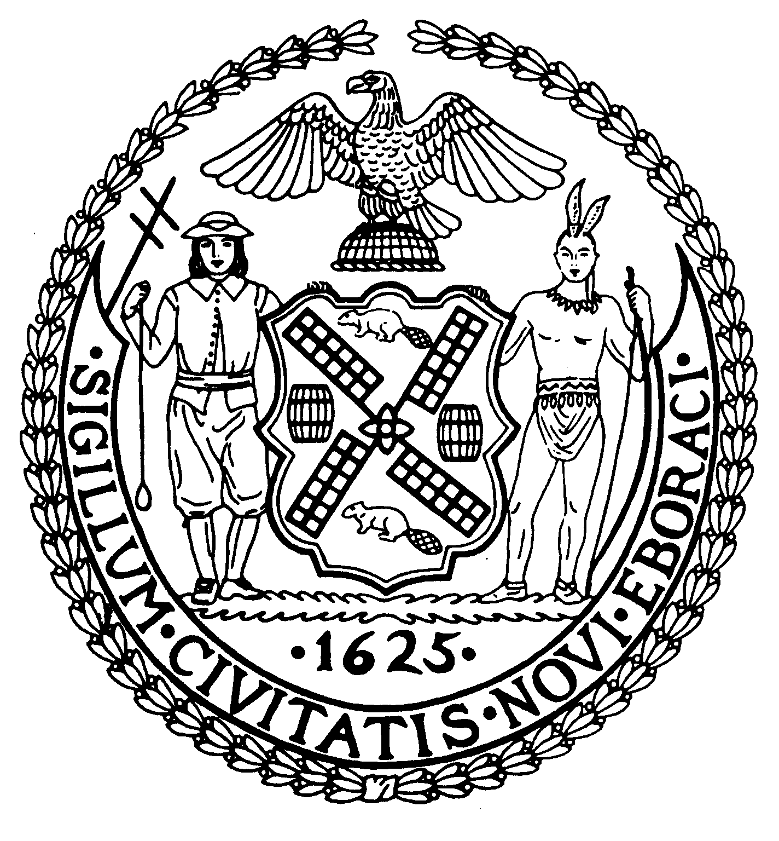
Chairman Suite 620
New York, N.Y. 10022

Latha Thompson (212) 758-4340
District Manager (212) 758-4616 (Fax)
www.cb8m.com Website
info@cb8m.com - E-Mail

The City of New York
Manhattan Community Board 8

LAND USE MEETING
WEDNESDAY, JANUARY 12, 2011
Hunter College School of Social Work
129 East 79th Street, Auditorium
6:30PM

Community Board Members Present: Elizabeth Ashby, Michele Birnbaum, Molly Blayney, Matthew Bondy, Lori Ann Bores, Roy Carlin, Barbara Chocky, Sarah Chu, James Clynes, David Helpern, Lorance Hockert, Jonathan Horn, David Liston, Jacqueline Ludorf, Domenico Minerva, Laurence Parnes, Jane Parshall, Mary Boresz Pike, N. Sharon Pope, Rita Lee Popper, Margaret Price, Barbara Rudder, William Sanchez, Judith Schneider, M. Barry Schneider, Teri Slater, Cos Spagnoletti, Marco Tamayo, Alexander Tisch, Nicholas Viest, Elaine Walsh, Charles Warren
Community Board Members (Excused): Joie Anderson, Christina Davis, Susan Evans, A. Scott Falk, Ruth Halberg, Dave Kleckner, David Rosenstein, Helene Simon, Debra Teitelbaum, Hedi White
Community Board Members (Unexcused): Michael Auerbach, Kenneth Austin, Deirdre Breslin, George Fuchs, Lorraine Johnson, Laura Lijewski, Ellen Polivy, H. Patrick Stewart
Total Attendance: 32

Chair Jacqueline Ludorf called the meeting to order at 6:30PM.

Public Hearing: N110090 ZRY Key Terms Clarification Text Amendment – The Department of City Planning is proposing a citywide text amendment of the Zoning Resolution to clarify the meaning and usage of the key terms “development” and “building”. In addition, the Department proposes other text modifications that are necessary to clarify the intent of the Zoning Resolution, resolve conflicting regulations, or bring a regulation into accordance with current Department of Buildings practice. This application is not subject to the Uniform Land Use Review Procedure (ULURP).
A representative from the Department of City Planning, Kurt Holmes, made a brief presentation on the approved N110090 ZRY Key Terms Clarification Text Amendment and accepted questions and comments from the board members and public. The comments will be taken into consideration by the City Council for their approval of this Key Terms Clarification Text Amendment.

Chair Jacqueline Ludorf introduced the newly appointed board member, Molly Blayney, to the rest of the board members. Molly Blayney replaces retired board member Betty Cooper Wallerstein.

Re: BSA Cal #899-650BZ, Block 1418, Lot 21; 231-245 East 63rd Street

Whereas, This Special Order Calendar (SOC) application has been filed at the Board of Standards and Appeals seeking to extend the term of the previously granted variance which permits public parking in the accessory parking garage of the residential building at the premises.
Whereas, Community Board 8M held a public hearing regarding this matter;
Be It Resolved, that Community Board 8M recommends approval of this application.
Community Board 8M adopted the resolution by a vote of 30 in favor, 0 opposed, and 0 abstentions.

Informational Presentation by Weill Cornell Medical College – A representative, Richard Homis, made a brief presentation on the update at the new medical research building project on east 69th street and distributed a handout with a summary of the construction.

1. Street Life Committee

1.a. Steven Jay, LLC d/b/a Parlor Steakhouse, 1600 Third Avenue (@ 90th Street) – Renewal application for an unenclosed sidewalk café with 13 tables and 26 seats, DCA #1306814.
WHEREAS there are no changes to the café and no one from the public objected,
BE IT RESOLVED THAT the application is Approved.
Manhattan Community Board 8 adopted the resolution by a vote of 31 in favor, 0 opposed, and 0 abstentions.

1.b. MBRP Restaurant, Inc. d/b/a The Stumble Inn, 1454 Second Avenue (@ 76th Street) – Renewal application for an unenclosed sidewalk café with 12 tables and 25 seats, DCA #0955674.
WHEREAS there are no changes to the café,
WHEREAS there was one person from the community with complaints about the establishment, and not specifically against the un-enclosed café,
WHEREAS the establishment will appear before the committee for their next liquor license renewal
BE IT RESOLVED THAT the application is Approved.
Manhattan Community Board 8 adopted the resolution by a vote of 25 in favor, 2 opposed, and 5 abstentions.

1.c. Taro Rest, Inc. d/b/a Due, 1396 Third Avenue (79th/80th Streets) – Renewal application for an unenclosed sidewalk café with 4 tables and 8 seats, DCA #0835262
WHEREAS there are no changes to the café and no one from the public objected,
BE IT RESOLVED THAT the application is Approved.
Manhattan Community Board 8 adopted the resolution by a vote of 31 in favor, 0 opposed, and 0 abstentions.

1.d. Mavima Restaurant, Inc. d/b/a Brio, 786 Lexington Avenue a/k/a 137 East 61st Street – Renewal application for an unenclosed sidewalk café with 6 tables and 12 seats, DCA #1184384
WHEREAS there are no changes to the café and no one from the public objected,
BE IT RESOLVED THAT the application is Approved.
Manhattan Community Board 8 adopted the resolution by a vote of 31 in favor, 0 opposed, and 0 abstentions.

1.e. Genino, Inc. d/b/a Vico, 1302 Madison Avenue (92nd/93rd Streets) – Renewal application for an unenclosed sidewalk café with 2 tables and 8 seats, DCA #1276520.
WHEREAS there are no changes to the café and no one from the public objected,
BE IT RESOLVED THAT the application is Approved.
Manhattan Community Board 8 adopted the resolution by a vote of 31 in favor, 0 opposed, and 0 abstentions.

2.a. Spice Corner 236, Inc. d/b/a Spice, 1479 First Avenue (@ 77th Street) – Application for an assignment of consent (new ownership) for an unenclosed sidewalk café with 4 tables and 8 seats, DCA #1378222
WHEREAS this is a new application for an old existing café,
WHEREAS the applicant was approved for the restaurant some time ago,
WHEREAS the café will be the same size as prior café,
BE IT RESOLVED THAT the application is Approved.
Manhattan Community Board 8 adopted the resolution by a vote of 31 in favor, 0 opposed, and 0 abstentions.

3.a. Nargila Place, Inc. d/b/a Nargila Grill, 1599 York Avenue (84th/85th Streets) – New application for the transfer of a wine and beer license
WHEREAS there was one person from the community with complaints about the canvas cover in the back yard,
WHEREAS the applicant will use their best efforts to have the property owner remove the structure,
WHEREAS the license area does not include the back yard and the back yard has not & will not be used,
BE IT RESOLVED THAT the application is Approved.
Manhattan Community Board 8 adopted the resolution by a vote of 31 in favor, 0 opposed, and 0 abstentions.

3.b. B&A Pizzaiolo, LLC d/b/a TBD, 1544 Second Avenue (80th/81st Street) – New application for the transfer of an on-premises liquor license
WHEREAS there was no one from the community present,
WHEREAS this is a restaurant rather than a drinking bar,
WHEREAS this is the existing Totonno’s restaurant
BE IT RESOLVED THAT the application is Approved.
Manhattan Community Board 8 adopted the resolution by a vote of 31 in favor, 0 opposed, and 0 abstentions.

4.a. Zesty Pizzeria, Inc., 1693 Third Avenue (@ 95th Street) – New application for a beer only license
WHEREAS there was no one from the community present,
WHEREAS this is for a beer only rather than a drinking bar,
BE IT RESOLVED THAT the application is Approved.
Manhattan Community Board 8 adopted the resolution by a vote of 31 in favor, 0 opposed, and 0 abstentions.

4.b. K&D By the Glass, LLC, 1372 Madison Avenue (@ 96th Street) – New application for a wine and beer license
WHEREAS there was one person from the community speaking out against the applicant because of an other nearby establishments garbage situation,
WHEREAS there were other community members speaking for the establishment,
BE IT RESOLVED THAT the application is Approved.
Manhattan Community Board 8 adopted the resolution by a vote of 30 in favor, 1 opposed, and 1 abstention.

4.d. Tatmar Restaurant, Inc. d/b/a Quatorze Bis, 323 East 79th Street (First/Second Avenues) – New application for an on-premises liquor license
WHEREAS there was no one from the community present,
WHEREAS this is an existing establishment with a change of corporate name only,
WHEREAS the existing license expired 12/31, and a temporary one issued 1/1
BE IT RESOLVED THAT the application is Approved.
Manhattan Community Board 8 adopted the resolution by a vote of 31 in favor, 0 opposed, and 0 abstentions.

4.e. East End Kitchen, LLC d/b/a TBD, 539 East 81st Street (York/ East End Avenue) – New application for an on-premises liquor license
WHEREAS there was no one from the community present,
WHEREAS this was an existing establishment which recently closed,
BE IT RESOLVED THAT the application is Approved.
Manhattan Community Board 8 adopted the resolution by a vote of 31 in favor, 0 opposed, and 0 abstentions.

4.f. 24 East 81st Street, LLC d/b/a The Crown, 24 East 81st Street (Madison/Fifth Avenues) – New application for an on-premises liquor license
WHEREAS there was no one from the community present,
WHEREAS this is an existing establishment which ceased to continue,
BE IT RESOLVED THAT the application is Approved.
Manhattan Community Board 8 adopted the resolution by a vote of 31 in favor, 0 opposed, and 0 abstentions.

2. Old Business

No old business.

3. New Business

No new business.

The meeting was adjourned at 8:00PM.

