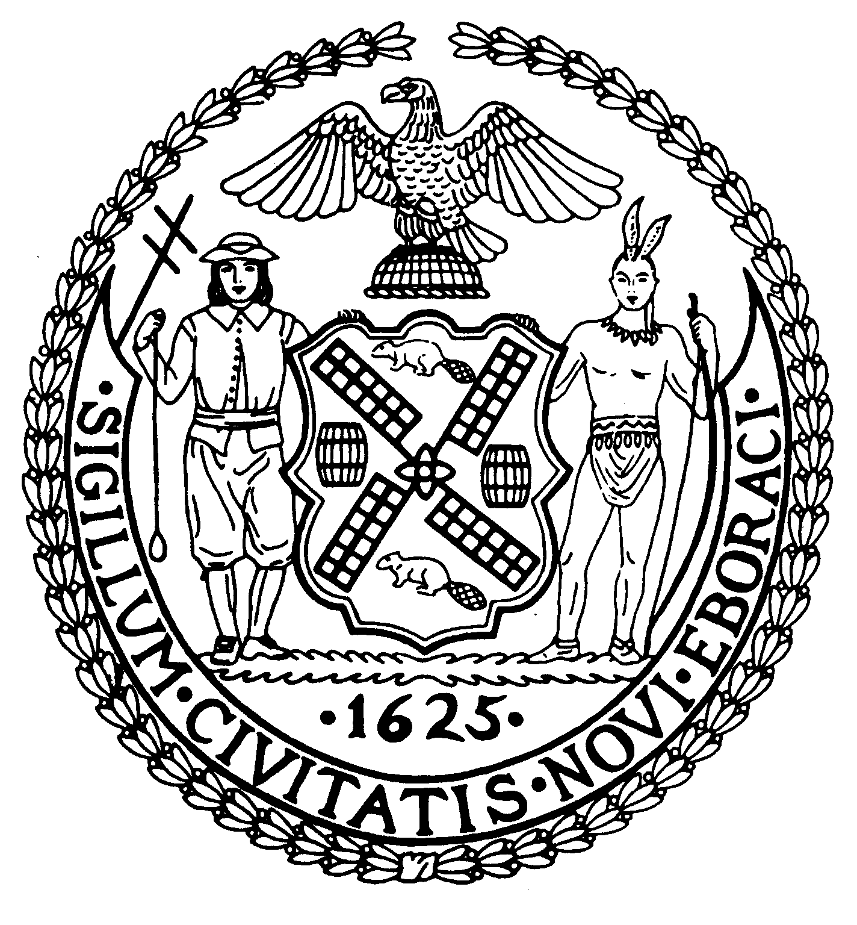

The City of New York Manhattan Community Board 8

505 Park Avenue, Suite 620 Phone: (212) 758-4340

New York, N.Y. 10022-1106 Fax: (212) 758-4616
www.cb8m.com info@cb8m.com - E-Mail
Jacqueline Ludorf, Chair Latha Thompson, District Manager
Community Bulletin Board – June 2010

PLEASE VISIT COMMUNITY BOARD 8’S WEBSITE AT www.cb8m.com

Street Activity Permit Office (SAPO) - You may now apply online for street fairs, block parties and festivals. Applicants can submit online applications at https://nyceventpermits.nyc.gov or www.nyc.gov/sapo. All applicants should be aware that the deadlines for applications submission remain unchanged as do the rules and regulations governing the SAPO permitting process. For more information, call 212-788-7567 or visit http://www.nyc.gov/html/cau/html/street_permitting/permit_and_events.shtml.

2010 Multi-Block Street Fairs
Third Avenue Street Fair-East 66th to East 86th Streets (former 2nd Avenue Fair) June 6, 2010
First Avenue Street Fair-East 68th to East 79th Streets June 12, 2010
Third Avenue Street Fair-East 66th to East 86th Streets September 12, 2010
92nd Street Fair-East 79th to East 96th Streets September 26, 2010

The 19th Precinct Community Council will meet on Monday, June 14, 2010 at 7:00PM, please note change of meeting date 19th Precinct, 153 East 67th Street (between Lexington and Third Avenues). For more information, contact the 19th Precinct Community Affairs at 212-452-0613 or via email The19pctcouncil@aol.com

The East 79th Street Neighborhood Association will meet on Thursday, June 10, 2010 at 6:00PM, please note earlier start time, City University of New York (CUNY), 535 East 80th Street, (At East End Avenue) First Floor Board Room. Agenda: 19th Precinct Police Report on Neighborhood Safety, Including Bike Stats; Special Guest Speaker: Councilmember Jessica Lappin. Public discussion of a Senior Space in John Jay Park, come bring your suggestions and ideas; Elected Officials Reports/Updates. Next Meeting is Thursday, July 8, 2010. All meetings are free and open to the public.

New York–Presbyterian Hospital Weill Cornell Medical College/Jay Monahan Center for Gastrointestinal Health will hold a Health Outreach Prevention program on Colon Cancer Monday, June 7, 2010 from 9:00AM to 2:00PM. This free event will be held at 1315 York Avenue, (at East 70th Street) Outdoor courtyard. Come out and walk through a human colon and learn more about colorectal cancer. For more information, please call Tamar Wallace (212) 746-3847.

Weill Cornell Medical Center/Iris Cantor Women’s Health Center will hold Health Education Seminars entitled Lose the Diet, Eat in Peace on Thursday, June 10, 2010. The seminars will be held at the Weill Greenberg Center, 1305 York Avenue, (at East 70th Street) 2nd Floor. The lectures are free and open to the public, for more information or to RSVP, please call (212) 821-0971 or womenshealth@med.cornell.edu.

City & Suburban Homes York Avenue Estate will hold an Historic District Walking Tour on Sunday, June 27, 2010 at 1:00PM; City & Suburban Homes Archive, 515 East 78th Street. The tour includes City & Suburban Homes Landmark; Shively Sanitary Tenements; PS 158, Webster Library; John Jay Park and the Former East Side House Settlement. For more information, contact Marie Beirne at (212) 388-0883.

Fire Department of New York offers free bystander CPR training to all New York City residents. The program takes less than an hour and each participant is given a free CPR training kit to bring home to friends and family. For more information, call (718) 999-2413 or email Michael Eichler at eichlem@fdny.nyc.gov.

The NYC Department of Parks and Recreation has begun to recruit lifeguard candidates for the 2010 summer season. The qualifying test for entry into the program is currently being offered at locations in all five boroughs. The lists of testing sites are available at www.nyc.gov/parks. For more information, please contact Elizabeth Ripotola, Chief of Staff to the First Deputy Commissioner at (212) 360-1332 or via email Elizabeth.ripotola@parks.nyc.gov

The US Department of Treasury and the Federal Reserve Bank Go Direct campaign encourages people who receive Social Security and other federal benefits to help protect themselves from financial crimes by switching from paper checks to direct deposit. For more information, please call Ashley Czernis at (312)-988-2419, or via email aczernis@webershandwick.com or visit www.GoDirect.org.

Legal Information for Families Today (LIFT) Family Legal Center offers free workshops, legal information and social work services to parents and grandparents involved in child support, custody, and visitation cases. All services are offered in English and Spanish at 350 Broadway, Room 400. For more information, please call (646) 613-9633 or visit www.LIFTonline.org.

Need a babysitter? A tutor for your child? Someone to walk your dog during the day? If so, consider hiring a Hunter student. Hunter Helpers is a service that matches up Hunter College students with residents in the neighborhood who need a helping hand. For more information, visit their website www.hunter.cuny.edu/babysitting

The Day Care Council of New York, Inc. is a not-for-profit organization that provides families with child care information in all five boroughs of New York City, particularly infant and young toddler care. They offer free information and guidance in choosing day care, family care, Head Start, after-school programs, nanny services, summer camps group family care and other child care concerns. For more information, please call Jon Pinkos at 212-206-7818 x114 or via email jpinkos@dccnyinc.org.

Crime Victim Services is a non-profit program, designed to aid and compensate innocent victims of crime who meet certain criteria. The program is free of charge. For more information, please call Teresa Navarro at 212-585-6142 or 6281.

Mt. Sinai Sexual Assault and Violence Intervention Program (SAVI) needs individuals to become Volunteer Emergency Advocates for survivors of sexual assault and domestic violence. Advocates are on call once a month in Manhattan or Queens to accompany people who have recently been assaulted. For more information please call (212) 423-2140 or (718) 736-1288 or visit www.mssm.edu/SAVI/.

Manhattan Community Board 8 strongly encourages you to contact us with your concerns or questions about issues affecting you and your neighbors. If you know of anyone who would like to receive our monthly mailing via standard mail or electronically, please encourage him or her to contact the board office at 212-758-4340 or info@cb8m.com.

