Jacqueline Ludorf 505 Park Avenue, Suite 620
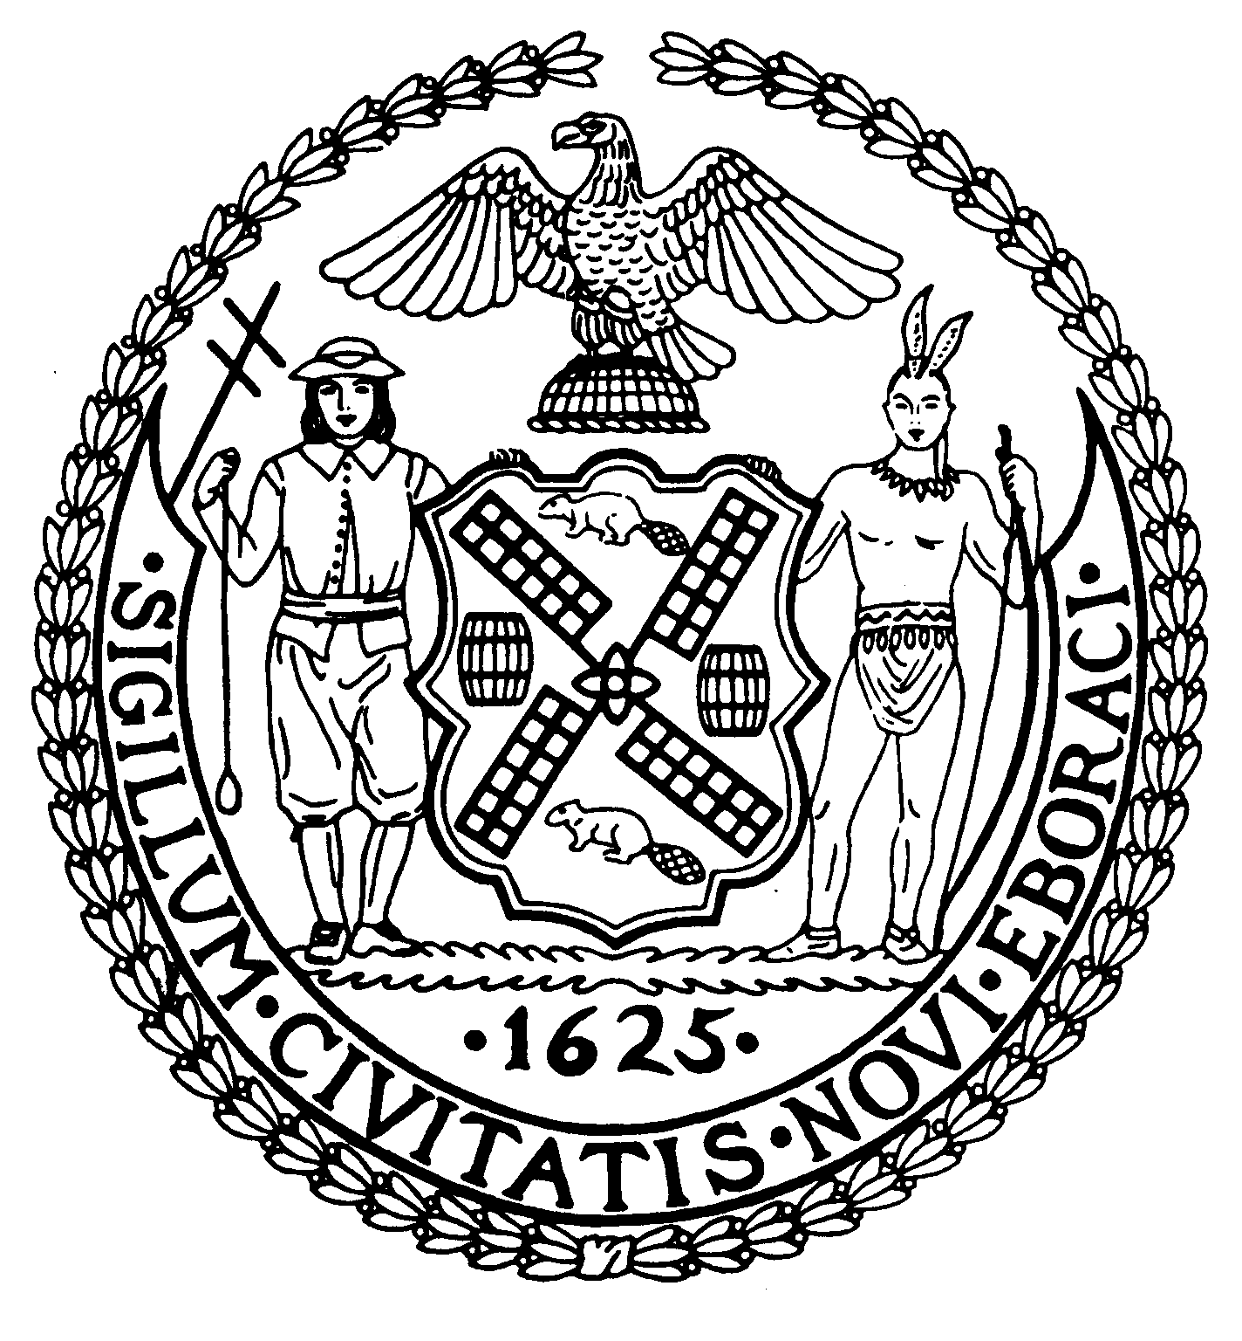
Chair New York, N.Y. 10022-1106

(212) 758-4340
Latha Thompson (212) 758-4616 (Fax)
District Manager www.cb8m.com - Website
info@cb8m.com E-Mail

The City of New York

Manhattan Community Board 8

Landmarks Committee, June 14, 2010 – 6:30PM
Hunter College School of Social Work, 129 East 79th Street, Room 1010

Agenda
PLEASE NOTE: When evaluating Applications for Certificates of Appropriateness, the Landmarks Committee of Community Board 8M ONLY considers the appropriateness of the proposal to the architecture of the building and, in the case of a building within an Historic District, the appropriateness of the proposal to the character of that Historic District. All testimony should be related to such appropriateness. The Committee recommends a Resolution to the full Community Board, which votes on a Resolution to be sent to the Landmarks Preservation Commission. These Resolutions are advisory; the decision of the Landmarks Preservation Commission is binding.

Applicants and members of the public who are interested in the issues addressed are invited, but not required, to attend the Full Board Meeting on June 16, 2010 at the New York Blood Center, 310 East 67th Street, Auditorium at 6:30PM. They may testify for up to three minutes in the Public Session, which takes place at 6:30PM. Members of the Board will discuss the items in executive session; if a member of the public wishes a comment made or a question asked at this time, he must ask a Board Member to do it for him.

- 211 East 61st Street (Second-Third)-Treadwell Farms Historic District- Mr. Todd Wilson, Architect -A three-story building built in 1875 by A & A Bussell. Application for exterior façade renovation.
- 66 East 93rd Street (Madison-Park)-Carnegie Hill Historic District-Mr. Oliver Cope, Architect-One of three flats buildings built in 1890-91 by A.B. Ogden & Son. Application for alterations to the front and rear facades.
- 1 East 70th Street (Fifth-Madison)-Individual Landmark-Upper East Side Historic District-Mr. Nat Hoyt, Architect-A French Louis XVI style mansion designed by Carrere & Hastings, built in 1913-14 and altered by John Russell Pope in 1931-35. Application is to enclose a loggia.
- In recognition of the special significance of Park Avenue, a proposal to extend the Carnegie Hill Historic District to include Park Avenue from 86th Street through 91st Street and from 94th Street (including 1192 Park Avenue south of 94th Street on the west side of Park Avenue) through 96th Street.
- Old Business
- New Business

Jane Parshall and David Liston – Co-Chairs, Landmarks Committee

