Jacqueline Ludorf 505 Park Avenue, Suite 620
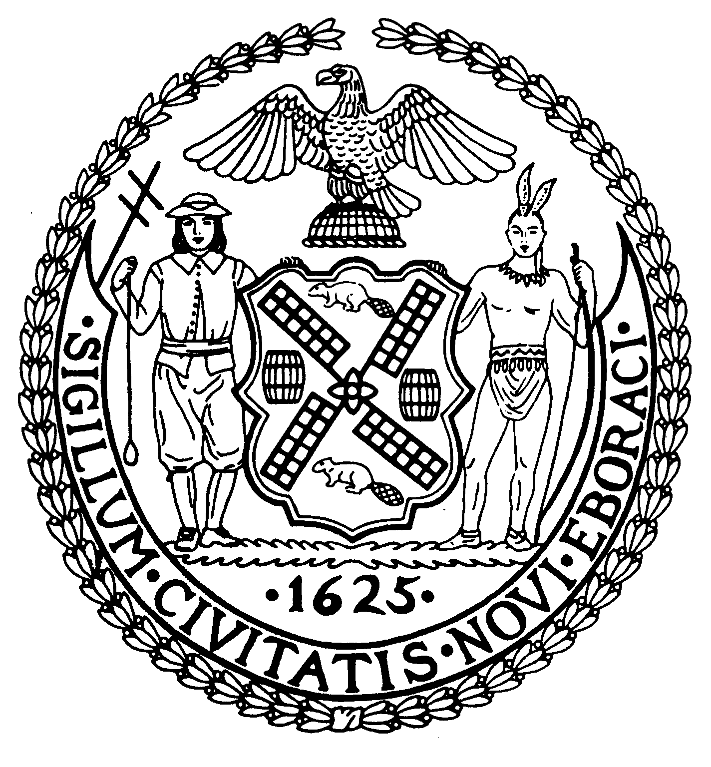
Chair New York, N.Y. 10022-1106

(212) 758-4340
Latha Thompson (212) 758-4616 (Fax)
District Manager www.cb8m.com - Website
info@cb8m.com E-Mail

The City of New York

Manhattan Community Board 8

Landmarks Committee, July 19, 2010 – 6:30PM
Hunter College School of Social Work, 129 East 79th Street, Room 1010

Agenda
PLEASE NOTE: When evaluating Applications for Certificates of Appropriateness, the Landmarks Committee of Community Board 8M ONLY considers the appropriateness of the proposal to the architecture of the building and, in the case of a building within an Historic District, the appropriateness of the proposal to the character of that Historic District. All testimony should be related to such appropriateness. The Committee recommends a Resolution to the full Community Board, which votes on a Resolution to be sent to the Landmarks Preservation Commission. These Resolutions are advisory; the decision of the Landmarks Preservation Commission is binding.

Applicants and members of the public who are interested in the issues addressed are invited, but not required, to attend the Land Use/Full Board Meeting on July 21, 2010 at Memorial Sloan Kettering, 430 East 67th Street, Auditorium at 6:30PM. They may testify for up to three minutes in the Public Session, which takes place at 6:30PM. Members of the Board will discuss the items in executive session; if a member of the public wishes a comment made or a question asked at this time, he must ask a Board Member to do it for him.

- 229 East 62nd Street (Second-Third)-Treadwell Farm Historic District-Mr. Donald Cantillo, Architect-A four story brownstone built in 1874-5 by Thomas and John D. Crimmins. Application for a proposed façade restoration and rooftop addition.
- 58 East 66th Street-(Park-Madison)-Upper East Side Historic District-Mr. Stephan Wang, Architect- A five-story Beaux-Arts building built in 1908-09 by Buchman & Fox. Application for a rear yard extension and window replacement.
- 1056 Fifth Avenue-(SE corner of 87th Street) Carnegie Hill Historic District-Mr. Carl Pucci, Architect-A modern apartment building designed by George F. Pelham, Jr., and built in 1948-49. Application to create a master plan for window replacement.
- Public Hearing: A request from the East 93rd Street Beautification Association to present its Request for Evaluation (RFE) to extend the Carnegie Hill Historic District one block east to include the collection of historic structures on East 93rd Street between Lexington and Third Avenues.
- Public Hearing: PROPOSED HELLGATE HISTORIC DISTRICT: The proposed area of designation includes the rowhouses on the north side of 94th Street and the south side of 95th Street between Lexington and Third Avenues and the rowhouses, synagogue and a seven-story apartment building (built in 1900) on Lexington Avenue. The rowhouses of these three contiguous blockfronts were built in the 1870s and designed in the neo-Grec style by Thom & Wilson, one of the most prolific architectural firms in rowhouse design in Manhattan. The Hellgate houses are among the earliest rowhouses constructed in Carnegie Hill and mirror in style and dates similar rowhouses built one block west on 94th Street, located within the Carnegie Hill Historic District. This application is being submitted by Carnegie Hill Neighbors.
- Old Business
- New Business

Jane Parshall and David Liston – Co-Chairs, Landmarks Committee

