Jacqueline Ludorf 505 Park Avenue, Suite 620
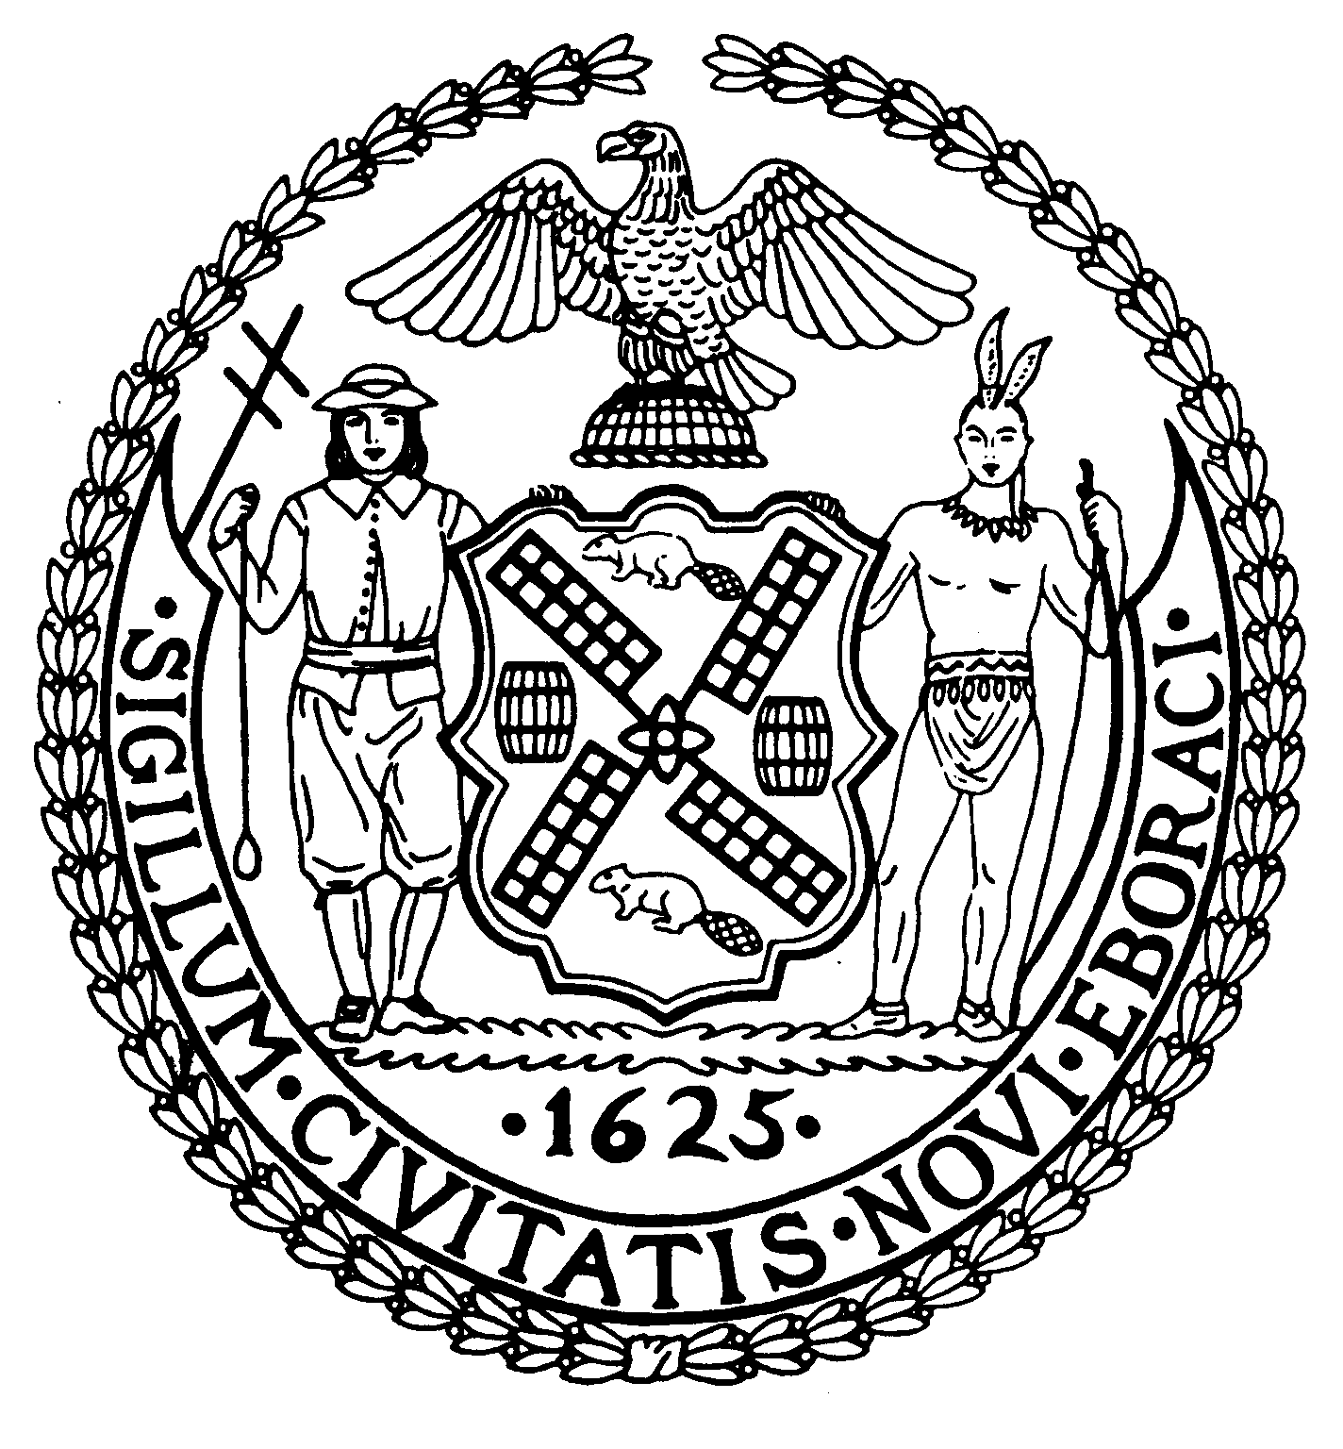
Chair New York, N.Y. 10022-1106

(212) 758-4340
Latha Thompson (212) 758-4616 (Fax)
District Manager www.cb8m.com - Website
info@cb8m.com E-Mail

The City of New York

Manhattan Community Board 8

Landmarks Committee, February 8, 2010 – 6:30PM
Hunter College School of Social Work, 129 East 79th Street, Room 1010

Agenda
PLEASE NOTE: When evaluating Applications for Certificates of Appropriateness, the Landmarks Committee of Community Board 8M ONLY considers the appropriateness of the proposal to the architecture of the building and, in the case of a building within an Historic District, the appropriateness of the proposal to the character of that Historic District. All testimony should be related to such appropriateness. The Committee recommends a Resolution to the full Community Board, which votes on a Resolution to be sent to the Landmarks Preservation Commission. These Resolutions are advisory; the decision of the Landmarks Preservation Commission is binding.

Applicants and members of the public who are interested in the issues addressed are invited, but not required, to attend the Land Use/Full Board Meeting on February 17, 2010 at the Memorial Sloan Kettering, 430 East 67th Street, Auditorium at 7:00PM. They may testify for up to three minutes in the Public Session, which takes place at 6:30PM. Members of the Board will discuss the items in executive session; if a member of the public wishes a comment made or a question asked at this time, he must ask a Board Member to do it for him.

- 8 East 75th Street (Fifth-Madison)-Upper East Side Historic District- Jennifer Gerakaris, Architect-A Beaux-Arts residence original designer unknown and built in 1872. Application to restore lower portion of building at street level to its historic state and add a layer of detail to better organize the original and non-historic elements.

- Discussion of Committee Procedures and Guidelines

- Old Business-Draft of Committee Guidelines to applicants to be circulated and discussed.

- New Business

Jane Parshall and David Liston – Co-Chairs, Landmarks Committee

