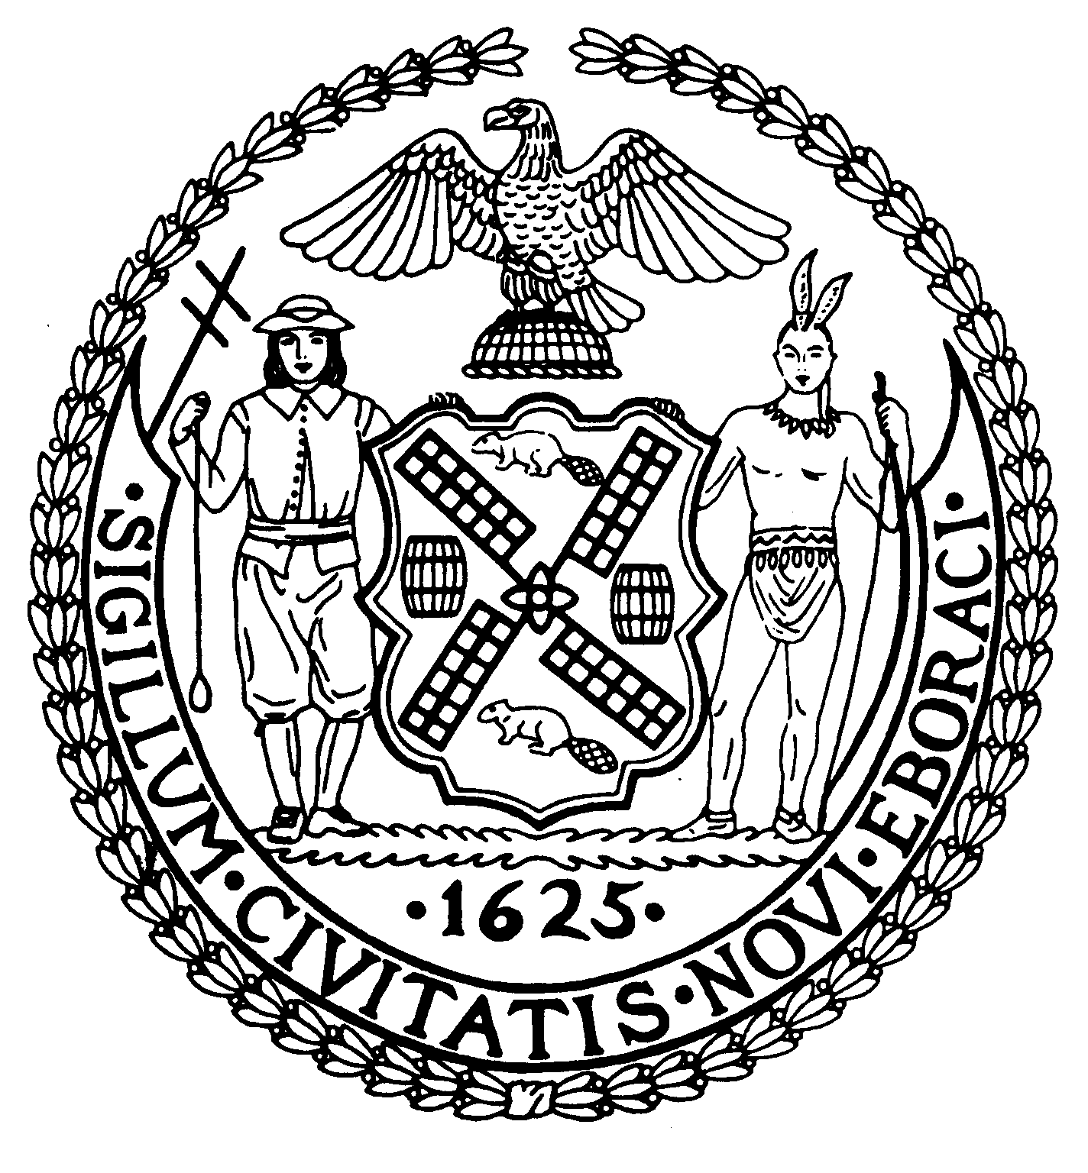

The City of New York Manhattan Community Board 8

505 Park Avenue, Suite 620 Phone: (212) 758-4340

New York, N.Y. 10022-1106 Fax: (212) 758-4616
www.cb8m.com info@cb8m.com - E-Mail
Jacqueline Ludorf, Chair Latha Thompson, District Manager
Community Bulletin Board –December 2010

PLEASE VISIT COMMUNITY BOARD 8’S WEBSITE AT www.cb8m.com

Street Activity Permit Office (SAPO) - You may now apply online for street fairs, block parties and festivals. Applicants can submit online applications at https://nyceventpermits.nyc.gov or www.nyc.gov/sapo. All applicants should be aware that the deadlines for applications submission remain unchanged as do the rules and regulations governing the SAPO permitting process. For more information, call 212-788-7567 or visit http://www.nyc.gov/html/cau/html/street_permitting/permit_and_events.shtml.

The NYC Department of Sanitation will require all City residents to fully encase within a sealed plastic bag all mattresses or box springs being discarded for DSNY collection beginning Friday, December 3, 2010. This new rule will help prevent an increase in bed bug activity, with bed bugs being found in homes and apartments. Bed bugs are generally nocturnal and tent to live in bedding, such as mattresses and box springs, hiding in their crevices until they feed. Under the new rule, failure to place a mattress or box spring out in a proper bag can result in a $100 fine. The Department will delay enforcing the new set-out rule for 30 days, followed by full enforcement beginning Monday, January 3, 2011. For more information, please call 311 or visit www.nyc.gov/sanitation.

The East 92nd Street Greenmarket at East 92nd Street between First and York Avenues will host Recycle-O-Rama on Sunday, December 5, 2010 from 10:00AM to 2:00PM. For more information, please contact the board office.

The 19th Precinct Community Council will hold their annual Holiday Party on Monday, December 6, 2010 at 7:00PM, Church of the Holy Trinity Auditorium, East 88th Street (between First and Second Avenues). For more information, contact the 19th Precinct Community Affairs at 212-452-0613 or via email The19pctcouncil@aol.com

The NYC Civilian Complaint Review Board (CCRB) invites you to their monthly meeting on Wednesday, December 8, 2010, 10:00-11:00AM, 40 Rector Street, 2nd Floor. The CCRB receives, mediates and investigates complaints against NYC police officers which allege the use of excessive or unnecessary force, abuse of authority, discourtesy or the use of offensive language. For more information visit www.nyc.gov/ccrb.

The East 79th Street Neighborhood Association will meet on Thursday, December 9, 2010 at 6:00PM, please note earlier start time, City University of New York (CUNY), 535 East 80th Street, (East End Avenue) First Floor Board Room. Agenda: Safety Measures and Crime Prevention Information presented by 19th Precinct Inspector Whelan, Police Officers and other officials. Q & A to follow; Announcements by Elected Officials Reps. All meetings are free and open to the public.

The East Sixties Neighborhood Association (ESNA) invites you to an evening of Old Fashion Holiday Caroling on Tuesday, December 14, 2010 at 6:00PM, TD Bank Rotunda, Northeast corner of Third Avenue and East 64th Street. Your generosity in bringing a gift of a toy, game or book for a needy youngster, newborn to 11 years of age, is greatly appreciated. Each gift should be unwrapped and in its original packaging. ESNA will deliver your gift to Ambulatory Pediatrics of NY-Presbyterian Hospital/Weill Cornell Medical Center on East 68th Street. For more information, please call (212) 713-5826 or via email info@esna-nyc.net.

Iris Cantor Women’s Heath Center at Weill Cornell Medical College will hold Health Education Seminars entitled Treat Me, Not My Age: Practical Advice for “Boomers and Beyond” on Navigating the Modern Healthcare System on Wednesday, December 8, 2010. The seminars will be held at the Weill Greenberg Center, 1305 York Avenue (East 70th Street), 2nd Flr. The lectures are free and open to the public, for more information or to RSVP, please call (212) 821-0971.

LaGuardia Community College offers free college classes and services for Veterans. For more information, please call (718) 482-5386 or 5231; or visit www.lagcc.cuny.edu/veterans

Fire Department of New York offers free bystander CPR training to all New York City residents. The program takes less than an hour and each participant is given a free CPR training kit to bring home to friends and family. For more information, call (718) 999-2413 or email Michael Eichler at eichlem@fdny.nyc.gov.

The US Department of Treasury and the Federal Reserve Bank Go Direct campaign encourages people who receive Social Security and other federal benefits to help protect themselves from financial crimes by switching from paper checks to direct deposit. For more information, please call Ashley Czernis at (312)-988-2419, or via email aczernis@webershandwick.com or visit www.GoDirect.org.

Legal Information for Families Today (LIFT) Family Legal Center offers free workshops, legal information and social work services to parents and grandparents involved in child support, custody, and visitation cases. All services are offered in English and Spanish at 350 Broadway, Room 400. For more information, please call (646) 613-9633 or visit www.LIFTonline.org.

Need a babysitter? A tutor for your child? Someone to walk your dog during the day? If so, consider hiring a Hunter student. Hunter Helpers is a service that matches up Hunter College students with residents in the neighborhood who need a helping hand. For more information, visit their website www.hunter.cuny.edu/babysitting

The Day Care Council of New York, Inc. is a not-for-profit organization that provides families with child care information in all five boroughs of New York City, particularly infant and young toddler care. They offer free information and guidance in choosing day care, family care, Head Start, after-school programs, nanny services, summer camps group family care and other child care concerns. For more information, please call Jon Pinkos at 212-206-7818 x114 or via email jpinkos@dccnyinc.org.

Crime Victim Services is a non-profit program, designed to aid and compensate innocent victims of crime who meet certain criteria. The program is free of charge. For more information, please call Teresa Navarro at 212-585-6142 or 6281.

Manhattan Community Board 8 strongly encourages you to contact us with your concerns or questions about issues affecting you and your neighbors. If you know of anyone who would like to receive our monthly mailing via standard mail or electronically, please encourage him or her to contact the board office at 212-758-4340 or info@cb8m.com.

