The City of New York Manhattan Community Board 8
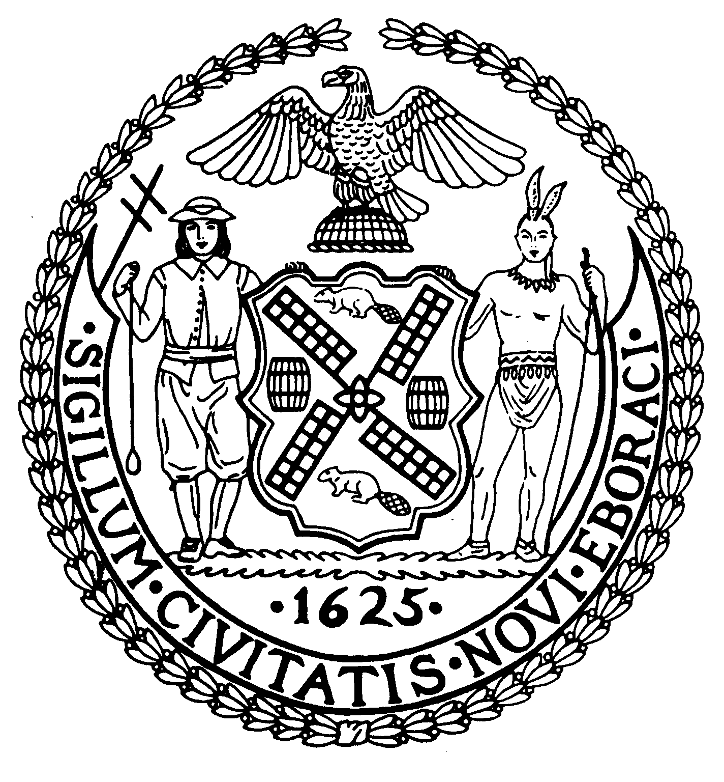

505 Park Avenue, Suite 620 Phone: (212) 758-4340

New York, N.Y. 10022-1106 Fax: (212) 758-4616
www.cb8m.com info@cb8m.com - E-Mail
Jacqueline Ludorf, Chair Latha Thompson, District Manager
December 2010 Agenda

Please Note: Meeting agendas are subject to change without notice. Call the Board office within 48 hours of the scheduled meeting for confirmation. All meeting rooms are accessible to the disabled. Please bring a photo ID to all meetings, as some locations require this to enter the building. Please call the Board office if you need assistance or further information. COMMUNITY BOARD 8 MEETINGS BEGIN AT 6:30PM UNLESS OTHERWISE NOTED.
Transportation Committee ♦ Wednesday, December 1st - 6:30PM
New York Blood Center 310 East 67th Street, Auditorium
- Discussion of MTA Service Issues including update on Select Bus Service
- Update from DDC on East 81st Street Pedestrian Bridge over FDR Drive (joint item with Parks Committee)
- A request for a Revocable Consent for steps and a fenced-in area at 522 East 87th Street. (Requested by DOT, Franchises, Concessions and Consents) (laid over from Oct & Nov meetings)
- A request for a “No Parking Anytime” sign in front of 124 East 73rd Street. (Requested by Ms. Borden, resident)
- Presentation by Hunter College on a Modular Newsrack Project
- Discussion of a transit rider bill of rights
- Old Business
- New Business
Jonathan Horn and Charles Warren, Co-Chairs
Street Life Committee ♦ Tuesday, December 7th – 7:00PM
Hunter College School of Social Work 129 East 79th Street, Hexter Lounge
1. Renewal Applications to the Department of Consumer Affairs for Sidewalk Cafes:
- 1465 3rd Ave. Rest. Corp. d/b/a Gael Pub, 1465 Third Avenue (83rd Street) – Renewal application for an unenclosed sidewalk café with 5 tables and 10 seats, DCA #1223078. Due date: 1/3/11
- Terminus Restaurant Associates, LLC d/b/a Orsay Restaurant, 1057 Lexington Avenue (75th Street)– Renewal application for an enclosed sidewalk café with 14 tables and 28 seats, DCA #1022739. Due date: 12/24/10
- 352 East 86th Street, Inc. d/b/a Gracie’s Corner, 352 East 86th Street (First/Second Avenues) – Renewal application for an enclosed sidewalk café with 8 tables and 20 seats, DCA #0737570. Due date: 1/6/111
- First Avenue Brother Jimmy’s, LLC d/b/a Brother Jimmy’s BBQ, 1485 Second Avenue (77th/78th Streets) – Renewal application for an enclosed sidewalk café with 9 tables and 30 seats, DCA #1067948. Due date: 12/21/10
- Viand Restaurant, Inc. d/b/a Viand Coffee Shop, 300 East 86th Street (First/Second Avenues) – Renewal application for an enclosed sidewalk café with 8 tables and 14 seats, DCA #0976475. Due date: 11/6/11
2. Transfer/Alterations Applications to the New York State Liquor Authority for Liquor Licenses:
- Edge Dream Lounge, LLC d/b/a Cascabel, 1542 Second Avenue (80th/81st Streets) – Application to alter an on-premises liquor license and add a sidewalk cafe
3. New Applications to the New York State Liquor Authority for Liquor Licenses:
- Richard Klein or Corp. to be formed, 1372 Madison Avenue (@ 96th Street) – New application for a wine and beer license
- The Best Chocolate Cake in UES, LLC d/b/a the Best Chocolate Cake in the World, 1046 Madison Avenue (79th/80th Streets) – New application for a wine and beer license
- Pull Cart d/b/a Arcade at Bethesda Terrace, Central Park – New application for a wine and beer license
- MJCL, Inc. d/b/a China Spice NYC, 1588 York Avenue (83rd/84th Streets) – New application for a wine and beer license
- The Explorers Club d/b/a The Explorers Club, 46 East 70th Street (Park/Madison Avenues) – New application for an on-premises liquor license (Laid over from the November meeting, at applicants request)
- SATO, Inc. d/b/a Mole by Taco Taco, 1735 Second Avenue (89th/90th Streets) – New application for an on-premises liquor license
- Emanuel S. or Corp to be formed, 1599 York Avenue (84th/85th Streets) – New application for an on-premises liquor license
- Midnight Blue, LLC d/b/a Midnight Blue Restaurant & Lounge, 1640 Second Avenue (85th/86th Streets) – New application for an on-premises liquor license
- ISI Café, Inc. d/b/ Joanna, 435 East 86th Street (First/York Avenues) – New application for an on-premises liquor license
Cos Spagnoletti and Nicholas Viest, Co-Chairs
Parks Committee ♦ Thursday, December 9th - 6:30PM
New York Blood Center 310 East 67th Street, Auditorium
- Further review of the Parks Dept.'s proposed design of 2 signs at the Central Park Reservoir describing the history of the Old Croton Aqueduct system, which had included the reservoir--joint issue with the Landmarks Committee.
- Discussion of the City's request for public input on sites for food vendors/trucks in NYC parks
- Old business
- New Business
Margaret Price and Barbara Rudder, Co-Chairs
Landmarks Committee ♦ Monday, December 13th - 6:30PM
Hunter College School of Social Work 129 East 79th Street, Room 1010
Please Note: The Landmarks Committee agenda is subject to frequent change, call the board office for the most current agenda.
- 124 East 62nd Street (Park and Lexington Avenues) - Upper East Side Historic District – Mr. Mark Gerstle, expeditor and Judy Licht-Della Femina, co-owner – A three story Italianate style brownstone building designed by Robert Mook, and built in 1869-70. Application to legalize a fence.
- 110 East 70th Street (Park and Lexington Avenues) - Upper East Side Historic District - A residence originally built in 1869 and altered by Robertson & Potter in 1905 in the simplified Beaux-Arts style. Application is to create an areaway.
- 215 East 61st Street (Third and Second Avenues) – Treadwell Farm Historic District – Ms. Sarah Drake, architect. A rowhouse building designed by A. & S. Bussell and built in 1875. Application is to replace windows, add a two-story extension, add a roof bulk head to the stairs, and change the stucco.
- 20 East 67th Street (Fifth and Madison Avenues) - Upper East Side Historic District – Forrest Sign Company, architect/engineer. A neo-Georgian style apartment building designed by Mott B. Schmidt and built in 1925. Application is to install a blade sign.
- 1012 Lexington Avenue (72nd and 73rd Streets) – Upper East Side Historic District Extension – Mr. Kang Chan, architect – A neo-Grec style rowhouse designed by Thom and Wilson and built in 1880-81. Application is to install storefront infill and signage.
- Old Business
- New Business
David Liston and Jane Parshall, Co-Chairs
Youth and Education Committee ♦ Monday, December 13th - 6:30PM
New York Blood Center 310 East 67th Street, Auditorium
- Re-zoning for Community District 8
Report on CECD2 Hearing on November 30, 2010
Additional comments by the Public
- Update on PS 151 and the EIS for moving to Richard R. Green School at 421 East 88 Street
- Capital Plan and need for additional school in Community District 8
- Update on 2nd Teacher/Aid in the classroom.
5. Future Meetings
January:
February:
6. Old/New Business
Jim Clynes and Judith Schneider, Co-Chairs
Land Use-Full Board Meeting ♦ Wednesday, December 15th -7:00PM
New York Blood Center 310 East 67th Street, Auditorium
1. Public Session – Those who wish to speak during the Public Session must register to do so by 6:45 pm
  - Public Hearing-BSA Cal #1095-64 BZ, 605 Park Avenue, Block 1399, Lot 74-Extension of Term of Variance-An application for the Extension of Term of Variance in accordance with Board of Standards and Appeals calendar #1095-64 BZ, adopted by the BS&A March 9, 1965, to permit the addition of transient parking for the unused and surplus space in the existing garage, not to exceed twenty (20) in number. Extension of the BS&A granted Variance expired on February 6, 2002 (Certificate of Occupancy #114280)
- Adoption of the Agenda
- Adoption of the Minutes
- Manhattan Borough President’s Report
- Elected Official’s Reports
- Chair’s Report – Jackie Ludorf
- District Manager’s Report-Latha Thompson
- Committee Reports and Action Items:
  - Transportation Committee-Jonathan Horn and Charles Warren
  - Street Life Committee-Cos Spagnoletti and Nicholas Viest, Co-Chairs
  - Parks Committee-Margaret Price and Barbara Rudder, Co-Chairs
  - Landmarks Committee-David Liston and Jane Parshall, Co-Chairs
  - Youth and Education Committee-Jim Clynes and Judith Schneider, Co-Chairs
- Old Business
- New Business
Jacqueline Ludorf, Chair

