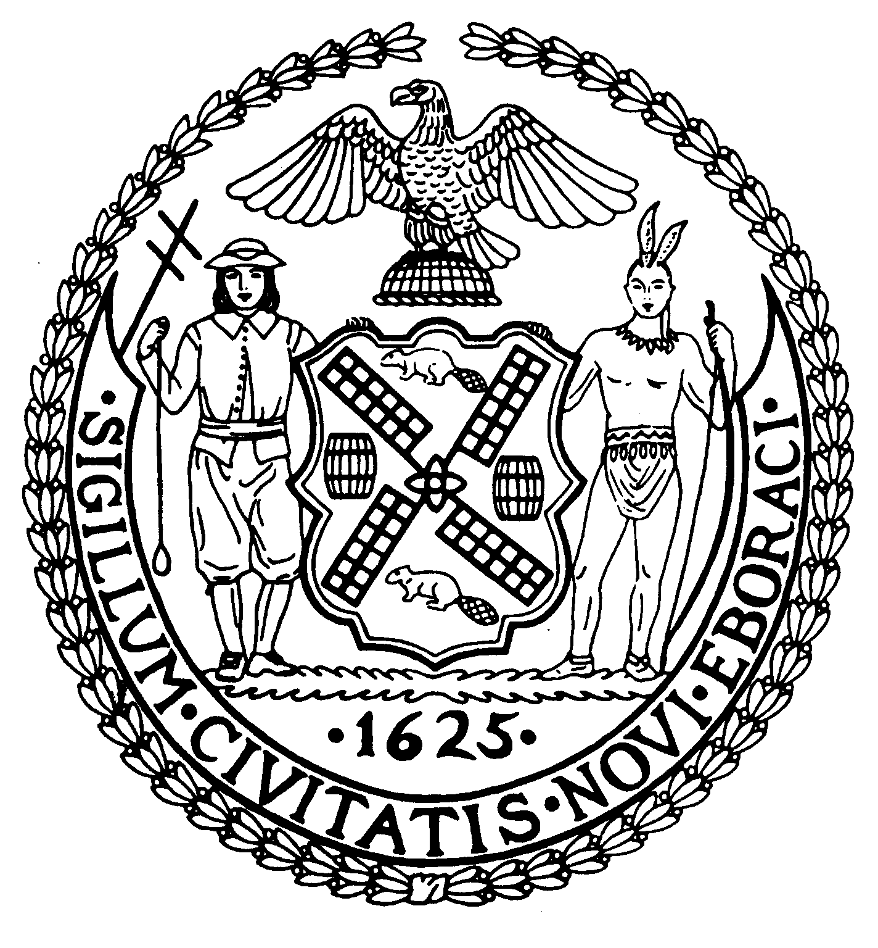

The City of New York Manhattan Community Board 8

505 Park Avenue, Suite 620 Phone: (212) 758-4340

New York, N.Y. 10022-1106 Fax: (212) 758-4616
www.cb8m.com info@cb8m.com - E-Mail
Jacqueline Ludorf, Chair Latha Thompson, District Manager
Community Bulletin Board –June 2011

PLEASE VISIT COMMUNITY BOARD 8’S WEBSITE AT www.cb8m.com

Street Activity Permit Office (SAPO) – You may now apply online for street fairs, block parties and festivals. Applicants can submit online applications at https://nyceventpermits.nyc.gov. SAPO will no longer accept paper application. All applicants should be aware that the deadlines for applications submission remain unchanged as do the rules and regulations governing the SAPO permitting process. For more information, call 212-788-2403 or visit http://www.nyc.gov/html/cau/html/street_permitting/permit_and_events.shtml.

New York-Presbyterian Hospital/Weill Cornell Medical Center will hold health and wellness seminars entitled Contemporary Treatment of Endometrial Cancer, presented by Divya Gupta, MD, on Thursday, June 2, 2011, 6:15pm-7:15pm, Women and Heart Disease, presented by Joy Gelbman, MD, on Thursday, June 9, 2011, 6:15pm-7:15pm, Prevention and Early Detection of Skin Cancer, presented by Hilary Johnson, MD, PhD, on Thursday, June 16, 2011, 6:15pm-7:15pm. The seminars will be held at the Weill Greenberg Center, 1305 York Avenue (at East 70th Street), 2nd Floor. The lectures are free and open to the public, for more information or to RSVP, please call 646-962-5721 or E-mail: mmprc@med.cornell.edu

Street Fairs/Parades Second Avenue Fair, Saturday, June 4, 2011, Third Avenue, 66th St-86th St, 11AM-5PM; Salute to Israel Parade, Sunday, June 5, 2011, Fifth Avenue, 44th St-79th St, 12PM-5PM; First Avenue Street Fair, Saturday, June 11, 2011, 68th St-79th St, 12PM-5PM; Puerto Rican Day Parade, Sunday, June 12, 2011, Fifth Avenue, 44th St- 79th St, 11AM-4PM.

Immanuel Lutheran Church will be holding their fundraiser Spring Bazaar on Saturday, June 4, 2011, from 11 AM to 5 PM. There you will find trash to treasures, and good food at the Immanuel Café. 1296 LEX. AVENUE 87/88 St. Enter through Red Door Next to CVS. The church was founded during the Civil War by natives of Yorkville, and was a respite for the Civil War Soldiers. Now the roof and steeple are in danger. The steeple is leaning and the roof needs to be replaced at a cost of a million plus dollars. So far about half that goal has been reached but more is needed. For further information call 212/289-8128.
The 19th Precinct Community Council will hold its Community Council Meeting on Monday, June 6, 2011 at 7:00PM at the 19th Precinct, 153 East 67th Street (between Lexington and Third Avenues). For more information, contact the 19th Precinct Community Affairs at 212-452-0613 or lynch19ca@aol.com.

Lenox Hill Hospital invites adult caregivers to come and learn about the many programs, services and resources available to help care for your loved ones. Free Caregivers Resource Guides available and light refreshments will be served. Tuesday, June 7, 2011, 6:00pm-8:00pm, Lenox Hill Hospital, Einhorn Auditorium, 131 East 76th Street, New York, NY 10075 (between Lexington and Park Avenues).

Manhattan Task Force on Housing Court will have a discussion on Domestic Violence and Housing Court with Judge Douglas Hoffman. Topics include: How does an order of protection affect tenancy rights?; Which court decides who gets the apartment?; Do survivors of domestic violence have special rights or concerns in eviction cases? Or when applying for new apartments?; And more…Wednesday, June 8, 2011, at 1:00pm-2:00pm, Manhattan Civil Court, 8th Floor Conference Room, 111 Centre Street (enter on White Street).

East 79th Street Neighborhood Association will meet on Thursday, June 9, 2011 at 6:00PM, City University of New York (CUNY), 535 East 80th Street, (East End Avenue) First Floor Board Room. Agenda: 19th Precinct Report On Neighborhood Safety; Elected Officials/Reps reports; Updates on community quality-of-life concerns. All meetings are free and open to the public.

City & Suburban Homes York Avenue Estate Historic District Walking Tour includes City & Suburban homes landmark, Shively Sanitary Tenements; PS 158, Webster Library, John Jay Park, former East Side House Settlement, Sunday, June 12, 2011, Tour: 1:00pm, meet at the City & Suburban Homes Archive Room, 515 East 78th Street. For more information, contact Marie Beirne @ 212-388-0883.

NYC Department of Parks and Recreation offers Senior Aerobics in John Jay Park, East 77th Street and Cherokee Place from Monday, April 25, 2011 to Friday, June 17, 2011, Body Fitness on Monday & Wednesday from 10:00AM to 11:00AM; Yoga on Tuesday & Friday from 10:00AM to 11:00AM. For more information, call 212-408-0275 or visit www.nyc.gov/parks.

Sunday, June 19th: The 92nd GREENMARKET RETURNS!! 92nd Street and First Avenue, 9am – 5pm. American Seafood,

Stannard Farms, Meredith’s Bakery, Norwich Meadows, the Gonzales and Phillips Farms will all be with us this season.

Sunday, June 26th: Recycle-O-Rama – Summer Edition First Avenue between 92nd & 93rd Streets (west side of First)
Electronics… Paper shredding… Clothes collection... Plus the #5 plastic, corks, Britta filters, CD/DVDs, ink cartridges and batteries we collect at both the 82nd and 92nd Greenmarkets every week. Will 92nd Street surpass 82nd’s recent recycling record? (Nothing like a good green rivalry!)

Legal Information for Families Today (LIFT) Family Legal Center offers free workshops, legal information and social work services to parents and grandparents involved in child support, custody, and visitation cases. All services are offered in English and Spanish at 350 Broadway, Room 400. For more information, please call (646) 613-9633 or visit www.LIFTonline.org.

Need a babysitter? A tutor for your child? Someone to walk your dog during the day? If so, consider hiring a Hunter student. Hunter Helpers is a service that matches up Hunter College students with residents in the neighborhood who need a helping hand. For more information, visit their website www.hunter.cuny.edu/babysitting

The Day Care Council of New York, Inc. is a not-for-profit organization that provides families with child care information in all five boroughs of New York City, particularly infant and young toddler care. They offer free information and guidance in choosing day care, family care, Head Start, after-school programs, nanny services, summer camps group family care and other child care concerns. For more information, please call Jon Pinkos at 212-206-7818 x114 or via email jpinkos@dccnyinc.org.

Crime Victim Services is a non-profit program, designed to aid and compensate innocent victims of crime who meet certain criteria. The program is free of charge. For more information, please call Teresa Navarro at 212-585-6142 or 6281.

Manhattan Community Board 8 strongly encourages you to contact us with your concerns or questions about issues affecting you and your neighbors. If you know of anyone who would like to receive our monthly mailing via standard mail or electronically, please encourage him or her to contact the board office at 212-758-4340 or info@cb8m.com.

