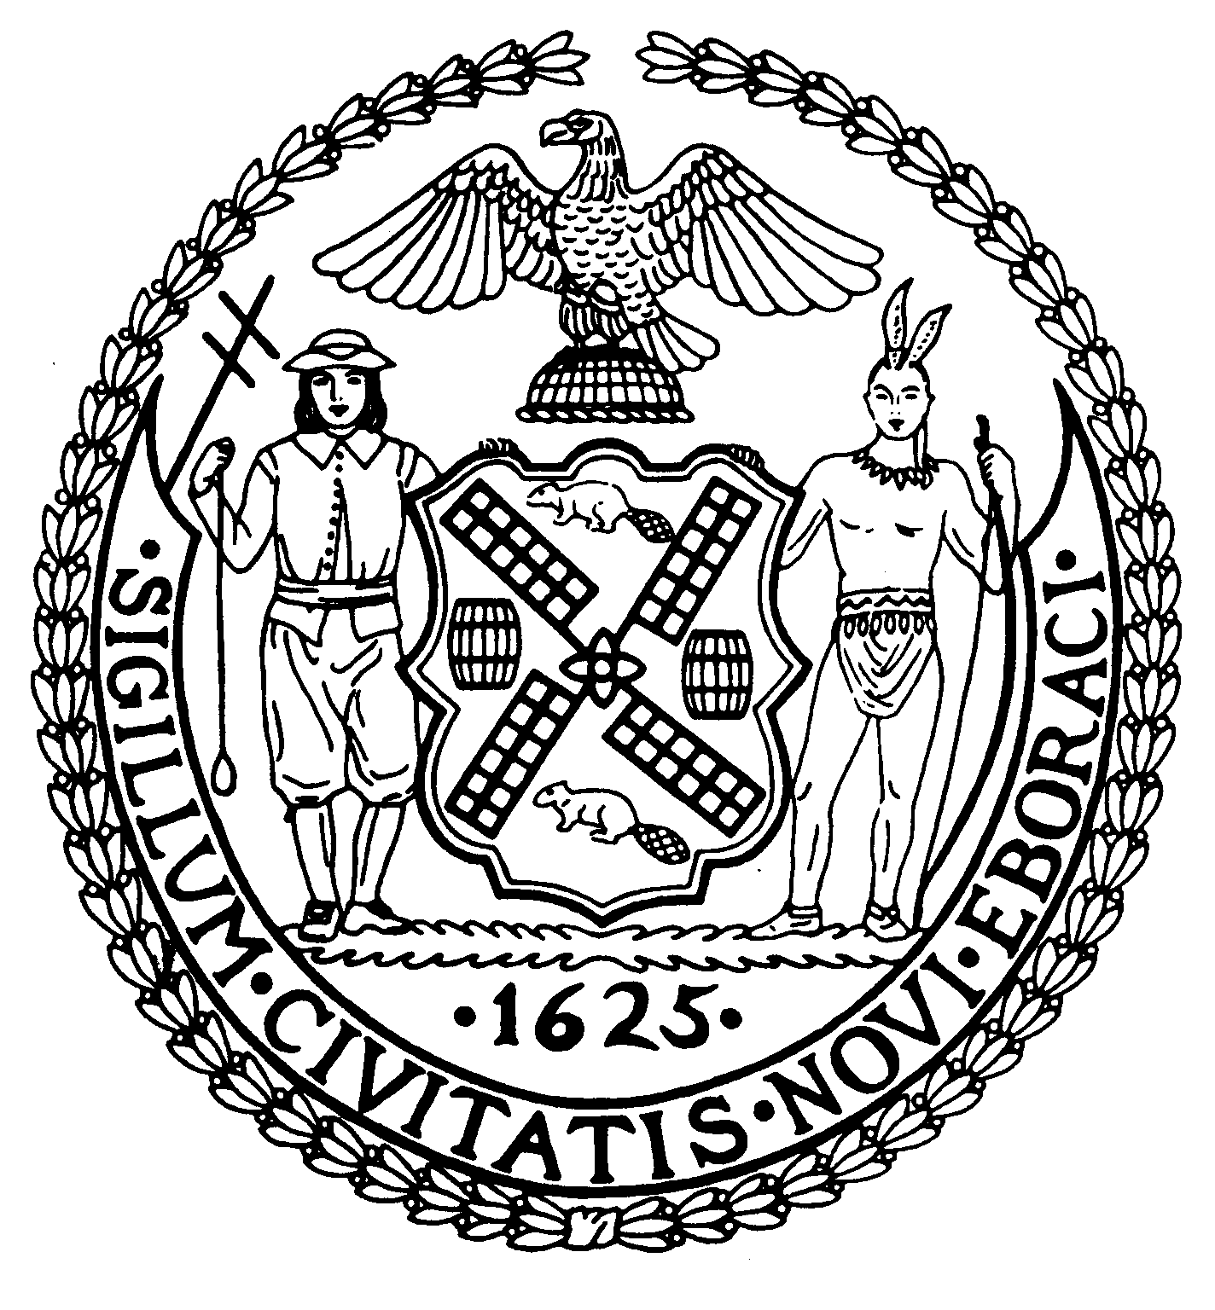

The City of New York Manhattan Community Board 8

505 Park Avenue, Suite 620 Phone: (212) 758-4340

New York, N.Y. 10022-1106 Fax: (212) 758-4616
www.cb8m.com info@cb8m.com - E-Mail
Jacqueline Ludorf, Chair Latha Thompson, District Manager
Community Bulletin Board –February 2011

PLEASE VISIT COMMUNITY BOARD 8’S WEBSITE AT www.cb8m.com

Street Activity Permit Office (SAPO) – You may now apply online for street fairs, block parties and festivals. Applicants can submit online applications at https://nyceventpermits.nyc.gov. SAPO will no longer accept paper application. All applicants should be aware that the deadlines for applications submission remain unchanged as do the rules and regulations governing the SAPO permitting process. For more information, call 212-788-7567 or visit http://www.nyc.gov/html/cau/html/street_permitting/permit_and_events.shtml.

The 19th Precinct Community Council will meet on Monday, February 7, 2011 at 7:00PM, 19th Precinct, 153 East 67th Street (between Lexington and Third Avenues). Speaker: Manhattan District Attorney Cyrus Vance, Jr. For more information, contact the 19th Precinct Community Affairs at 212-452-0613 or via email The19pctcouncil@aol.com

The East 79th Street Neighborhood Association will meet on Thursday, February 10, 2011 at 6:00PM, City University of New York (CUNY), 535 East 80th Street, (East End Avenue) First Floor Board Room. All meetings are free and open to the public.

Legal Information for Families Today (LIFT) Family Legal Center offers free workshops, legal information and social work services to parents and grandparents involved in child support, custody, and visitation cases. All services are offered in English and Spanish at 350 Broadway, Room 400. For more information, please call (646) 613-9633 or visit www.LIFTonline.org.

Need a babysitter? A tutor for your child? Someone to walk your dog during the day? If so, consider hiring a Hunter student. Hunter Helpers is a service that matches up Hunter College students with residents in the neighborhood who need a helping hand. For more information, visit their website www.hunter.cuny.edu/babysitting

The Day Care Council of New York, Inc. is a not-for-profit organization that provides families with child care information in all five boroughs of New York City, particularly infant and young toddler care. They offer free information and guidance in choosing day care, family care, Head Start, after-school programs, nanny services, summer camps group family care and other child care concerns. For more information, please call Jon Pinkos at 212-206-7818 x114 or via email jpinkos@dccnyinc.org.

Crime Victim Services is a non-profit program, designed to aid and compensate innocent victims of crime who meet certain criteria. The program is free of charge. For more information, please call Teresa Navarro at 212-585-6142 or 6281.

Manhattan Community Board 8 strongly encourages you to contact us with your concerns or questions about issues affecting you and your neighbors. If you know of anyone who would like to receive our monthly mailing via standard mail or electronically, please encourage him or her to contact the board office at 212-758-4340 or info@cb8m.com.

