Jacqueline Ludorf 505 Park Avenue, Suite 620
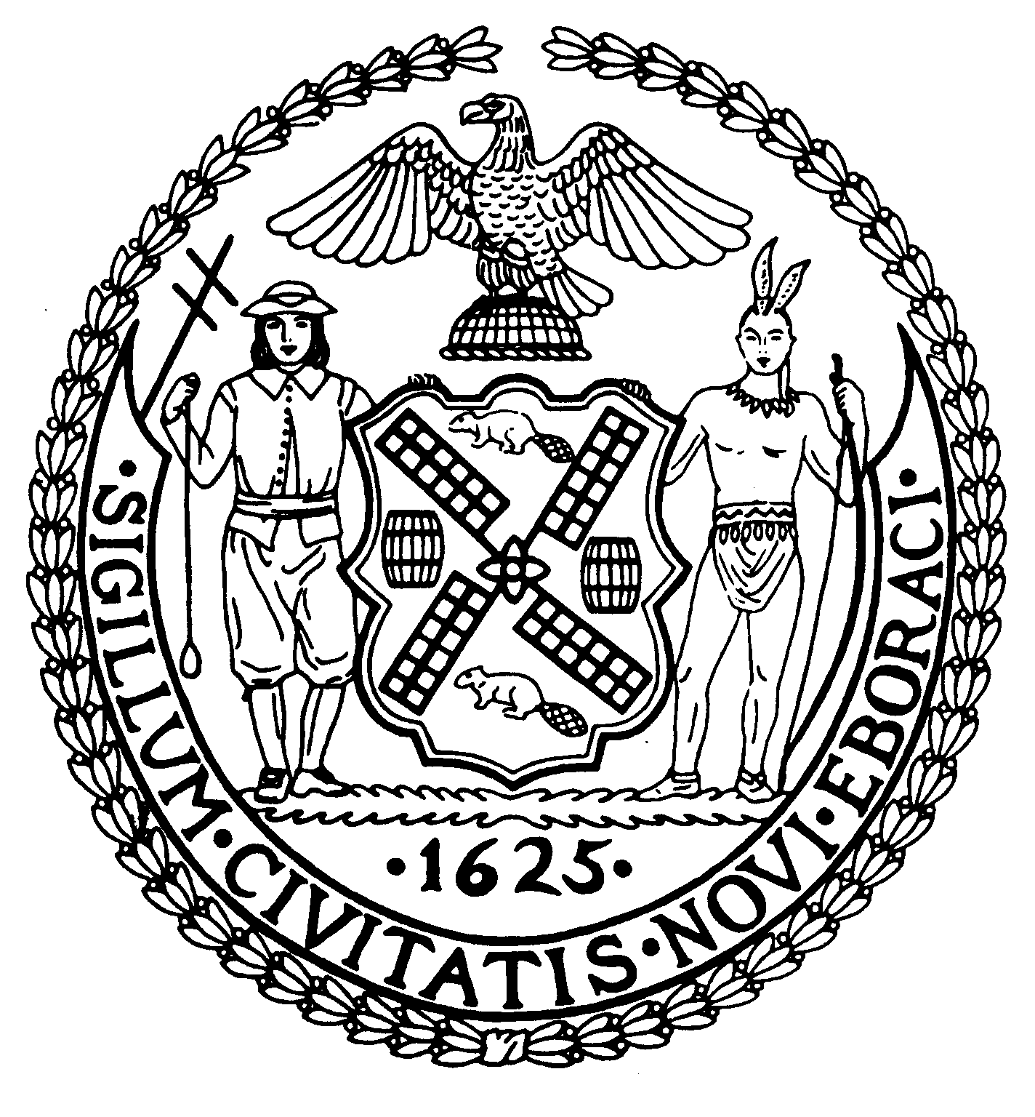
Chair New York, N.Y. 10022-1106

(212) 758-4340
Latha Thompson (212) 758-4616 (Fax)
District Manager www.cb8m.com - Website
info@cb8m.com E-Mail

The City of New York

Manhattan Community Board 8

Landmarks Committee, April 19, 2010 – 6:30PM
Hunter College School of Social Work, 129 East 79th Street, Room 1010

Agenda
PLEASE NOTE: When evaluating Applications for Certificates of Appropriateness, the Landmarks Committee of Community Board 8M ONLY considers the appropriateness of the proposal to the architecture of the building and, in the case of a building within an Historic District, the appropriateness of the proposal to the character of that Historic District. All testimony should be related to such appropriateness. The Committee recommends a Resolution to the full Community Board, which votes on a Resolution to be sent to the Landmarks Preservation Commission. These Resolutions are advisory; the decision of the Landmarks Preservation Commission is binding.

Applicants and members of the public who are interested in the issues addressed are invited, but not required, to attend the Land Use/Full Board Meeting on April 21, 2010 at the Hunter College School of Social Work, 129 East 79th Street, Auditorium at 6:30PM. They may testify for up to three minutes in the Public Session, which takes place at 6:30PM. Members of the Board will discuss the items in executive session; if a member of the public wishes a comment made or a question asked at this time, he must ask a Board Member to do it for him.

- 923 Fifth Avenue (East 73rd-74th Streets)-Upper East Side Historic District-Steven Kratchman, Architect-An apartment building designed by Sylvan Bien and built in 1949-51. Application to install a pergola on the 12th floor terrace.
- 730 Park Avenue (East 70th -71st Streets) Upper East Side Historic District-Murielle C. Trenard-Bejin, Architect-A neo-Renaissance/neo-Jacobean building designed by Lafayette A. Goldstone in 1928-29. Application to replace existing window and install two new fiberglass casement windows.
- 1048 Fifth Avenue (SE corner of East 86th Street) Metropolitan Museum Historic District-Annabelle Selldorf, Architect-A French Classic style mansion designed by Carrere & Hastings and built in 1912-14. Application to install a flagpole and banner.
- 790 Madison Avenue (SW corner of East 67th Street) Upper East Side Historic District-Kenneth Park, Architect-A brick apartment building constructed in 1960. Application to reclad the base and second floor and establish a master plan for storefront infill and signage.
- Old Business
- New Business

Jane Parshall and David Liston – Co-Chairs, Landmarks Committee

