Jacqueline Ludorf 505 Park Avenue
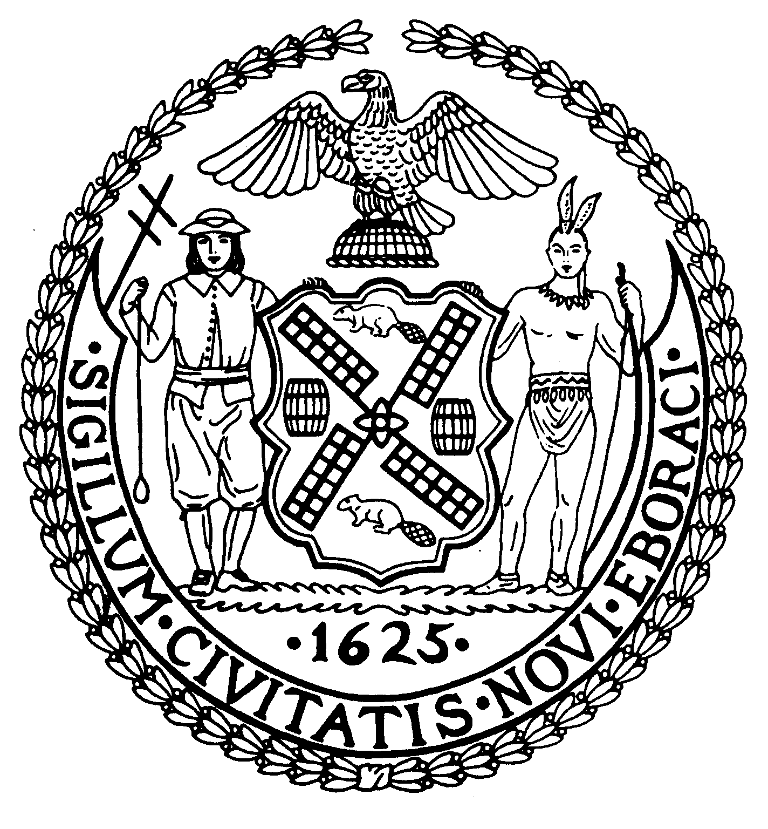
Chairman Suite 620
New York, N.Y. 10022

Latha Thompson (212) 758-4340
District Manager (212) 758-4616 (Fax)

W ww.cb8m.com Website
info@cb8m.com - E-Mail

Public Safety Committee
Community Board 8
December 5, 2011
New York Blood Center
310 E. 67th Street, Conference Room 1,
6:30PM

Present: Matthew Bondy, Jackie Ludorf, Ellen Polivy, and Sharon Pope (Public Member)

Absent (Excused): James Clynes

The meeting was called to order at 6:45p

1. A discussion of flash mobs, and the potential thereof, in CB8M including, motorcycle and off road vehicle flash mobs, and the NYPD’s preparedness and ability to respond thereto

By email to the board office, a resident expressed concern over roving bands of motorcycles and four wheeled off road vehicles that are recklessly driven up and down the avenues in our neighborhood without regard for traffic safety by young people, many of whom do not wear helmets, and who often travel in groups of twenty or more. This phenomenon has been witnessed personally by the chair of the Public Safety Committee and at least one other member of the committee. The 19th precinct community affairs officers were invited to speak about whether they were aware of the issue and what, if any, steps, have already or can been taken with respect thereto. No one from the 19th precinct was available to attend because of other commitments on the meeting date. Accordingly, the matter was tabled and will be re-scheduled.

- A request to oppose congressional bill H.R. 822 which would expand national concealed carry reciprocity, forcing all states to recognize any state license to carry concealed weapons

We were asked to opine on a proposed resolution for discussion at the Borough Board in connection with H.R. 822 (the “Proposed Bill”), the purpose of which, as stated in the Proposed Bill, would be to “amend title 18, United States Code, to provide a national standard in accordance with which nonresidents of a State may carry concealed firearms in the State.”

The Bill would have Congress declare that “. . . preventing the lawful carrying of firearms by individuals who are traveling outside their home State interferes with the constitutional right of interstate travel, and harms interstate commerce” and therefore, Congress should “. . . provide for national recognition, in States that issue to their own citizens licenses or permits to carry concealed handguns, of other State permits or licenses to carry concealed handguns.” A copy of the Proposed Bill is attached hereto.

To aid in the discussion, Colin Weaver, of New Yorkers Against Gun Violence (NYAGV.org) provided the committee with a fact sheet prepared by Mayor’s Against Illegal Guns, of which Mayor Bloomberg is a member. A copy of the fact sheet is attached hereto.

According to the fact sheet, the proposed Bill would “override the laws of almost every state by obliging each to accept concealed handgun carry permits from every other state, even if the permit holder would not be allowed to carry or even possess a handgun in the state where he or she is traveling. That policy would undercut states’ rights and create serious problems for law enforcement. For those reasons, Congress rejected similar legislation in 2009.”

The fact sheet goes on to state that the Bill would “effectively overturn New York’s concealed carry laws by allowing concealed carrying by people who cannot meet New York’s standards” and “would create serious and potentially life threatening situations for law enforcement officers” including, during traffic stops, and in their ability to detect criminals, prevent gun trafficking, and determine if individuals are in compliance with the laws of other states.

A discussion of the proposed resolution ensued after which it was determined that since a quorum of committee members was not present, the proposed resolution would be put to the full board for a vote. A copy of the proposed resolution is attached.

There being no other business, the meeting was adjourned at 7:15p

Respectfully submitted, Matthew Bondy, Housing and Public Safety Committee Chair.

Matthew Bondy, Chair

