Jacqueline Ludorf 505 Park Avenue
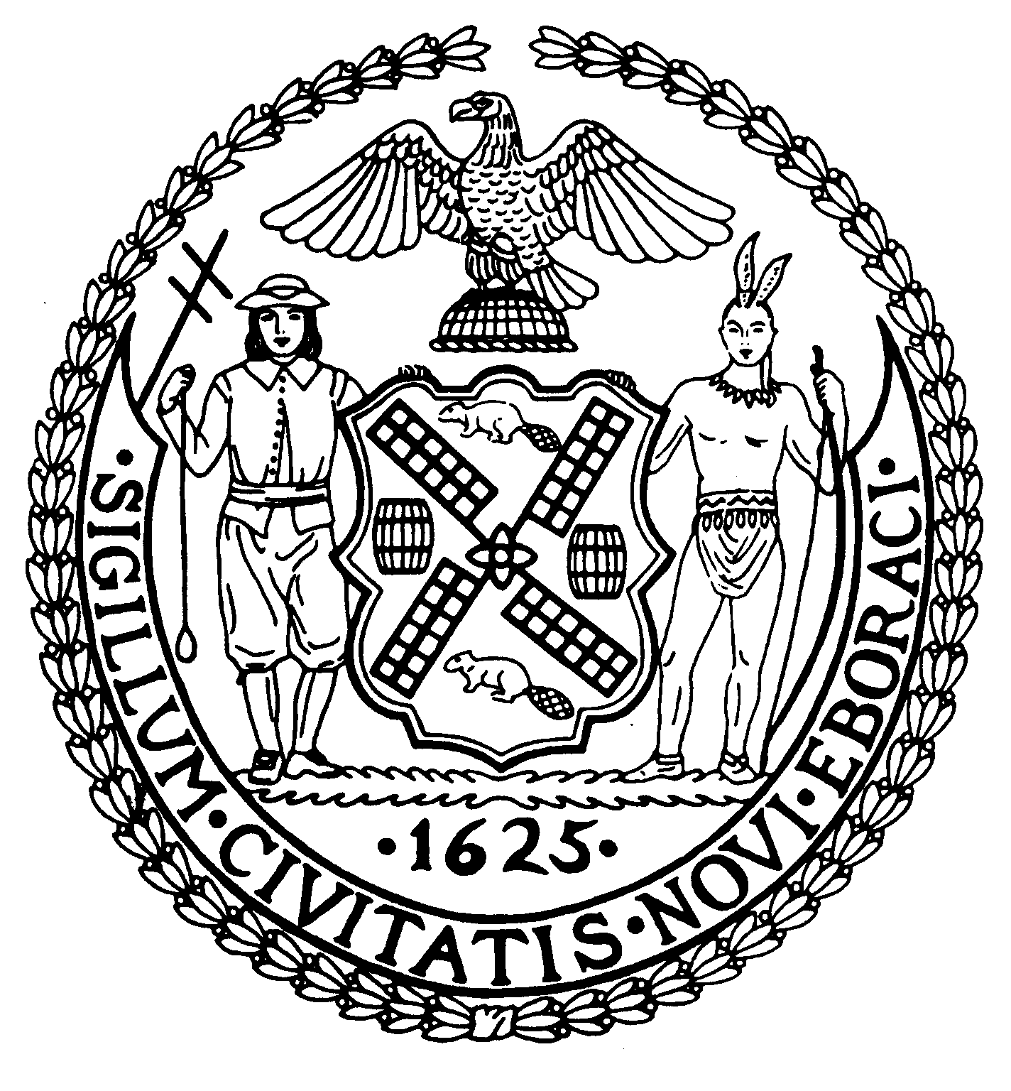
Chairman Suite 620
New York, N.Y. 10022

Latha Thompson (212) 758-4340
District Manager (212) 758-4616 (Fax)
www.cb8m.com Website
info@cb8m.com - E-Mail

The City of New York
Manhattan Community Board 8

Parks Committee Meeting
Thursday, December 9, 2010, 6:30 pm
New York Blood Center, 310 East 67th St., Auditorium

CB8M members in attendance: Susan Evans, Scott Falk, Rita Popper, Peggy Price, Barbara Rudder, Barry Schneider, Judy Schneider, Helene Simon, Teri Slater, Marco Tamayo

1. Proposal for Signs in Central Park Describing the Old Croton Aqueduct System, a joint issue with the Parks and Landmarks committees.
The CB8M Parks and Landmarks committees jointly revisited an issue first presented to the committees in November: a plan for signs in Central Park describing the Old Croton Aqueduct System, which had included the Central Park reservoir. This issue had been held over from the November joint meeting of the Parks and Landmarks committees due to insufficient information about the project at that time.
At the December meeting, Nancy Owens of Nancy Owens Studio LLC, a landscape architecture firm, presented plans for the proposed signs in Central Park. The presentation included a slide show and a full-sized replica of the signs under consideration.
As proposed, the Parks Dept.-sponsored plan calls for the placement of two signs, each 7.5 feet tall, with three panels, each 18 inches wide, to be placed in two Central Park locations: one near the Delacorte Theater and a second one on a pathway just in from West 85th St. and Central Park West. Each panel would present information about the Old Croton Aqueduct system, including a history of the system, a map of it and site-specific information.
Panels would be made of phenolic materials with steel plates. Lettering on the signs would be in Franklin Gothic type face. The two Central Park signs would be part of a project that would include a total of 13 signs. It was reported that Manhattan Community Boards 5 and 7 have approved the signage plan.
CB8M members expressed divergent views on the proposed project. Opinions favoring the idea included: the educational value of the signs, which would convey historical information on the aqueduct system, and which could prompt even greater tourism to Central Park. In addition, proponents cited the attractive and natural-looking design of the signs, including their vertical shape, which, they held, would consume less park space than horizontally shaped signs and which would blend with the trees and other elements in Central Park. One CB8M member also maintained that our board hasn’t had a request for additional signage in Central Park in nearly a decade.

Those opposing the signs cited the intrusion on the landmarked park of these tall signs with their modern design, which conflicts with the scenic and natural landscape of Central Park. Several members aired concerns about allowing, especially unnecessary, signs in Central Park—and the potential difficulty of disapproving other requests for park signs if we agreed to the Croton Aqueduct signage. In addition, a member cited concerns about the materials being used on the proposed signs, which are said to be less durable than the metal signs created by the Central Park Conservancy. Furthermore, according to another CB8M member, the extensive information provided on the proposed signs would make the information on them difficult to read. Moreover, she said that the large size of the proposed signs could overplay the local importance of the system, since the Old Croton Aqueduct “is only a tiny part of what Central Park has represented.”
The vote on a motion to approve the proposal was divided 5 in favor, 5 opposed. Thus, the committees had no recommendation for the full board.
VOTE: 5-5-0
In favor: Scott Falk, Rita Popper, Barry Schneider, Judy Schneider, Helene Simon.
Opposed: Susan Evans, Peggy Price, Barbara Rudder, Teri Slater, Marco Tamayo.

2. Discussion of the City’s request for public input on sites for food vendors/truck in NYC parks.
CB8M members discussed how to respond to the Parks Dept.’s move to seek public suggestions of sites for park concessions. Concerns centered on trying to avoid the kinds of unwelcome surprises that occurred with the redesign and use of the Tavern on the Green site in Central Park.
Prior to the meeting, Charles Kloth of the Parks Department told the committee’s co-chairs in writing that the Department hasn’t yet received any concession requests involving the CB8 district. Should such requests materialize, he said he will meet with the CB8M Parks Committee. To be proactive, the committee decided to write a letter to Parks Commissioner Benepe, complimenting the department for seeking public input, but also providing guidelines for appropriate concessions in the CB8M area. Guidelines would cite CB8M’s preference for vending via carts, instead of trucks, to blend with the bucolic setting of a park, and would emphasize the need for vendors to avoid noise, pollution and odors.

3. Old Business.
Jennifer Ratner, who recently created an East River Conservancy, briefly aired her plans for the organization. That group aims to be a community advocacy group, providing a grass roots voice on how to rehabilitate and possibly redesign the East River Esplanade. CB8M’s Parks Committee expects to work closely with Ms. Ratner to help expedite the much-needed improvements to the Esplanade.

