Jacqueline Ludorf 505 Park Avenue
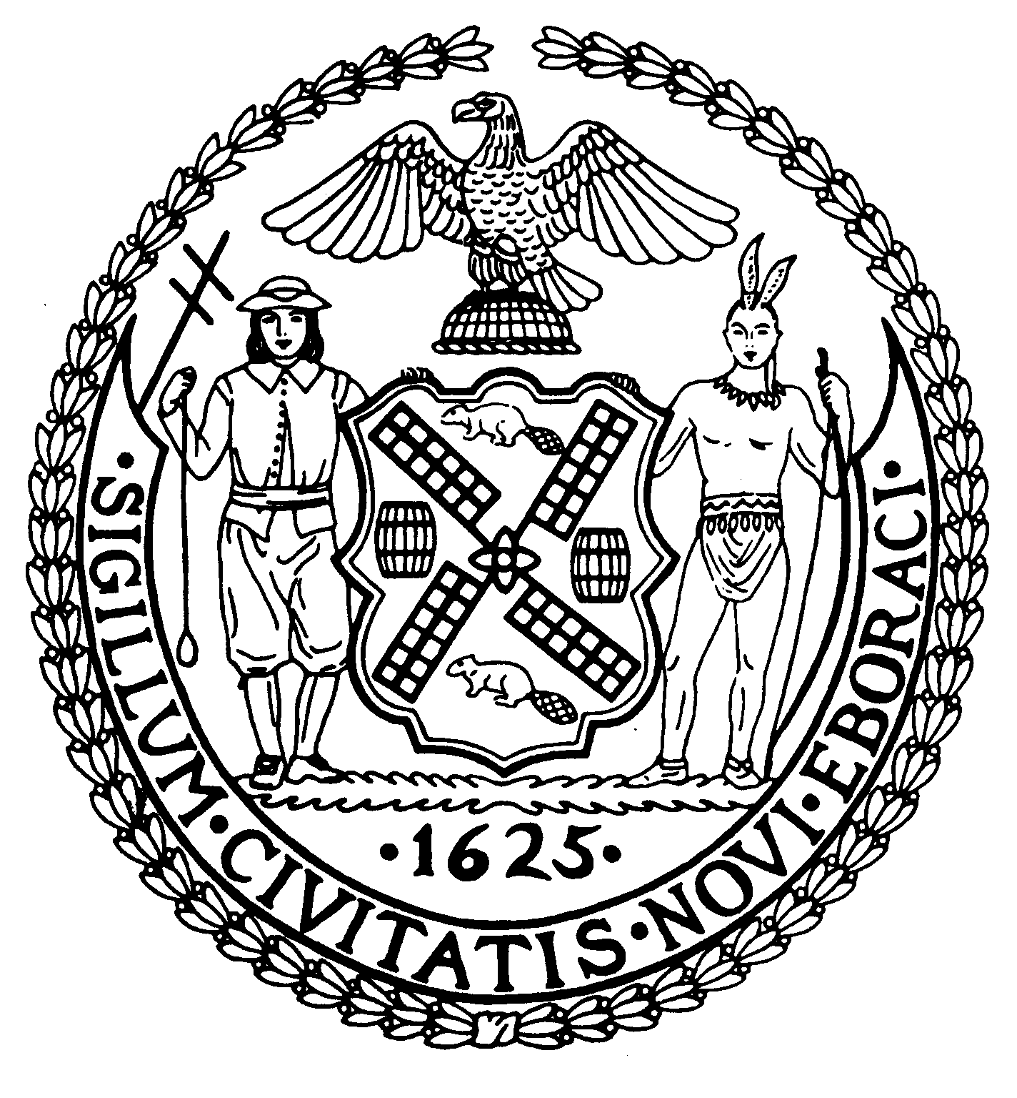
Chairman Suite 620
New York, N.Y. 10022

Latha Thompson (212) 758-4340
District Manager (212) 758-4616 (Fax)
www.cb8m.com Website
info@cb8m.com - E-Mail

The City of New York
Manhattan Community Board 8

Parks Committee
Thursday, December 9, 2010 @ 6:30 PM

New York Blood Center, 310 East 67th Street
Auditorium

Agenda

- Further review of the Parks Dept.'s proposed design of 2 signs at the Central Park Reservoir describing the history of the Old Croton Aqueduct system, which had included the reservoir--joint issue with the Landmarks Committee.
- Discussion of the City's request for public input on sites for food vendors/trucks in NYC parks
- Old business.
- New Business

Margaret Price and Barbara Rudder, Co-Chairs

