Jacqueline Ludorf 505 Park Avenue
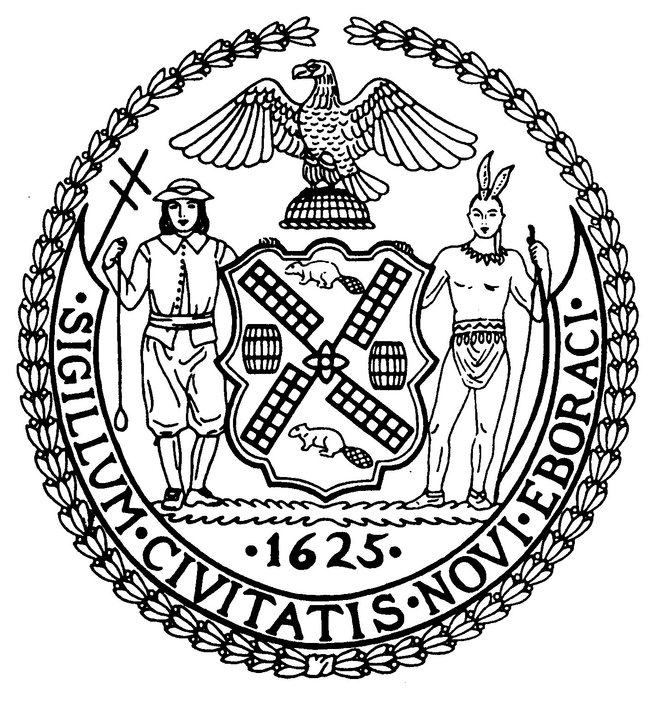
Chairman Suite 620
New York, N.Y. 10022

Latha Thompson (212) 758-4340
District Manager (212) 758-4616 (Fax)
www.cb8m.com Website
info@cb8m.com - E-Mail

The City of New York
Manhattan Community Board 8
Transportation Committee
Wednesday, November 2, 2011
New York Blood Center, 310 East 67th Street, Auditorium

Present: Michele Birnbaum, Roy Carlin, Scott Falk, Lorance Hockert, Jonathan Horn, Rita Popper, David Rosenstein, Helene Simon, Cos Spagnoletti, Charles Warren, Hedi White

The meeting was called to order by co-chair Jonathan Horn at 6:35 pm.

- Informational Presentation on NYC Bike Share by DOT

Representatives from DOT and Alta Bicycle Share updated the committee on the status of NYC Bike Share. The program will begin to roll out next Spring with the full launch of 10,000 bicycles and 600 stations taking place in Summer 2012. There will be approximately 25 to 30 stations located in CB8 between 59th Street and 79th Street. Sometime this winter, DOT and Alta will hold community forums to get input on possible sites. They will be presenting the CB with a choice of 3 or 4 options for each location needed by the program. There will be bicycle safety training classes available as a part of the program. A copy of the presentation and the station siting guidelines will be posted on the CB8 website.

- Informational Presentation on the “5 to Ride” campaign and it’s “Pedal Pledge” for delivery bicyclists (joint item with Street Life Committee)

George Mathews, Vice-President of the Stuart C. Gruskin Family Foundation described the foundations “5 To Ride Pedal Pledge” campaign. This is a program under which restaurants and other bike delivery businesses agree to keep the streets safe for pedestrians and other cyclists by following the rules of the road. They have signed up a number of restaurants in the Tribeca area, as well as a number of chains including Lenny’s and Hale & Hearty. Recently, they have started working with Seamless Web, an online delivery order service to expand the program’s reach. The Committee welcomed their efforts and suggested working with our Street Life Committee to reach restaurants when they appear to renew their sidewalk café and liquor licenses, as well as reaching out to the 19th Precinct’s Community Affairs officers for help in contacting establishments in our area. Information on the program can be found at www.5toride.org.

- Update and Discussion on the legal status of Electric-Assisted Bicycles and proposed legislation affecting that status (joint item with Street Life and Public Safety Committees)

The committee was provided with materials issued by the NYPD and the NYS DMV which stated that motor-assisted bicycles may not be operated on NYC streets. An extensive discussion followed on whether this was clear enough proof of the illegality of
their use for restaurant deliveries, as well as whether or not we wanted to establish an absolute policy of denying any applicant from establishments which are using them for delivery. It was pointed out that our Street Life Committee already imposes a number of required stipulations on all applicants and that the use of motor-assisted bicycles has become a significant safety issue for the community. The following resolution was made and approved.

WHEREAS Community Board 8M currently requires all applicants for Department of Consumer Affairs Sidewalk Cafe permits and State Liquor Authority licenses to agree to certain stipulations, and
WHEREAS, among these stipulations is an agreement to abide by New York City’s delivery bicycle regulations, and
WHEREAS, many establishments have recently begun using motor-assisted bicycles for delivery, and
WHEREAS, both the NYPD and the NYS Department of Motor Vehicles have issued public documents or statements that use of such vehicles on any streets, highways or sidewalk located in NY State is illegal,
THEREFORE BE IT RESOLVED, that Community Board 8M will add to its list of stipulations for all DCA and SLA applications a requirement that the applicant agrees not to use motor-assisted bicycles for deliveries, and
BE IT FURTHER RESOLVED, that this policy will be reviewed if the legal status of motor-assisted bicycles is changed by legislation or court decision.

Approved 9-0-2
Yes: Birnbaum, Carlin, Falk, Hockert, Horn, Popper, Rosenstein, Spagnoletti, Warren
Abstain: Simon, White

- Continued discussion of bicycle licensing and registration requirements for commercial bicycles.(Joint item with Street Life Committee)

The discussion focused on the fact that commercial delivery bicycles are already subject to a set of regulations that are rarely being enforced. One key reason for this lax enforcement is that only the NYPD is allowed to issue violations. It was pointed out that the full Board has already passed a resolution urging the City to allow other agencies to enforce these rules. Various suggestions on other ways of beefing up enforcement of and adherence to the law were discussed, including making a violation of the bicycle delivery law a health code violation that would impact a restaurant’s letter grade. Following a spirited debate, the decision was made to have the Chairs work with our City Council members to determine what other enforcement options were possible and might be able to pass muster in the Council. Following this, the issue will be brought back to the committee in January or February.

- Discussion of proposed ban on tourist helicopter flights over Manhattan and both the East and Hudson Rivers

Patrick Madigan from State Senator Liz Krueger’s office updated the Committee on her letter to the FAA requesting that non-essential helicopters, including sightseeing flights should be banned over Manhattan. The recent crash of a private recreational flight near the 34th Street Heliport has reignited the debate over these flights. Our Congresswoman, Carolyn Maloney, has also gone on record supporting such a ban and Councilmember Gail Brewer has introduced legislation in the City Council on the issue. A discussion ensued on the history of this issue, the economic value of these flights to New York City and other related issues. A member of the public reminded the committee that our board had passed a resolution in 1997, along with several other community boards, supporting the elimination of these flights and that Mayor Giuliani had begun the process of phasing them out in 2000. The committee decided to have the Chairs track down a copy of our 1997 resolution, get more information on Councilmember Brewer’s proposal and work with Senator Krueger’s office to obtain accurate data on what the economic impact of banning these types of flights would be. Further committee discussion will take place in a few months.

- Old Business

There was no old business.

- New Business

There was no new business.

The meeting was adjourned at 8:40 pm

Respectfully submitted,
Jonathan Horn and Charles Warren, Co-chairs

