Jacqueline Ludorf 505 Park Avenue
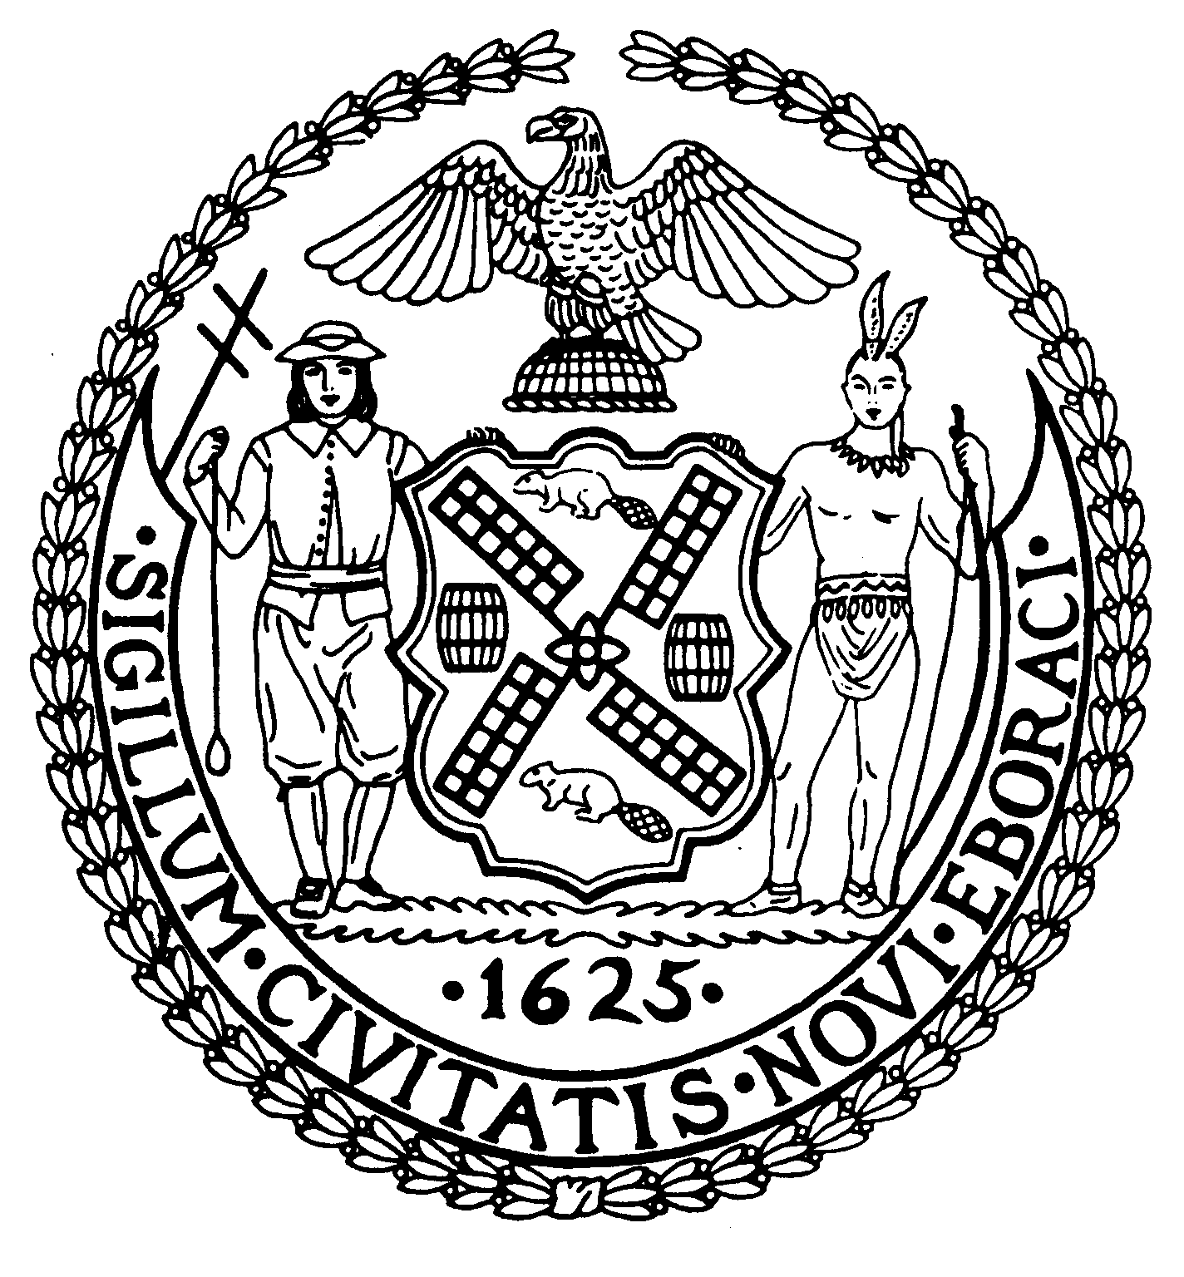
Chairman Suite 620
New York, N.Y. 10022

Latha Thompson (212) 758-4340
District Manager (212) 758-4616 (Fax)
www.cb8m.com Website
info@cb8m.com - E-Mail

The City of New York
Manhattan Community Board 8

SECOND AVENUE SUBWAY TASK FORCE
Manhattan Community Board 8
Tuesday, November 22, 2011
NY Blood Center, 310 East 67th Street, New York, NY Auditorium
6:30 PM
Present: Rita Popper, Barry Schneider, Judith Schneider, H. Patrick Stewart, Marco Tamayo
Excused: Barbara Chocky, Margaret Price, David Rosenstein, Helene Simon, Cos Spagnoletti
The meeting was called to order at 6:35 PM
- A presentation by the Manhattan Chamber of Commerce: Shop 2nd Avenue, It's Worth It.

Nancy Ploeger, President, Manhattan Chamber of Commerce, and Bob Schwartz, MCC Board Member, introduced the program, "Shop 2nd Avenue, It's Worth It" – the Chamber's program, in partnership with the MTA, to promote the businesses along the construction alignment. The link to the website is http://www.manhattancc2ndave.org/common/11089/default.cfm?clientID=11089.

- 86th Street Station: Muck Handling Systems

Phil Rice, MTA Capital Construction Manager, presented the newly designed muck removal system for the E. 86 – E. 87 Street. The PowerPoint presentation is available at pages 1 - 24
http://www.mta.info/capconstr/sas/pdf/111122%20CB8%20presentation.pdf

- Construction Update
Construction work zone progress – 96th Street Station, 86th Street Station, 72nd Street Station and Lexington/63rd Street Stations - presented Tom Peyton. construction program director. The PowerPoint presentation is available at pages 25 – 50 http://www.mta.info/capconstr/sas/pdf/111122%20CB8%20presentation.pdf.
Following the question and answer period, the meeting was adjourned.

Respectfully submitted, M. Barry Schneider and Patrick Stewart, SAS TF Co-Chairs

