Jacqueline Ludorf 505 Park Avenue
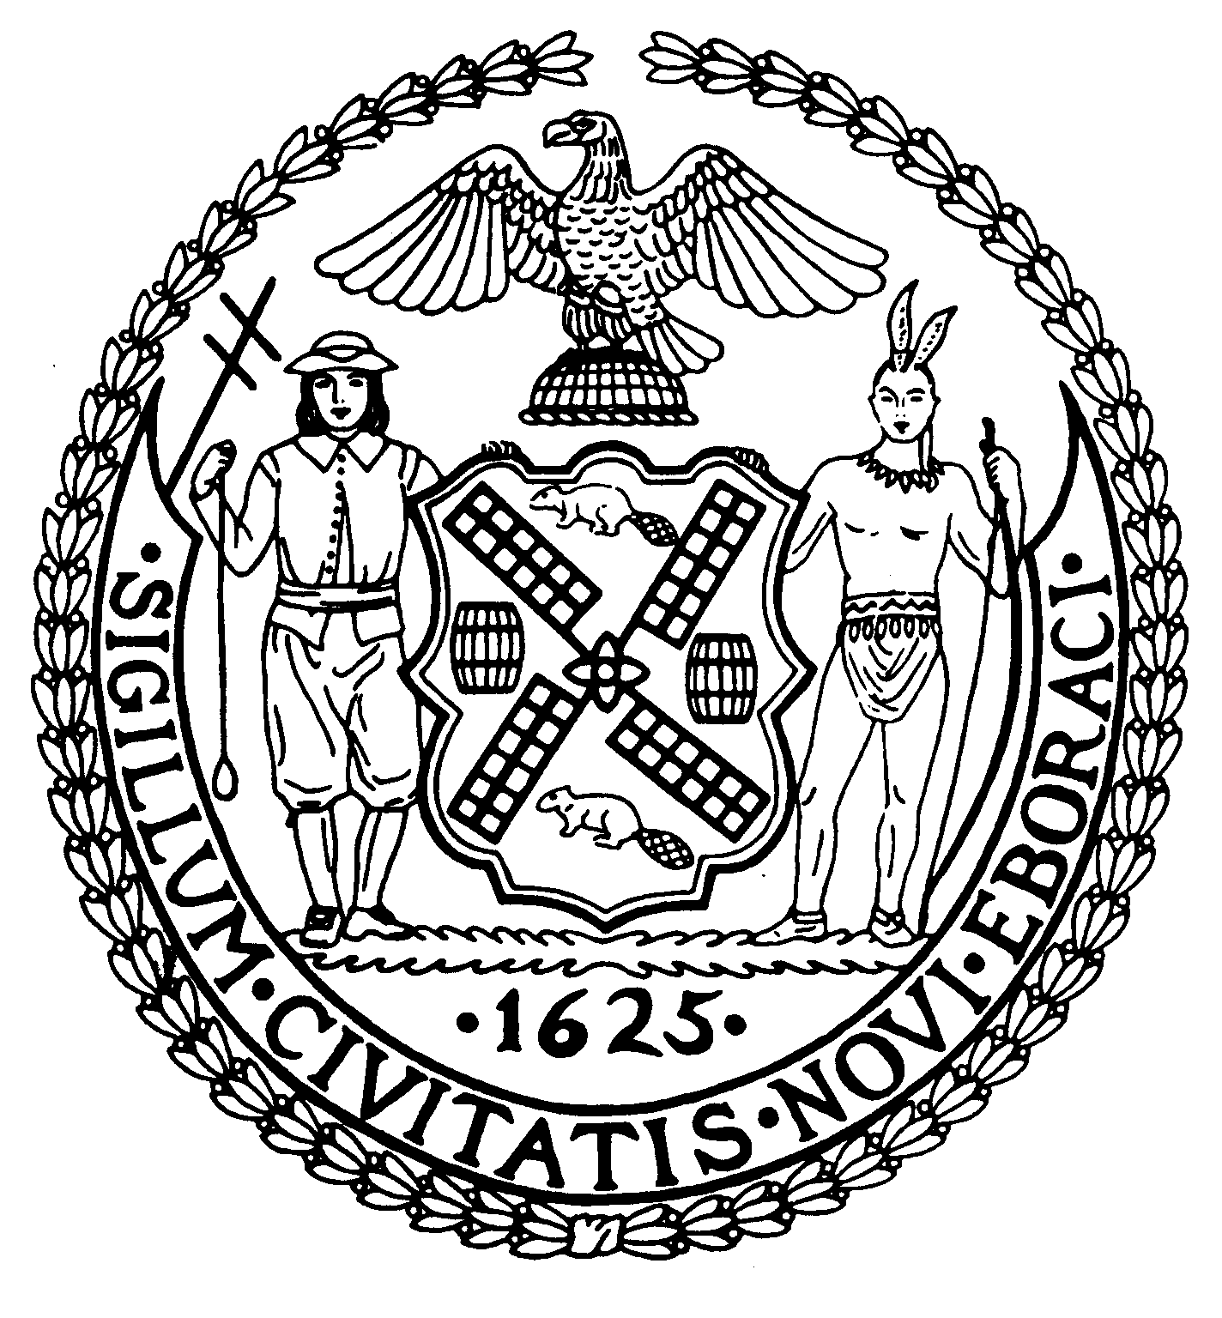
Chairman Suite 620
New York, N.Y. 10022

Latha Thompson (212) 758-4340
District Manager (212) 758-4616 (Fax)
www.cb8m.com Website
info@cb8m.com - E-Mail

The City of New York
Manhattan Community Board 8

Parks Committee Meeting
Thursday, November 3, 2011
New York Blood Center, 310 East 67th St.
Auditorium

CB8M members present: Elizabeth Ashby, Michele Birnbaum, Molly Blayney, Sarah Chu, Jim Clynes, Susan Evans, Scott Falk, Lorraine Johnson, Jackie Ludorf, Mary Pike, Ellen Polivy, Rita Popper, Peggy Price, David Rosenstein, Barbara Rudder, Barry Schneider, Judy Schneider, Helene Simon, Teri Slater, Cos Spagnoletti, Marco Tamayo, Elaine Walsh.

1. CIVITAS-sponsored Competition for Ideas to Redesign the East River Esplanade

Citing high public interest in upgrading the East River Esplanade, Hunter Armstrong, executive director of CIVITAS, detailed his organization’s contest for ideas to redesign that area of the waterfront from E. 60th St. to E. 125th St.
According to Mr. Armstrong, 60% of respondents to an NYU Capstone survey want improvements in the East River Esplanade. To further that effort, CIVITAS has launched a competition to elicit “dramatic and original ideas” for redesigning the decaying area.
Entitled Reimagining the Waterfront, the contest began in September and will be open to submissions through January 15. In February, an 8-person jury will select the winners, who will receive a monetary award as well as publicity. The public will be able to view these entries on the competition website, http://reimaginethewaterfront-civitas.com.
According to Mr. Armstrong, contestants will include architects, landscape architects, urban planners, students and artists. Along with bold landscape designs, submissions could also include provisions for new activities, such as boat-renting, easier access to the site and means for allowing pedestrians to walk closer to the water.
Winning entries may or may not ever be implemented. But Mr. Armstrong indicated that he hopes the competition, and the ideas it generates, will further spur support from the public and governmental officials for creating an exceptional waterfront park. “We are a densely populated area, with limited park space,” Mr. Armstrong pointed out. That makes improving the Esplanade area all the more crucial, he suggested.
He said that the contest has been made possible by grants from the Anna-Maria and Stephen Kellen Foundation and monies obtained by City Council Member Jessica Lappin.

- Update on Plans for an Older Adults Recreation Area in John Jay Park
The proposal to create an Older Adults Recreation area of John Jay Park was first presented to the Community Board in December, 2009. At that time, the board passed a resolution authorizing CB8M’s chair to send a letter to Manhattan Parks Commissioner Castro introducing the proposal. The letter would describe the plan, its intended location in John Jay Park, and would ask the Parks Dept. to undertake a “scope of work” required for it.
As described in this letter, the project’s components include comfortable benches, chess tables, safety surfacing, landscaping, as well as outdoor, low-impact exercise equipment targeted to older adults.
The exercise equipment for older adults, which exists in many countries outside the U.S., would be an innovation in our area.
Thus far, the Parks Dept. has not presented the Community Board with a landscape design for the proposal.

Given the discussion about how many pieces of exercise equipment the project should contain, CB8’s Chairperson, Jackie Ludorf, has recommended four pieces of equipment. With this amount, users could obtain a full and free exercise workout, with equipment that would not consume much of the targeted area, which is the large tract adjacent to the bathhouse in John Jay Park.
In September, in recognition of the Upper East Side’s rapidly aging population, a member of the community offered to donate free exercise equipment to the project. Following up on the offer, Parks Department began discussions with the donor, and, according to the Parks Dept.’s Mark Vaccaro, will decide if the equipment being proposed meets Parks Dept. requirements.
At the Parks Committee’s meeting, several members of the public stressed that they mainly want to get exercise in John Jay Park through classes, which are currently being offered. Others said they looked forward to having exercise equipment, which would be available throughout the time when John Jay Park is open.
It was noted that the targeted area can easily accommodate all aspects of the plan for an Older Adults area—including at least four pieces of equipment as well as exercise classes, new benches and chess and checkers tables.
So far, the City has earmarked $250,000 for this project, but this allocation from Council Member Jessica Lappin does not specify number of pieces of equipment the plan should have. That decision is normally left to the Parks Dept.
After a long discussion, the board members passed a resolution to resend the December, 2009 letter to the Parks Department asking to develop a design plan for an Older Adults Recreation area in John Jay Park, and bring this plan to the Community Board for discussion, as quickly as possible.

Resolution:

WHEREAS CB8M requested in December 2009 that the Parks Dept. create a for an Older Adults Recreation and Exercise area in John Jay Park; and
WHEREAS the Parks Department has not yet presented this plan to Community Board 8, Manhattan; therefore,
BE IT RESOLVED that Community Board 8M approves resending the December, 2009 letter, signed by the CB8M chairperson, to Manhattan Parks Commissioner William Castro asking his department to create a design plan for the Older Adult Recreation area in John Jay Park as soon as possible. (letter attached)

VOTE: 20-0-2:
In favor: Elizabeth Ashby, Michele Birnbaum, Sarah Chu, Jim Clynes, Susan Evans, Scott Falk, Lorraine Johnson, Jackie Ludorf, Mary Pike, Ellen Polivy, Rita Popper, Peggy Price, David Rosenstein, Barbara Rudder, Barry Schneider, Judy Schneider, Helene Simon, Teri Slater, Cos Spagnoletti, Elaine Walsh.
Abstaining: Molly Blayney, Marco Tamayo

Letter to Commissioner Castro

Dear Commissioner Castro:

Community Board 8 in Manhattan is proposing to have a designated area in John Jay Park targeted to recreation for older adults.
The proposed area would be the tract adjacent to the bathhouse’s entrance in the park.
Conceptually, the scope of the work would include: new plantings, repair of the ground surfacing and installation of equipment designed for older adults.
Ideally, the new equipment would entail picnic benches, chess and checkers tables and, as an innovation in New York City, outdoor exercise equipment for adults/seniors. The latter could include such items as leg presses, air walkers and sitting rotators--equipment that’s been very popular in parks where it exists.
We very much hope to elicit your support of this project. At this stage, we would need a plan from the Parks Dept. that would include a design of the area.
As you know, demographics show an increasingly older population, but one whose recreational needs remain underserved. Thus, creating a senior/adult recreation area in John Jay Park could serve the growing needs of our community. It also could provide a model for other parks in New York City and elsewhere.
We would be grateful to hear back from you as soon as possible on this request for a design for the proposed Older Adults Recreation Area in John Jay Park.

Thank you very much.

Jacqueline Ludorf, Chair, Community Board 8, Manhattan
Margaret Price and Barbara Rudder, Co-Chairs, Parks Committee, Community Board 8 Manhattan

3. Presentation and discussion of the Parks Dept.'s plans to issue an RFP for the operation and maintenance of a casual restaurant and outdoor cafe and bar at Central Park's Tavern on the Green site.--a joint issue with the Landmarks Committee.

Charles Kloth, the Parks Department’s Director of Concessions, announced that the Department would soon issue an RFP for a high quality, casual restaurant and outdoor café at Central Park’s Tavern on the Green site. Food trucks, which have been vending food at the site, have been removed.
Mr. Kloth said that the City aims to create a restaurant that is accessible to Park users. He held that the terms, “casual” and “high quality,” are not contradictory.
However, the Department does not want an establishment that is primarily a catering business.
Given several CB8M members’ objection to having too casual a restaurant at the site that once housed an upscale, destination restaurant, some members asked that the word “casual” be dropped from the RFP. Mr. Kloth said that he would convey that request to other Parks Dept. officials.

4. Presentation of the Central Park Conservancy’s Plan for Play Report on Playgrounds in Central Park—a joint issue with the Landmarks Committee.

The Central Park Conservancy has produced a highly detailed 110-page report, entitled Plan for Play, on the history and status of playgrounds in Central Park. According to the Conservancy, “this planning study is intended to inform and guide the continued stewardship of Central Park’s 21 playgrounds.”
The CPC’s new book provides a description, with photos of each CP playground, with information on its location, facilities, dates of improvements to it, and a description of design goals and opportunities for the site.
Among its features, the Plan for Play report notes the changing views on children’s play and play areas since Central Park was first created. Indeed, CP’s first official playground—Heckscher Playground—wasn’t even created until 1926. Since then, ideas have evolved and changed about the needs and safety of designated children’s play areas in Central Park, and how they should fit into the larger CP landscape and overall park experience, said Conservancy officials.
All of CP’s 21 playgrounds have been renovated in or rebuilt since the Conservancy was established. However, in some cases, the renovations took place a number of years ago. In the last 5 years, the Conservancy has reconstructed the Heckscher Playground, the West 110the St. Playground, the Tarr Family Playground, Ancient Playground and Levin Playground. “But there are still playgrounds with equipment from 1979,” a CPC official told meeting attendees.
According to the Plan for Play report, a goal of the Conservancy is to “raise each of the playgrounds to the same standard of excellence at the same time.” As presented at the meeting, the CPC said its playground design objectives include: improving the relationship between the playgrounds and the park; enhancing the quality and variety of play experiences; maximizing user accessibility; ensuring compliance with current safety standards; preserving unique and successful aspects of existing designs; practicing sustainable design and construction; and designing innovative solutions.
A CB8M member aired a problem she’d noticed at the park’s Ancient Playground: A considerable amount of the playground had been built of concrete. Because of its height, a concrete wall in the play area blocked visibility of the children—creating a worrisome situation for kids’ parents and guardians. Given this visibility problem, she said that “concrete walls don’t belong in playgrounds.”

5. Plan to Reconstruct Central Park’s North Harlem Meer Landscape, Shoreline and Playground—a joint issue with the Landmarks Committee.

The Central Park Conservancy presented a preliminary $3 million plan for reconstructing the landscape, shoreline and playground at Central Park’s North Harlem Meer—an upper-park area along East 110th St., between 5th Avenue and Lenox Avenue. The CPC is aiming to begin construction on this project in mid-2012. It would likely take about 15 months to complete.
The project is a continuation of the CPC’s earlier landscaping work in this area.

Goals include: restoring and enhancing the landscape on the north side of the Meer; providing traditional play equipment and features within a landscape setting that blurs the boundary between the playground and the park; and providing opportunities for landscape play within a safe, contained space.
Specific landscaping plans calls for realigning and re-grading the paths (a few of which are too steep and the path along the lake is dangerously close to the water’s edge) reconstructing the drainage infrastructure, restoring the lawn, and undertake planting along the shoreline.
Within the playground, the deteriorated equipment would be replaced and expanded on with such items as swings, climbers and a water spray feature. The design would include a series of distinct play spaces connected by a meandering path. To enclose the playground the CPC would use a new, lighter, 4-4.5 foot, “very transparent” fence, which would be installed further out into the landscape, instead of being placed right at playground’s edges. New drainage and irrigation and connections to water service and electrical utilities would support the playground’s water feature.
Play would be also encouraged outside of the playground in a “transitional zone”—an area which could be defined by the use of plantings and other materials.
During Q&A, one CB8M member said he felt that the lake area visually “boring” and asked if some redesigning could enhance it—which CPC officials said they would consider.

RESOLUTION:

WHEREAS The Central Park Conservancy has proposed a preliminary plan for restoring the Harlem Meer landscape, shoreline and playground that calls for enhancing the safety, accessibility and overall usability of the space; and
WHEREAS specific plans call for reconstructing area paths to make them safer; upgrading the scenic quality of the area through additional and improved planting; making open space more usable; and replacing deteriorated equipment in the East 110th St. Playground with new and more diverse forms of play equipment; and
WHEREAS the planned renovation of the E. 110th St. Playground would fulfill the CPC’s goal of better integrating playgrounds into the overall park landscape and park experience; therefore,
BE IT RESOLVED that Community Board 8 Manhattan approves of the Central Park Conservancy’s preliminary plans for the reconstruction of the North Harlem Meer landscape, shoreline and playground.

VOTE: 20-0-0:
In favor: Elizabeth Ashby, Michele Birnbaum, Molly Blayney, Susan Evans, Scott Falk, Lorraine Johnson, Jackie Ludorf, Mary Pike, Ellen Polivy, Rita Popper, Peggy Price, David Rosenstein, Barbara Rudder, Barry Schneider, Judy Schneider, Helene Simon, Teri Slater, Cos Spagnoletti, Marco Tamayo, Elaine Walsh.

6. Plan to Reconstruct the Landscape in the Reservoir East Area of Central Park—a joint issue with the Landmarks Committee.

The Central Park Conservancy presented its plan for reconstructing the landscape in the Reservoir East area—a section ranging from E. 86th to 96th Streets, between the bridle path and perimeter wall, in Central Park.
The project, which would cost about $2.5 million, is a phase of the “Met to Meer” project to restore the east side landscapes stretching from the Metropolitan Museum of Art to the Harlem Meer in Central Park. If all approvals are obtained, work on this phase would begin next spring.
This project’s area entails the landscapes on either side of the East Drive from E. 86th St. to E. 96th St. , the slope between the roadway and the bridle path on the west side and the pedestrian path and marginal landscape between the roadway and perimeter wall on the east side. The landscape in this area has not been fully reconstructed since the early 20th Century. Over time, changes to the area, including modernizing the drive for city traffic, have made this one-time country-road looking area appear more like a city street. In addition, area plantings and vegetation have become haphazard and without cohesion. And the path that parallels the drive has deteriorated. According to the CPC, the vegetation, exposed slopes with views of 5th Ave. and diminished separation between path and roadway contribute to “a landscape that lacks character and feels disconnected from the rest of the park.”
To address these issues, the CPC proposes to:

--Reconstruct the pedestrian path with new porous asphalt paving, curbs, drainage infrastructure, pipe rail fence and new site furnishings.
--Replace the granite block margin between the pedestrian path and the drive with a planting bed, and along the roadside, plant new trees where large gaps exist in the canopy and replace older trees as they die.
--Install a structural soil mix to enlarge the root zone of new trees and shrubs.
--Remove invasive species and vegetation in poor condition from the slope between the pedestrian path and perimeter wall. Add fill where possible to raise the slope closer to the top of the wall to increase the sense of separation from the city and improve planting conditions. And add plantings to provide shade and block out views of 5th Avenue.
--In the area between the drive and bridle path, recreate the area’s former “Rhododendron Mile” by planting different varieties of rhododendrons and azaleas (with colors ranging from white to purple).
--Install additional irrigation infrastructure to serve the areas between the bridle trail and drive and between the drive and perimeter wall.
In the Q&A portion, a CB8M member held that the area is “unattractive and not well used.” In response, a CPC official said that the Conservancy intends that the new plantings will make this park section “more of a destination area.”

RESOLUTION:

WHEREAS the landscaping, irrigation system and pathway in the Reservoir East area of Central Park have become deteriorated, requiring reconstruction; and
WHEREAS proposed new plantings and soil regradings would improve the appearance of the area, restore some of the previously existing scenic elements, such as the extensive rhododendron plantings, and generally better integrate this area into the overall design of Central Park; and
WHEREAS proposed new landscaping would better screen out views of 5th Avenue and other cityscapes for those in the Reservoir East area, enhancing their park experience; therefore,
BE IT RESOLVED that Community Board 8 Manhattan approves of the Central Park Conservancy’s plan to reconstruct the landscape in Central Park’s Reservoir East area—a section of Central Park that runs along both sides of the East Drive from E. 86th St. to E. 96th St.

VOTE: 20-0-0:
In favor: Elizabeth Ashby, Michele Birnbaum, Molly Blayney, Susan Evans, Scott Falk, Lorraine Johnson, Jackie Ludorf, Mary Pike, Ellen Polivy, Rita Popper, Peggy Price, David Rosenstein, Barbara Rudder, Barry Schneider, Judy Schneider, Helene Simon, Teri Slater, Cos Spagnoletti, Marco Tamayo, Elaine Walsh.

