Jacqueline Ludorf 505 Park Avenue, Suite 620
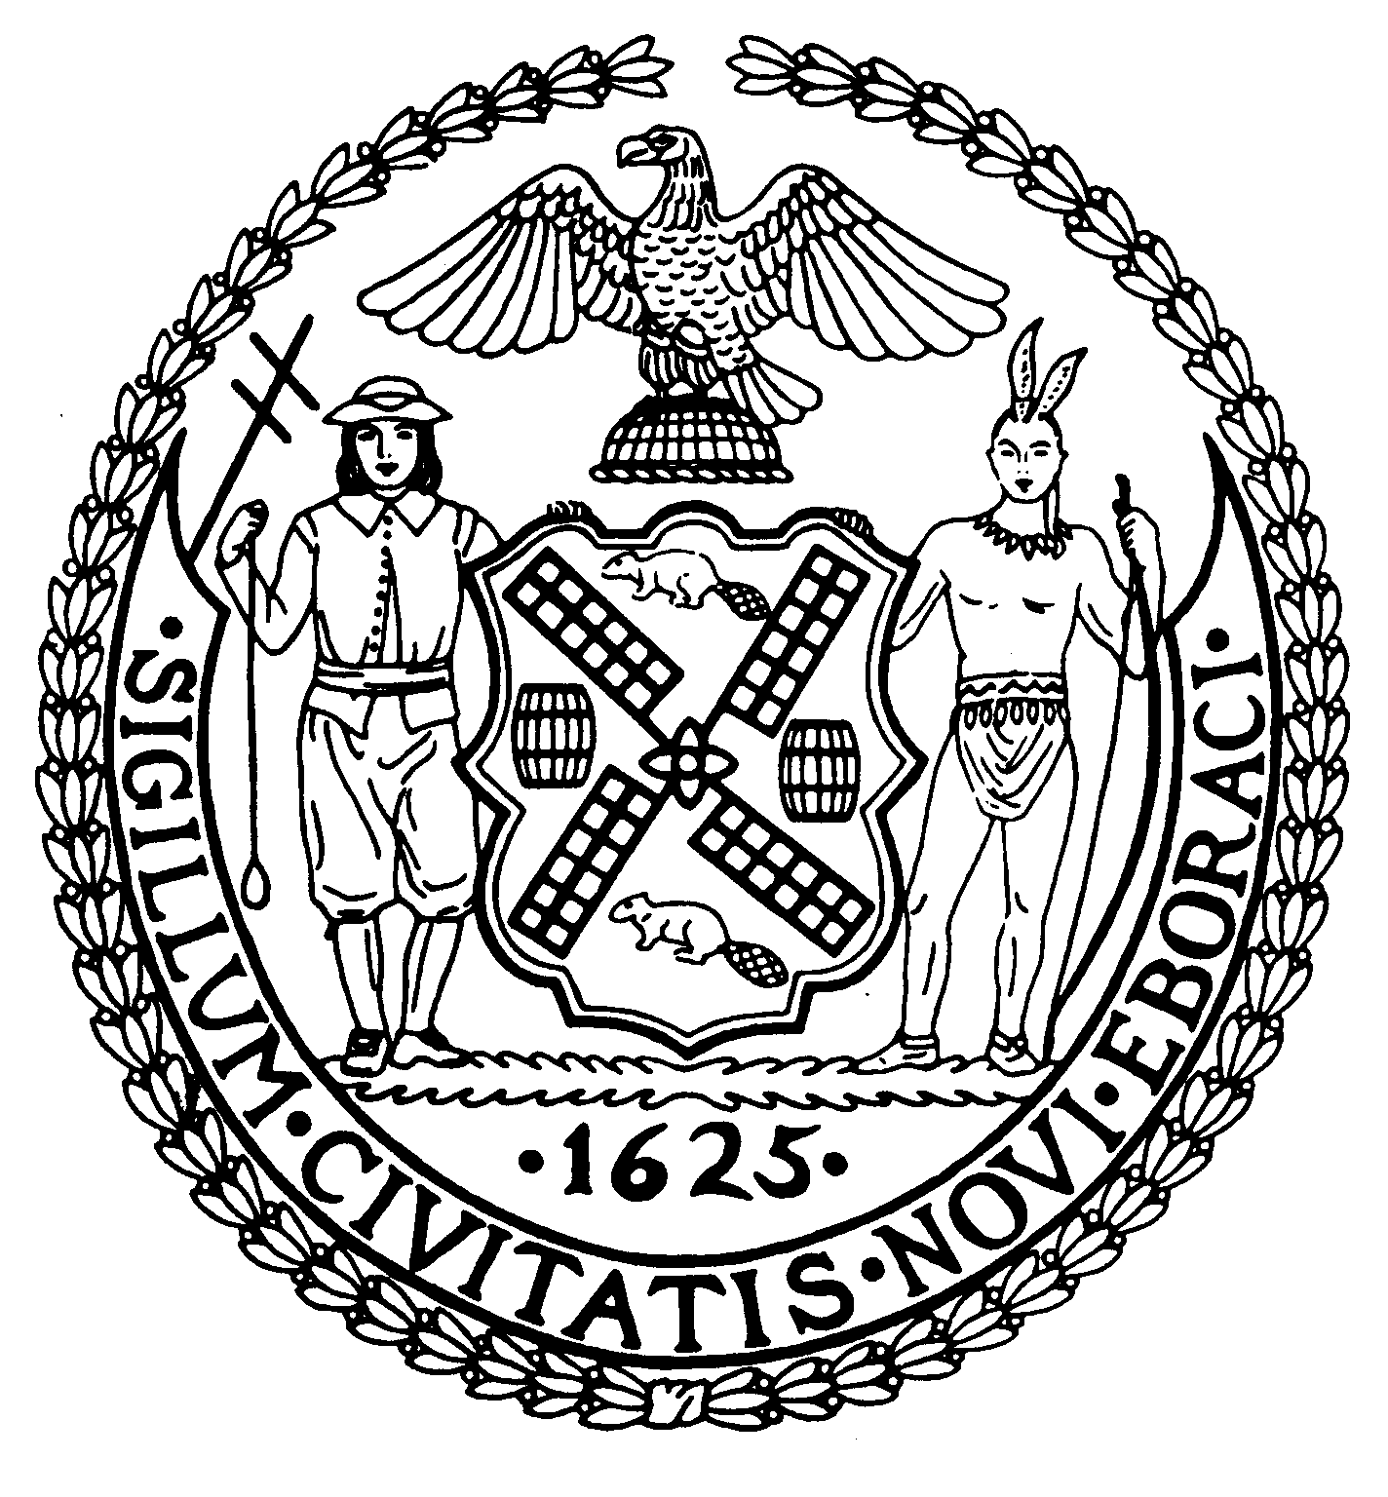
Chair New York, N.Y. 10022-1106
(212) 758-4340

Latha Thompson (212) 758-4616 Fax
District Manager www.cb8m.com - Website
Info@cb8m.com - E-Mail

The City of New York
Manhattan Community Board 8

Health, Seniors and Social Services Committee
Thursday, November 17, 2011
6:30 PM
New York Blood Center
310 East 67th Street
Conference Room 1

CB8 members: Ellen Polivy, Mary Pike, Hattie Quarnstrom

Excused absence: Molly Blayney, Barbara Rudder

Although Ellen had personally called representatives of religious institutions, and letters were written and sent, they representatives never actually received the formal invitations and thus they did not show up. The mail must have gotten hung up somewhere.

Discussion ensued on how to reach the religious institutions that had missed the meeting in order to keep up the interest that many of them had expressed about how they could become organizational members.
The interns from Time Banks said that they could reach out personally to each institution and discuss with them becoming members. We will forward them the list of the institutions that we created.

The interns talked about organizing a Time Banks meeting with the interested institutions during the daytime which is a better time for most groups. They will use the Community board name when they approach the organizations.

We reviewed the work that the interns have been doing since we met them two months before when they were new workers.
Each intern is working on a different project. Ellen Lehman has been speaking at Libraries in Queens. They are looking for people with more diverse sets of skills like carpentry and electrical and home repair ability. They are intentionally expanding to communities where they are likely to find those skills.
Library outreach taps into a different population, a much younger. Senior center members are not so active. And many don’t remember what Time Banks was when they receive a reminder call Reggie Ware is. They are also looking into working with the younger families, but that may be a negative since children cannot be Time Banks members and their parents don’t have much time to volunteer.
Also homebound people have greater difficulty being involved as they must be able to give and receive. They can however make phone calls, as in telephone reassurance.
Jimmy Ng has been calling the existing Time Banks members and getting people to become more active.

Old Business: Discussion of our December and January meetings.
December will be on Homeless and a brief overview of the new NYU Women’s Center on the Upper East Side.
January will be the Foster care forum. Hattie will be finding a presenter from the foster agency in our neighborhood.

Mary Pike and Ellen Polivy, Co-Chairs

