Jacqueline Ludorf 505 Park Avenue, Suite 620
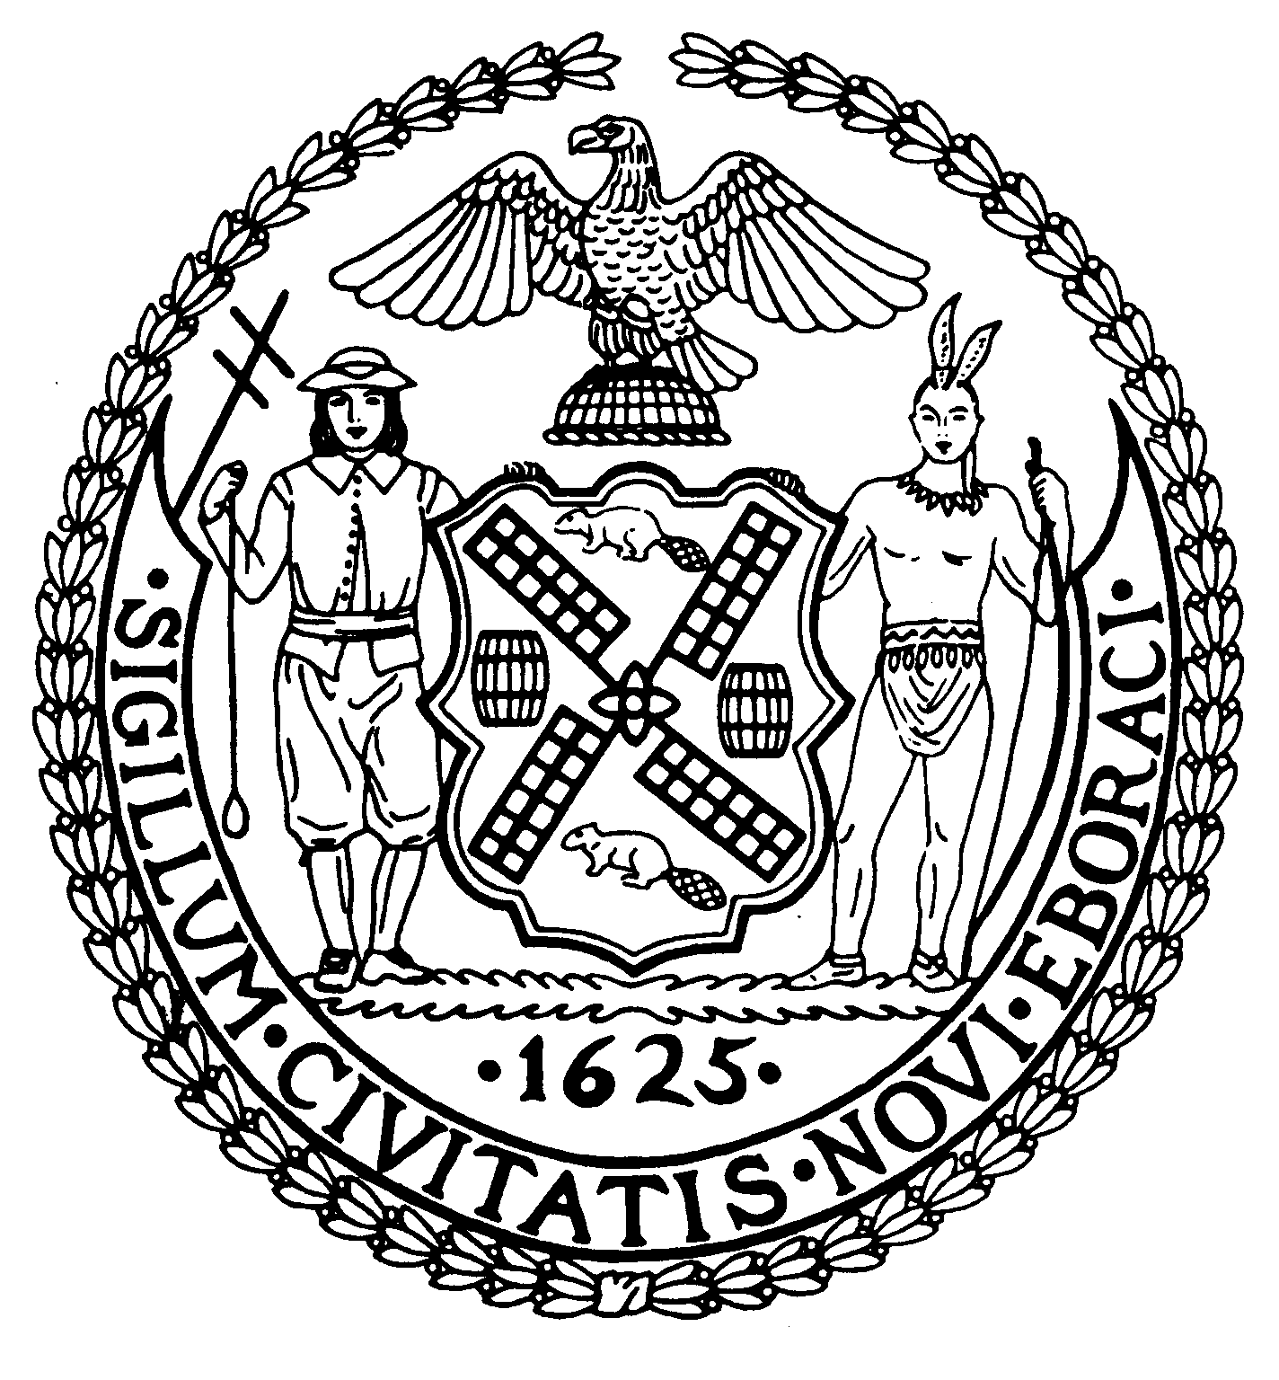
Chair New York, N.Y. 10022-1106
(212) 758-4340
Latha Thompson (212) 758-4616 (Fax)
District Manager www.cb8m.com - Website

info@cb8m.com - E-Mail

The City of New York
Manhattan Community Board 8

ZONING & DEVELOPMENT COMMITTEE
MINUTES
Tuesday, November 30, 2010
Hunter College School of Social Work, Auditorium
129 East 79th Street, NY, NY 10075

Present: Elizabeth Ashby, Barbara Chocky, Michele Birnbaum, Lawrence Parnes, Teri Slater (Co-Chair), Marco Tamayo, Elaine Walsh (Co-Chair)
Lovaeta Amoako (staff) Sam Stein (MBPO Fellow)

Excused: Kenneth Austin, Ruth Halberg

1. Shake Shack – A request from the community to resolve an issue regarding the use of adjacent public plaza by Shake Shack located on 86th Street between Third and Lexington Avenue. The community expressed strong support for limiting the plaza hours.

According to the Department of City Planning, the location is a public plaza and is therefore required to remain open 24/7. CB8M has taken a position that it is not feasible for public plazas be open 24/7 in a residential/mixed use neighborhood. Council Member Jessica Lappin, State Assembly Member Micah Kellner, and the East 86th Street Association have all written a letter to DCP with a request to modify the hours of the public plaza. Tiana Prado of Council Member Lappin’s office expressed support restricting the hours as requested by the community. In addition the committee also felt that a letter be sent by CB8, recommending modification of the hours for the plaza to be open.

The following resolution was passed:

Whereas, Shake Shack is required to submit an application to the Department of City Planning requesting permission to modify the hours during which a public plaza may remain open,
Whereas, the New York City zoning laws require that public plazas remain open 24/7,
Whereas, Shake Shack has made positive efforts to improve and maintain the public plaza,
Whereas, Shake Shack and the building owner would like to modify the hours during which the public plaza would be closed,
Whereas, the Community Board received complaints of noise and safety concerns since the plaza has been open 24/7,
Whereas, several members of the public appeared to express concern and requested the plaza close no later than 11pm,
Whereas, in the past, Community Board 8 has taken a position that it is not feasible to allow public plazas to remain open 24/7 in a mixed use community,
Whereas, Council Member Jessica Lappin, State Assembly Member Micah Kellner, and the East 86th Street Association have all written a letter to DCP with a request to modify the hours of the public plaza,
Whereas a representative of the 19th precinct has stated that the Plaza poses a safety hazard when open 24 hours a day and recommends the plaza be closed at night,
Therefore be it resolved that Community Board 8 urges the Department of City Planning to close the public plaza from 11pm to 7am due to the current adverse uses occurring in the plaza after 11pm when Shake Shack is closed,
Be it further resolved that Community Board 8 urges the Shack Shake establishment to immediately file an application to the Department of City Planning requesting a modification of the hours during which the outdoor plaza may be open.

Vote: 7-0-0

- UPDATE: Mid-Block Rezoning Text Amendment. –The R8B rezoning text amendment was submitted with the requested information to the Department of City Planning. The Board is waiting to hear back from DCP. Laurence Parnes will follow up.

- PRESENTATION AND DISCUSSION: "Preserving and Strengthening Local Retail: Issues and Strategies, Saving Independent Retail, Policy Measures To Keep Neighborhoods Thriving” – The presentation was conducted by Vickie Weiner, Director of Planning and Preservation, Pratt Center for Community Development. It addressed the major problems local retail merchants face, such as adverse tax policy and high commercial rent. It explored the problems and benefits associated with “big box” retailers in New York communities and the effects they have on local retailers. Ms. Weiner also addressed the impact of the Second Avenue Subway construction site on small businesses and the community. The construction has resulted in service disruptions, a loss of traffic lanes and parking, a loss of sidewalk space, a loss of business, the inability to maintain a sidewalk café, and a danger when crossing streets.

- DISCUSSION AND UPDATE: Illegal Signage - Mr. Steven A. Figueiredo, representative for DOB gave an update on sign violations in the community district.

  - Duane Reade has been issued a violation. The violation was issued to the architect who filed the initial application in 2003. The architect has 90 days to respond to DOB. ( A violation was issued in stead of a Commissioner’s order)
  - Fairway, 240 E. 86th Street – Fairway has proposed a large illuminated sign, that will read “Fairway” in large letters and have images of fruits and vegetables. The Committee believes it will be a violation. The application has not been filed with DOB yet.
  - Mr. Figueiredo confirmed that an establishment can display a sign behind its window/glass frontage. The sign is considered “accessory advertising.”
  - Orva shoe store– DOB inspected the sign from street level and will make an appointment to look at the sign form the complainant’s apartment.
  - Subway Sandwich shop – DOB has not inspected the signage as yet.

Other illegal for future DOB inspection:

- Euro Pain
- Canopies/signs – ie. PC Richard, Our Place (242 East 79th Street)
- Sole Cycle
- An updated list of illegal signage was requested.

