Jacqueline Ludorf 505 Park Avenue
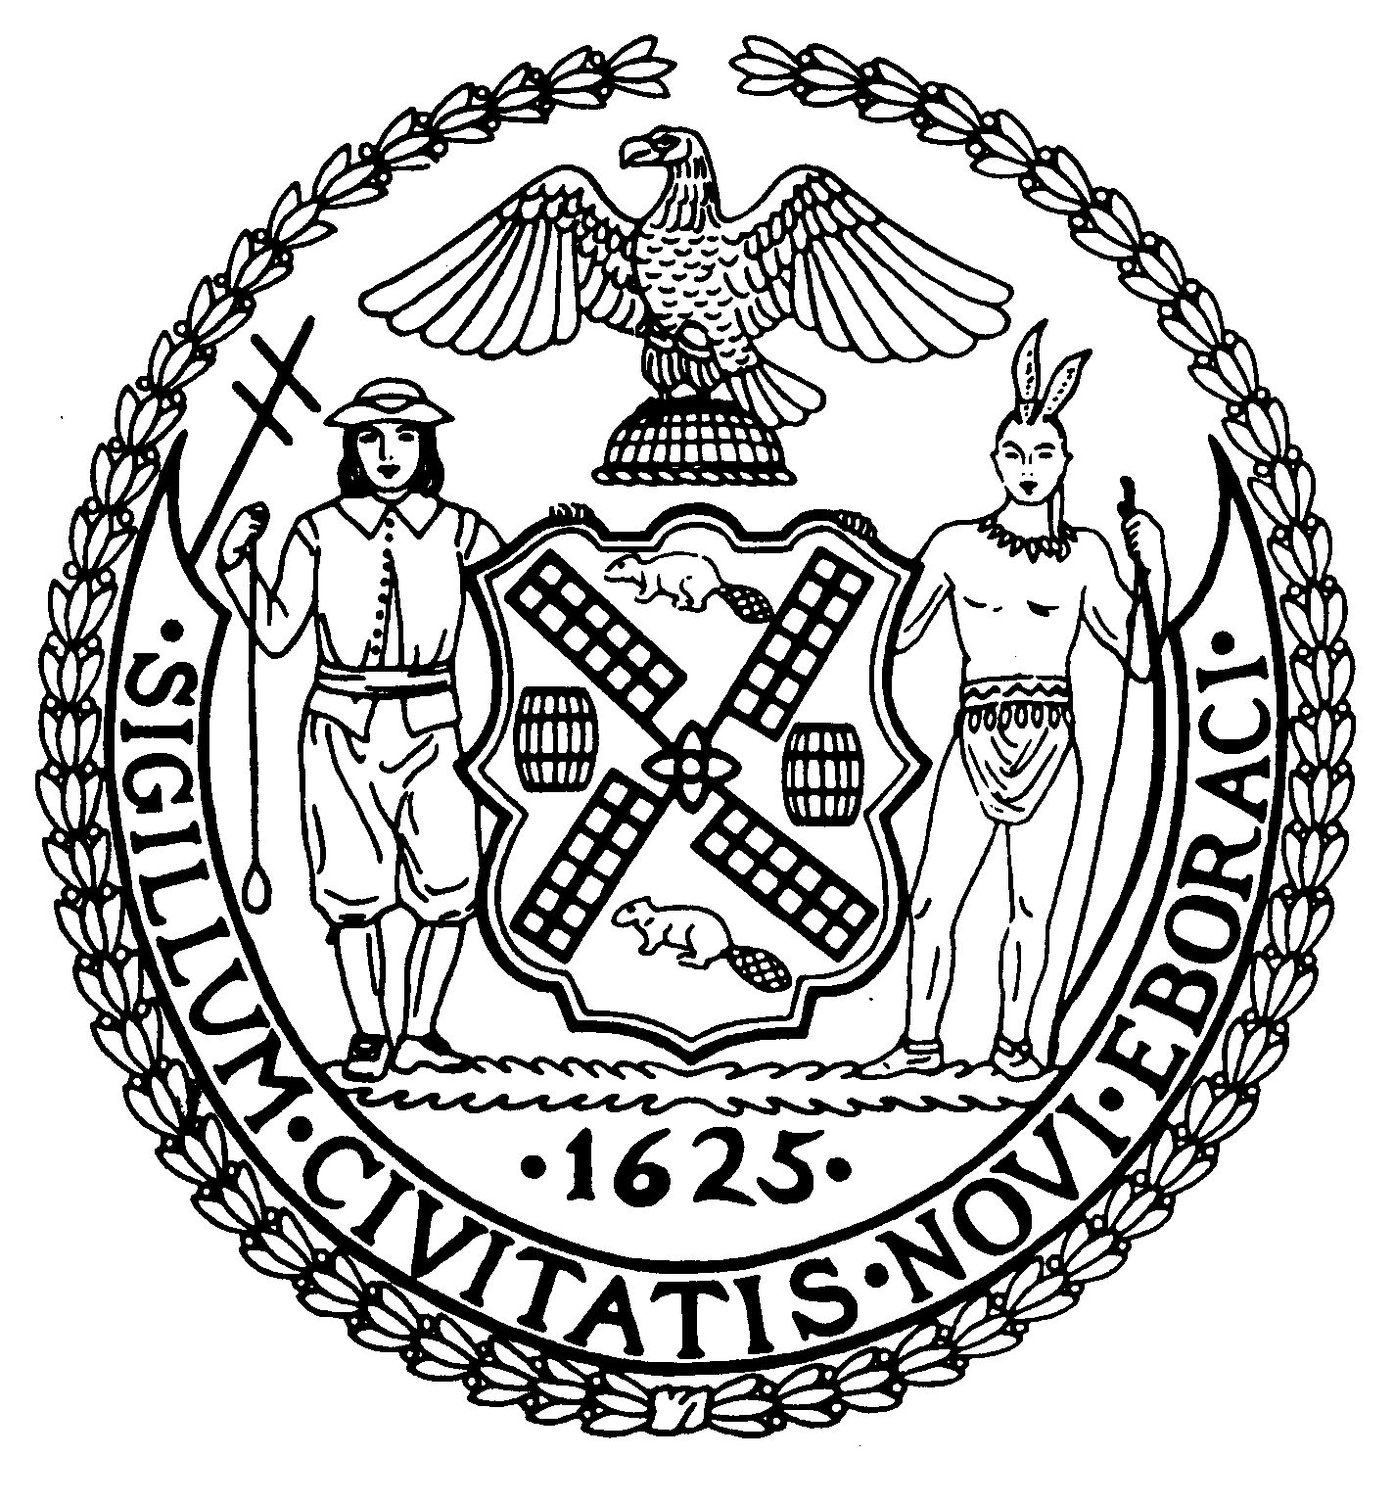
Chairman Suite 620
New York, N.Y. 10022

Latha Thompson (212) 758-4340
District Manager (212) 758-4616 (Fax)
www.cb8m.com Website
info@cb8m.com - E-Mail

The City of New York
Manhattan Community Board 8
Transportation Committee
Wednesday, November 3, 2010
New York Blood Center
310 East 67th Street, Auditorium

Present: Michele Birnbaum, Deirdre Breslin, Scott Falk, Lorance Hockert, Jonathan Horn, Rita Popper, Barry Schneider, Judy Schneider, Helene Simon, Alex Tisch, Charles Warren, Hedi White

Absent (unexcused):, Michael Auerbach

The meeting was called to order by co chair Jonathan Horn at 6:35 pm.
- Update on Roosevelt Island Tram renovations (joint item with Roosevelt Island & Parks Committees)

No representative from RIOC or the contractor, POMA was present. It is believed that they are still hoping to have the tram back in service by the end of November. Several committee members reported seeing the new tram cars being tested.

- Update from DDC on Traffic Issues relating to the Third Water Tunnel Construction Project

Sarah Wilmoth from DDC provided an update. Work continues to proceed on 59th Street. The weekend closures of the block between 2nd and 3rd Avenues have begun with one change. The closures will occur only between 7am and 5pm on Saturdays and Sundays. The street will be re-opened at 5pm (or earlier) on both weekend days. There are no reports of any unexpected impacts from the construction as of yet, but the committee will continue to monitor the project over its expected three year life.

- A request for a Revocable Consent for steps and a fenced-in area at 522 East 87th Street. (Requested by DOT, Franchises, Concessions and Consents)

The applicant failed to appear for the second consecutive month. DOT will be notified.

- Discussion of proposed Transit Rider Bill of Rights

Brodie Enoch talked about a project started by Transportation Alternatives to have residents and community groups sign onto a Transit Rider’s Bill of Rights. They have already presented to and received support from a number of other CBs in the city. The committee held a brief discussion on the proposal from TA, as well as some alternate ideas from members of the committee on what should be included in such a document. It was agreed that a fuller discussion would take place at the December meeting after a more vigorous effort at posting and public outreach was made.

- Old Business

There was no old business.

- New Business

A question was raised about the reconfigured exit at 96th Street from the southbound FDR Drive. There are some concerns over proper signage and early notification to drivers of the changes. Since the changes were made as a result of work being done for the Second Avenue Subway on 96th Street, it was suggested that these concerns be forwarded to Claudia Wilson, the project liaison for investigation and response.

The committee was provided a tentative list of meeting dates for 2011.

The meeting was adjourned at 7:25 pm
Respectfully submitted,
Jonathan Horn and Charles Warren, Co-chairs

