Jacqueline Ludorf 505 Park Avenue
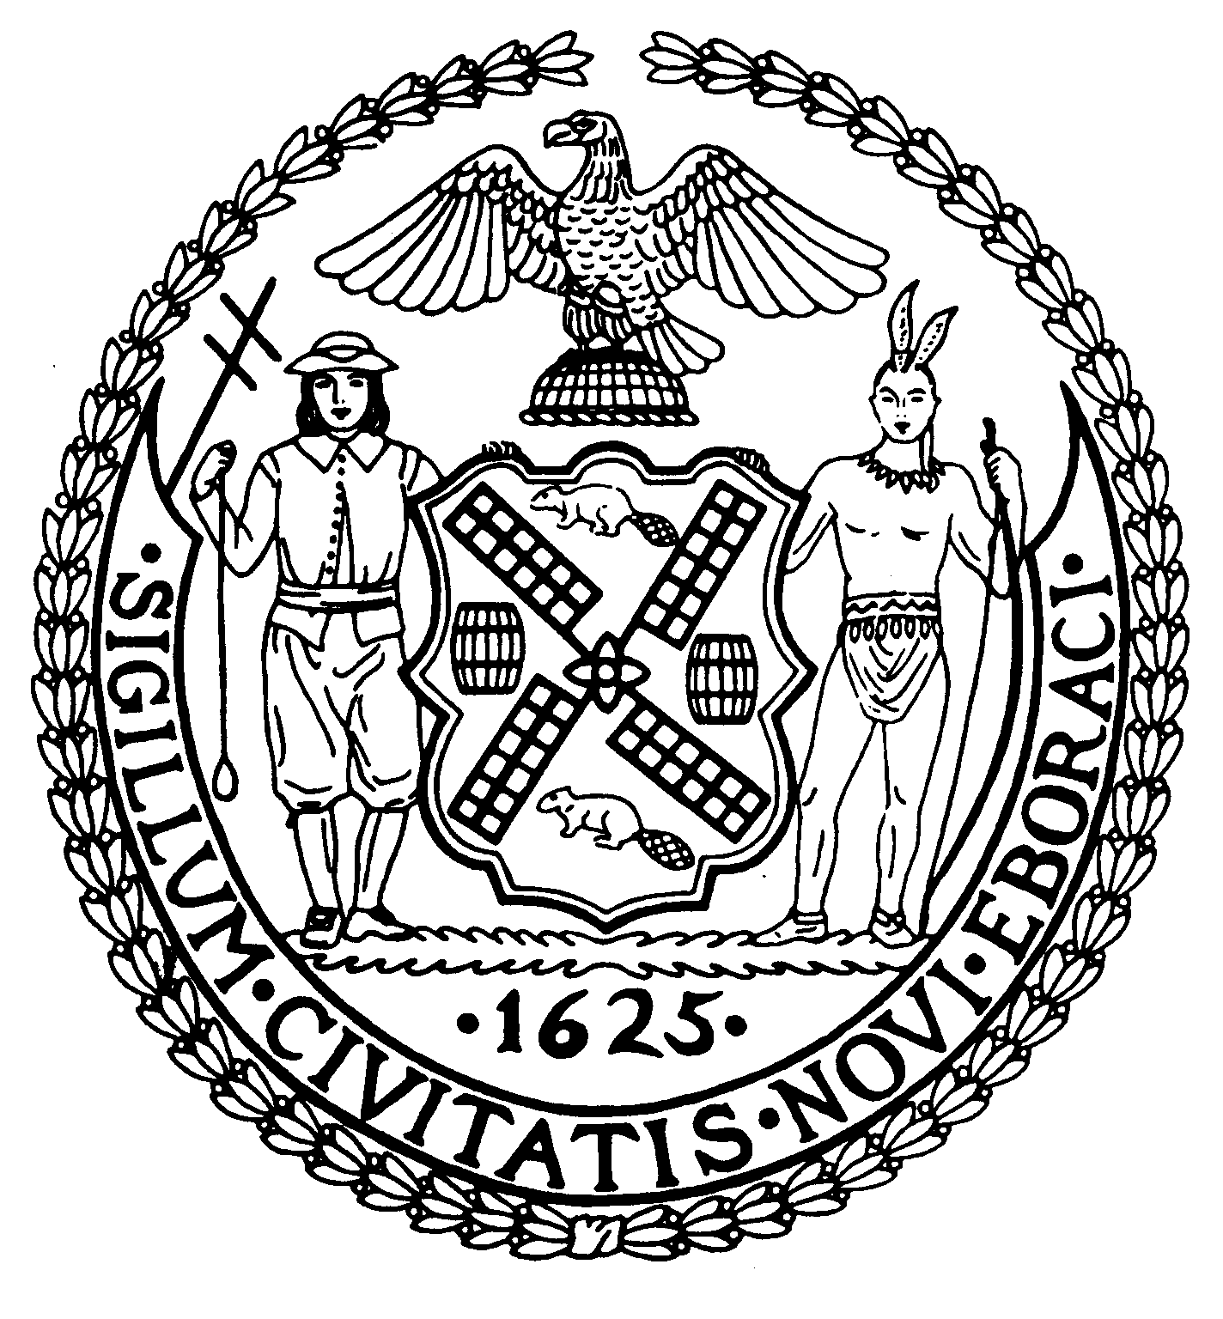
Chairman Suite 620
New York, N.Y. 10022

Latha Thompson (212) 758-4340
District Manager (212) 758-4616 (Fax)
www.cb8m.com Website
info@cb8m.com - E-Mail

The City of New York
Manhattan Community Board 8

Parks Committee Meeting
Thursday, November 4, 2010, 6:30 PM
New York Blood Center, 310 East 67th St.
Conference Room One

CB8M members present: Elizabeth Ashby, Michele Birnbaum, Susan Evans, Scott Falk, Jane Parshall, Rita Popper, Peggy Price, Barbara Rudder, Judy Schneider, Barry Schneider, Teri Slater, Marco Tamayo

1. Proposal for Signs in Central Park Describing the Old Croton Aqueduct System, a joint issue with the Parks and Landmarks committees.
Nancy Owens of Nancy Owens Studio LLC, a landscape architecture firm, presented plans for proposed signs in Central Park describing the Old Croton Aqueduct system, which had included the reservoir in Central Park.
As proposed, the Parks Dept.-sponsored plan calls for the placement of two signs, each standing 7.5 feet tall, with three 18-inch wide panels, to be placed in two Central Park locations: one near the Delacorte Theater and a second one on a pathway near West 85th St. and Central Park West. Each of the panels would present information about the Old Croton Aqueduct system, including a history of the system, a map of it and site-specific information about it.
Panels would be made of phenolic materials with steel plates. Lettering on the signs would be in Franklin Gothic type face.
While some CB8M members approved of the plan, others voiced concerns over the large size and “intrusiveness” of the signs and their modernistic design, which they considered incongruous with the natural, scenic setting of the landmarked Central Park.
Since presenters were unable to show detailed pictures of the proposed signs, they agreed to return with these materials to a December Parks/Landmarks joint committee meeting.
2. Discussion of the Changes to Central Park’s Tavern on the Green site—a joint issue with the Landmarks Committee.
Members of the Parks and Landmarks committees discussed the drastic renovations made to the Tavern on the Green site, and the rewarding of contracts to four large food vending trucks, without Further discussion of the recent alterations to the Tavern on the Green site in Central Park--prior presentation to the Community Board. Bob Redmond of the Parks Department acknowledged the mistake in failing to inform the Community Board of the changes but called the alterations an “interim solution.” After extensive discussion, committee members decided to express CB8M’s concerns in a letter to the Mayor and the Parks Dept. Commissioner. It was agreed that the letter would describe both our concerns over the failure to present the Community Board with plans for changes at Tavern on the Green, and our views on how the Board wishes to see the restaurant site used after the current “interim solution” expires. The letter to the Mayor and Parks Commissioner:

Dear Mayor Bloomberg and Commissioner Benepe:
Manhattan’s Community Board 8 is dismayed by the extensive alterations to Central Park’s Tavern on the Green restaurant, completed without any prior consultation to our Community Board.
Beyond the dramatic changes to the restaurant itself, the Board deeply regrets the introduction of food vending trucks at the site, which ignores our community’s strong objections to the pollution and blight caused by such trucks. Had we had a chance to provide prior input on these moves, as required by the New York City Charter, we could have suggested food vending processes more appropriate to the landmarked, scenic Central Park.
However, since these food vendors’ contracts expire next year, we wish to outline our suggestions for usage of the site after the contracts run out.
Specifically, we would like Tavern on the Green restored as an iconic restaurant, with its appearance suited to its verdant, pastoral setting. Given its landmarked status, the structure should remain free of unsightly machinery and clutter, and the parking lot eliminated or reduced in size. From all of its sides, the building should visibly blend with its environment.
We understand that operating a restaurant at the Tavern on the Green site involves a substantial financial commitment. Therefore, we hope all appropriate City agencies will work together to assist the business, if needed, to ensure its success.
Our Community Board also hopes that City agencies will return to their prior practice of consulting community boards before making changes to public land usage. This way, the public can offer insightful ideas that serve the interests of everyone.
Thank you very much.

3. Plans to Follow Up the October Forum on Restoring the East River Esplanade
Committee members discussed ways to maintain the momentum created by the October 7 forum for restoring the esplanade/waterfront in the CB8M district.
Attendees pointed out that the area still lacks a master plan for such a restoration. One member of the public noted that the narrowness of the area, which she felt would be overtaken by bicycle-riders once it’s repaired.
Citing the need for a high-quality design for the area, one CB8M member suggested sponsoring a competition to redesign the Esplanade area. Such a plan, she felt, could generate ideas for a master plan.
Meeting participants agreed that a conservancy group should pursue ways to restore the Waterfront/Esplanade. It was pointed out that Council Member Lappin and Rep. Maloney have created an East River Task Force to seek ideas and money for restoring the Esplanade/Waterfront on the East Side of Manhattan. In addition, meeting attendees felt that a separate conservancy group could bring ideas, and perhaps financial resources, to the restoration effort. One CB8M member suggested that the Parks Committee co-chairs meet with Parks Dept. Commissioner Adrian Benepe about creating such a conservancy.
However, at the October 7 forum, Jennifer Ratner volunteered to create a Friends of the East River Esplanade group, which has already held its first meeting. The Parks Committee co-chairs said they would soon confer with Ms. Ratner about her plans for this group.

