Jacqueline Ludorf 505 Park Avenue, Suite 620
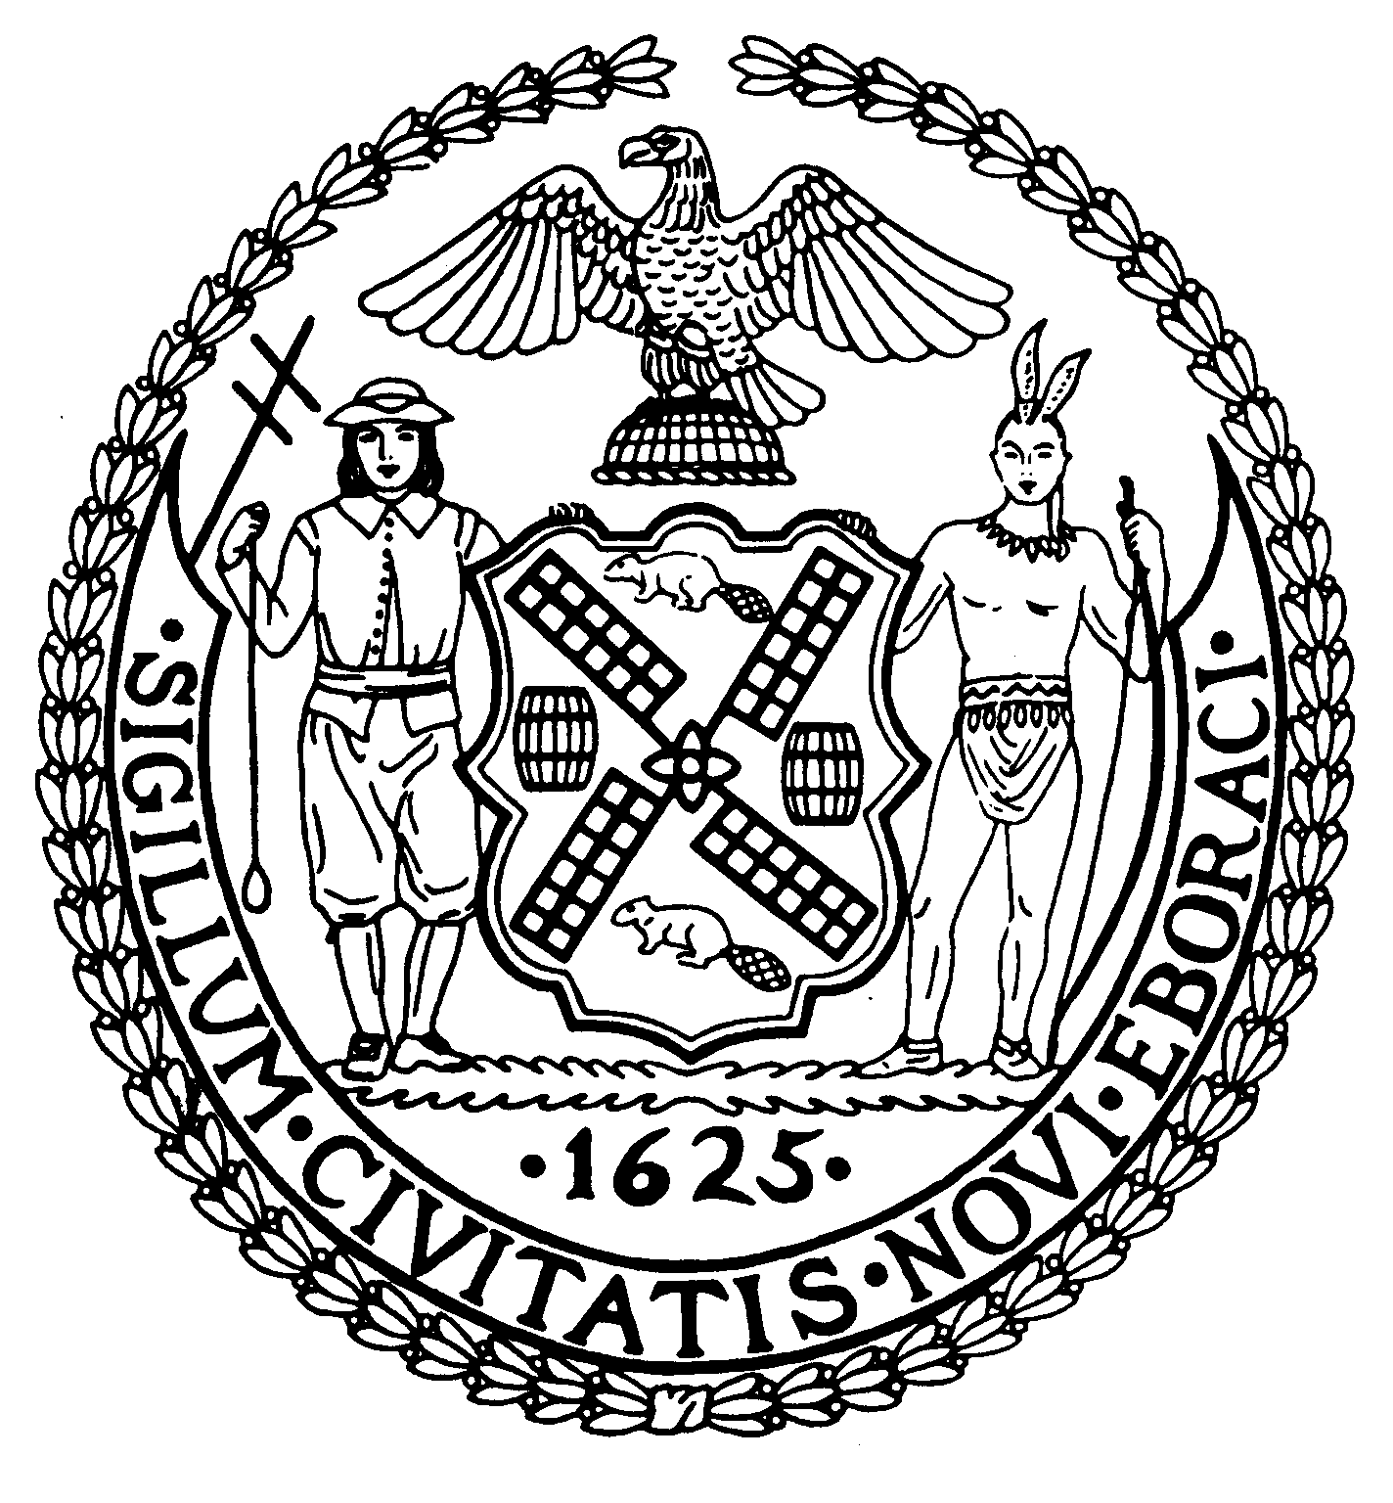
Chair New York, N.Y. 10022-1106
(212) 758-4616 (Fax)
Latha Thompson www.cb8m.com – Website
District Manager info@cb8.com - E-Mail

The City of New York
Manhattan Community Board 8

Zoning & Development Committee
Tuesday, November 30, 2010 – 6:30 PM
Hunter College, 129 East 79th Street, Auditorium

Agenda

- PRESENTATION AND DISCUSSION: "Preserving and Strengthening Local Retail: Issues and Strategies, Saving Independent Retail, Policy Measures To Keep Neighborhoods Thriving.”
Vickie Weiner, Director of Planning and Preservation, Pratt Center for Community Development.

- Shake Shack - Request from a community business (Shake Shack) in resolving an issue regarding the use of adjacent public plaza outdoor space.

- UPDATE: Mid-Block Rezoning Text Amendment.

- DISCUSSION AND UPDATE: Illegal Signage.
Donald Ranshte, Director of Intergovernmental and Community Affairs, Department of Buildings, Steven Figueiredo, Manhattan Community Affairs Liaison.

- OLD BUSINESS

- NEW BUSINESS

Teri Slater and Elaine Walsh, Co-Chairs

