Jacqueline Ludorf 505 Park Avenue
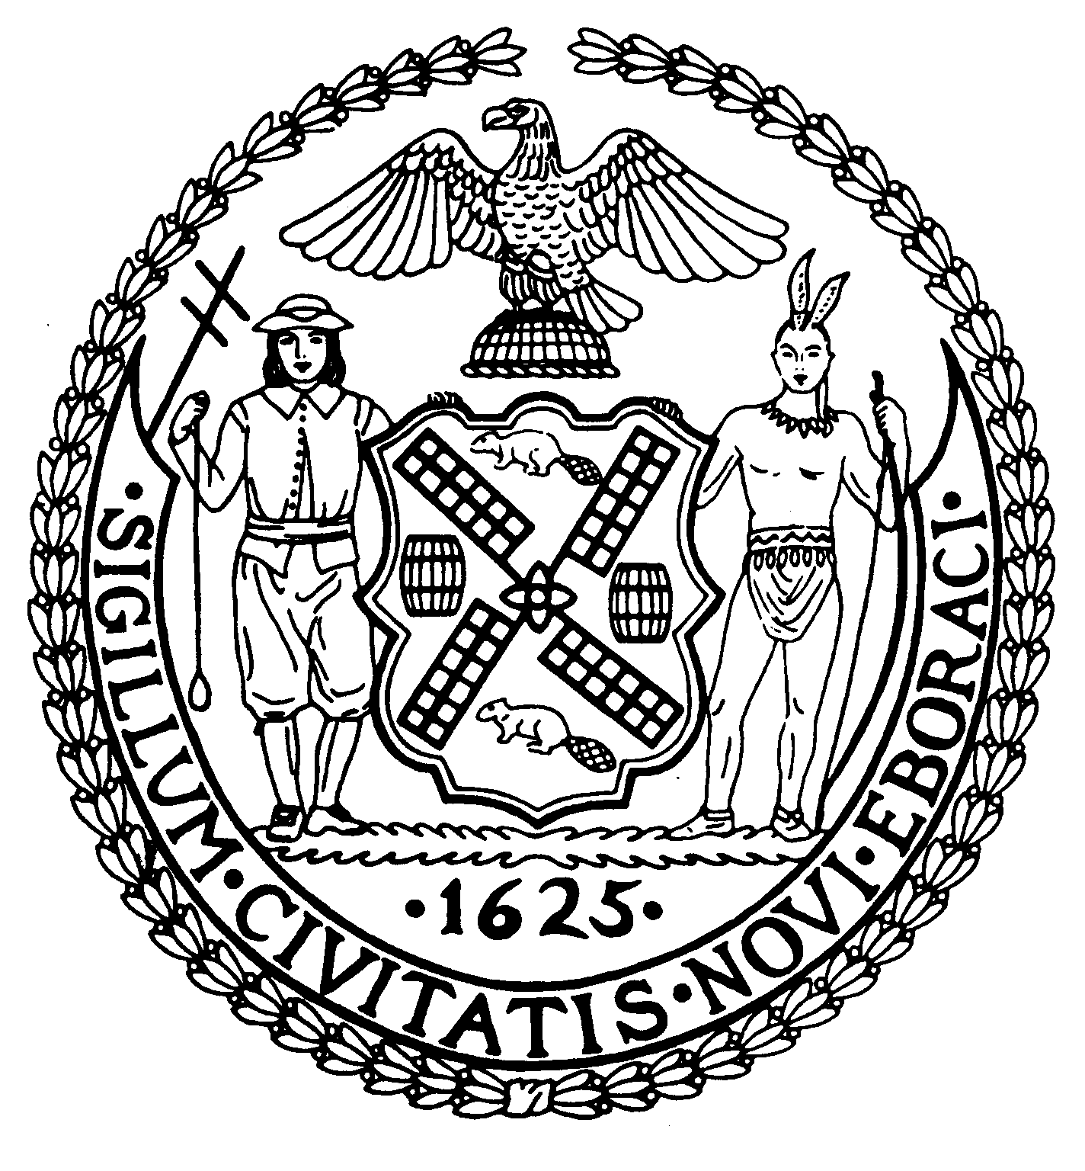
Chairman Suite 620
New York, N.Y. 10022

Latha Thompson (212) 758-4340
District Manager (212) 758-4616 (Fax)

W ww.cb8m.com Website
info@cb8m.com - E-Mail

The City of New York

Manhattan Community Board 8

Youth and Education Committee Meeting

Ramaz School, 125 East 85th Street, Auditorium
Thursday, November 18, 2010 7:00 pm

Agenda

- Re-zoning for Community District 8
Report on CECD2 Meeting on November 17, 2010
PUBLIC HEARING ON PROPOSED ZONING MAP ON TUESDAY, NOVEMBER 30

- Update on PS 267

- Update on 2nd Teacher/Aid in the classroom.

4. Future Meetings
January:
February:

5. Old/New Business

James Clynes and Judith Schneider, Co-Chairs

