Jacqueline Ludorf 505 Park Avenue, Suite 620
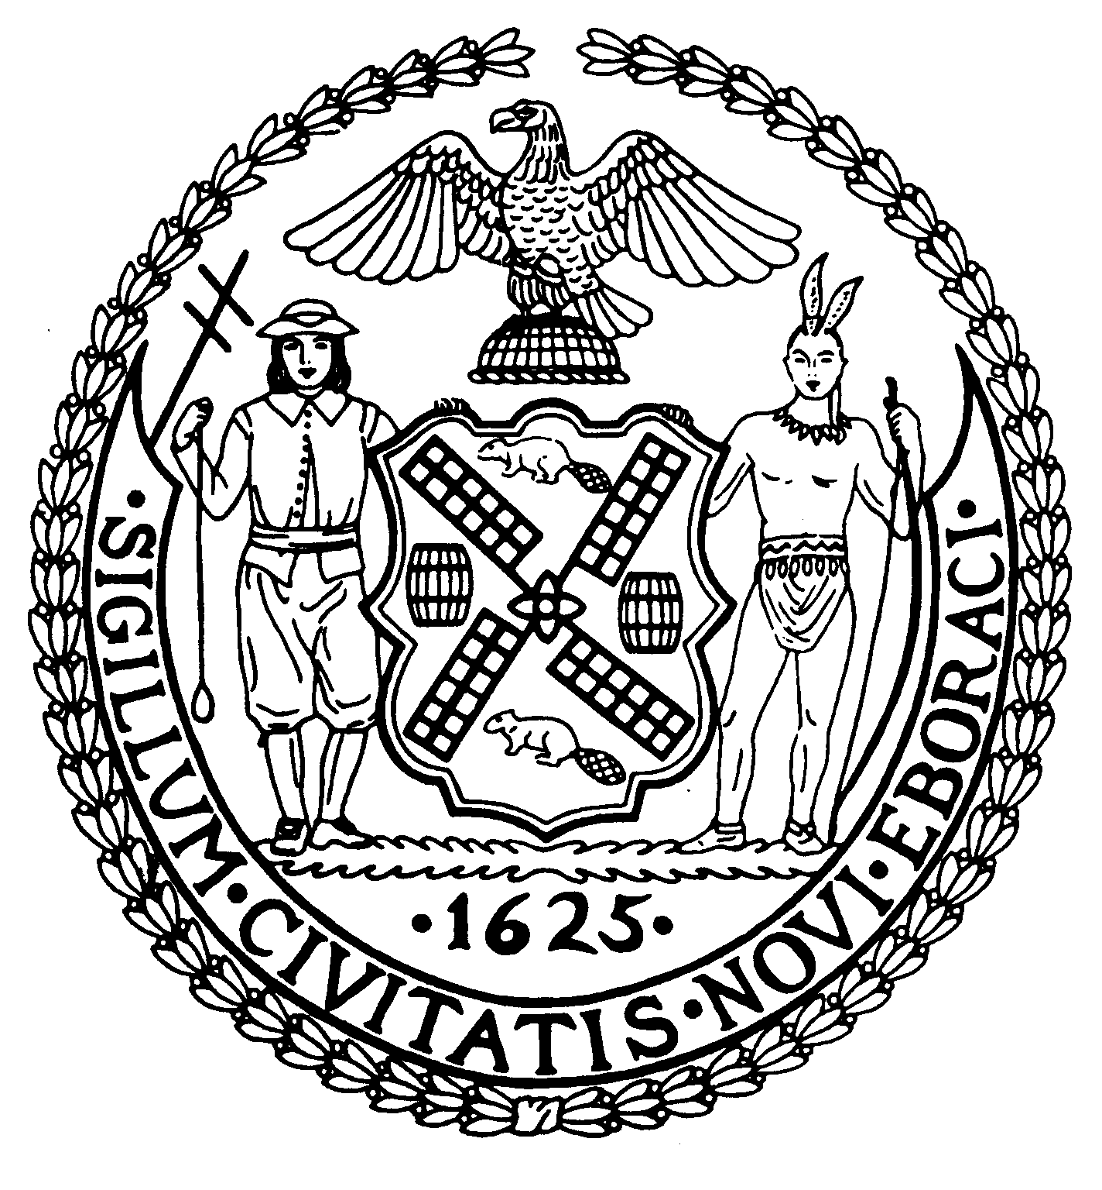
Chair New York, N.Y. 10022-1106

(212) 758-4340
Latha Thompson (212) 758-4616 (Fax)
District Manager www.cb8m.com - Website
info@cb8m.com - E-Mail

The City of New York
Manhattan Community Board 8

Parks Committee
Thursday, November 4, 2010 @ 6:30 PM

New York Blood Center, 310 East 67th Street, New York, NY
Conference Room 1

Agenda

1. Review of the Parks Dept.'s proposed design of 2 signs at the Central Park Reservoir describing the history of the Old Croton Aqueduct system, which had included the reservoir--joint issue with the Landmarks Committee.

2. Further discussion of the recent alterations to the Tavern on the Green site in Central Park--joint issue with the Landmarks Committee.

3. Review of the Oct. 7th forum on Restoring the East River Esplanade in the Community Board 8 district.

Margaret Price and Barbara Rudder, Parks Committee Co-Chairs

