Jacqueline Ludorf 505 Park Avenue
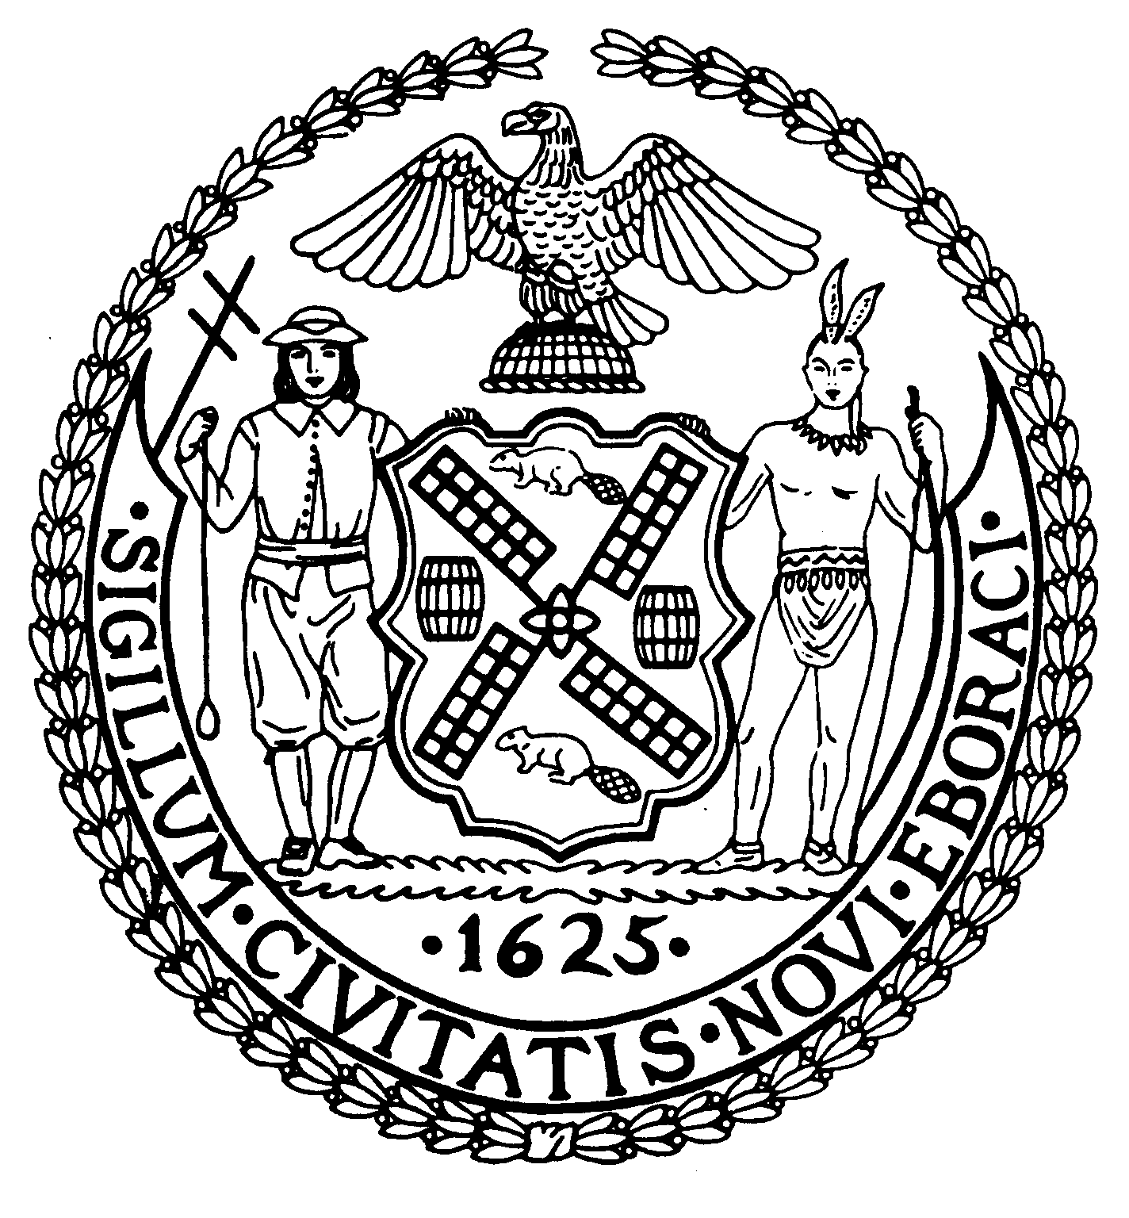
Chair Suite 620
New York, N.Y. 10022

Latha Thompson (212) 758-4340
District Manager (212) 758-4616 (Fax)
info@cb8m.com- E-Mail
www.cb8m.com – Website

The City of New York
Manhattan Community Board 8

Environment and Sanitation Committee Meeting
Tuesday, Oct 25, 2011
6:30 pm

Board Members Present: Dave Kleckner, Debbie Teitelbaum, Roy Carlin, Ed Hartzog, Larry Hockert, Mary Pike, Judy Schneider, Barry Schneider,

Committee Members Absent: Ellen Polivy

Number of Attendees: 14

The meeting was called to order at 6:50 pm.

1. Third Harbor Water Tunnel Shaft 33-B Water Main Update by NYC Department of Environmental Protection (DEP) and NYC Department of Design & Construction (DDC)

DEP Assistant Commissioner Mark Lanaghan, accompanied by Humberto Galarza, and DDC’s Shane Ojar and consultant/community liaison Sarah Wilmoth provided an update on the Third Harbor Water Tunnel Shaft 33-B and water mains (project time frame Summer 2010 – Summer 2015).

- DEP is close to completing its evaluation process and announcement (within the next 2 to 4 weeks) of the location of the redundant (back-up) water main, which is likely to be situated on either 58th Street or 56th Street between 1st Ave and 3rd Ave.
- DEP is continuing to install electrical and mechanical devices needed for the Shaft 33-B.
- DDC’s Community Liaison Sarah Wilmoth can provide a written update shortly on the work to be performed during the next 6-12 months.
- Several Venturi boxes are being installed, which will enable DEP to monitor water consumption.
- It is anticipated that the 59th Street water main (1st Ave to 3rd Ave) will be completed in the summer of 2013. The redundant water main would likely be completed by 2015 if work begins next year.
- The Committee may draft a letter for the CB8 Chair to send to Parks Commissioner Benepe and DEP Commissioner Strickland outlining the estimated costs to restore 14 Honey Locust Park (please see attached cost estimate), which has been used as a staging area for this project.

2. New Business

The Committee was pleased to learn that flyers will be distributed inviting people to drop off their used Christmas trees for collection and recycling (mulching) by the Department of Parks & Recreation at Friends of St. Catherine Park located on 1st Avenue between 67th and 68th St. This will be one of numerous Parks Department MulchFest locations (www.nycgovparks.org/services/mulchfest/mulchfest.html)

Meeting adjourned at ~7:45 pm.

Respectfully submitted,
Dave Kleckner and Debbie Teitelbaum
Co-chairs Environment and Sanitation Committee

