Jacqueline Ludorf 505 Park Avenue
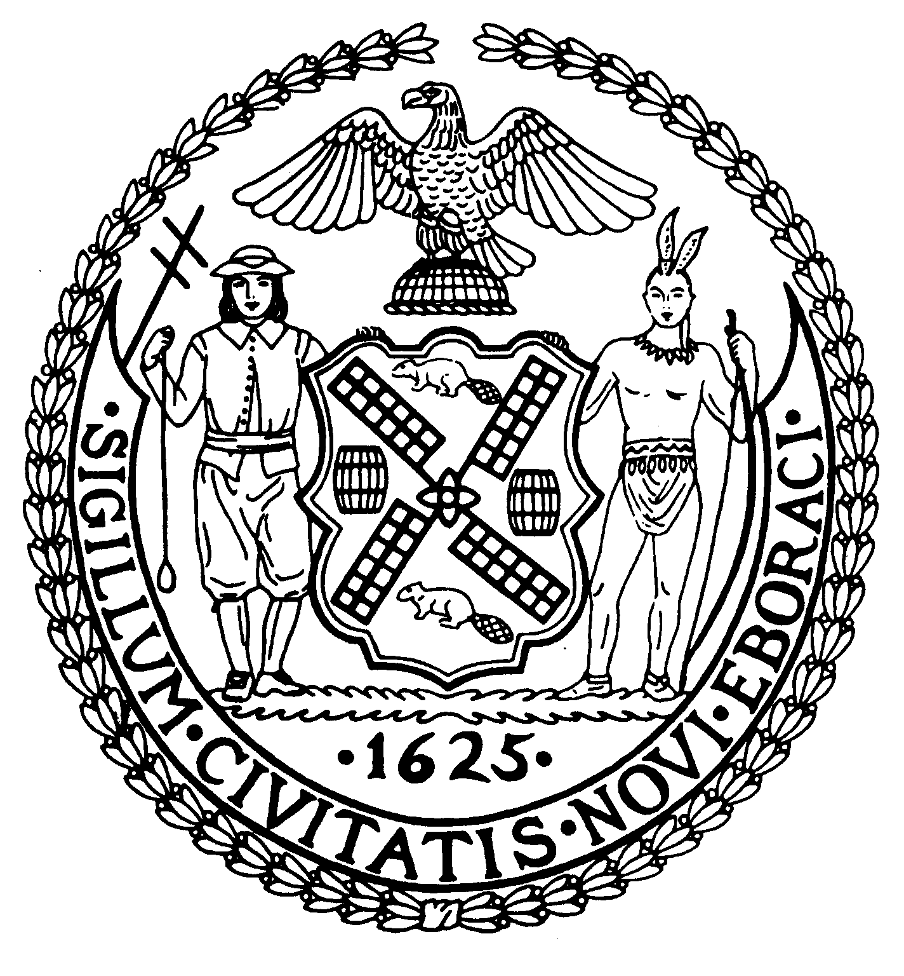
Chairman Suite 620
New York, N.Y. 10022

Latha Thompson (212) 758-4340
District Manager (212) 758-4616 (Fax)
www.cb8m.com Website
info@cb8m.com - E-Mail

The City of New York
Manhattan Community Board 8

Second Avenue Task Force Committee
Tuesday, October 12, 2010
New York Blood Center
310 East 67th Street
Auditorium
6:30PM

Agenda

1. Construction Updates

2. Introduction to 72nd Street Cavern Excavation Contractor

3. Review of Ancillary Facility Architecture

4. 86th Street Ancillary Facility Design Update

5. 72nd Street Elevator Entrance

6. 72nd Street Station Ancillary Facilities – Rooftop Equipment Screens

7. Old Business

8. New Business

M. Barry Schneider and H. Patrick Stewart, Co-Chairs, Second Avenue Subway Task Force

