Jacqueline Ludorf 505 Park Avenue
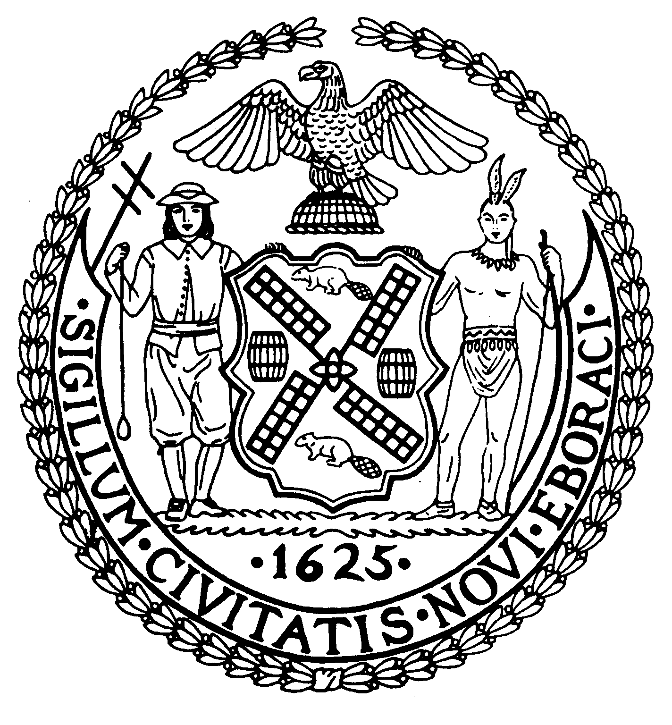
Chairman Suite 620
New York, N.Y. 10022

Latha Thompson (212) 758-4340
District Manager (212) 758-4616 (Fax)
www.cb8m.com Website
info@cb8m.com - E-Mail

The City of New York
Manhattan Community Board 8
Transportation Committee
Wednesday, October 6, 2010
New York Blood Center
310 East 67th Street, Auditorium

Present: Michele Birnbaum, Deirdre Breslin, Scott Falk, Lorance Hockert, Jonathan Horn, Rita Popper, Barry Schneider, Judy Schneider, Helene Simon, Alex Tisch, Charles Warren

Absent (excused):, Michael Auerbach, Betty Wallerstein, Hedi White

The meeting was called to order by co chair Jonathan Horn at 6:30 pm.
- Update on Impact of Third Water Tunnel Construction on Traffic and Parking

Sarah Wilmoth, Community Construction Liasion for the project presented an update on the status of work. Currently, only Con Ed utility relocation work is underway. The actual installation of the water tunnel will not begin for several more months. The planned weekend closures of East 59th Street between First and Second Avenue have not yet begun. DDC and DOT are finalizing the traffic mitigation plan and Sarah hopes to have more details on this to present at our November meeting.

- Discussion of Traffic Issues related to the 59th Street Bridge Approaches

John Duggan, a resident of East 60th Street expressed concerns over a recent increase in traffic related noise, especially horn honking, caused by an emergency DOT project on the 59th Street Bridge. His comments echoed others received over the summer by the board office. Josh Orzeck
Of DOT confirmed that they started doing emergency repairs to the lower roadway of the bridge in July. The work is being done during overnight hours to minimize traffic disruptions, since it requires the closure of some travel lanes and certain approaches to the bridge. The work is expected to last approximately 3 more months.
After some discussion, the committee agreed that the chairs should draft a letter to be sent by the Board Chairperson to DOT expressing our disappointment at not being notified in advance of this work, our concerns over the failure to have a traffic mitigation plan in effect and our desire to see some sort of traffic control agent present during the overnight work hours to direct drivers away from closed entrances to the bridge. (Note: Subsequent to the meeting, we were informed that a letter from the DOT Borough Commissioner was being sent to Councilmember Lappin’s office addressing these issues. It was decided to await this letter before proceeding further)

- Update on York Avenue Traffic Issues related to Hospitals and Institutions

Arlene Kline, a resident of East 72nd Street presented her observations on traffic and safety issues around the hospitals on York Avenue, particularly on the streets leading to and from the FDR Drive. She also presented several ways to alleviate some of these problems. Representatives of the hospitals were present and offered to look into some of the issues raised by Ms. Kline, particularly concerning Access-a-Ride vehicles immediately. The committee agreed that the chairs should schedule a site visit before our December meeting with the hospital representatives and Ms. Kline to get an “eyes-on” look at the current situation. Following that visit, the chairs will report back to the committee and we will consider possible solutions offered by the hospitals and whether any actions by DOT are needed.

- Update from DOT on the 86th Street Park Smart pilot program

David Stein of DOT presented a status report of the Park Smart pilot program begun on 86th Street and parts of Madison Avenue in June. A summary of the pre-implementation parking conditions was provided to the committee. Over the next several months, surveys of merchants, parkers and passersby will occur, followed by the collection of post-implementation data. An evaluation of the results will be reported to the committee in January 2011. Following that, we will consider modifications and/or expansion of the program. It was reinforced by several members of the committee that we consider it vital that the avenues from 83rd Street to 88th Street be included in any continuation of the program. DOT is reasonably confident that additional Muni-Meter equipment will be available by then.

- A request for a Revocable Consent for steps and a fenced-in area at 522 East 87th Street. (Requested by DOT, Franchises, Concessions and Consents)

The applicant failed to appear. DOT will be notified and the item will be placed on our November agenda.

- A request for a “No Parking Anytime” sign in front of 124 East 73rd Street. (Requested by Ms. Borden, resident)

The applicant failed to appear. The request is considered withdrawn without prejudice.

- Old Business

There was no old business.

- New Business

There was no new business.

The meeting was adjourned at 7:35 pm
Respectfully submitted,
Jonathan Horn and Charles Warren, Co-chairs

