Jacqueline Ludorf 505 Park Avenue, Suite 620
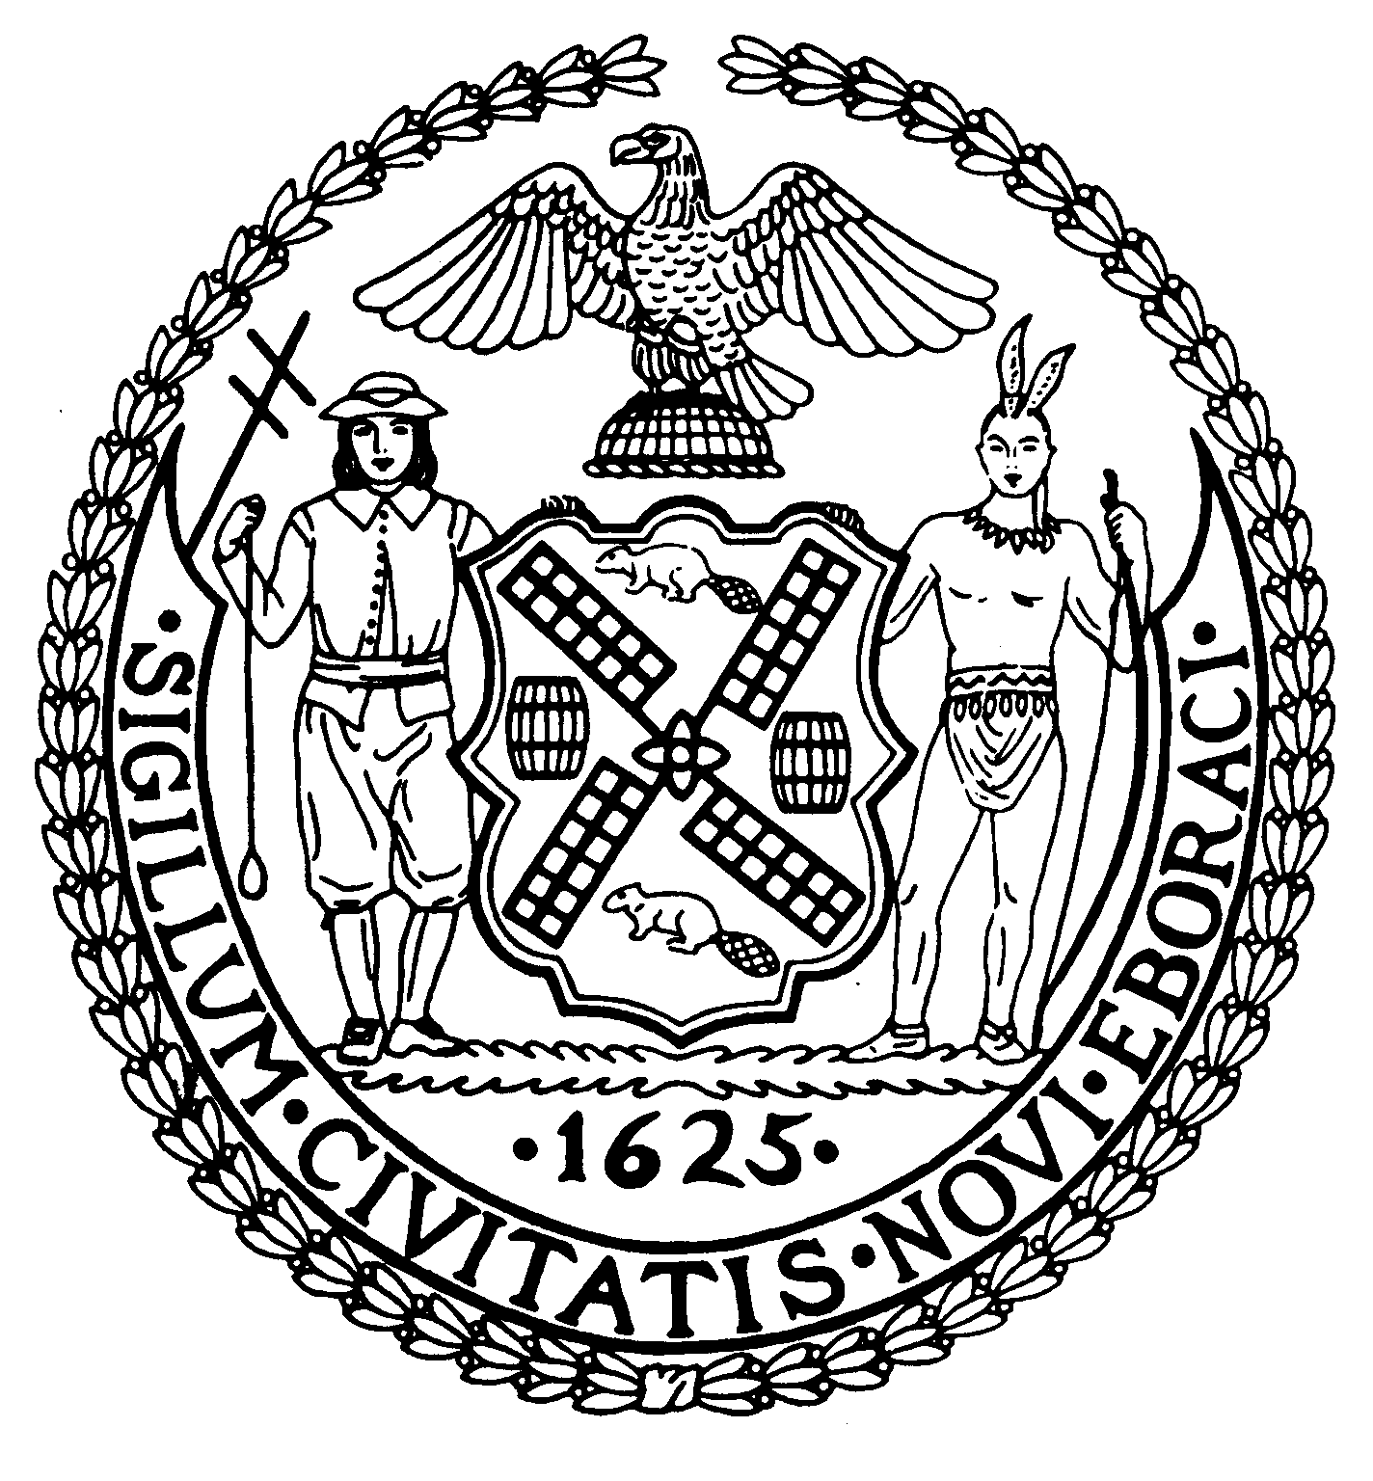
Chair New York, N.Y. 10022-1106
(212) 758-4340
Latha Thompson (212) 758-4616 (Fax)
District Manager www.cb8m.com - Website

info@cb8m.com - E-Mail

The City of New York
Manhattan Community Board 8
Parks Committee Forum
Thursday, October 7, 2010, 6:30 PM
Ramaz School, 125 East 85th St., Manhattan

CB8M members in attendance: Michael Auerbach, Michele Birnbaum, Susan Evans, Scott Falk, Lori Bores, Ruth Halberg, Rita Popper, Peggy Price, David Rosenstein, Barbara Rudder, Barry Schneider, Judy Schneider, Helene Simon, Marco Tamayo
Forum: Restoring the East River Esplanade in the CB8M District
CB8M’s Parks Committee sponsored a forum Oct. 7 on Restoring the East River Esplanade in the Community Board 8 District. The event, held at the E. 85th St. Ramaz School, highlighted the community’s concerns about the ever-deteriorating and dangerous conditions along the Esplanade and the East River Waterfront, generally, and aired ways to tackle the immediate need for repairs while mapping a long-term more scenic and usable public space.
Five panelists addressed these issues from a governmental perspective, and the public then weighed in with a broad range of questions and comments.
The forum’s five panelists included Minna Elias, chief of staff to Rep. Carolyn Maloney; Joshua Laird, Assistant Commissioner for Planning and Natural Resources, Council Member Jessica Lappin; Roland Lewis, CEO of the Metropolitan Waterfront Alliance; and Michael Marrella, the NYC Planning Dept.’s project director, Comprehensive Waterfront Plan. Parks Committee co-chairs, Barbara Rudder and Margaret Price, served as moderators.
Each speaker highlighted his or her own perspective on the urgent need to restore the Esplanade. Council Member Lappin illustrated the extent of the disrepair along the East River Esplanade in CB8M—the myriad of potholes, the sinkholes, missing sections of guard rail, rust, unused piling, empty flower boxes, the “unattractive” Con Edison building, and a “seawall crumbling into the water.” She also noted the 90th St. boat dock was not being used.
The Council Member reported that she, along with Rep. Carolyn Maloney, had formed an East River Task Force, which is “already working with city, state and federal agencies to tackle the problems” of enhancing the East River Waterfront area. She has secured $500,000 as initial funding toward that goal.
Minna Elias told the audience that Cong. Maloney was giving her “full attention to finding federal resources” for restoring the Esplanade/Waterfront area. While acknowledging the

difficulty these days getting funds to cover the entire costs of repairing the Esplanade, she cited several potential funding sources: The Urban Park and Recreation Recovery Program, the Land & Water Conservation Fund, Congestion Mitigation and Air Quality (CMAQ) Improvement Program which, she said, would be an ideal source for Esplanade renovation—and one or more of the 12 funding categories within the Recreational Trails program.
Roland Lewis stressed the commitment of his organization—the Metropolitan Waterfront Alliance—to “revitalizing our harbor,” and described his group’s Waterfront Action Agenda and WAVES initiatives. Among other specific projects, he described the use of eco-docks, which can further enable water sports along the East River. To Mr. Lewis, rebuilding the waterfront requires a “holistic, broad, comprehensive” solution that includes a design, funding and community input. Since, today, “New York gets the short end of the stick” when it comes to funding for the waterfront, he said that the city “needs bring our Congressional delegation together” to push for more funding.
Michael Marrella of the NYC Planning Dept. described his department’s updated Comprehensive Waterfront Plan—the first such city-wide review in 18 years. Now in draft form, the portion of that plan relating to the Upper East Side includes recommendations to: fund and maintain the East River esplanade; repair the bulkhead before embarking on improvements to it; maintain what exists along the esplanade and upgrade it with such enhancements as: widening it where possible and providing noise barriers, seating, lighting, dedicated paths, drainage and ADA access; explore alternative edge conditions and opportunities for safe in-water recreation.
The Parks Dept.’s Joshua Laird detailed waterfront projects in various areas of NYC as illustrations of possible ways to enhance the East River Esplanade/Waterfront. Concerning the Esplanade in the CB8M district, he acknowledged that passage along the Esplanade currently ranges from “narrow to non-existent.” He said that the Parks Dept. is handling the “badly worn-out” waterfront conditions along the East River by “correcting as many cave-ins as possible.”
During the Q&A portion of the program, the audience posed such questions as: Who will redesign the Esplanade (Mr. Laird said the answer to that question is “unknown”); Can the Army Corp. of Engineers help; Is federal economic stimulus money available for Esplanade upgrading (According to Mr. Laird, the stimulus monies legally cannot be used for parks projects); How will rising sea levels affect the Esplanade and the FDR Drive; Can the FDR Drive overhang at Carl Schurz Park be extended southward; Can the city take advantage of existing bulkheads to provide better access to the river for water sports?
Forum speakers had stressed the need for community/grassroots involvement in the renovation of the East River Waterfront. To that end, audience member Jennifer Ratner volunteered to create a “friends of the greenway” group to promote public interest and participation in the drive to restore the East River Esplanade.

