Jacqueline Ludorf 505 Park Avenue
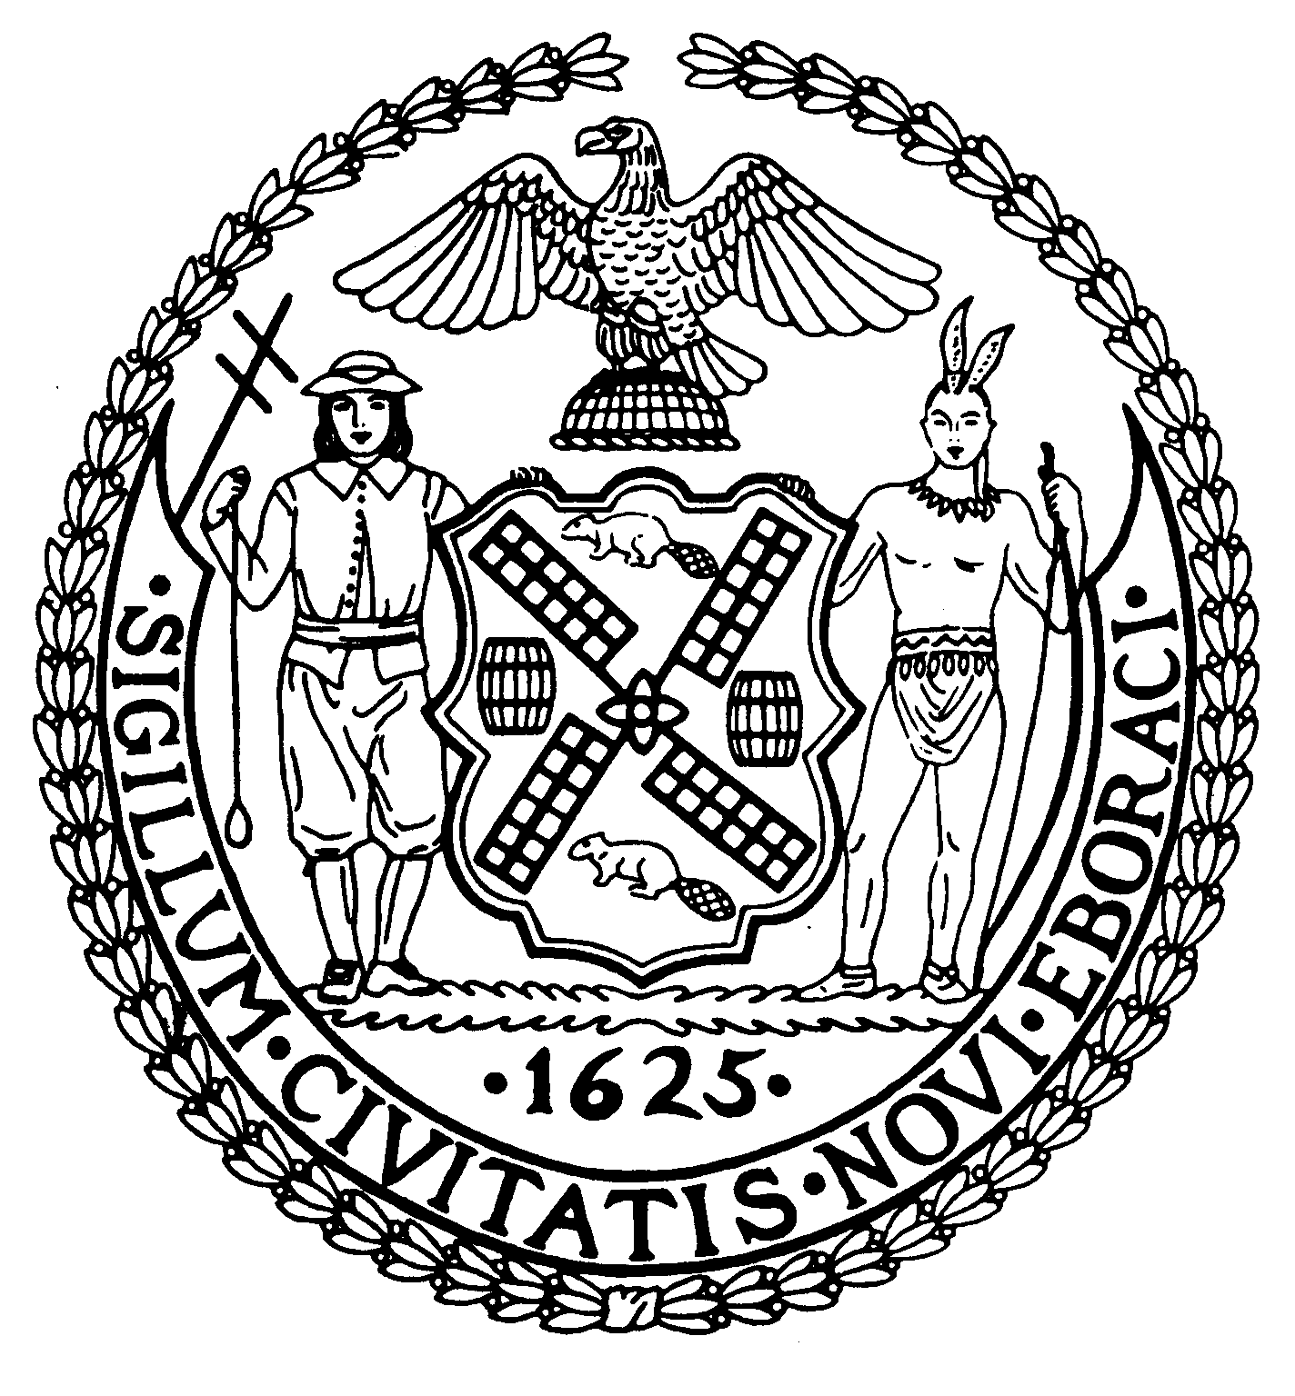
Chairman Suite 620
New York, N.Y. 10022

Latha Thompson (212) 758-4340
District Manager (212) 758-4616 (Fax)
www.cb8m.com Website
info@cb8m.com - E-Mail

The City of New York
Manhattan Community Board 8

LAND USE MEETING
WEDNESDAY, OCTOBER 13, 2010
Hunter College School of Social Work
129 East 79th Street, Auditorium
6:30PM

Community Board Members Present: Joie Anderson, Elizabeth Ashby, Michael Auerbach , Kenneth Austin, Michele Birnbaum, Matthew Bondy, Lori Ann Bores, Deirdre Breslin, Sarah Chu, James Clynes, Christina Davis, Susan Evans, Ruth Halberg, David Helpern, Lorance Hockert, Jonathan Horn, Dave Kleckner, Laura Lijewski, David Liston, Jacqueline Ludorf, Jane Parshall, Mary Boresz Pike, Ellen Polivy, N. Sharon Pope, Rita Lee Popper, Margaret Price, David Rosenstein, Barbara Rudder, Judith Schneider, M. Barry Schneider, Helene Simon, Teri Slater, Cos Spagnoletti, Marco Tamayo, Debra Teitelbaum, Alexander Tisch, Nicholas Viest, Betty Wallerstein, Elaine Walsh, Charles Warren, Hedi White
Community Board Members (Excused): Roy Carlin, Barbara Chocky, A. Scott Falk, Lorraine Johnson, Domenico Minerva, Laurence Parnes, William Sanchez, H. Patrick Stewart
Community Board Members (Unexcused):, George Fuchs,
Total Attendance: 41

Chair Jacqueline Ludorf called the meeting to order at 6:30PM.

1. Street Life Committee

1.a. By the Glass, Inc. d/b/a Uva Restaurant, 1486 Second Avenue (77th/78th Streets) – Renewal application for an unenclosed sidewalk café with 8 tables and 16 seats, DCA #1190933. Hours: 5p – 12a weekdays 5p – 1a weekends. Food/Drink: 70/30
Manhattan Community Board 8, adopted the following resolution by a vote of 32 in favor, 0 opposed, and 0 abstentions.
WHEREAS there are no changes to the café and no objections raised by the public,
BE IT RESOLVED THAT the application is approved.

1.b. Egg White, Inc. d/b/a Blockheads, 1563 Second Avenue (81st/82nd Streets) – Renewal application for an unenclosed sidewalk café with 9 tables and 16 seats, DCA #1023023. Hours: 11- 1a weekdays and 11 – 2a weekends. Food/Drink: 80/20.
Manhattan Community Board 8 adopted the following resolution by a vote of 32 in favor, 0 opposed, and 0 abstentions.
WHEREAS there are no changes to the café and no objections raised by the public,
BE IT RESOLVED THAT the application is approved.

1.c. K.K.&D of 79th St. Rest. Corp. d/b/a Nectar Café, 1022 Madison Avenue (@ 79th Street) – Renewal application for an unenclosed sidewalk café with 3 tables and 12 seats, DCA #1171759. Hours: 6a – 9p weekdays and 6p – 8p weekends Food/Drink:90/10
Manhattan Community Board 8 adopted the following resolution by a vote of 32 in favor, 0 opposed, and 0 abstentions.
WHEREAS there are no changes to the café and no objections raised by the public,
BE IT RESOLVED THAT the application is approved.

1.d. Baraonda Restaurant, Inc. d/b/a Baraonda Restaurant, 1439 Second Avenue (@ 75th Street) – Renewal application for an unenclosed sidewalk café with 20 tables and 40 seats, DCA #1215929. Hours 5p – 12a weekdays and 11a – 1a weekends. Food/Drink: 80/20.
Manhattan Community Board 8 adopted the following resolution by a vote of 32 in favor, 0 opposed, and 0 abstentions.
WHEREAS there are no changes to the café and no objections raised by the public,
BE IT RESOLVED THAT the application is approved.

1.f. Phillipos Restaurant, Inc. d/b/a Barking Dog Luncheonette, 1678 Third Avenue (@ 94th Street) – Renewal application for an unenclosed sidewalk café with 16 tables and 32 seats, DCA #1222470. Hours: 8a – 11p. Food/Drink: 90/10
Manhattan Community Board 8 adopted the following resolution by a vote of 32 in favor, 0 opposed, and 0 abstentions.
WHEREAS there are no changes to the café and no objections raised by the public,
BE IT RESOLVED THAT the application is approved.

1.g.Thierry, Inc. d/b/a le Charlog, 19 East 69th Street (@ Madison Avenue) – Renewal application for an unenclosed sidewalk café with 6 tables and 17 seats, DCA #1167909. Hours: 12p – 12a. Food/Drink: 95/5
Manhattan Community Board 8 adopted the following resolution by a vote of 32 in favor, 0 opposed, and 0 abstentions.
WHEREAS there are no changes to the café and no objections raised by the public,
BE IT RESOLVED THAT the application is approved.

1.h. 62 & 1st, LLC d/b/a Merchants NY, 1125 First Avenue (61st/62nd Streets) – Renewal application for an unenclosed sidewalk café with 20 tables and 40 seats, DCA #1136669. Hours: 11:30a – 4a Food/Drink: 60/40
Manhattan Community Board 8 adopted the following resolution by a vote of 32 in favor, 0 opposed, and 0 abstentions.
WHEREAS there are no changes to the café and no objections raised by the public,
BE IT RESOLVED THAT the application is approved.

- NYC 1, LLC d/b/a Neely’s Pig Parlor, 1125 First Avenue (61st/62nd Streets) – New application for an on-premises liquor license Hours: 11:30a – 4a Food/Drink: 60/40
Manhattan Community Board 8 adopted the following resolution by a vote of 32 in favor, 0 opposed, and 0 abstentions.
WHEREAS this establishment will take over the upstairs space from Merchants NY,
WHEREAS the representative stated that this would be a high end barbecue restaurant,

WHEREAS the applicant stated that the signage would be tastefully done,

BE IT RESOLVED THAT the application is approved.

1.i. Haru Too, Inc. d/b/a Haru Sake Bar, 1327 Third Avenue (@ 76th Street) – Renewal application for an unenclosed sidewalk café with 19 tables and 38 seats, DCA #1106426. Hours: 12p – 12a weekdays and 12p – 1a weekends. Food/Drink: 78/22.
Manhattan Community Board 8 adopted the following resolution by a vote of 32 in favor, 0 opposed, and 0 abstentions.
WHEREAS there are no changes to the café and no objections raised by the public,
BE IT RESOLVED THAT the application is approved.

1.j. Tiramisu Restaurant, LLC d/b/a Tiramisu Restaurant, 1410 Third Avenue (@ 80th Street) – Renewal application for an unenclosed sidewalk café with 13 tables and 26 seats, DCA #1282359. Hours: 12pm – 11pm weekdays, 11am – 12am Sat. and Sun, and 11am -11pm Sundays. Food/Drink: 10/10
Manhattan Community Board 8 adopted the following resolution by a vote of 32 in favor, 0 opposed, and 0 abstentions.
WHEREAS there are no changes to the café and no objections raised by the public,
BE IT RESOLVED THAT the application is approved.

1.k. Remedy Bar Group, LLC d/b/a Uptown, 1576 Third Avenue (88th/89th Streets) – Renewal application for an unenclosed sidewalk café with 9 tables and 21 seats, DCA #1161913. Hours: 4p – 2a weekdays and 11a – 4a. Food/Drink: 60/40.
Manhattan Community Board 8 adotped the following resolution by a vote of 32 in favor, 0 opposed, and 0 abstentions.
WHEREAS there are no changes to the café and no objections raised by the public,
BE IT RESOLVED THAT the application is approved.

1.l. Arkady, Inc. d/b/a Al Forno Pizzeria, 1484 Second Avenue (77th/78th Streets) – Renewal application for an unenclosed sidewalk café with 9 tables and 19 seats, DCA #1103699. Hours: 12p – 11p weekdays and 12p – 12a weekends. Food/Drink: 80/20.
Manhattan Community Board 8 adopted the following resolution by a vote of 32 in favor, 0 opposed, and 0 abstentions.
WHEREAS there are no changes to the café and no objections raised by the public,
BE IT RESOLVED THAT the application is approved.

2.a. Paramount Foods, Inc, dba Baluchi’s1724 Second Avenue (89th/90th Streets) – New application for an unenclosed sidewalk café with 7 tables and 13 seats, DCA #1371211. Hours: 12p – 11p. Food/Drink: Food/Drink: 90/10.
Manhattan Community Board 8 adopted the following resolution by a vote of 32 in favor, 0 opposed, and 0 abstentions.
WHEREAS there is ample space for a café,
BE IT RESOLVED THAT the application is approved.

4.a. G & G Café, Inc., 1303 Third Avenue (74th/75th Streets) – Application to make alterations to an on-premises liquor license Hours: 12 – 2a weekdays and 12 – 4a weekends. Food/Drink: 70/30.
Manhattan Community Board 8 adopted the following resolution by a vote of 32 in favor, 0 opposed, and 0 abstentions.
WHEREAS the application is to make alterations inside the establishment,
BE IT RESOLVED THAT the application is approved.

5.a. Heidi’s House, LLC d/b/a Heidi’s House by the Side of the Road, 308 East 78th Street (Second/Third Avenues) – New application for a wine and beer license
Manhattan Community Board 8 adopted the following resolution by a vote of 34 in favor, 3 opposed, and 4 abstentions.
WHEREAS the applicant said they submitted paperwork prior to the previous meeting.
WHEREAS the establishment will be a small wine bar,
WHEREAS the owner has spoken to residents in the building,
WHEREAS the owners live directly across the street from the establishment,
WHEREAS the owners agreed to shut the front doors by 10p,
BE IT RESOLVED THAT the application is approved.

5.c. Elim Deli Café, Inc., 851 Lexington Avenue (64th/65th Streets) – New application for a beer only license Hours: 7a – 11:30p Food/Drink:80/20.
Manhattan Community Board 8 adopted the following resolution by a vote of 32 in favor, 0 opposed, and 0 abstentions.
WHEREAS this application is from a deli establishment with food service,
BE IT RESOLVED THAT the application is approved.

5.e. MJAJ Food Corp. d/b/a EATS, 1055 Lexington Avenue (@ 75th Street) – New application for an on-premises liquor license Hours: 8a-12am. Food/Drink: 65/35
Manhattan Community Board 8 adopted the following resolution by a vote of 32 in favor, 0 opposed, and 0 abstentions.
WHEREAS the application is for a new establishment serving an upscale cuisine,
WHEREAS the applicant will need to get DCA's permission to use the enclosed cafe space,
WHEREAS a letter of "No Objection" has been filed with the Dept of Buildings regarding the Certificate of Occupancy which the owner does not currently have,
BE IT RESOLVED THAT the application is approved.

5.h. Jamon Jamon, LLC, 247 East 81st Street (@ Second Avenue) – New application for an on-premises liquor license. Hours: 11a – 4a. Food/Drink: 35/65.
Manhattan Community Board 8 adopted the following resolution by a vote of 27 in favor, 8 opposed, and 5 abstentions.
WHEREAS the establishment is in the former space of Etas Unis,
WHEREAS there is no kitchen,
WHEREAS the establishment will be modeled after a Spanish style European Café serving cheeses and Spanish hams and sandwiches,
WHEREAS the bar will be relatively small with 8 seats,
WHEREAS there will only be background music,
WHEREAS the applicant agrees to shut the front doors by 10p,
BE IT RESOLVED THAT the application is approved.

2. Old Business

There was a brief discussion among the board members involving a court case brought up by Councilmember Jessica Lappin concerning the approval of liquor licenses by community boards. It was requested by the board that the Community Board obtain a copy of that court case so that it could be posted on the Community Board web site.

There was a brief discussion on whether the new motorized E-bikes are bicycles or motorcycles. Most E-bike users are parking their E-bikes on the bicycle racks throughout the community. Under the current NYS law any motorized bike that does not exceed 30 mph is considered a bicycle. There is legislation being introduced that is more restrictive regarding the 30 mph issue but it has not been approved due to objections from both the public and E-bicycle manufacturers.

Board member Betty Cooper Wallerstein announced her resignation from Manhattan Community Board 8 and thanked everyone by providing refreshments after the meeting.

3. New Business

No new business was discussed.

The meeting was adjourned at 7:11PM.

