Jacqueline Ludorf 505 Park Avenue
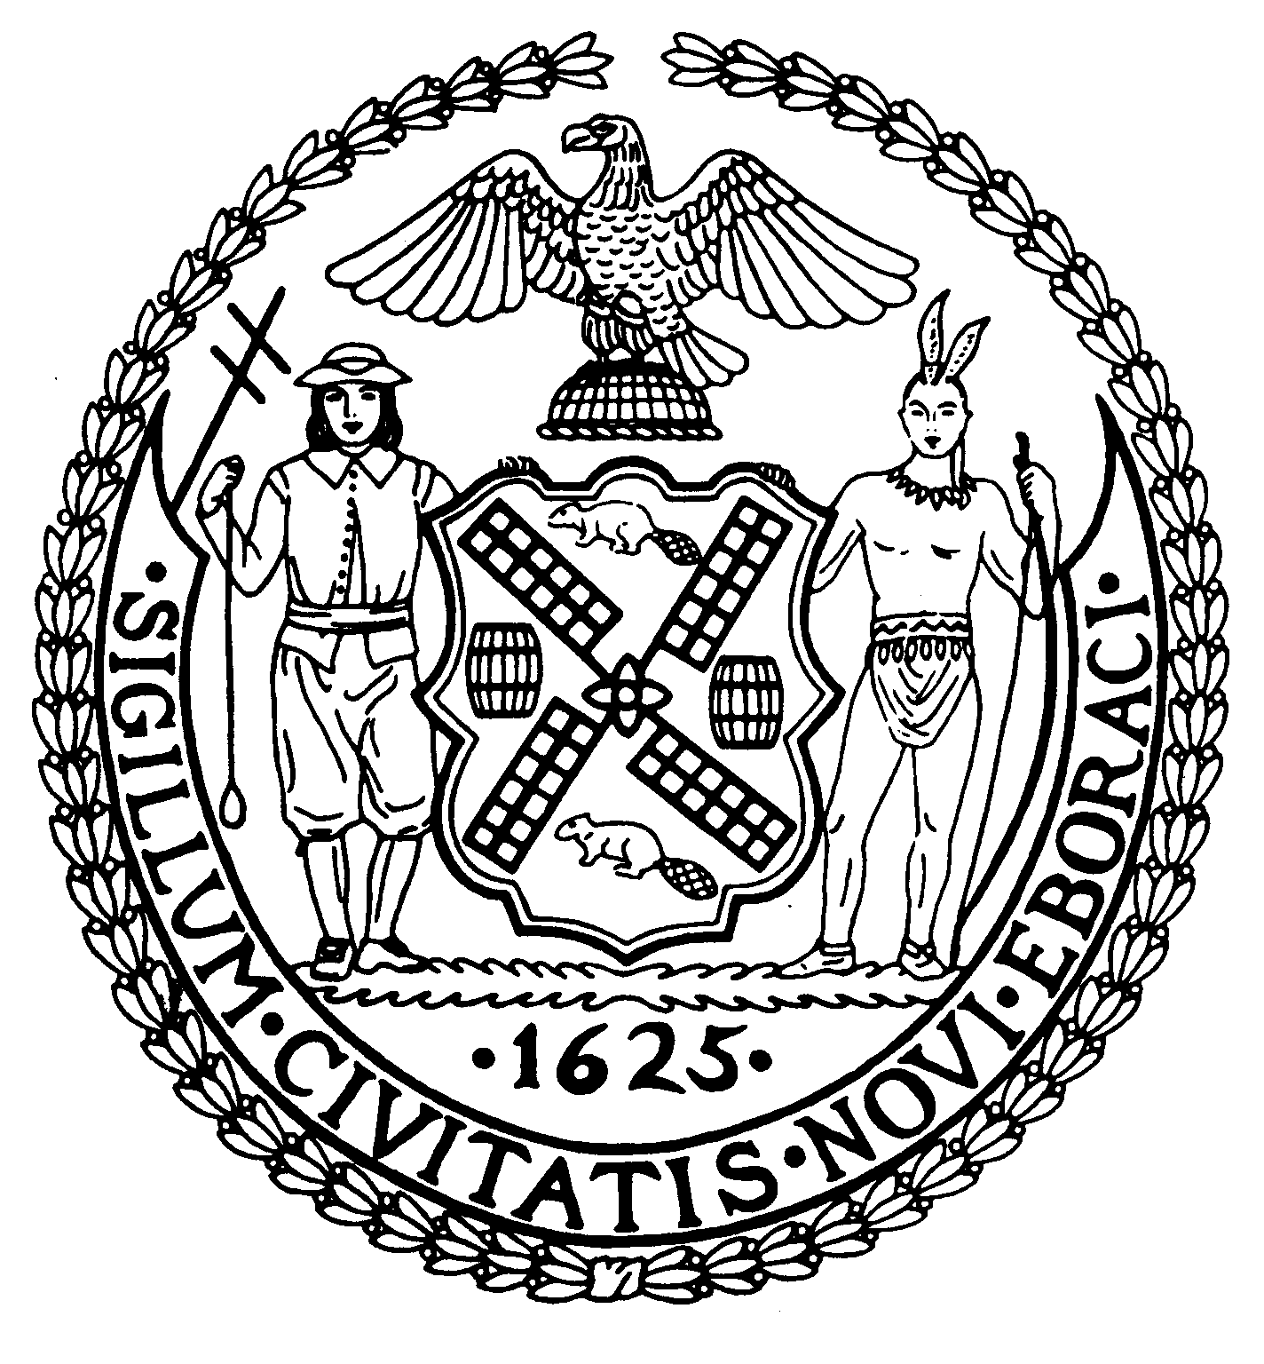
Chairman Suite 620
New York, N.Y. 10022

Latha Thompson (212) 758-4340
District Manager (212) 758-4616 (Fax)
www.cb8m.com Website
info@cb8m.com - E-Mail

The City of New York
Manhattan Community Board 8

FULL BOARD MEETING
WEDNESDAY, OCTOBER 20. 2010
Ramaz School
125 East 85th Street, Auditorium
6:30PM

DRAFT

Community Board Members Present: Joie Anderson, Elizabeth Ashby, Kenneth Austin, Michele Birnbaum, Lori Ann Bores, Deirdre Breslin, Roy Carlin, Sarah Chu, James Clynes, Christina Davis, Susan Evans, A. Scott Falk, Ruth Halberg, Lorance Hockert Lorraine Johnson, Dave Kleckner, Laura Lijewski, David Liston, Jacqueline Ludorf, Laurence Parnes, Jane Parshall, Mary Boresz Pike, Ellen Polivy, Rita Lee Popper, Margaret Price, David Rosenstein, Barbara Rudder, William Sanchez, Judith Schneider, M. Barry Schneider, Helene Simon, Teri Slater, Cos Spagnoletti, Marco Tamayo, Debra Teitelbaum, Alexander Tisch, Nicholas Viest, Betty Wallerstein, Elaine Walsh, Charles Warren, Hedi White
Community Board Members (Excused): Barbara Chocky, David Helpern, Jonathan Horn, Domenico Minerva, H. Patrick Stewart
Community Board Members (Unexcused): Michael Auerbach, Matthew Bondy, George Fuchs, N. Sharon Pope
Total Attendance: 41

Chair Jacqueline Ludorf called the meeting to order at 6:30PM.

1. Public Session:
- Member of the public, Bonnie Lane Webber, spoke briefly on hydrofracking environmental issue.
- Member of the public, Joel Mindez, representing the East 64th Street Lexington to 3rd Avenue Neighbors Association spoke on his opposition to the 157 East 64th Street restorations.
- Member of the public, David F. Segal, representing the East 64th Street Lexington to 3rd Avenue Neighbors Association spoke on his opposition to the approval of construction at 157 East 64th Street.

2. Adoption of the Agenda

3. Adoption of the Minutes – February-July 2010 Land Use and Full Board Minutes

4. Manhattan Borough President’s Report:
Kristen Ellis, a representative from the Manhattan Borough President’s office, reported on the work that Manhattan Borough President Scott Stringer was doing for the community. Among the issues are the Borough President’s commitment to keeping senior centers open, the allocation of nearly $750,000 to the NYC Dept. of Aging, rallying against rent hikes at the Rent Guidelines Board, and bringing the New York City Housing Authority’s elevators up to safety standard.

5. Elected Official’s Reports:
- State Senator Liz Krueger reported on her work with hydrofracking (gas drilling) and its detrimental effects. She stated that the Senate has passed a moratorium on hydrofracking. The Assembly has not passed it yet. She urged all New Yorkers to educate themselves on the risks of hydrofracking. She spoke on her programs for boomers, seniors and youth.
- Yvonne Przybyla, a representative from New York State Senator Jose Serrano’s office, reported on issues involving the new Select Bus Service. She announced a partnership between Senator Serrano’s office and the Legal Aid Society to hold 2 workshops on intellectual property for artists and art organizations in November. She stated that Senator Serrano is the Chair of the Cultural Affairs, Parks, Tours & Recreation Committee and recently toured the renovated Roberto Clemente State Park and the Harlem River Festival at the recently completed park at 153rd Street. She also mentioned that the Senator is on the same page with Senator Krueger on the issue of hydrofracking.
- Jean Fischman, a representative from Assembly Member Micah Z. Kellner’s office announced that Assembly Member Kellner’s legislation was signed into law. This new law will make prescription drugs more affordable to the residents of NYS especially those with chronic health problems such as HIV/AIDS and multiple sclerosis. She announced that the CBC District 2 Rezoning Committee will be meeting on October 21st, at the Wagner Middle School. The rezoning proposal will be presented and discussed during this important meeting. On November 9th Assembly Member will be meeting with constituents who have any landlord/tenant issues.
- Adam Brickman, a representative from Assembly Member Jonathan Bing’s office, announced that a mammogram van will be at the Stanley Isaacs Center on October 25th. He spoke about the Annual Senior Health Fair which was held on October 13th and stated that it was one of the most successful senior health fairs. He gave special thanks to Rita Popper and the people at Knickerbocker for helping to organize the event. They gave out 110 flu shots free of charge to seniors and over 20 organizations participated. He also expanded on the Select Bus Service. Assembly Member Bing authored a bill on camera enforcement. The cameras will be mounted on the buses and on the street routes and would work as red light cameras. The cameras will be installed in mid-November by the Department of Transportation and will help to keep the SBS bus line route clear of traffic. Also, people who purchase a paper receipt for the SBS will also be able to use their paper receipt on the local buses. Adam announced his resignation from Assembly Member Bing’s office to accept a position with the Department of Labor in Washington. He introduced his replacement, Kelly Postlewait to the board members and the public.
- David Kimble Stanley, a representative from Council Member Daniel R. Garodnick’s office, reported on the Select Bus Service and how Council Member Garodnick is working on ironing out the kinks. He also spoke about the new Energy-Saving Lighting Bill that Council Member Garodnick authored. The new law will conserve energy in new and renovated commercial buildings updating the City’s Lighting Code. He also spoke on Council Member Garodnick’s plan to overhaul the “Socks and Sausages” street fairs. The legislative package will tie street fair permits to participation by neighborhood businesses and will seek to return street fairs to their neighborhood roots.
- Dara Adams, a representative from Congresswoman Carolyn Maloney’s office, reported on the launching of the Select Bus Service and left information on the issues that Congresswoman Maloney is currently working on which includes the Second Avenue Subway report card, the celebration of the green roof at Regis High School, the US House passing of the 9/11 Health Bill, the implementation of the Patient’s Bill of Rights, federal help for NY’s small businesses, and her joint effort with other elected officials in calling for Iran to do an about-face on nuclear weapons and human rights abuses.

- Jane Swanson, a representative from Council Member Jessica Lappin’s office, reported on the free flu shots for seniors Council Member Lappin’s office was sponsoring on October 27th. She announced “It’s My Park Volunteer Day” on October 23rd - a day for volunteers to assist in cleaning up the East River Esplanade site. She thanked the CB8 Parks Committee for their efforts in coordinating the East River Esplanade Forum and stated that Council Member Lappin’s office is making a lot of progress on this. She announced the important legislation introduced by Council Member Lappin concerning anti-choice centers masquerading as health clinics. The centers are not licensed medical facilities, do not have medical staff, are located near planned parenthood clinics and their goal is to confuse people and steer
them away from legitimate medical facilities. The legislation will make these centers post signs that disclose that there is no medical staff on site, they must also post in their offices, web sites and on their advertising that they do not offer abortions, or FDA approved birth control or make referrals to places that do. They also must make any personal information provided by women in these centers confidential. A hearing will be held in a month or two regarding this important piece of legislation.

6. Chair’s Report – Jacqueline Ludorf:

Chair Jacqueline Ludorf introduced Sam Stein, a Community Planning Associate Fellow who will work with Community Board 8 this year on business issues. Sam Stein, an Urban Planning student at Hunter College spoke briefly before the board. She announced that she had the resignation letter from Betty Cooper Wallerstein, a CB8 board member and highlighted Betty’s accomplishment over the past 50 years. Betty served on the Transportation Committee, the Street Life Committee, established the 79th Street Block Association and helped to landmark the City & Suburban Houses. She thanked Betty for all her years of service. Betty also thanked the board for helping her with her work on the board.

7. Nominating Committee Report:
Election of Community Board 8 Officers
The Chair of the Nominating Committee presented the following slate of officers for the 2011 term.

Jacqueline Ludorf – Chair
Nicholas Viest– First Vice-Chair
James Clynes – Second Vice-Chair
Jonathan Horn – Secretary
Lori Ann Bores was nominated by Judith Schneider
Marco Tamayo was nominated by Teri Slater

8. Committee Reports and Action Items:
- Environment and Sanitation Committee – David Kleckner and Debbie Teitelbaum, Co-Chairs
The following resolution was adopted by a vote of 37 in favor, 0 opposed, and 0 abstentions.

WHEREAS, Manhattan Community Board 8 (CB8) convened a public forum on April 28, 2009 where information and views were shared by staff of elected officials, environment advocacy organizations, industry, and the general public which highlighted concerns about drilling in upstate New York for natural gas through a process called “hydraulic fracturing;”
WHEREAS, at the May 20, 2009 Full Board Committee Meeting of CB8, a resolution was adopted (by a vote of 38 in favor, 0 opposed, and 2 abstentions) calling for a moratorium on gas drilling by means of hydraulic fracturing at least within the Catskill/Delaware watershed region, unless and until it may be determined by DEC and other decision makers that hydraulic fracturing is safe within NYS, including posing no threat to the NYC’s water supply;
WHEREAS, the U.S. Environmental Protection Agency (EPA) is now conducting a study on hydraulic fracturing’s potential impact on drinking water, human health and the environment;

WHEREAS, a bill was introduced in the NYS legislature sponsored by Assembly Member Englebright and Senator Addabbo (A.10490A/S.7592A) that would establish a moratorium on hydraulic fracturing until 120 days after the EPA issues the report (PLEASE SEE ATTACHED LEGISLATIVE PROPOSAL);
THEREFORE, be it resolved that Manhattan CB8 supports the intent of NYS legislative proposal A.10490A/S.7592A that would establish a moratorium on hydraulic fracturing until 120 days after the U.S. EPA issues its study on hydraulic fracturing.

- Street Fair Committee – Barbara Chocky and Laura Lijewski, Co-Chairs
The following resolution was adopted by a vote of 33 in favor, 5 opposed, and 1 abstention.
RE: The public versus private use of the street closings of single block for events, i.e., the event is not open to the general public.

Whereas, there is an increase in the number of requests to close single blocks for private use by organizations and institutions,
Whereas, attendance to the event excludes the general public,
Whereas, such events can be an inconvenience to other residents of the block as well as the flow of traffic,
Whereas, city resources in time and equipment expended far out weigh the applicant fee(s) paid to the city,
Therefore, Be It Resolved, in the future, only single block closings that are fully open to the public will be approved by Community Board 8 and will be so stated in the Community Board 8 Single Block Street Fair and Event Guidelines.

- Parks Committee – Margaret Price and Barbara Rudder, Co-Chairs
1. Discussion of the extensive changes to the Tavern on the Green site in Central Park--a joint issue with the Landmarks Committee
The following resolution was adopted by a vote of 34 in favor, 2 opposed, and 2 abstentions.

RESOLUTION:
WHEREAS the Parks Dept. failed to inform Community Board 8M about the renovations to the Tavern on the Green site, which is a landmarked structure in a landmarked park; and
WHEREAS the Parks Dept., without any consultation to the Community Board 8M, awarded contracts to food vendors who will sell cooked food from unattractive and potentially polluting trucks at the Tavern on the Green site, in contrast to plans presented to Community Board 8M for vending via specialty carts; and
WHEREAS the Parks Dept. ignored Community Board 8M’s July 2010 resolution asking the Department to postpone issuing RFPs for food vendors on the Tavern on the Green site until they presented their plans to the Community Board; and
WHEREAS the Parks Dept. ignored all of Community Board 8M’s suggestions effective and attractive ways to sell food temporary at the Tavern on the Green site; therefore,
BE IT RESOLVED that Community Board 8, Manhattan, expresses outrage over the failure to inform the Board before renovations were made to the Tavern on the Green site and contracts were awarded for selling food at the site from trucks instead of the previously intended specialty carts; and
BE IT FURTHER RESOLVED that CB8M urges the Parks Department to halt plans for allowing vendors to sell food at the Tavern on the Green site until an alternative to the use of trucks is identified
2. Proposal for a Concession to sell Christmas trees at Tramway Plaza
The following resolution was adopted by a vote of 36 in favor, 2 opposed, and 0 abstentions.

RESOLUTION:
WHEREAS the Parks Dept.’s proposed concession to sell Christmas trees at Tramway Plaza annually for four years from Nov. 24 to Dec. 26 could interfere with current and future construction projects in that immediate area; and
WHEREAS a large stock of Christmas trees for sale along the Second Avenue side of Tramway Plaza could obstruct the area’s sidewalk, making passage difficult for pedestrians; and double wide strollers; and
WHEREAS the area lacks the space for the vendor’s necessary truck on either E. 59th or E. 60th and Second Avenue; and
WHEREAS the sidewalk on the west side of Second Ave. carries all north/south pedestrian traffic due to the lack of sidewalk on the east side of Second Ave at the Queensboro Bridge; therefore,
BE IT RESOLVED that Community Board 8, Manhattan, disapproves of the Parks Dept.’s proposal for a Christmas tree concession at Tramway Plaza for four years.
BE IT FURTHER RESOLVED that CB8M disapproves of any future plans for Christmas tree sales at Tramway Plaza due to the likelihood that the trees on display would obstruct the area’s sidewalk.

- Landmarks Committee – David Liston and Jane Parshall, Co-Chairs
1. The Solomon R. Guggenheim Foundation – 1071 Fifth Avenue (89th Street)- Individual Landmark -- Mr. Andre Kikoski, Architect – Application is to install a free standing kiosk in front of the building.
The following resolution was adopted by a vote of 39 in favor, 0 opposed, and 0 abstentions.

WHEREAS 1071 Fifth Avenue is a Modern-style museum building designed by Frank Lloyd Wright and constructed 1956-59.
WHEREAS the applicant has proposed at 75 sq. ft. teardrop-shaped kiosk (for food) that would sit below the overhang of the museum and in front of the book store.
WHEREAS the tear-drop shape of the kiosk mimics the “football-shaped” geometry that Frank Lloyd Wright used throughout the building for various design elements such as the drinking fountains.
WHEREAS the kiosk would be 6 ½’ wide x 12’ long and the material would be simple resin.
WHEREAS the kiosk would clean up some of the visual noise in front of the museum and improve the flow of people in a very public space.
WHEREAS the kiosk, although designed to be portable, would not be removed every day and has the danger of looking like a permanent addition to the museum.
WHEREAS the design for the kiosk takes away from the sweep of the concrete spiral above it which expands upward from a low base (the most prominent design feature of the landmarked museum) and presents an architectural statement that will appear to be permanent.
WHEREAS the kiosk will add to the congestion of the streetscape, already very congested.
WHEREAS the kiosk interferes with the imagery of the Frank Lloyd Wright museum
WHEREAS to put an object of any kind in front of one of the most architecturally significant buildings in New York City makes it appear as if one is actually adding on to Wright’s building.
WHEREAS The Solomon R. Guggenheim Museum is a masterpiece; it should not be tampered with.
THEREFORE BE IT RESOLVED that this application is disapproved as presented.

2. 930 Fifth Avenue (74th Street) – Upper East Side Historic District – Mr. Stephen Wang Architect. Application is to install new windows.

WHEREAS 930 Fifth Avenue is a nineteen-story Classicizing Modern apartment building designed by Emery Roth & Sons, and built in 1940.
WHEREAS the original windows at the above-referenced location were steel casement windows with vertical and horizontal divisions.

WHEREAS in 1985 the Landmarks Preservation Commission approved a Master Plan (the “1985 Master Plan”) for the installation of new windows with reduced mullions compared to those in the original windows.
WHEREAS many windows were replaced as per the at the 1985 Master Plan however there remains a patchwork of windows of various window configurations, including single pane, double pane, and triple pane windows, with only a few original windows remaining.
WHEREAS the applicant proposes a new Master Plan (the “Proposed Master Plan”) pursuant to which there will be various window configurations for different vertical lines of the building and 1) all windows on the first three floors will be exact replicas of the original windows (“Part 1 of the Proposed Master Plan”) and 2) all windows above the third floor will be the same as the original windows except that they will not have the horizontal mullions that were part of the original windows and which will be part of the windows on the first three floors as per the Proposed Master Plan (“Part 2 of the Proposed Master Plan”).
WHEREAS the Landmarks Committee wishes to vote separately on the Parts 1 and 2 of the Proposed Master Plan.

The following resolution was adopted by a vote of 39 in favor, 0 opposed, and 0 abstentions.
Part 1 of the Proposed Master Plan:

WHEREAS Part 1 of the Proposed Master Plan will restore the windows of the first three floors to their original configurations, thereby reverting back to the architect’s original intent and original design.
THEREFORE BE IT RESOLVED that Part 1 of the Proposed Master Plan is approved as presented.

The following resolution was adopted by a vote of 3 in favor, 29 opposed, and 7 abstentions.
Part 2 of the Proposed Master Plan:

WHEREAS Part 2 of the Proposed Master Plan will result in a uniform plan consistent with the architect’s original intent and original design.
THEREFORE BE IT RESOLVED that Part 2 of the Proposed Master Plan is approved as presented.

- 841 Lexington Avenue (64th Street) -- Upper East Side Historic District- Mr. Daniel P. Allen, Architect – Application is to replace storefront infill and install signage.
The following resolution was adopted by a vote of 36 in favor, 0 opposed, and 2 abstentions.

WHEREAS 841 Lexington Avenue is a Simplified Colonial Revival style store and apartment building, designed by Thomas W. Lamb and constructed in 1929.
WHEREAS the second floor windows are similar to the windows in the 1940 tax photo. (The applicant was not able to locate any earlier photographs of the building.)
WHEREAS the applicant will make repairs to the first two floors of the building (the top three floors are not part of this application) including cleaning and patching the existing limestone and removing paint.
WHEREAS the large storefront mullion-less windows are appropriate to a retail establishment.
THEREFORE BE IT RESOLVED that this application is approved as presented.

- 44 East 74th Street (Madison and Park Avenues) – Upper East Side Historic District – Mr. Paul Gregory, architect – Application is to legalize modifications to a bay window and replacement of a window without Landmarks Preservation Commission permits.
The following resolution was adopted by a vote of 38 in favor, 0 opposed, and 0 abstentions.

WHEREAS 44 East 74th Street is a Beaux Arts style residence, designed by the George F. Pelham and built in 1904-1905.
WHEREAS without approval by the Landmarks Preservation Commission, a bay window on the south rear yard of the building was modified and a window, also on the south rear yard, was replaced.
WHEREAS the above referenced bay window was converted from a straight casement window to a Juliet balcony with doors that swing inward.
WHEREAS the above-referenced window was a casement window and was replaced by a French doors and a walkout balcony.

WHEREAS Community Board 8 does not condone such changes being made without approval by the Landmarks Preservation Commission.
WHEREAS despite the fact that the necessary approvals were not obtained prior to the changes being made, said changes have resulted in a rear facade more consistent with the character of the building and with the intentions of the original architect.
THEREFORE BE IT RESOLVED that this application is approved as presented.

- Budget Committee – Barbara Chocky and Roy Carlin, Co-Chairs
Manhattan Community Board 8 adopted the following Capital and Expense Budget Priorities for Fiscal Year 2012. The Capital Budget Priorities were passed by a vote of 33 In Favor, 2 Opposed, 2 Abstentions and 1 Not Voting For Cause and the Expense Budget Priorities were passed by a vote of 37 in favor, 1 opposed and 0 abstentions.

Capital Budget Priorities-40
- Increase funding for permanent housing for homeless people.
- Provide funding to repair and restore the Esplanade.
- Funding for the creation of an Older Adult recreation area in John Jay Park
- Fund repair of roof and rooftop HVAC at 67th Street Library to protect recently restored millions spent on this branch
- Fund the installation of Fire Alarm system for the Yorkville and Webster Branch libraries
- Fund a permanent school building for children zoned for PS 151
- Fund a fully built park along the East River between 60th and 63rd Streets
- Fund full renovation of Carnegie Hill Library located at 112 East 96th Street
- Fund the expansion of the Roosevelt Island Branch Library
- Fund the installation of pedestrian countdown timers and audible accessible crossings signals for intersections
- Increase funding for HPD 8A Loan Program for rehabilitation of Multiple Dwelling Buildings
- Provide funding to make the Yorkville Branch Library ADA compliant
- Provide funding to relocate and upgrade the energy source for Stanley Isaac Housing to prevent brownouts
- Provide funding for the design and reconstruction of the NYC Department of Sanitation’s M6/M8/M8A Garage

Continuing Support/Capital:
CS Provide funding to construct additional public school seats to accommodate current and projected overcrowding
CS Provide funding for the renovation of the woman’s homeless shelter at the Park Avenue Armory
CS Provide funding for the reconstruction of the East Meadow in Central Park
CS Provide funding to complete the repair and reconstruction of the bridges at 78th and 81st Street over the FDR
CS Provide funding for air conditioning in all homeless shelters
CS Provide funding to upgrade the computer center at Hunter College Campus School
CS Provide funding for Third Water Tunnel Main

Expense Budget Priorities-25
- Continue to fund Out of School Time Programs for all children who go to school in Community District 8 or who have parents that work in Community Board 8.
- Increase funding for youth programs in Community Board 8.
- Increase funding for Rodent Extermination on city streets.
- Fund the NYC Department of Parks and Recreation and the Department of Sanitation for the placement of “rat-proof” garbage containers with lids in Community Board 8 Parks and throughout the district.
- Increase funding for services to Older Adults, including Personal and Home Care; Transportation Services; Meals-On-Wheels; and Senior Congregate Care Meal Programs.
- Increase funding for Homeless Services Outreach personnel, especially during the overnight hours and provide the Department of Homeless Services with updated Information Technology equipment.

- Provide funding to the NYC Department of Transportation for the necessary materials and personnel to repair potholes and repave avenues and major cross-town streets more frequently than every 10 years within Community Board 8.
- Fund maintenance workers to repair and preserve the infrastructure
- Extend funding for NYC Department of Parks and Recreation workers from seasonal to year round
- Provide funding to purchase Bobcat and accessories for NYC Department of Parks and Recreation for Community Board 8
- Provide funding for additional Traffic Control Agents
- Provide additional funding for Eviction Prevention Services for At-Risk Senior Citizens.
- Increase funding for the Department of Health enforcement of all Food Vendor rules and regulations.
- Increase funding for additional Park maintenance staff, tree pruners and tree climbers.
- Provide funding to all NYPL to maintain six-day service, increase hours, resources and programs.
- Provide additional funding for Children’s Services, especially programs to prevent abuse and neglect.
- Restore funding for all staffing of FDNY Fire Marshalls.
- Provide funding for small business loans to all businesses affected by Second Avenue Subway construction.
- Fund additional PEP officers for all Community District 8 Parks.
- Continue funding for basket service.
- Maintain recycling program
- Continue funding to NYCHA to insure that all community senior centers remain open.
- Continue funding to insure all NYCHA community centers remain open.
- Fund additional DCA inspectors for sidewalk café and street vendor regulation enforcement.

9. Old Business:

No old business discussed.

10. New Business:

No new business discussed.

With no further business the meeting was adjourned at 10:00PM.

