Jacqueline Ludorf 505 Park Avenue
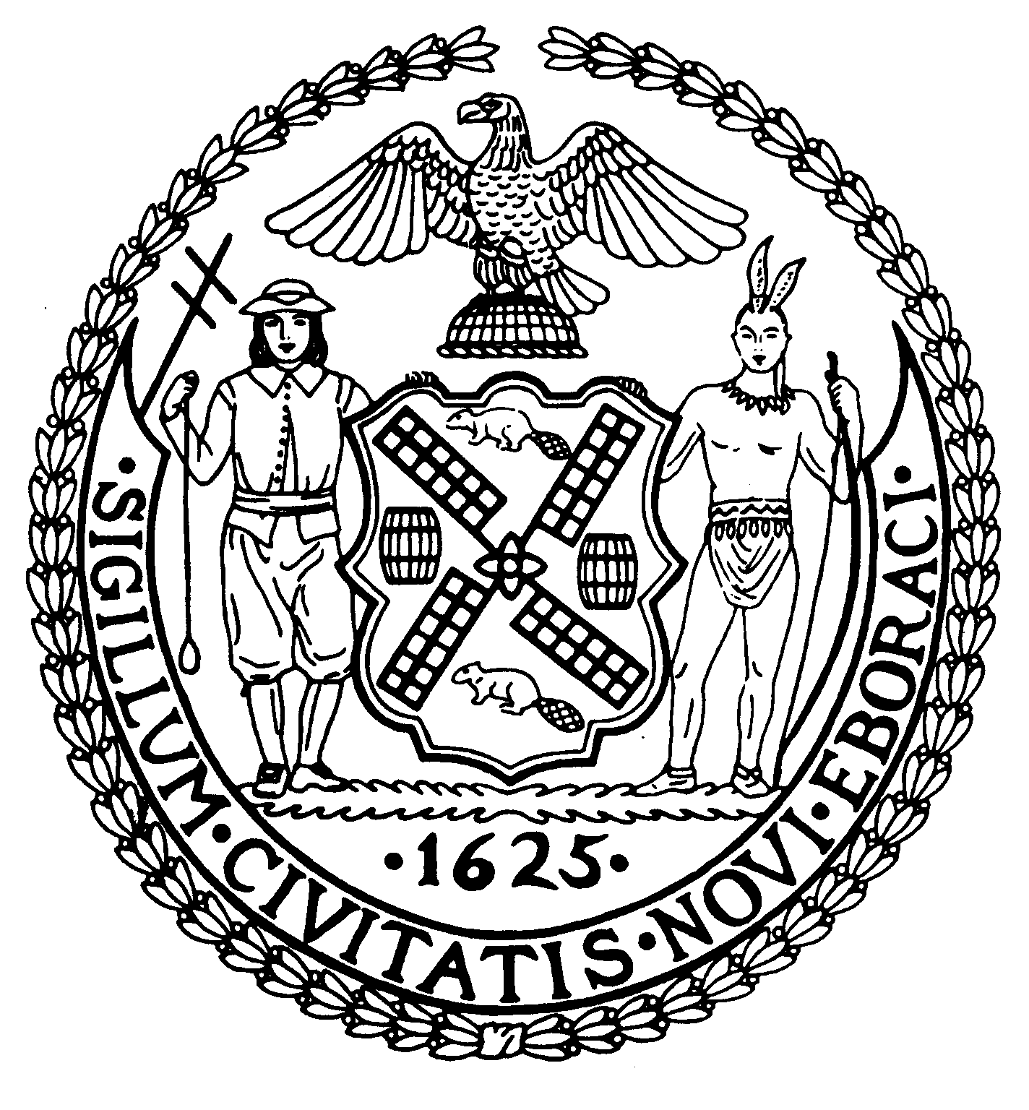
Chairman Suite 620
New York, N.Y. 10022

Latha Thompson (212) 758-4340
District Manager (212) 758-4616 (Fax)

W ww.cb8m.com Website
info@cb8m.com - E-Mail

The City of New York

Manhattan Community Board 8

Youth and Education Committee Meeting

New York Blood Center, 310 East 67th Street, Conference Room 1
October 25, 2010 7:00 pm

ADDITIONAL ITEMS MAY BE ADDED TO THE AGENDA, PLEASE CHECKWITH THE BOARD OFFICE.

Agenda

- Re-zoning for Community District 8

- Update on PS 267

- Update on 2nd Teacher/Aid in the classroom.

4. Future Meetings
November:
December:

5. Old/New Business

James Clynes and Judith Schneider, Co-Chairs

