Jacqueline Ludorf 505 Park Avenue, Suite 620
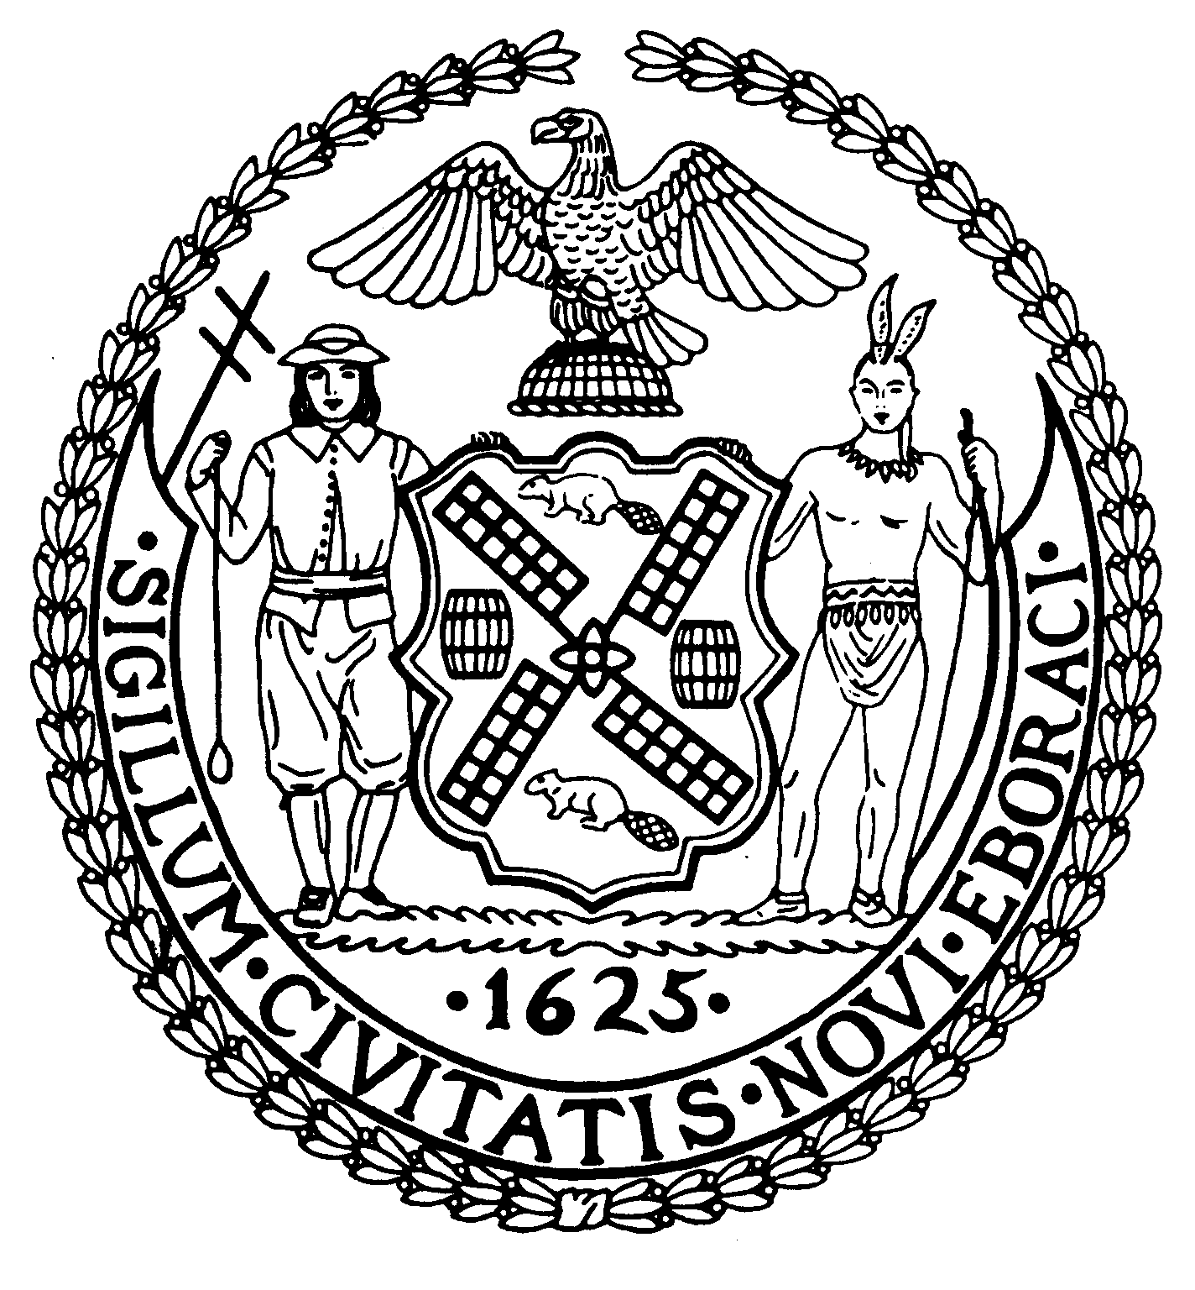
Chair New York, N.Y. 10022-1106
(212) 758-4340
Latha Thompson (212) 758-4616 (Fax)
District Manager www.cb8m.com - Website

info@cb8m.com - E-Mail

The City of New York
Manhattan Community Board 8

Landmarks Committee, September 19, 2011 – 6:30PM
Marymount Manhattan College, 221 East 71st Street, Regina Peruggi Room, 2nd Fl.

Present: Jane Parshall, Teri Slater, Elizabeth Ashby, Marco Tamayo, Susan Evans, Michele Birnbaum, David Liston, Joie Anderson, Christina Davis, Kenneth Austin, Molly Blayney

Absent Excused: David Helpern

- 3 East 80th Street (between Fifth and Madison Avenues) – Metropolitan Museum Historic District – Mr. George Schwartz, Architect – Application is to legalize the installation of areaway fence, windows, and security grilles in non-compliance with COFA 98-6801.

WHEREAS, 3 East 80th Street is a Beaux-Arts style residence designed by Welch, Smith and Provot and constructed in 1898-99.
WHEREAS, the Committee was not given an opportunity to evaluate the design; the applicant presented to the committee without any boards.
WHEREAS, the presentation was incomplete.
THEREFORE BE IT RESOLVED, that this application is disapproved as presented.

VOTE: 9 in favor (Blayney, Tamayo, Anderson, Evans, Birnbaum, Parshall, Davis, Ashby, Austin)

- 34 East 67th Street – (between Madison and Park Avenues) [The International Wallenberg Foundation] – Upper East Side Historic District - George Schwarz Architect PLLC – A rowhouse built in 1877-78, and altered in the neo-French Classic style in 1910 by S.E. Gage. Application is to install a flagpole and artwork.

WHEREAS, the flagpole would be bronze in color, would be 4' long and extend at an angle from a second floor window on the front of the building;
WHEREAS, the flag itself would be approximately 3' by 2.5'; and the proposed bust of Raoul Wallenberg would be 14" and 7" wide and would sit on an existing second floor ledge on the front of the building;
WHEREAS, the dimensions and design of the above changes would not negatively alter the character of the building
THEREFORE BE IT RESOLVED, that this application is approved as presented.

VOTE: 5 in favor (Slater, Birnbaum, Liston, Davis, Austin) 5 absentions (Anderson, Tamayo, Blayney, Evans, Parshall, Ashby)

- 155 East 72nd Street (between Lexington and Third Avenues) – Upper East Side Historic District Extension - A Renaissance Revival/Colonial Revival style apartment building, constructed in 1920s. Application is to replace windows.

DID NOT SHOW

- 630 Park Avenue (between 65th and 66th Street) – Upper East Side Historic District - Donata Maselli RA – A Neo-Renaissance apartment building designed by J.E.R. Carpenter and built in 1923-24. Application for enlargement and alterations to existing penthouse apartment.

WHEREAS, application to enlarge and alter existing penthouse
WHEREAS, said changes are to include a 6' by 25' enlargement of the kitchen on the West side of the penthouse, replacing post-modern windows with casement windows, and replacing dilapidated gutters, pipes, and windows.
WHEREAS, the proposed changes will be minimally visible from the public way, will incorporate symmetry to a hodgepodge of windows and other elements, and will involved materials consistent with the rest of the building.
THEREFORE BE IT RESOLVED, that this application is approved.

VOTE: 11 in favor (Anderson, Slater, Tamayo, Blayney, Evans, Birnbaum, Parshall, Liston, Davis, Ashby, Austin)

- 933-943 Madison Avenue (between 74th and 75th Streets) – Upper East Side Historic District – Beyer, Blinder, Belle, Architects. Application is to demolish and construct a new building at 943 Madison (“a no-style” building in the district designation report), to construct rooftop additions on and restore the bases to 933-41 Madison and 31-33 East 74th Streets, to install new storefronts at 933-41 Madison and for new construction at the rear of 933 Madison.

WHEREAS, 943, 941, 939, 937, 935 and 933 Madison Avenue consist of 6 neo-Grec style row houses adjacent to the Whitney Museum.
WHEREAS, 5 of these houses are contributing buildings within the historic district; 943 Madison, which is adjacent to the Whitney, is considered a non-contributing or no-style building within the historic district; all 6 houses have infill in the rear yards.
WHEREAS, 933/935 Madison Avenue turns the corner and extends along E. 74th Street for 56’7 ½”; followed by an approx. 18’ wide infill two-story building along 74th Street and culminating in 31 E. 74th Street, a neo-Gre style brownstone and 33 E. 74th Street, a Beaux Arts mansion designed by Grovesnor Atterbury.
WHEREAS, 31 E. 74th Street has an existing bulkhead that presents as a huge mechanical box so that the overall height is approx. 82’; 33 East 74th St. has infill in the rear yard.
WHEREAS, the Whitney Museum opened in 1966; the roofline/outline of the Whitney plays an important part in the overall design presented by the applicant.
WHEREAS, the applicant is proposing to restore the front elevations only of the houses along Madison and E. 74th Streets; to redesign in a more modern vocabulary – the house adjacent to the Whitney and the infill building on 74th Street (933/935 Madison turns the corner, then the 2-story infill building and then 31 East 74th St.) and to construct a mid-rise building with set-backs behind all of the restored facades.
WHEREAS, the applicant, believes that the contributing row houses inform the site and that the design for 943 Madison and the design for the infill site on E. 74th Street, will anchor the proposed modern mid-rise building that will sit directly behind all of the restored facades.
WHEREAS, the proposed mid-rise building will contain 13-15 apartments and be from 7 to 10 stories high; the only place where the proposed mid-rise building will come down to the ground and not present any setbacks is at the proposed construction on E. 74th St. to replace the infill building, which will be setback 7 ft. from the street line. This new construction will contain the entrance to the proposed mid-rise building and will have a glass canopy/marquee.
WHEREAS, all of the brownstones along Madison, including the no-style building at 943 Madison have 3 sets of paired windows at the 3rd, 4th, and 5th floors with enframements and projecting cornices.
WHEREAS, behind these brownstone elevations, the proposed mid-rise building will be stepped back: at the 1st floor enlargement/addition, [the new 7th floor], there will be a 17’set back, the floor above will have a 34’ setback (the 2nd floor of the proposed enlargement/addition) [the new 8th floor] – the additional floors of the proposed mid-rise building will be set back 56’ from Madison Avenue so that the building presents as “a step-up” building that mimics the roofline of the adjacent Whitney Museum (designed in the Brutalist manner by Marcel Breuer).
WHEREAS, the no-style non-contributing house at 943 Madison will present a more contemporary expression of a row-house and will ground the proposed contemporary mid-rise building back to Madison Avenue.
WHEREAS the new construction will have a terracotta finish – matching the color of the brownstones along Madison - both at 943 Madison and on the site of the infill building on 74th Street. The proposed mid-rise will be finished in a lighter color.
WHEREAS, the proposed new construction at the site of the infill building on E. 74th St. will be set back 7’ and will be the entrance to the proposed mid-rise building.
WHEREAS, 31 East 74th St. and 33 E. 74th Street are at the street wall; the proposed mid-rise building will be set back 25’ from the street wall on 74th St.
WHEREAS, at the Atterbury house at 33 East 74th St., there is an existing one-story addition with an infill structure at the rear; this infill structure will be removed and a garden will be returned to the rear yard.
WHEREAS, the proposed mid rise building mimics from all elevations the step-back roofline of the Whitney and is minimally visible from the street.
WHEREAS, the applicant is preserving the aggregate nature of the row-houses along Madison with the proposed mid-rise behind; along the east elevation of the proposed mid-rise building, the new building will present as mostly a concrete wall.
WHEREAS, the mechanical penthouse at the top of the proposed new mid-rise building will be covered in zinc.
WHEREAS, the applicant proposes the complete restoration of the 5 contributing (within the historic district) row houses along Madison including new wood windows that will match the profiles of the existing windows, the window enframements will be repaired, the bracketed cornice will be repaired, the pilasters will be restored or replaced.
WHEREAS at 31 East 74th Street, there will be a complete restoration of the façade as well at 33 East 74th St.
WHEREAS, the applicant presented a Master Plan for the storefronts along Madison Avenue that will give some flexibility to the individual retail uses (as yet undetermined).
WHEREAS, the houses on both Madison Avenue and East 74th St. plus including all existing infill, now consist of approx. 53,000 sq. ft.; there will be approx. 17,000 sq. ft. of new construction so that the proposed application will result in a property with approx. 70,000 sq. ft.
WHEREAS, at its highest point, the proposed mid-rise building will be 102’ and if the height to the top of the mechanicals is included, the overall height will be 117’.
WHEREAS, the applicant will need height and setback waivers [Zoning Variance] from the Board of Standards and Appeals since the proposed mid-rise building with its series of setbacks is in conflict with the Madison Avenue Special District Guidelines which require a straight line up from the street wall until a height of 110’.

THIS APPLICATION IS DIVIDED INTO 3 PARTS: 1. The proposed restoration of 941, 939, 937, 935, 933 Madison Avenue and 31 and 33 East 74th Street; 2. The proposed mid-rise building which includes the roof-top additions/enlargements to the contributing row houses along Madison Avenue and the two houses on E. 74th Street and 3. The proposed treatment for the no-style row house at 943 Madison Avenue and the infill building on E. 74th Street.

PART 1. The proposed restoration of 941, 939, 937, 935, 933 Madison Avenue and 31 and 33 East 74th Street

WHEREAS, the proposed work on the above houses will restore them to their original condition, including keeping the rhythm of the storefronts to the doors for the retail space along Madison Avenue.
WHEREAS, all original historic fabric will be restored to a significant intact row of houses along Madison Avenue.
THEREFORE BE IT RESOLVED, that Part 1of this application is approved as presented.

VOTE: 11 in favor (Anderson, Slater, Tamayo, Blayney, Evans, Birnbaum, Parshall, Liston, Davis, Ashby, Austin)

PART 2. The proposed mid-rise building which includes the roof-top additions/enlargements to the contributing row houses along Madison Avenue and the two houses on E. 74th Street.

WHEREAS, the proposed mid-rise building artificially attempts to integrate contemporary architecture with the traditional existing streetscape within the historic district.
WHEREAS, the architecture within the existing streetscape consists of the Brutalist architecture of the Whitney Museum, the Beaux Arts masterpiece at 33 East 74th Street and the neo-Grec brownstones along Madison; the proposed new construction for the mid-rise building, even though to be clad in terra cotta, is not contextual within the historic district.
WHEREAS, the proposed design has too many parts to it; with the mechanicals, it will be at the approximate height of the Whitney Museum.
WHEREAS, while the applicant is restoring the brownstones along Madison and the brownstone and house along 74th Street, no historic material of any kind will be retained anywhere beyond the depth of the front elevations; the proposed project does not fit into the urban context within the historic district
THEREFORE BE IT RESOLVED, that Part 2 of this application is disapproved as presented.

VOTE: 10 in favor (Anderson, Slater, Tamayo, Blayney, Evans, Birnbaum, Parshall, Liston, Ashby, Austin) 1 abstention (Davis)

PART 3. The proposed treatment for the no-style row house at 943 Madison Avenue and the infill building on E. 74th Street.

WHEREAS, the no-style, non-contributing building at 943 Madison presents as a contemporary row house design and will be clad in terra cotta with retail space at the first two floors and residential space above
WHEREAS, the intent of the modern design is to anchor the proposed mid-rise building back to Madison Avenue.
WHEREAS, the new construction proposed for the infill building on E. 74th St. (between the turn onto 74th St. of 933 Madison and 31 East 74th Street) will be set back 7 ‘ from the street line and will provide the entrance to the proposed mid-rise building.
WHEREAS, the modern design of both buildings is out of context and inappropriate within the historic district and artificially attempts to integrate contemporary architecture with the existing historic streetscape within the historic district.
THEREFORE BE IT RESOLVED, that Part 3 of this application is disapproved as presented.

VOTE: 5 in favor (Anderson, Tamayo, Evans, Ashby, Austin), 3 against (Parshall, Liston, Davis), 3 abstentions (Slater, Blayney, Birnbaum)

- 75 East 93rd Street aka 1180 Park Avenue – Expanded Carnegie Hill Historic District – URS Corporation – A neo-Federal mansion designed by Delano & Aldrich and built in 1917-18. Application is to install telecom antennas.

WHEREAS, there are presently two antennas, both on the corner of the property at 93rd Street and Park Avenue, one on the 93rd Street side and the other on the Park Avenue side.
WHERAS, the applicant wishes to install two more antennas, both on the corner of the property at 93rd Street and Park Avenue, one on the 93rd Street side and the other on the Park Avenue side, each to be identical to the two existing two antennas in terms of size and general presentation, one new antenna approximately 12" away from an existing antenna, and the other new antenna the same distance from the other existing antenna.
WHEREAS, doubling the number of antennas in so visible a portion of this building will be at odds with the character and design of same.
THEREFORE BE IT RESOLVED, that this application is disapproved.

VOTE: 11 in favor (Anderson, Slater, Tamayo, Blayney, Evans, Birnbaum, Parshall, Liston, Davis, Ashby, Austin)

- 20 East 93rd Street (between Fifth and Madison Avenues) – Expanded Carnegie Hill Historic District - Brian E Boyle, AIA – A Romanesque Revival rowhouse constructed in 1892-93 by Walter Reid, Jr. and altered in 1949 by Joseph Schucheim. Application is to alter the entrance, rear façade, and windows.

WHEREAS, the applicant proposes to alter the entrance, rear facade, and windows.
WHEREAS, the application proposes to return the stoop and the front door to its historic condition.
WHEREAS, the building presently has an extension of 14' into the rearyard, and the applicant wishes to pull that extension back by 7' and extend the adjacent portion of the rear of the building so that the portion pulled back and the portion extended will meet and form an even rear facade.
WHEREAS, the applicant proposes to replace the existing one over one double hung aluminum windows at the rear of the building with eight over eight double hung windows made of wood.
WHEREAS, the proposed changes will restore the building to its historic appearance, make the building more consistent with the character of neighboring buildings, and will restore space to the rearyard.
THEREFORE BE IT RESOLVED, that this application is approved.

VOTE: 11 in favor (Anderson, Slater, Tamayo, Blayney, Evans, Birnbaum, Parshall, Liston, Davis, Ashby, Austin)

- Old Business: Continued Discussion of Committee Procedures and Practices.

- Discussed the importance of talking through in an open, inclusive, and constructive fashion suggestions related to the manner in which the committee functions
- Discussed a number of suggestions concerning committee practices and procedures
- Discussed the importance of collegiality and of maintaining a civic dialogue.

