Jacqueline Ludorf 505 Park Avenue
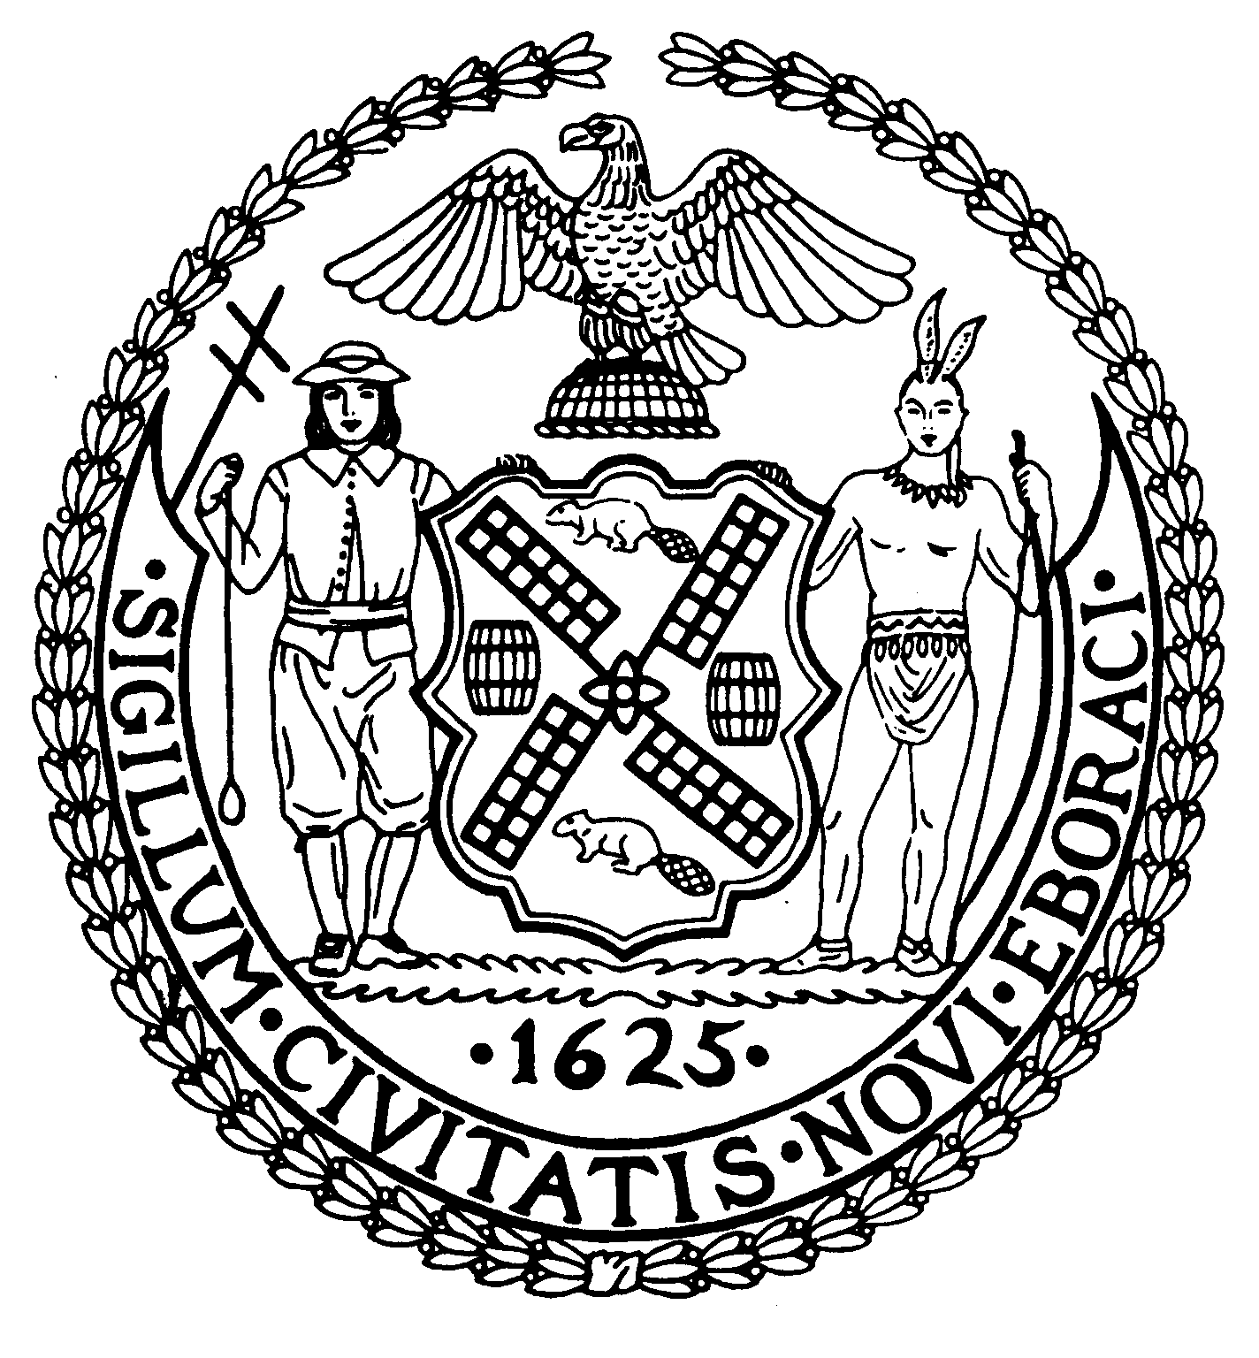
Chairman Suite 620
New York, N.Y. 10022

Latha Thompson (212) 758-4340
District Manager (212) 758-4616 (Fax)
www.cb8m.com Website
info@cb8m.com - E-Mail

The City of New York
Manhattan Community Board 8
Transportation Committee
Wednesday, September 1, 2010
NY Blood Center
310 East 67th Street, Auditorium

Present: Michele Birnbaum, Scott Falk, Lorance Hockert, Jonathan Horn, Rita Popper, Barry Schneider, Judy Schneider, Betty Wallerstein, Charles Warren, Hedi White

Absent (excused):, Helene Simon, Alex Tisch, Jim Clynes
Absent (unexcused): Michael Auerbach,

The meeting was called to order by co chair Jonathan Horn at 6:35 pm.
- Update on Roosevelt Island Tram Station Design (joint item with Roosevelt Island & Parks Committee)

Fernando Martinez from RIOC provided an update on the tram station design. Both the RI and Manhattan stations will be renovated and feature improvements including an expanded, enclosed waiting area. The final design of the Manhattan station is similar to the proposal shown to CB8 in June 2009. There was some concern about the translucent lighting at the top of the station. The committee was reassured that the lighting will not shine upwards and that they are working closely with a lighting consultant to minimize impacts to the front and sides. The lighting will be LED and they will be able to control the brightness as needed.

- Update on Wall Street shared ride taxi stands, Wall Street vans and other group ride stands

Dominic Coluccio from the TLC was present. The group ride stand at 72nd and Lexington has not been successful. The new Wall Street stand at 71st and York has also not been successful so far. The committee was extremely concerned by Mr. Coluccio’s comment that the long-standing taxi stand at 79th and York was now for Wall Street group rides only. This is contrary to what the CB and the public wanted, as well as not in keeping with TLC’s own regulations and signage. There is tentatively a meeting scheduled for next week with TLC Commissioner Yassky by Jessica Lappin’s office which will be attended by representatives of all our local elected officials to discuss this stand. (Note: The meeting occurred on September 7, at which time the Commissioner confirmed that Mr. Coluccio spoke in error. The 79th & York stand remains a “group and standard” ride stand. However, he would not commit to additional outreach to the public and taxi drivers to reinforce this fact at that time. He promised a further answer the week of September 13th)

- Update on Bolt Bus stop locations in CB8.

Item laid over to October at applicant’s request.

- Update from DOT on the installation of pedestrian crosswalk timers in CB8

Josh Orzeck from DOT reported that as a result of a recent Pedestrian Safety study, 1500 countdown pedestrian timers will be installed citywide. In CB8, they will be installed on the entire length of Park Avenue. Manhattan Borough Commissioner Forgione has requested that certain intersections (such as 79th & York) that were previously targeted by CB8 be prioritized for the second phase of installation. At this time, there are no plans for any of the other measures recommended by the study to be implemented in CB8.

- Old Business

There was no old business.
- New Business

There was no new business.

The meeting was adjourned at 7:40 pm
Respectfully submitted,
Jonathan Horn and Charles Warren, Co-chairs

