Jacqueline Ludorf 505 Park Avenue, Suite 620
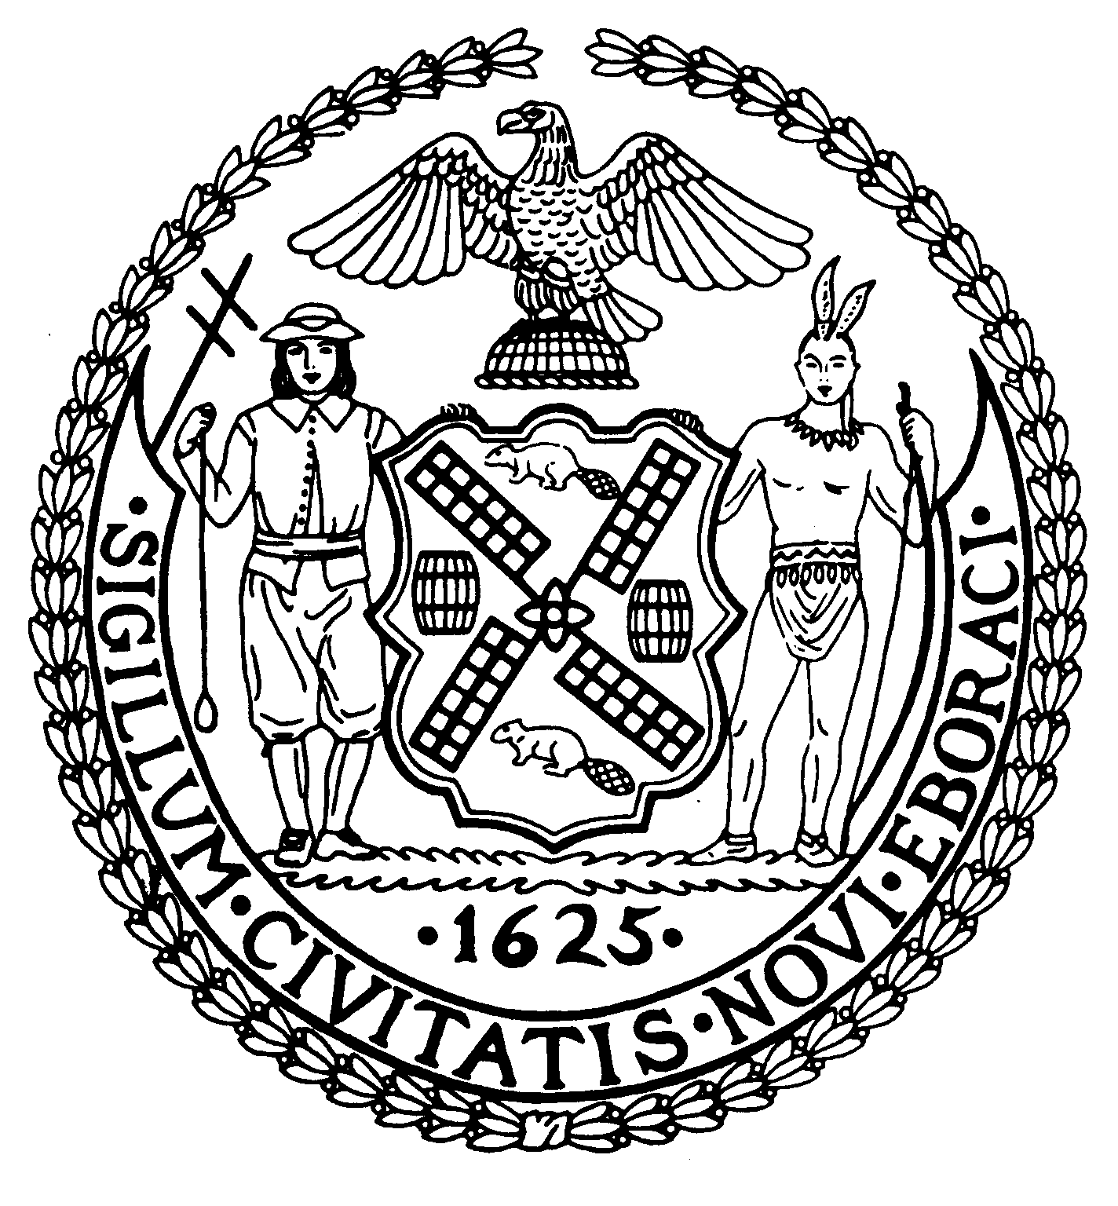
Chair New York, N.Y. 10022-1106
(212) 758-4340
Latha Thompson (212) 758-4616 (Fax)
District Manager www.cb8m.com - Website

info@cb8m.com - E-Mail

The City of New York
Manhattan Community Board 8
Parks Committee meeting
Thursday, September 16, 2010, 6:30 PM
New York Blood Center
310 East 67th St., Conference Room 1
CB8 members present: Michele Birnbaum, Susan Evans, Scott Falk, Mary Pike, Rita Popper, Peggy Price, Barbara Rudder, Judy Schneider, Teri Slater, Betty Wallerstein.
Excused: Barry Schneider
Public member Excused: Laura Mayer

1. Discussion of the extensive changes to the Tavern on the Green site in Central Park--a joint issue with the Landmarks Committee
At the July Parks Committee meeting, two representatives from the Parks Department discussed a pending RFP for three specialty food and one beverage/liquor carts to be placed on the terrace of the Tavern on the Green site. We were told that these carts would serve cold, gourmet food. The contract would be for one year, with a possible one year renewal. The Central Parks Conservancy would operate a Visitors’ Center in the building for three years while the City identifies a restaurant operator for this site. Because the plans were very vague, and the two representatives had very little information, Community Board 8 passed a resolution requesting that the City postpone issuing an RFP until the Parks Committee, jointly with the Landmarks committee, review the information. However, the Parks Dept. did not comply with this request. Instead, the Parks Dept. issued its RFP without notifying the Community Board 8 and obtaining any input from it and began extensive construction at the Tavern on the Green site.
CB8 invited Caroline Greenleaf, Community Relations Manager of the Central Park Conservancy and Charles Kloth from the Parks Dept to discuss the current status of the RFP, what is happening with the construction, and the future status of the site. They stated that the City had selected four food truck vendors, which will serve cooked food and which can apply for liquor licenses. At the Mayor’s request, the Conservancy will install an interim Visitors’ Center and gift shop, likely in mid-October. While the Conservancy is handling some of the renovations, including updating the bathrooms and landscaping, the Parks Dept is undertaking the more-extensive operations, such as repairing the roof, removing the Crystal Room, building a long ramp for the vendor trucks to go back and forth, and removing rococo mirrors and detail. The aim, according to Ms. Greenleaf is to make the site a “gorgeous historical structure”.
Coming as a fait accompli, the plans outraged CB8M members in attendance. Their chief concerns:
- At the last Parks Committee meeting, attendees were told the vending contracts would seek vendors using upscale specialty carts, serving cold food. Instead, the contracts went to vendors who will be selling cooked food via trucks—despite the city’s and CB8M’s on-going complaints about food vendors who use trucks. This is especially egregious in the beautiful, landmarked Central Park.
- The City is spending considerable amounts of work and money on what is being billed as “temporary” operations. Is the City looking for a restaurant as a permanent tenant? What is the City’s goal?
- Outdoor dining is not practical most of the year. But the trucks will be there year-round, spewing exhaust.
- The Parks and Landmarks committees of CB8M were not briefed about the leveling of the Crystal Room and other extensive renovations to the Tavern on the Green. Has the Landmarks Commission been informed?
- At the Parks Committee’s July meeting, two Parks Dept. representatives invited to discuss Tavern on the Green plans had little information to share—other than to say they will include high end carts with no cooking. CB8M made many recommendations, which were ultimately ignored. The Parks Dept. also ignored the CB8 Parks Committee’s offer to hold a special August meeting about the Tavern on the Green site before an RFP was issued.
- The Community Board had been promised that the Parks Dept. would provide information on any new projects before they were approved. We should not be hearing about park projects via press reports. All projects should be presented to the Community Board before they are approved.
- In the case of the Tavern on the Green renovations, Parks Committee members only learned of the extensive work by discovering it themselves.
- What should be our next steps? We believe that Parks did not follow the legal rules and inform the public about the concessions and renovations.

RESOLUTION:
WHEREAS the Parks Dept. failed to inform Community Board 8M about the renovations to the Tavern on the Green site, which is a landmarked structure in a landmarked park; and
WHEREAS the Parks Dept., without any consultation to the Community Board 8M, awarded contracts to food vendors who will sell cooked food from unattractive and potentially polluting trucks at the Tavern on the Green site, in contrast to plans presented to Community Board 8M for vending via specialty carts; and
WHEREAS the Parks Dept. ignored Community Board 8M’s July 2010 resolution asking the Department to postpone issuing RFPs for food vendors on the Tavern on the Green site until they presented their plans to the Community Board; and
WHEREAS the Parks Dept. ignored all of Community Board 8M’s suggestions effective and attractive ways to sell food temporary at the Tavern on the Green site; therefore,
BE IT RESOLVED that Community Board 8, Manhattan, expresses outrage over the failure to inform the Board before renovations were made to the Tavern on the Green site and contracts were awarded for selling food at the site from trucks instead of the previously intended specialty carts; and
BE IT FURTHER RESOLVED that CB8M urges the Parks Department to halt plans for allowing vendors to sell food at the Tavern on the Green site until an alternative to the use of trucks is identified
VOTE: 10-0-0. In favor: Michele Birnbaum, Susan Evans, Scott Falk, Mary Pike, Rita Popper, Peggy Price, Barbara Rudder, Judy Schneider, Teri Slater, Betty Wallerstein.
2. Proposal for a Concession to sell Christmas trees at Tramway Plaza
Glenn Kaalund, project manager in the Parks Dept.’s Revenue Dept. presented the Parks Dept.’s proposal for a four-year concession to sell Christmas trees and related holiday items at Tramway Plaza from November 24 to December 26. Vending would take place around the clock at the site, and the operation would include a tented area and a cutting machine. According to Mr. Kaalund, the vendor would display the trees along the Second Ave. barricades at the site, which he said would prevent intrusion onto the sidewalk.
However, several CB8M members voiced strong concern to the plan, based on the number of current and proposed construction projects in that immediate area and the likelihood that the vending would create sidewalk obstructions in a heavily trafficked area.
According to one CB8M member, current construction projects right around Tramway Plaza include: the water main on E. 59th St. between First and Third Avenues, which is expected to take at least 3 years, and possibly, a secondary water main on E. 60th.; tram renovation, whose completion date is unclear; and upcoming roof renovation to the tram’s station.
In addition, CB8M members pointed to the narrowness of the site’s sidewalk, which is already hard to navigate. Further sidewalk intrusions would only worsen the problem, members said.
Given the objections to the proposed Christmas tree concession, Charles Kloth, also of the Parks Dept.’s Revenue Dept., announced that the Parks Dept. would drop this proposal. However, CB8M attendees opted for a resolution to ensure that the proposal was laid to rest.
RESOLUTION:
WHEREAS the Parks Dept.’s proposed concession to sell Christmas trees at Tramway Plaza annually for four years from Nov. 24 to Dec. 26 could interfere with current and future construction projects in that immediate area; and
WHEREAS a large stock of Christmas trees for sale along the Second Avenue side of Tramway Plaza could obstruct the area’s sidewalk, making passage difficult for pedestrians; and double wide strollers; and
WHEREAS the area lacks the space for the vendor’s necessary truck on either E. 59th or E. 60th and Second Avenue; and
WHEREAS the sidewalk on the west side of Second Ave. carries all north/south pedestrian traffic due to the lack of sidewalk on the east side of Second Ave at the Queensboro Bridge; therefore,
BE IT RESOLVED that Community Board 8, Manhattan, disapproves of the Parks Dept.’s proposal for a Christmas tree concession at Tramway Plaza for four years.
BE IT FURTHER RESOLVED that CB8M disapproves of any future plans for Christmas tree sales at Tramway Plaza due to the likelihood that the trees on display would obstruct the area’s sidewalk.
VOTE: 10-0-0. In favor: Michele Birnbaum, Susan Evans, Scott Falk, Mary Pike, Rita Popper, Peggy Price, Barbara Rudder, Judy Schneider, Teri Slater, Betty Wallerstein.

3. Plans for the Upcoming Older Adults Recreation Area in John Jay Park
Nancy Prince, a Parks Dept. senior landscape architect, discussed plans for this innovative program targeted to older adults, especially seniors.
Last December, the full CB8M board approved plans for a senior recreation area that included outdoor exercise equipment for older adults; stone tables usable for a variety of purposes, including chess and checkers games; benches with low slats; new paving; and additional landscaping.
Through Council Member Jessica Lappin, the plan has received initial city funding of $250,000. According to Ms. Prince, the full project would cost about $1.2 million.
As the first step in preparing for the new senior park, Parks Committee members asked that the Parks Dept. prepare a master plan for the site. According to Ms. Prince, the Parks Dept. could begin work on such a plan next February and likely complete it by next June.
Although full funding for the project hasn’t yet been obtained, Ms. Prince ruled out doing the project in stages, which, she said, “wouldn’t be cost-effective.” However, Jane Swanson of Council Member Lappin’s office, said that completion of the site’s master plan would coincide with work on the city’s next budget. Thus, perhaps more funding could be secured next year to advance the project farther--although next year’s “budget season” would be a difficult one for the city, she forecasted.
Addressing other related concerns, meeting attendees noted that John Jay Park is already undergoing several major construction projects—among them, the reconstruction of the bathhouse and the renovation of the playground. Meeting participants cited the need for the Parks Dept. to coordinate the current and future park projects and to communicate to the public about when projects would begin and end.
Members of the public and CB8M also stressed the need for safety at the new senior area. Even though the site would be removed from ball-playing activities, the site still needs to be highly visible to park-goers. Moreover, safety surfacing would be needed beneath the new exercise equipment.
Questions arose about the maintenance of the upcoming senior area. According to Ms. Prince, as standard procedure, the Parks Dept. seeks a 5-year guarantee on equipment it purchases. Moreover, the Parks Dept.’s maintenance staff handles equipment malfunctions.
In another issue, it was announced that the Parks Dept. is now offering a 6-week Yoga program from 10-11 AM every Tuesday through early November at John Jay Park.
4. Review of plans for the Parks Committee's October 7 forum on the repair and redesign of the East River Esplanade.
The Parks Committee co-chairs announced that the Waterfront forum planned at the last meeting will be held on Oct 7 starting at 6:30 pm at the Ramaz School. The forum will seek community input about ways to enhance the greatly deteriorated esplanade that runs from East 60th to 96th Streets. Forum panelists are Council Member Jessica Lappin; Minna Elias, office of Rep. Carolyn Maloney; Joshua Laird, NYC Parks Department; Roland Lewis, Metropolitan Waterfront Alliance; and Michael Marrella, NYC Department of Planning.

