Jacqueline Ludorf 505 Park Avenue
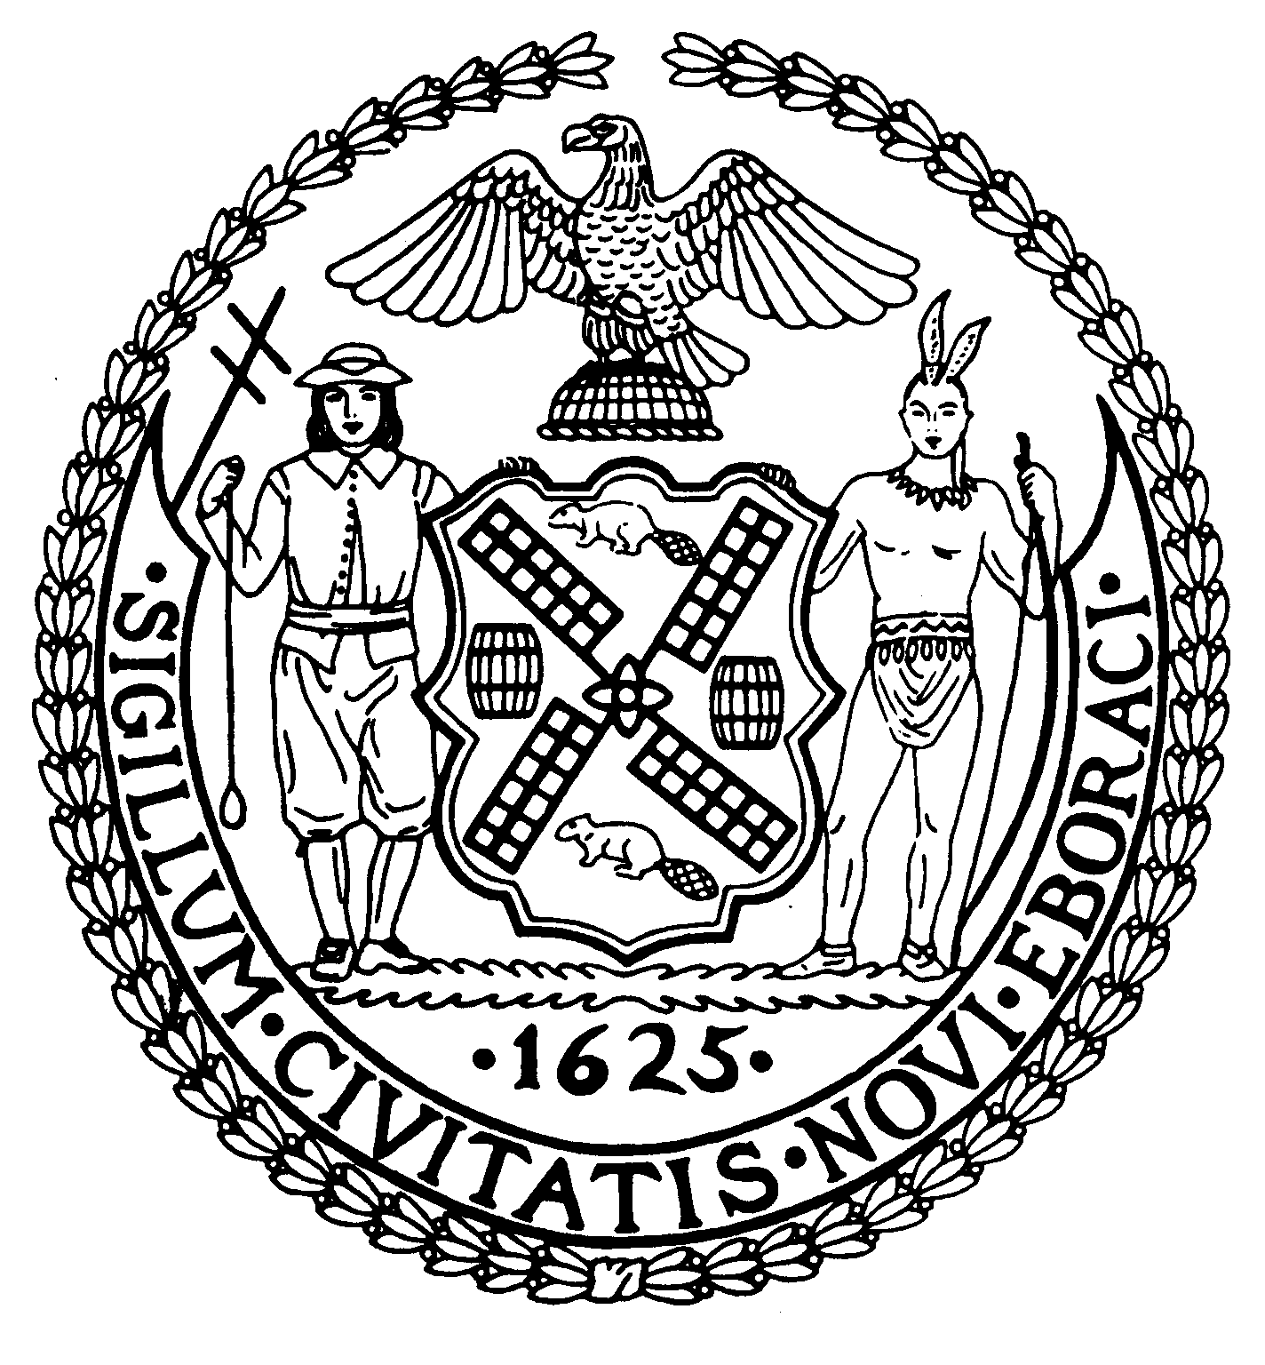
Chair Suite 620
New York, N.Y. 10022

Latha Thompson (212) 758-4340
District Manager (212) 758-4616 (Fax)
W ww.cb8m.com Website
info@cb8m.com - E-Mail

The City of New York

Manhattan Community Board 8

Youth and Education Committee Meeting

New York Blood Center, 310 East 67th Street, Conference Room 1, New York, NY
Monday, September 27, 2010 7:00 pm

Agenda

    - Re-zoning for Community District 8

    - Update on PS 267

    - Waitlists and questions from parents

    - Update on 2nd Teacher/Aid in the classroom.

    - Update on G &T Programs at Roosevelt Island PS 217 and PS 198

    - Future Meetings
October:
November:

7. Old/New Business

Jim Clynes and Judith Schneider, Co-Chairs

